Discussion about the Water Sanitation Old & New used ways

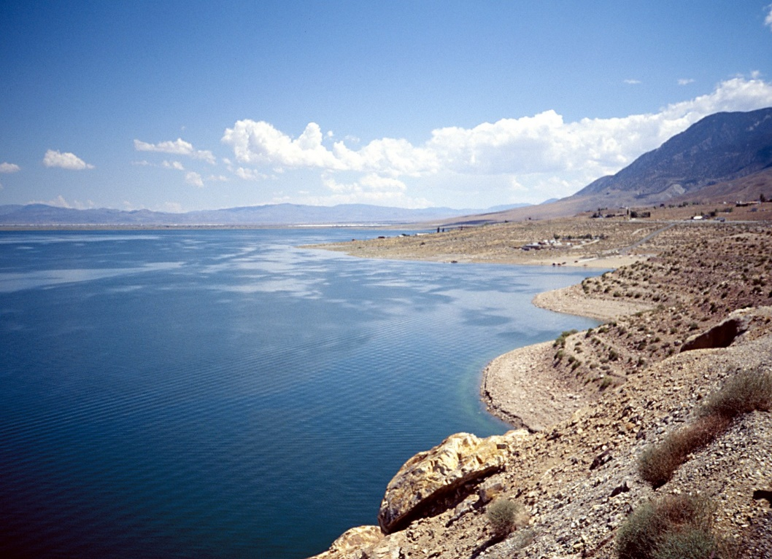
Abstract

This report will discuss the different systems for the water sanitation, the advantages & disadvantages of each system, and the best usages of each system. It will also take into consideration the water treatment in general, which in some of the cases do not need sanitation at all.
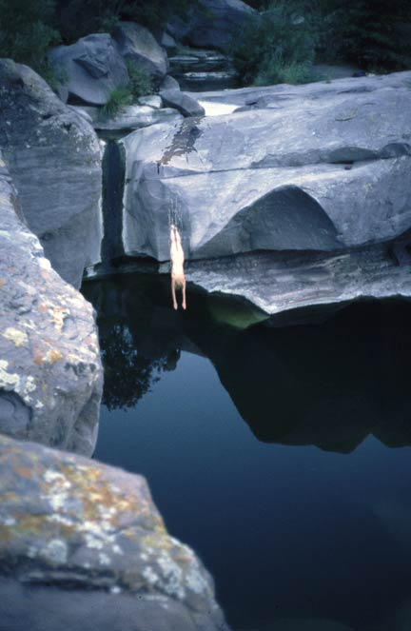
Introduction

Can we imagine our life without water? In fact the life on our Earth was created due to the existence of the water on this planet. Therefore, we are now trying to discover any life evidence on another planet by tracing the existence of the water on those planets.

Moreover, as water is very essential to our life we have to very much protect, preserve and clean if we have to. The first appearance of human life on Earth didn’t have to do any cleaning (sanitation) to water that they were drinking. However, this started to happen with the increase of human population, which of course decreases the water resources and polluted them. Therefore, human nowadays have to clean (sanitize) their water before using it in different purposes.

Table of contents
- What we use water for?
- Why we sanitize the water?
- Review on the water treatment in general.
- Types of sanitation products used nowadays?
- The advantages & disadvantages?

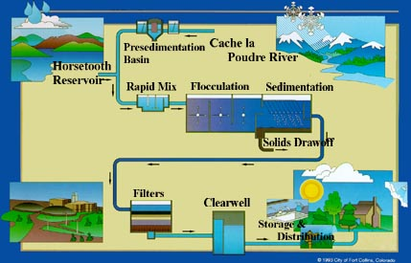

#As it appears in this picture no Chlorine or any other sanitation is used!
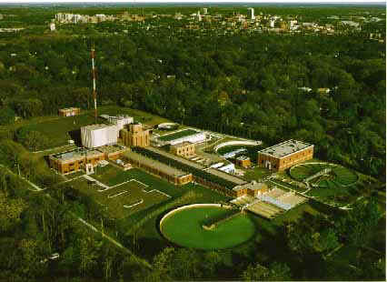
Discussion:

* What we use water for?

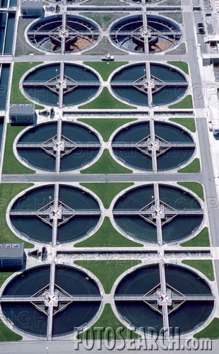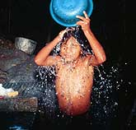
- Drinking.
- Food products.
- Washing.
- Swimming.
- Medicine & Curing.

Why we sanitize the water?
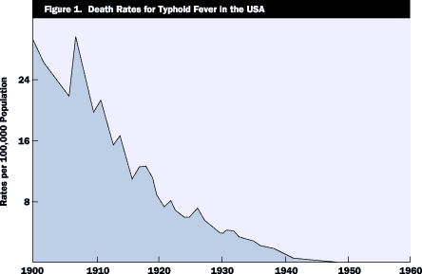

Sanitation provision reduces diarrhea and other water-borne illnesses. Avoiding such illnesses saves time and money for both individuals, households, and government agencies, as healthier people are more economically productive.
The sanitation study built on a recent analysis by the WHO to analyze the CBA of sanitation investments in 12 of the countries analyzed in the water study. The analysis included two sets of sensitivity analyses to test the underlying range of assumptions in the model, to yield pessimistic (worst case) and optimistic (best case) scenarios.
The findings present a strong case for investment in sanitation:
• The net returns are positive (> 1) across all 12 countries, indicating that sanitation yields greater benefits than costs at the country level;
• The analysis finds that for every US$1 invested in providing improved sanitation, resulting societal economic benefits of between US$5 and US$23 will be realized, depending on the country;
• Net returns are positive even in the most pessimistic scenario, for all countries studied.

In the United States, the effective sanitary procedures developed and enforced by Public Health Authorities for application in the Food Service Industry, have been vital for ensuring the protection of Public Health. The maintenance of these high standards of cleanliness and sanitation has resulted in great benefits to the Food Service Industry as well. Today, Americans are spending more dollars on foodservice products and meals prepared by others than on food prepared at home.
Unfortunately, according to the Food and Drug Administration, we are now experiencing an increasing number of illnesses associated with microbial contamination and food-borne disease, most of which are associated with an increased laxity in maintaining proper sanitary procedures. Over two-thirds of the source of all food-borne illnesses reported is attributed to restaurants. Infectious disease and illness resulting from unsanitary conditions occur from the microbial contamination that can effect any food handling establishment - patrons infected with communicable diseases can contaminate glasses, silverware, or any other surface they may contact - employees' hands can become contaminated by any soiled surface and can transmit that contamination to other surfaces - uncooked food may contain many types of harmful bacteria that can contaminate any surface it touches. Given the fact that infectious bacterial organisms can double their number every 20 minutes, it is no surprise that even a brief delay or lapse in following established sanitary procedures can result in microbial contamination that involves the risk of serious illness. The cost to a restaurant implicated in an incidence of food-borne illness can be quite high. The most important task in controlling microbial contamination is the proper cleaning and effective sanitizing of all food contact articles, preparation surfaces, and processing equipment immediately following each use.
Because proper sanitization is essential to public health, Federal Law requires that only chemical sanitizers which are accepted by the U.S. Food and Drug Administration (FDA) and are registered with the ENVIRONMENTAL PROTECTION AGENCY (EPA) and display the EPA registration number on the product label may be legally sold or used for sanitizing food contact surfaces. This insures that sanitizing products can be relied upon to be effective as claimed when used as directed.

* Review on the Water treatment in general.

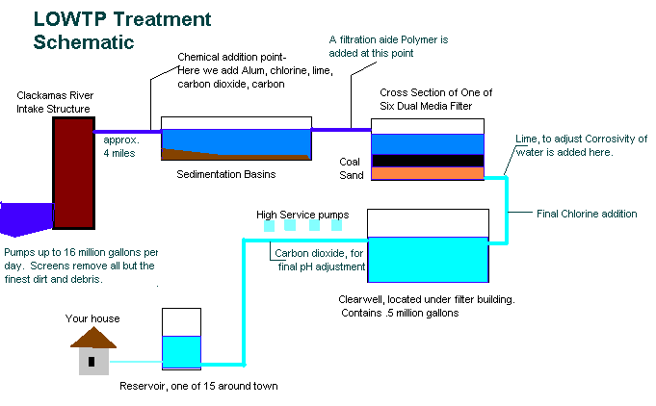
Water treatment plant is mostly consists of:-
- Intake structure.
- Sedimentation Basin (Tank, which we usually add additives for efficient sedimentation and pre-sanitation).
- Filter (Tank of sand and/or Coal).
- Odder clearness (add of Carbon Dioxide).
- Final Sanitation (Chlorine).
- Storage (Tanks).
- Distribution (Pumps).

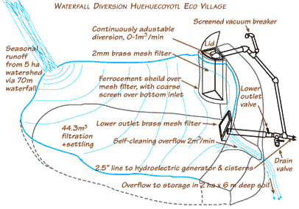
* Types of sanitation products used nowadays?
Chlorine and Chloramines
Dr. Gordon R. Finch of the University of Alberta, Canada, released a study of chlorine inactivation of Cryptosporidium in May 1996.24 Dr. Finch evaluated a two-step disinfection approach in which different types of chlorine were applied sequentially - i.e., free chlorine (elemental chlorine, hypochlorous acid or hypochlorite ion) pretreatment followed by monochloramine. He also proposed a disinfection model for use by engineers to design C. parvum control processes for water treatment facilities.
Dr. Finch theorized that chlorine pretreatment sensitized the oocysts to the effects of monochloramines, increasing levels of inactivation. He also found that hypochlorous acid performed significantly better than hypochlorite ion for inactivation.
The study concluded that chlorine followed by chloramines could be used as an alternative methodology with appropriate disinfectant concentrations and contact times. Increasing levels of chlorine pretreatment proportionally reduce the subsequent monochloramine concentration and contact time necessary for a given level of inactivation.
Dr. Finch further suggested that the proposed two-step model for sequential chlorine-monochloramine disinfection could provide a potential disinfection barrier to C. parvum for water systems with adequate contact time.
Chlorine Dioxide
Dr. Finch also described several studies that reported C. parvum inactivation by chlorine dioxide in water at high pH levels and low temperature. More recent evidence suggests that effective inactivation can be achieved with a chlorine dioxide dose followed by free chlorine.^{25M}
Ultraviolet Radiation
A joint venture in the United Kingdom has proposed an ultraviolet (UV) system to inactivate Cryptosporidium and Guardia in drinking water. Rather than treating the water, the system directly treats the oocysts to achieve inactivation. Water enters a treatment chamber and passes through a screen where the oocysts are trapped and irradiated. Using a two-step process, the water flow is reversed, and the oocysts are trapped and irradiated a second time. While additional development is needed, especially with regard to cost and design requirements, initial animal infectivity studies resulted in no infection to laboratory mice after treatment.²²
Ozone
Ozone has been used to achieve the inactivation of Cryptosporidium oocysts. After conventional treatment processes (coagulation, flocculation, sedimentation or dissolved air flotation) accomplish 99.0% to 99.9% removal of the oocysts, ozone disinfection can successfully inactivate the rest. Important considerations in designing models for ozone disinfection of Cryptosporidium include water temperature, CT (concentration X time) criteria and residual levels.³⁹
In water systems using ozone, Dr. Finch's research has shown that combining ozone as the primary disinfectant with chlorine or chloramines to furnish a dependable residual disinfectant may provide very effective.
* Advantages and disadvantages of each type?
Chlorine-based Disinfectants Chloramines
This process involves the addition of ammonia and chlorine compounds to a water filtration plant. When properly controlled, the mixture forms chloramines. They are commonly used to maintain a residual in the distribution system following treatment with a stronger disinfectant, such as free chlorine.
Chloramines advantages
- Persistent residual.
- Taste and odor minimization.
- Lower levels of trihalomethane (THM) and haloacetic acid (HAA) formation.
- Effective disinfection of biofilms in the distribution system.
Chloramines disadvantages
- Produces disinfection by-products (DBPs), including nitrogen-based compounds and chloral hydrate, which may be regulated as a DBP in the future. There is limited information on the toxicity of chloramines DBPs. In an analysis of the health effects of alternatives, Bull states that "there is little information on which to base an estimate of the health hazard that chloramines poses."⁶
- Presents problems to individuals on dialysis machines. Chloramines residuals in tap water can pass through membranes in dialysis machines and directly induce oxidant damage to red blood cells.
- Causes eye irritation. Exposure to high levels of chloramines may result in eye irritation.
- Requires increased dosage and contact time (higher CT values, i.e., concentration X time).
- Has questionable value as viral and parasitic biocides.
- Can promote growth of algae in reservoirs and an increase in distribution system bacteria due to residual ammonia.
- Can produce HAAs.
- Provides weaker oxidation and disinfection capabilities than free chlorine.
Chlorine Dioxide
Chlorine dioxide is generated on-site at water treatment facilities. The popularity of chlorine dioxide as a water disinfectant increased in the 1970s when it was discovered that it did not promote THM formation.
Chlorine dioxide advantages
- Acts as an excellent virucide.
- Does not react with ammonia nitrogen to form chlorinated amines.
- Does not react with oxidizable material to form THMs; destroys up to 30% of THM precursors.
- Destroys phenols that cause taste and odor problems in potable water supplies.
- Forms fewer chlorinated DBPs such as THMs, HAAs and TOX.
- Disinfects and oxidizes effectively, including good disinfection of both Guardia and Cryptosporidium.
- Works at low dosage in postdisinfection step with no need of booster stations.
- Improves removal of iron and manganese by rapid oxidation and settling of oxidized compounds.
- Does not react with bromide to form bromate or brominated by-products.
- Has enhanced turbidity removal under certain conditions.
Chlorine dioxide disadvantages
- Reacts with natural organic matter and forms inorganic by-products. Chlorite ion, and to a lesser extent chlorate ion, are formed when chlorine dioxide is used.
- Requires on-site generation equipment and handling of chemicals.
- Occasionally poses unique odor and taste problems.
Alternative Disinfectants
Ozone
Ozone has been used for several decades in Europe for taste and odor control, color removal and disinfection.
Ozone (O3) is generated by irradiation of an air stream with ultra-violet (UV) light at a wavelength of 185 nm or by passing dry air or oxygen through a corona discharge (CD technology) generator. For low ozone concentrations (ca. 0.14% by weight, or 0.5 grams per hour), the less expensive UV equipment is sufficient. For more demanding situations, where higher ozone concentrations (1.0% to 14% by weight) are required, CD systems are used.
Ozone advantages
- Acts as an excellent virucide.
- Disinfects and oxidizes very effectively.
- Produces no chlorinated THMs, HAAs or other chlorinated by-products.
- Enhances turbidity removal under certain conditions.
- Inactivates both Cryptosporidium and Guardia, as well as other known pathogens.
- Controls taste and odor.
Ozone disadvantages
- Produces disinfection by-products, including:
- ~Aldehydes
~Ketones
~Carboxylic acids
~Brominated THMs (including bromoform)
~Brominated acetic acids
~Bromate (in the presence of bromide)
~Quinones
~Peroxides
- Fosters THM formation when some ozonation by-products combine with secondary disinfection processes. A biologically active filter will likely be necessary to remove these newly formed precursors.
- Does not provide a persistent residual.
- Raises regulatory concerns. Future DBP regulations may require plants using ozone to install costly precursor removal systems (such as granular activated carbon filtration systems).
- Requires capital investment. Ozone must be produced on-site by costly generation that requires a high level of maintenance and substantial operator training.
- Promotes microbial growth. Ozone readily reacts with more complex organic matter and can break this down to smaller compounds that serve to increase nutrients in water supplies, thus enhancing microbial regrowth in water distribution systems.
Ultraviolet Radiation
This process involves exposing water to ultraviolet (UV) radiation, which inactivates various microorganisms. The technique has enjoyed increased application in wastewater treatment but very limited application in potable water treatment.
Ultraviolet radiation advantages
- No chemical storage, handling or feed equipment required.
- No identified disinfection by-products.
Ultraviolet radiation disadvantages
- No residual action.
- High maintenance requirements.
- High initial capital costs.
- High operating (energy) costs.
- Disinfecting action can be compromised by variables such as water clarity, hardness (scaling on the UV tubes), fouling (biological materials) of UV lamps, wave length of the UV radiation or power failure.
Unknown Factors Associated with Alternatives
Scientific investigation of risk associated with alternative disinfectants and alternative disinfection by-products is limited. A decision by water facilities to switch from chlorination could be risky because scientists know so little about DBPs from processes other than chlorination.
Drinking Water Disinfectants At a Glance
Disinfectants | Residual  Maintenance | State of Information  on By-Product  Chemistry | Color Removal | Removal of  Common Odors
Chlorine | Good | Adequate | Good | Good
Chloramines | Good | Limited | Unacceptable | Poor
Chlorine dioxide | Unacceptable* | Adequate | Good | Good
Ozone | Unacceptable | Limited | Excellent | Excellent
Ultraviolet radiation | Unacceptable | Nil | N/A | N/A

Other usages of Water; “Hot Tub & Spa Sanitizer Comparison”

Bromine
Bromine generally comes as tablets that go into a floater dispenser in the spa. Bromine contains some chlorine and has become one of the more popular chemical sanitizers in recent years.
Advantages | Disadvantages
- Convenient to use...put tablets into floater and refill every 10 to 14 days.  - Readily available...most pool and spa dealers carry it.  - Can be used with ozone  - Does not have "chlorine smell"  - No difference between the effectiveness of free vs. combined bromine | - Has low pH (aprox. 3.5 - 4.5)...pH levels need to be adjusted frequently to prevent equipment damage.  - More expensive than chlorine  - Can not be used with Nature2  - Bromine odor is more difficult to shower off  - Requires the use of 'sodium bromide' when water is changed to establish a bromine reserve

Chlorine
Chlorine has been used the longest in the spa industry. It comes in granular form and ideally should be dissolved in water before adding to your spa.
Advantages | Disadvantages
- More neutral pH...sodium di-chlor has a pH of 7.0  - Readily available...Most Pool and Spa dealers carry it.  - Less expensive than bromine  - Can be used as sanitizer and also as "shock"  - Can be used with ozone and Nature2 | - Less convenient...needs to be added manually several times a week.  - Confusion of varieties...Numerous types are available, only sodium di-chlor should be used in spas.  - Combined chlorines cause the "odor" but has no sanitizing ability

Ozone
Ozone has become the most popular chemical-free sanitizer in the last few years. Depending on it's application, it may or may not be very effective.
Advantages | Disadvantages
- Reduces required amount of bromine or chlorine  - Most new spas come "ozone ready" for easy installation  - Easily connected to most spas  - Can be used with bromine , chlorine, or Nature2 | - Needs to be supplemented with chlorine or bromine  - Can be expensive...$150 - $500 depending on application  - Bulb needs replacing every 2-4 years  - Should not be used on indoor spas

Nature2
Nature2 is one of the newer sanitizing methods. It seems to work very well and is based on the same principle as an ionizer, without the electricity.
Advantages | Disadvantages
- Easy to use...fits in filter  - Lasts 4 months  - Can be used with chlorine or ozone  - No chemical smells | - Need to shock frequently with chlorine or non-chlorine shock  - May be difficult to locate...though we do carry it  - Can not be used with bromine

Ionizers
Can be expensive, though many people swear by sanitation with ionizers. Can greatly reduce conventional sanitizer usage.
Advantages | Disadvantages
- Uses copper and silver for sanitizing...similar to the space shuttle.  - No chemical odors  - Can be used on indoor spas  - Has no effect on pH levels | - Copper and Silver rods need to be replaced every year or two  - Very expensive  - Kills organic matter, but doesn't oxidize them  - Spa still needs to be chemically shocked occasionally

Other types in the market for different purposes are:-

Compare These Advantages:
Steramine tablets possess every advantage offered by other Sanitizers plus additional important and distinct benefits which combine to make Steramine outstanding.
Property | Chlorine  Compounds | Steramine  1-G Tabets | Iodine  Compounds | Liquid  Quaternaries
Odor | yes | none | yes | none
Corrosive | yes | no | yes | yes
Skin Irritation | yes | no | yes | yes
Objectionable Residue | yes | no | yes | no
Stability | poor | good | fair | good
Visible Indication | none | yes | none | none
Probable Waste | yes | no | yes | yes
Probable Error | yes | no | yes | yes
Freezes | yes | no | yes | yes
Chemical Exposure  Hazard Category* | I-Danger | II-Warning | I-Danger | I-Danger
*EPA classifies products into one of three chemical hazard categories based on a worker's risk of exposure to the concentrated product from ingestion, inhalation, and skin and eye contact. One of the three specific "signal words" (DANGER, WARNING, or CAUTION) must appear on each product label to properly identify which exposure hazard category the product represents.
Category I - DANGER: Most toxic, risk of permanent injury or death.
Category II - WARNING: Less toxic, risk of temporary injury.
Category III - CAUTION: Least toxic, least risk of temporary injury.

Why Chlorination is the most used one?
Alternatives to chlorination have been studied throughout the history of water treatment, and various disinfection methods have been proposed. Some treatment techniques have questionable value in drinking water treatment. Studies by Richard J. Bull and others indicated that alternative disinfectants produced a series of by-products. These findings demonstrated that all known methods (with the possible exception of ultraviolet radiation) of drinking water disinfection involve the use of reactive chemicals and, as such, lead to by-product formation.⁶
The water industry has been assessing alternatives to chlorine-based disinfectants. While each alternative has its advantages and disadvantages, all must be assessed on the basis of risks and uncertainties, as well as benefits. This is especially important in light of the limited experience and scientific knowledge associated with these processes. Compared with chlorination, relatively little is known about the potential by-products of alternative disinfectants.
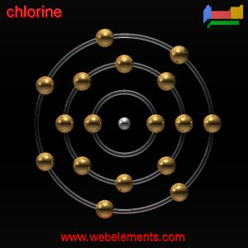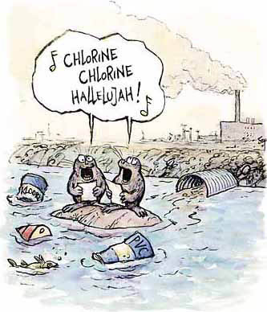
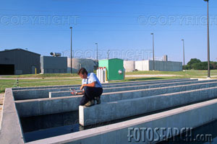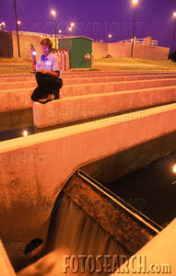
- It does not produce a series of by-products.
- It last longer especially in the long pipes of the water distribution systems.

-----------------------------------------------------------
Conclusion
Chlorination is the most usable sanitizer for Water on our Earth.
However, as it was show before, it has some disadvantages.
Therefore, we should always think of alternatives, and most important of all is to always think and act towards keeping our Earth clean, working in this issue for all the environmental parameters necessary for our life, will eventually (of course) affect positively the main source of our existence; WATER, so we maybe don’t need those sanitizers in future.
