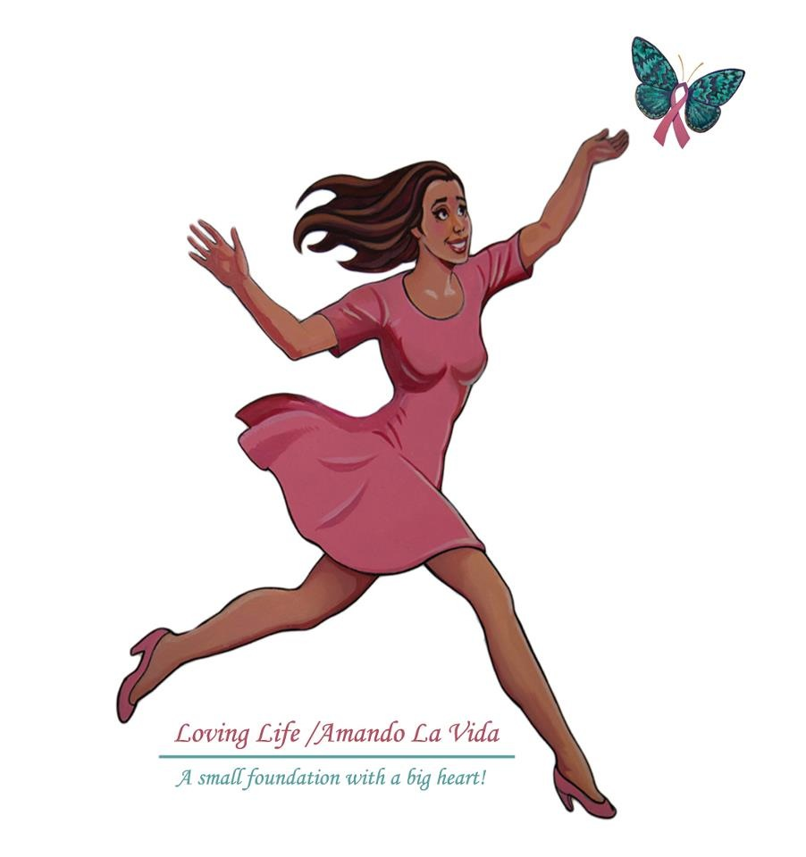
Loving Life Supporters~
What a year of transition we have had, between moving from North Carolina to Florida, changes in work environments and the start of a Satellite for Loving Life/Amando La Vida in Florida. We have been blessed through it all and while the work has been intense, we are excited about all of the changes.

Incorporating a new State (Florida) to a non-profit is not a simple task, but getting a new community behind your passion is probably the hardest part but one that we have been privileged to accomplish nicely. While there is still much work in the months/years to come, we are up and running. Up and running of course means, that it is a work in progress one that has delayed my abilities to put together our traditional “Havana Nights” fundraising event during the month of October-our largest form of funding each fiscal year.

Reaching out to the new health care communities in Florida, and setting up those relationships is always hard work but we accomplished that fairly quickly in North Carolina. The population in the Florida areas of Hispanic patients, is obviously higher than in the Carolinas but we no longer simply assist the Hispanic population but anyone in need.

As a recount of what has been occurring with Loving Life/Amando La Vida this past year:

* Continued free mammograms for those with lower income or lack of insurance
* Education with our (30) Ambassadors continues in the Rural areas
* High School’s are getting early awareness education in the Carolinas
* Youth involvement and interest in the Foundation continues to develop
* Assistance with transportation, meals, and medical supplies to current patients
* Translation assistance to new patients-buddy program in full force

As you can see we are still working hard, our mission to assist continues to unfold excited that it is growing so much faster and embracing a much larger audience. We have many very encouraging news for 2016, which we are in the process of organizing (we will disclose soon). But because so much is happening, we continue to need your support and trust that you can see our vision as we do….a world without breast cancer is a much better place to be.

Because we use our October Fundraiser as our strongest funding, and because we are not prepared this year to organize such a large event I am reaching out to you here as the foundations Founder. We have created a donation through PayPal, which with your support will assist us this year to continue to grow and develop this small foundation with a big heart!

For a Breast Cancer Survivor-Breast Cancer Month is every month, but we do encourage a larger awareness and support during this month and look for you to continue to stand behind us.

Please either reach out to us directly or visit our website at www.lovinglife-foundation.org, for a much appreciated donation through the new PayPal feature. Remember no donation is too small, and more importantly they can be made anonymous.
Sincerely, Eli Arroyo-Allen

