2022-2023 Member Interest Survey (MIS)

The completion of this survey is optional, and the information you provide is not intended to be confidential.

League leaders will utilize the aggregate survey results from all members affiliated with the Chapter/Express Network to determine the annual curriculum (monthly program topics and initiatives) that are best aligned with the members’ needs and interests. Recognizing needs/interests change, the league leaders may choose to revisit this survey and/or administer additional surveys throughout the Award Year.
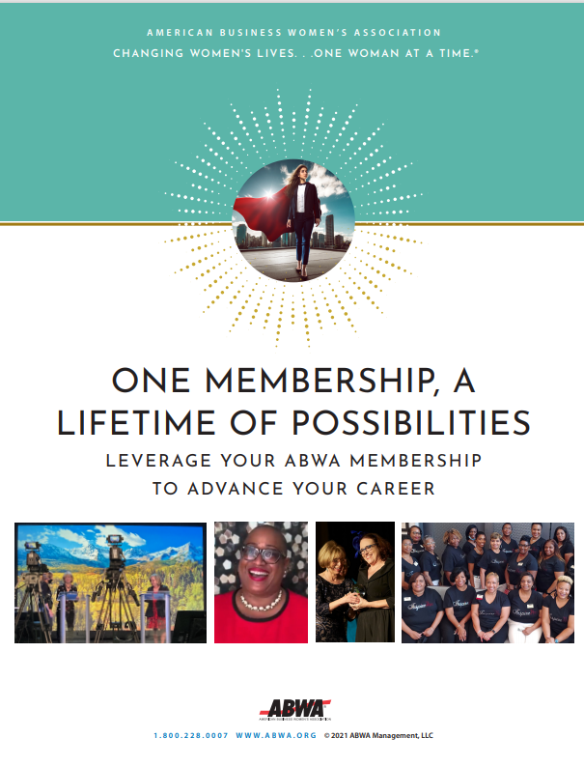
Before completing this survey, we recommend that you define the areas of development that you would like to focus on in the next twelve months. To get you started, consider downloading the Professional Development Template included in the One Membership a Lifetime of Value Guide from the National Resources in Community Connections.

Thank you for taking the time to complete this survey in a timely manner.

After completing this survey, print and return to: Click or tap here to enter text.
Member Name: | Click or tap here to enter text.
Member Signature
Date Completed | Click or tap here to enter text.

- The reason I chose to become a member of the American Business Women’s Association (ABWA) is because: (Choose all that apply)

To network with other professional women in and outside of my industry.
To acquire new knowledge and skill sets that will accelerate my career advancement and wages.
For Professional Development Opportunities provided by ABWA (e.g., online learning content in the Apex Campus).
To earn CEUs that I need to maintain my license/certification.
My employer was willing to pay my annual dues if I joined.
Other (please specify) Click or tap here to enter text.

2. I’ve been an ABWA member for:
Less than 1 year.
Between 1-5 years.
Between 6-10 years.
Between 11-20 years.
Between 21-30 years.
Between 31-40 years.
Between 41-50 years.
Between 51-60 years.

3. The most important reason for renewing my membership in ABWA and in this league is…
(Note: If you are a new member of ABWA, move onto survey question number four)

4. My current job position can best be described as:
Teacher/Professor.
Business Trainer or Consultant.
Entrepreneur/Business Owner.
Senior Manager (CEO, COO, CFO, Director, Vice President).
Supervisor/Manager, Sales Account Representative, Sales Executive, Sales Consultant, Sales Agent.
Marketing/Communications and/or Public Relations Professional.
Human Resource Professional.
Engineer.
Information Technology or Web Designer.
Customer Service or Administrative Professional.
Retired/Active Military.
Other.
5. In the next twelve months, my ONE MAIN GOAL (OMG) is to:
Find a new job in the same industry.
Get promoted with my current employer.
Start a new career in a different industry.
Grow my business.
Complete my college (or post-graduate) education.
Earn a certification (e.g., project management) that will advance my career.
Update my professional portfolio (resume, cover letter, references) in preparation for a job change.
Retire.
6. What do you know about ABWA’s Career Connections? (Choose one)
I know ABWA’s Career Connections is a job portal accessible from the ABWA National Website (www.abwa.org).
I’ve taken advantage of ABWA’s Career Connections job portal by posting my resume to the site and monitoring the site for job postings.
Wow! I didn’t know that ABWA had a job portal located on the National website. I plan to research ABWA’s Career Connections at www.https://careers.abwa.org.

7. The knowledge, skill sets and experiences I will need to achieve my ONE MAIN GOAL (OMG) in the next twelve months are:
I will need to acquire knowledge about… Click or tap here to enter text.

I will need to acquire skill sets such as… Click or tap here to enter text.

I will need to acquire more experience in these specific area(s)… Click or tap here to enter text.

- What do you know about ABWA’s Apex Campus and how have you taken advantage of this member only benefit?
I didn’t know about ABWA’s Apex Campus (learning portal) and as such, have never taken advantage of the online curriculum. I plan to check it out at www.myapexcampus.org.
I’ve not registered for and/or completed a course in the past twelve months.
I’ve successfully completed at least one course in the past twelve months.

- List and prioritize from highest to lowest impact, six program topics that will be beneficial in acquiring the knowledge and skill sets you want to achieve in the next twelve months. The information you provide in this survey will be useful in determining the types of programs that will be delivered at our league’s Regular Monthly Meetings.

Highest Impact on My Career Objectives | Lowest Impact on My Career Objectives
1. Click or tap here to enter text. | 4. Click or tap here to enter text.
2. Click or tap here to enter text. | 5. Click or tap here to enter text.
3. Click or tap here to enter text. | 6. Click or tap here to enter text.

- The volunteer leadership positions that will help me acquire the knowledge, skills and experiences I will need to achieve my career goals are: (Choose all that apply)
Membership Recruitment Committee | SBMEF - Scholarships Committee
Fund-Raising Committee | American Business Women’s Day Committee
Newsletter Chair | New Member Orientation Committee
Publicity Committee | Hospitality Committee
Auditing Committee | Best Practices Committee
Nominating Committee | Local Awards/Committee (e.g., Woman of the Year, Protégé’)
Programming (Professional Development) Committee | Top Ten Business Woman Nominee Committee

- Ten members are recognized every year as the Top Ten Business Women of ABWA. We would like to assist you in meeting the eligibility requirements so you will be eligible for this prestigious honor in the future. Please take an inventory of your contributions to the American Business Women’s Association thus far.
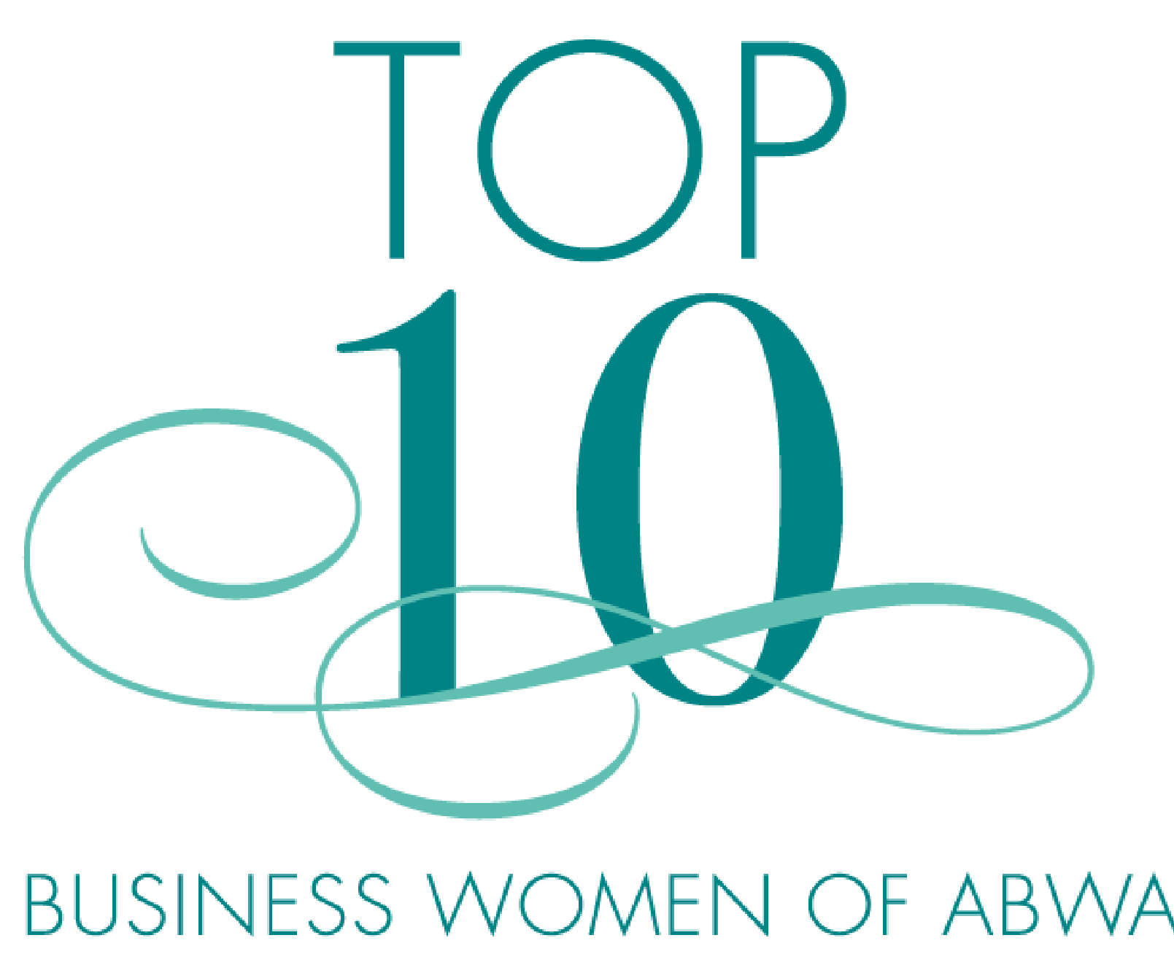

(Choose all that apply)
I’ve completed at least one course in the Apex Campus in the past twelve months. | Since 2020, I’ve served as as league officer and/or committee chair.
I’ve attended at least two nationally sponsored ABWA events (regional and/or national conference) since 2020. | Since 2020, I’ve sponsored at least three new members.  I will be affiliated with this league for at least one year as of May 15, 2023.

Note to League Officers…
Additional survey questions may be added if deemed useful.

