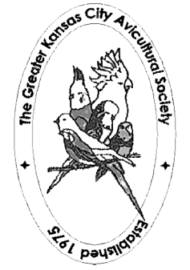
Greater Kansas City 2018 Budgerigar Show
BAA Affiliated
Junior, Novice, Intermediate, Champion & Rare Divisions
Judge: Dan Scholtes
Saturday, July 21, 2018
At: CORNER STONE CHURCH
1316 S. Osage, Independence, MO 64055
Check In: Friday 5:00 – 7:00 PM & Saturday 7:30 – 9:00 AM
Entry Fee: $3.00 per bird
Show will be held in conjunction with GKCAS SUMMER BIRD FAIR
Recommended Hotel:
Royal Plaza Hotel, 13712 East 42nd Terrace S, Independence MO
Bird Show Special - $99 + tax – King or Double/Double Rooms – Inc Breakfast
Reservations (816) 373-2800
Directions: I-70 to Exit 12. Head South. Hotel is first driveway on right.
Show Information:
Bob Wilson - (913)908-3202 bw@49w.us or Donna PIerce - (816)836-3681 dlpteah07@gmail.com

