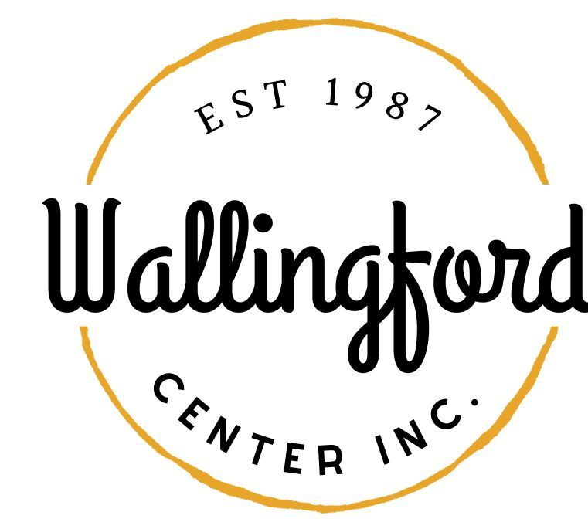
Regular Meeting
Tuesday May 3, 2022
Wallingford HubCap
128 Center Street Wallingford, Ct 06492
5:00pm in person

- Call to Order
  - Appointment of Alternates
- Approval of minutes
  - Regular Meeting April 5, 2022
  - Special Meeting April 13, 2022
- Treasurer’s Report
- Executive Director’s Report
- New Business
  - Annual Meeting scheduled for June Meeting
- Old Business
  - discussion and possible action regarding new member policy
- Report from committees
  - downtown collabtive
  - hubcap
  - 350th
- Public Comment
- Executive Session pursuant to CGS 1-200 6a ; purpose of session is discussion of annual review of staff
- Adjournment

