Volume 9, Issue 12
December 2021

Trinity Times

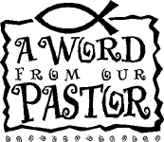

Part II of Ministry in My Community
(Part I in the November Newsletter)

Serve your neighbors.
The word ministry means service. You can be in ministry in your community.
1. Look closely at the people and institutions around you. Invite others in your congregation to see more clearly the hopes, hurts, and needs of people who live nearby.
2. Share what you learn with others. Speak about your neighbors’ aspirations and struggles with members of your church.
3. Take initiative to make a difference. Lend a helping hand to groups working to provide services locally or to effect positive change in public policy. Invite others to help organize a self-help group or sponsor a community program to serve neighbors.
4. Through recognition services, postings on church bulletin boards, and articles in the church newsletter, encourage members and leaders of your congregation to affirm persons who are living as good neighbors.

5. Contact community organizations for information about needs and opportunities for service. Watch for articles in your local newspaper describing volunteer opportunities and “wish lists” for community service groups and charities. Check out the bulletin board at your local grocery store. Ask your pastor about programs sponsored by your annual conference.
Call local organizations, such as Meals on Wheels, Second Harvest Food Bank, Habitat for Humanity, after-school tutoring and mentoring programs, hospices, halfway houses, The Red Cross, domestic violence centers.

6. Go online. Many communities host websites where volunteers can find opportunities to assist others and where persons in need of your help can post a request. Excellent examples are www.volunteermatch.org and www.networkforgood.org where all you have to do is enter your zip code to find countless opportunities for a wide range of service.

Make a choice.
Jesus said that the way to live is to love God and neighbor.
You can know the neighbors in your own community.
You can begin to see them and listen to them. You can work with them. Jesus told the story of the Samaritan who was a good neighbor, then instructed: “Go and do likewise” (Luke 10:29-37).

Lord, help me know my neighbors. Help me see more clearly their pain and longings. Help me keep from “passing to the other side.” Help me show mercy and compassion as one way of loving you with all my heart, strength, and mind. Amen.ontinued

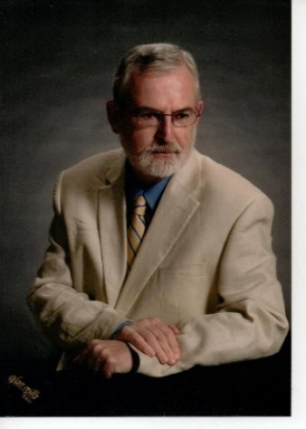
In Christ,
Pastor Doug

Carrie and I would like to wish everyone a very Merry Christmas and a Happy New Year. We are so happy to be a part of the Trinity UMC Family. We hope your holidays are filled with love, peace, family, and happiness.

Trinity United Methodist Church
1160 Trinity Church Road
Newberry, SC 29108
803-276-1245 Office
803-542-0082 Pastor Cell
dobenton@umcsc.net
trinityumcnewberry@gmail.com
www.trinityumcnewberry.net
PLEASE VISIT OUR WEBSITE
AS OFTEN AS YOU CAN!

Peggy Bogart, Church Secretary
Head Usher: Harry Longshore
Choir Director: Jane Pollard
Organist: Eddie Welborn
Substitute Organist: Phyllis Sanders
Video Board: Josh Pitts, Caroline Senn, Bryan Waldrop
Acolytes/Cross Bearers Coordinator: Eli Martin
Newsletter Editor: Harriet Stevenson

Sunday Worship:
Worship Service: 11:00 a.m.

We are a nurturing and open church to all who enter into our Sanctuary. We base our ministry on the Word of God and a caring spirit. Jesus invites us to share our ministry to all that come into our church.

Pastor Doug and Carrie
Invite you to a
Christmas Drop-In

Church Parsonage
Dec. 19, 2021
3:00 - 6:00 p.m.

We are a caring and loving church and we want to share your concerns. Let us know if you or someone you know would like to share a prayer request with us. We will be happy to pray for you. Contact Harriet Stevenson, Peggy Bogart, Church Secretary, or Pastor Doug to add or remove names from the Prayer List.
Recent Hospitalization/Surgery:
Nursing Home: Gloria Brehmer (Springfield)
Shut-Ins: James and Jeanette Poag, Shirley Berry, Boyd Hendrix

Continued Prayers: Robert Pollard, Family of Kim Eubanks, Lavone Coates (fall), Betsy Black (shingles), Carrie Benton
Family and Friends of Trinity: Homer Bowles, Neil Thomas, Francis Leopard, Kinsley Bouknight, Janna Longshore, Philip Sanders

Thank you to all who helped fill the church with beautiful poinsettias during the month of December.
These poinsettias were purchased in honor or memory of loved ones.

Thank you to Sharon Baughman for coordinating this effort and keeping the poinsettias watered. A special thanks also to Wilson Senn for typing up the In Honor Of/In Memory Of List. You may pick up your poinsettia after the service on Dec. 29.

If you would like to place flowers in the church, please sign the flower chart located on the bulletin board opposite the pastor’s study. Record your name on the Sunday you wish to place flowers in the church. You will need to fill out an Altar Flower Sheet located on the bulletin board next to the Flower Chart at least a week prior to your date to have the flowers. Please complete and return the form to the desk of Peggy Bogart, Church Secretary.

For December
Dec. 5 – Betty Way
Dec. 12 – Jane Woodward
Dec. 19 – John Pollard
Dec. 26 – Linda Lominack

Dec. 5 Harriet Stevenson
Dec. 12 Dixie Waldrop
Dec. 19 Crystal Waldrop
Dec. 26 Lynn Mohler

4-Donna Davenport
11-Craig Kesler 23-Phyllis Sanders
11-Becky Poag 24-DavidHendrix
15-Charleigh Armstrong
18-Kim Hendrix 27-Dalton Morris
19-Betsy Black 28-Gene Thomas
20-Keith Hendrix

- Trinity collected 33 shoeboxes for Operation Christmas Child. Thank you to all who filled shoeboxes for this wonderful ministry.
- Laura Mohler, daughter of Burt and Lynn Mohler, was a member of the NHS tennis team who won the Region 3 AA tennis championship. She was also named All-Region. Congrats, Laura.
- Noah Mohler, son of Burt and Lynn Mohler, participated in the US Kids Golf Series of tournaments and finished in 14th place out of 22 in the 13-14 age group. Good
Playing, Noah.

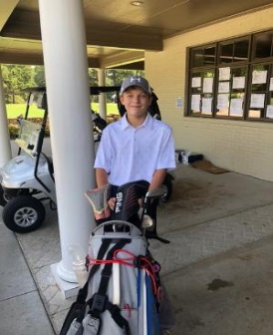

December 2021

Sunday | Monday | Tuesday | Wednesday | Thursday | Friday | Saturday
Nov. 28 | Nov. 29 | Nov. 30 | 1 | 2 | 3 | 4
1st Sunday in Advent | . |  | .
5 | 6 | 7 | 8 | 9 | 10 | 11
2nd Sunday in Advent |  |  | Silver and Gold  Holiday Luncheon  Jim and Dixie’s House  11:30 a.m. | . .
12 | 13 | 14 | 15 | 16 | 17 | 18
3rd Sunday in Advent |  |  | Men’s Club  Holiday Dinner  Blue Ocean  6:30 p.m. | . |  | .
19 17 13 14 15 16 17 18  4th Sunday in Advent  Christmas Drop-in at the Parsonage  Light Refreshments  3:00 – 6:00 p.m. | 20 14 15 16 17 18  Deadline for January Trinity Times | 21 14 15 16 17 18 | 22 14 15 16 17 18 | 23 23 14 15 16 17 18 | 24 14 15 16 17 18  Christmas Eve  Service  With  Communion  5: 30 p.m.  Trinity | 25 14 15 16 17 18  Jesus’s Birthday
26  Pick up Poinsettias  After Church Service | 27 | 28 | 29 | 30 | 31
Visit our website: www.trinityumcnewberry.com Visit our FB Page: trinityumcnewberry

Organizations and Opportunities to Serve:

Trinity  Women’s Club  (Circle)  1st Monday | 2021 Leaders – Harriet Stevenson; Dixie Waldrop, Susan Waldrop  The Trinity Women’s Club would like to thank everyone who supported the Hotdog Lunch/Bake Sale Fundraiser we had in November. It was a great success due to the kindness of those who ate with us, baked, and bought baked goods and made donations. The fundraiser will be used to pay for shipping for our cookbooks which will be out in early 2022. The fundraiser also allowed us to help provide a local family with food, gifts, and toys for Christmas. The fundraiser was headed up by Joan Morris and Jane Pollard. We had a lot of help but we especially thank Joan Morris and her helpers, Barbara Rogers, and Kelly Morris for their hard work in the kitchen and Jane Pollard and her helper, Sharon Baughman, for all of her hard work on the Bake Sale.  .  Next Meeting: January 3 - Devotions: Jane Pollard

Silver  And  Gold  2nd  Wednesday  __________  Men’s Club  1st Wednesday | 2021 Officers:  Silver and Gold met for the first time post-covid on November 10 in the Fellowship Hall. Harriet and Phyllis welcomed everyone back and asked them to get ready to FALL for JESUS because He never LEAVES. The tables were decorated with Fall Leaves and a FALL theme and devotions were based on Deuteronomy 31:8 “ The Lord Himself goes before you and will be with you. He will never leave you nor forsake you. Be not afraid; be not discouraged.”  A delicious lunch of homemade soups, cornbread and apple cake was served. Afterwards the group had fun playing FALL Bingo and other games.  Next Fellowship Meeting: Wednesday, Jan. 12. Dues for 2022 will be $12.00 per person and will be due by March 15, 2022. You will be notified of details later.  Officers: President- Johnnie Pitts; Vice President-Ashley Wilson; Sec/Treas-Wilson Senn; Program Coordinator-Foster Senn.  The Men’s Club will meet at Blue Ocean for their holiday gathering on Dec. 15 at 6:30 p.m.. All Men’s Club members are invited. See Johnnie Pitts for more information. You do not have to be a member of Trinity to participate in the Men’s Club.  Next Meeting: Jan. 5 at 7:30 p.m. Cooks will be announced in next month’s newsletter.
Invite a friend to come to church with you! All are welcome! With YOUR help, we can grow our membership at Trinity!

Methodist Youth Fellowship (MYF) – Josh and Erin Pitts, Leaders.

The MYF filled six shoeboxes for Operation Christmas Child. A few pictures are below. The MYF will meet on December 12th from 5 – 7 :30 for a Holiday Movie Night. We would like to wish everyone a very Merry Christmas and a Happy New Year.

Filling Shoeboxes for Operation Christmas Child
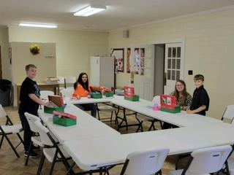

Sympathy is extended to the family of Trinity member Kim Eubanks on her recent passing after a long illness. Our prayers are with David, Alex, Carol and the entire family.

We also remember those we lost in 2021:

Johnny Marlowe
Ronald Davenport

EVENTS
December 5, 12, 19, Lighting of the Advent Candle during 11:00 a.m. service
December 8 The Silver and Gold – 11:30 a.m. Jim and Dixie Waldrop’s Home
December 12 MYF Holiday Movie Night at church from 5 – 7:30 p.m.
December 15 Men’s Club Holiday Dinner at Blue Ocean – 6:30 p.m.
December 19 Reception at the Parsonage from 3:00-6:00 p.m. hosted by Pastor Doug and Carrie
December 24 Christmas Eve Worship Service with Communion – 5:30 p.m. Lighting of Advent Candle. Come as you are. All are welcome!
December 29 Pick Up Poinsettias after church service.
January 2 An order for the Consecration and Installation of our Church Leaders for 2022 during 11:00 a.m. service.
From the Editor, Harriet Stevenson
All of us know the beautiful Christmas hymn ''O Holy Night.'' This poem was written by Placide Cappea and set to music by Adolph Charles Adam, a French composer. Ironically, it was frowned upon by church authorities who denounced it for poor taste and a ''total absence of the spirit of religion.''
In the first stanza, we are invited to close our eyes and imagine the world before the birth of Jesus. He says it is a world that lay ''in sin and error pining.'' The word pining refers to the wasting away of the human spirit as it grieves and endures pain. In other words, he paints a picture of a world of darkness without light, and a world in deep despair without hope. In the face of our fractured country and our cries for peace, I would say we are again in that position. Our country is severely divided right now. Everyone is hurting for one reason or another but no one seems to know what to do. But in the song, we hear the next three words ''till He appeared.'' When He appeared everything changed.
That is exactly why Jesus came; to change the world. Our world is once again turned upside down, “in sin and error pining.” As Pastor Benton said recently, some pastors are watering down their sermons just so they can be politically correct. Sometimes, it seems that Jesus is nowhere to be found. But no one can take Jesus out of our hearts. No one can keep us from telling of the good news of Jesus Christ. At Christmas we are reminded that miracles can take place. He will appear again. This beautiful hymn tells of the glory of Christmas. The night on which Jesus was born was such a Holy Night. Let us pray for a miracle in our world. Let us pray for love in our world. Let us pray for peace in our world again. Let us pray for Jesus Christ in our world. Only then will it truly be a Merry Christmas.
Listen carefully to the words of verse 3:
Truly He taught us to love one another;
His law is Love and His gospel is Peace;
Chains shall he break, for the slave is our brother,
And in his name all oppression shall cease,
Sweet hymns of joy in grateful Chorus raise we;
Let all within us praise his Holy name!

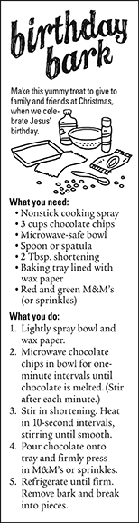

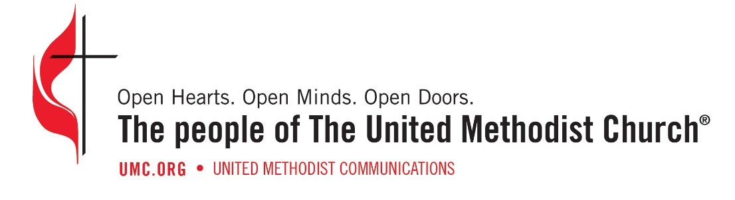

Trinity United Methodist Church
1160 Trinity Church Road
Newberry, SC 29218

