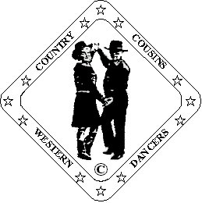
Ron & Ann Williams.
D & G Fully Qualified Instructors
023 9234 1758 ronannwilliams@ntlworld.com

Win or Lose

Partner Dance (64 Count)

Choreographed By Ann Williams. Country Cousins Western Dancers.

Music: “You Win, I Win, We Lose” Kenny Chesney

Beats/Step Description.
Start in Right Side By Side Position “Sweetheart” Same feet throughout.

Side. Behind. Together-Cross-Point. Behind. Side. Forward Shuffle.
1-2 3&4 Step left to left side. Cross right behind left. Step left beside right-Cross right over left-Point left to left side.
5-8 Cross left behind right. Step right to right side. Left shuffle forward.

Turn. Behind. Turn Forward Shuffle. Turn. Behind. Turn Forward Shuffle. (Lady Back Shuffle)
9-12 Turn ¼ turn left stepping onto right. Cross left behind right. Turn ¼ turn right and right shuffle forward.
Raise right hands over lady’s head, release left hands. Rejoin left hands in front facing L.O.D.
13-16 Man: Turn ¼ turn right stepping onto left. Cross right behind left. Turn ¼ turn left and left shuffle forward.
Lady: Turn ¼ turn right stepping onto left. Cross right behind left. Turn ¼ turn right and left shuffle back.
Raise left hands over lady’s head, finish hands crossed in front left hands on top, right shoulder to right shoulder.
Man facing L.O.D. Lady facing R.L.O.D.

Rock. Recover. Walk x 4. (Lady: Walk. Walk. ½ Turn) Back Shuffle.
17-24 Man: Rock forward on right. Recover onto left. Walk back stepping on right, left, right, left. Right shuffle back.
Lady: Rock back on right. Recover onto left. Walk forward stepping on right, left. Turn ¼ turn left stepping onto right.
Turn ¼ turn left stepping back on left. Right shuffle back.
Raise left hands over lady’s head followed by right hands, finish both facing L.O.D. hands crossed in front right on top.

Rock Recover. Walk x 4. (Lady: Walk. Walk. ½ Turn) Forward Shuffle.
25-32 Man: Rock back on left. Recover onto right. Walk forward stepping on left, right, left, right. Left shuffle forward.
Lady: Rock back on left. Recover onto right. Walk forward stepping on left, right.
Turn ¼ right stepping onto left. Turn ¼ right stepping back on right. Left shuffle back.
Raise right hands over lady’s head followed by left. Man facing L.O.D. Lady facing R.L.O.D.
right shoulder to right shoulder. Hands crossed left on top.

Side. Behind. ¼ Turn. Step. Pivot ½ Turn. ¼ Turn. Rock. Recover.
33-40 Step right to right side. Cross left behind right. Turn ¼ right stepping onto right. Step left forward.
Release hands and pass in front of partner.
Pivot ½ turn right. Turn ¼ right stepping onto left. Rock back on right. Recover onto left.
After ¼ turn facing partner rejoin hands crossed in front left on top.

Man: Step. Step. (Lady: Step. Pivot ½ Turn) Forward Shuffle. Walk. Walk. Forward Shuffle.
41-44 Man: Step right beside left. Step left beside right. Right shuffle forward.
Lady: Step forward on right. Pivot ½ turn left. Right shuffle forward.
Raise left hands over lady’s head into Sweetheart Position facing L.O.D.
45-48 Walk forward stepping on left, right. Left shuffle forward.

Walk. Walk. Shuffle Windmill Turn. Walk. Walk.
49-60 Walk forward stepping on right, left. Turn ¼ turn right into a right cross shuffle.
Facing O.L.O.D. hands held over lady’s shoulders
Turn ¼ turn right into a left shuffle back. Turn¼ turn right into a right shuffle.. Face I.L.O.D.
Raise left hands, lower right. Face R.L.O.D. Release right hands, lower left and rejoin right behind man’s back.
Now facing I.L.O.D.
Turn ¼ turn right into a left shuffle forward. Facing L.O.D. Walk forward stepping on right, left.
Release left hands, raise right to finish facing L.O.D. Rejoin left hands in front in Right Side By Side.
(Sweetheart Position.) You are moving down L.O.D. on these shuffles.

Rock. Recover. Step Back. Touch.
61-64 Step and rock forward on right. Recover onto left. Step right back. Touch left beside right.

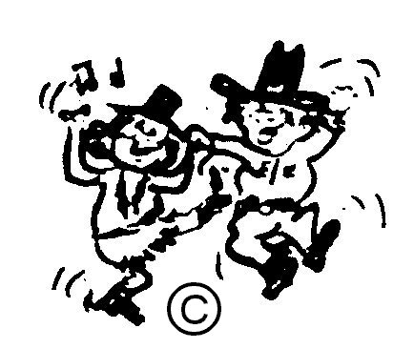
HAPPY DANCING

