National Interpreting Agency 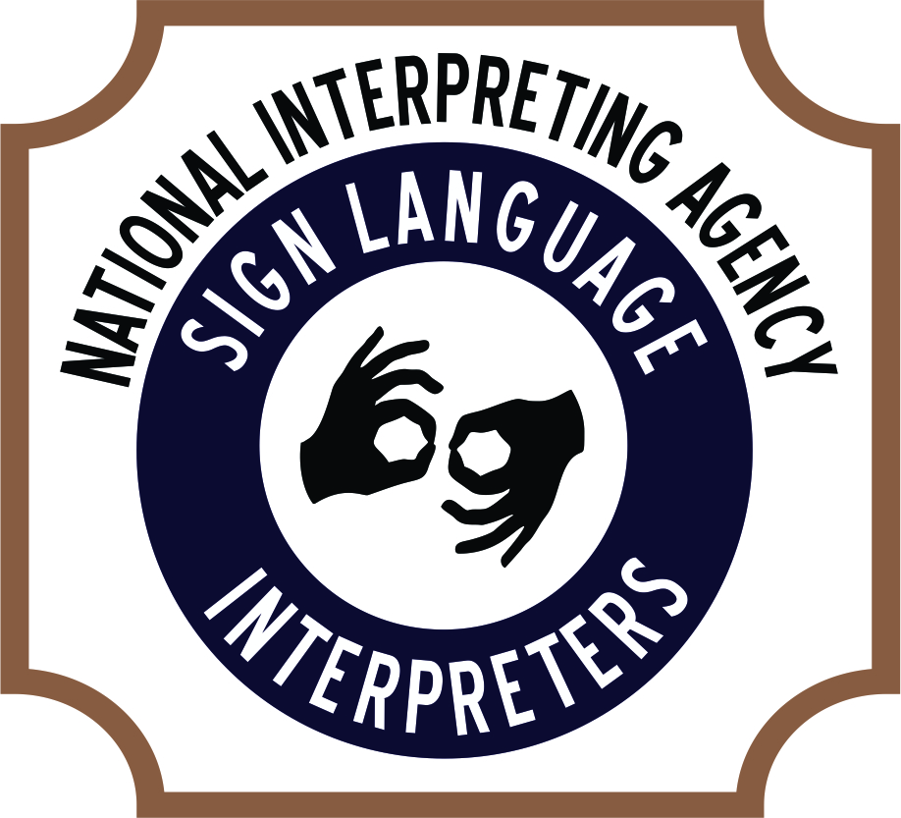
Gina D Asad
Executive Director
P.O. Box 35478
Cleveland, Ohio 44135
216-527-3400 office
216-527-4181 cell
330-975-4419 fax
N.Interpreting.A@aol.com
www.nationalinterpretingagency.com

Signed Agreement of Services (SAS form)

Services from National Interpreting Agency will be performed for (YOUR NAME): _____________________________________________________________________________________
Company name: _______________________________________________________________________
Billing party address: ___________________________________________________________________
Phone number: ________________________________________________________________________
Email: _______________________________________________________________________________
Fax: _________________________________________________________________________________
(M, T, W, Th, F, S, Sun), _________________2013 at ____________AM/PM_____________AM/PM (day of week) (Date) (start time) (est. End time)
Type of interpreting setting (church, medical, legal, educational, community): _____________________________________________________________________________________
How many interpreters needed: _____________________________________________________________________________________
Type of interpreting – ASL, Tactile, Signed English: _____________________________________________________________________________________
Name of location where assignment is held: _____________________________________________________________________________________
Address of specific assignment scheduled: _____________________________________________________________________________________
(Department/room#/title): _____________________________________________________________________________________
(Client/Student/Patient/Employee – individual who is deaf): _____________________________________________________________________________________
Contact person name /Title: _____________________________________________________________________________________
Contact phone number: _____________________________________________________________________________________
Parking suggestion: _____________________________________________________________________________________
Special instructions or requests (Please send any vital information that will assist interpreter):__________________________________________________________________________
Brief description of assignment: __________________________________________________________________________________________________________________________________________________________________________
Billing invoice will be sent to (name, telephone #, ext., fax#): ____________________________________________________________________________________
Does any paperwork need signed for 3rd party agency? YES____ NO_____

I have read and agree upon the Terms and Conditions of National Interpreting Agency policies and procedures, rate of payment, time frame and procedure for how to submit payment for services. All documentation and forms for this assignment and billing are completely finalized.
_________________________________________ _________________________________ (Print name) (Title)

____________________________________________ _________________________________ (Signature) (Date)

