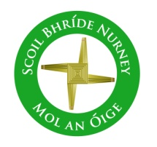
Scoil Bhríde
Nurney, Co. Kildare
Telephone: (045) 526767
www.nurneyns.com
sbnurney@gmail.com

6th October 2021
Dear Parents/Guardians

Tuesday October 5th was ‘World Teachers Day!’
Thanks to all teachers, past and present, who have contributed to make Scoil Bhríde the great school it is today. The Pandemic has certainly shown the hard and valuable work that’s teachers do each and every day across the World.
To have a teacher is a Blessing. Cherish it every day. To them all we say well done and Thank you.
Thank you also parents, as according to the Irish Constitution, you are the primary educator and carer of your child. We are delighted to assist you in that journey!

The Sacrament of Communion
Congratulations to all the boys and girls from 3rd class who received their First Holy Communion last week in Nurney Church. A wonderful celebration for all. God’s Blessings to you all and your families from all the team in Scoil Bhríde Nurney.

Halloween Fancy Dress
Children may wear their Halloween costumes to school on Friday October 22nd. School opening and closing times will be as normal on Friday October 22nd. Please do not allow your child dress up as killer clowns or bring replica guns to school. Thank you.

Dates for your diary
- Public Witches Walk and Halloween Bun Sale – cancelled
- Halloween Closure – School closed Oct. 25th to Oct. 29th inclusive

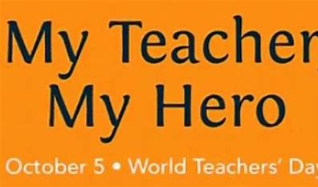

Wednesday Note and school information also
available
on www.nurneyns.com
Thank you for your co-operation with the above.
______________________________
Vinny Thorpe – Principal
(Doctoral student) M.Ed (SL), MA.Comp.Mus, H.Dip.Prim.Ed, H.Dip.Mus.Tech, P.Grad.Dip.Ed.St(SEN), B.Mus.Ed(H.Dip.Ed), Dip.Mus.Ed, T.Dip.ICT

Scoil Bhríde
Nurney, Co. Kildare
Telephone: (045) 526767
www.nurneyns.com
sbnurney@gmail.com

6th October 2021
Dear Parents/Guardians

Tuesday October 5th was ‘World Teachers Day!’
Thanks to all teachers, past and present, who have contributed to make Scoil Bhríde the great school it is today. The Pandemic has certainly shown the hard and valuable work that’s teachers do each and every day across the World.
To have a teacher is a Blessing. Cherish it every day. To them all we say well done and Thank you.
Thank you also parents, as according to the Irish Constitution, you are the primary educator and carer of your child. We are delighted to assist you in that journey!

The Sacrament of Communion
Congratulations to all the boys and girls from 3rd class who received their First Holy Communion last week in Nurney Church. A wonderful celebration for all. God’s Blessings to you all and your families from all the team in Scoil Bhríde Nurney.

Halloween Fancy Dress
Children may wear their Halloween costumes to school on Friday October 22nd. School opening and closing times will be as normal on Friday October 22nd. Please do not allow your child dress up as killer clowns or bring replica guns to school. Thank you.

Dates for your diary
- Public Witches Walk and Halloween Bun Sale – cancelled
- Halloween Closure – School closed Oct. 25th to Oct. 29th inclusive

Wednesday Note and school information also
available
on www.nurneyns.com
Thank you for your co-operation with the above.
______________________________
Vinny Thorpe – Principal
(Doctoral student) M.Ed (SL), MA.Comp.Mus, H.Dip.Prim.Ed, H.Dip.Mus.Tech, P.Grad.Dip.Ed.St(SEN), B.Mus.Ed(H.Dip.Ed), Dip.Mus.Ed, T.Dip.ICT

