I’m Moving up to Secondary school

My Name________________________________
New Schools Name________________________
Soon, I will make a big move along my educational journey when I start secondary school. This will be an exciting time for me, but it could also prove to be a little bit scary or overwhelming.
I am completing this activity book to make myself more prepared for this important change in my life.

Date started: __________ Date completed: __________


This is me

My last day in Year 6 My first day in Year 7

Stick photo here

Stick photo here

What things have changed about you?

Here is where my new school is

Print out a map showing your home and where your school is,
draw in the route from your home to school.
Driving_________________
Walking________________
Bus___________________


Bus Numbers from home to school


This is my new school

Photos on the inside

Photos on the inside

Photos on the inside

Photos on the inside

Photo of your school from the outside

How you’re feeling about Secondary school

Answer the following based on your feelings about secondary school as honestly as possible.

- What do you think secondary school will be like?
____________________________________________________________
________________________________________________________

- When you think about moving to secondary school, what feelings do you experience? Give reasons your answer.
______________________________________________________________
________________________________________________________


- What are you looking forward to the most in secondary school? Ex- plain your answer.
____________________________________________________
_______________________________________________



- What are you looking forward to the least in secondary school?
Ex- plain your answer.
____________________________________________________________
________________________________________________________

- What is your biggest fear about secondary school?
_________________________________________________________
________________________________________________________

- What could you do to work on this fear?
_________________________________________________________
________________________________________________________

- What strategies might you use to deal with feeling nervous or stressed as you begin secondary school?
____________________________________________________________
________________________________________________________

- Name one person you would be able to talk to about any concerns you may have about your move to secondary school.
____________________________________________________________
_______________________________________________________

New Subjects


Make a list of the subjects you will be studying in your first year in secondary school below. Write a description of what they will involve. If you’re not sure, use the internet to research this information.
Subject | Description

Now write the subjects in your order of your preference, starting with the one you are looking forward to studying most.



Subject

Who my New Teachers will be

Head Teacher_____________________________
Head of Year______________________________
Form Tutor_______________________________
SENCO___________________________________
Teaching Assistant__________________________
Subject Teachers
English
Maths
Science
Geography
History
Drama
PE
Art
Media studies
Music

Journal & Timetable
You will be given a school journal with your timetable, homework diary, note and other important information.
All timetables are a bit different in all schools, but they will all have the same information on them.
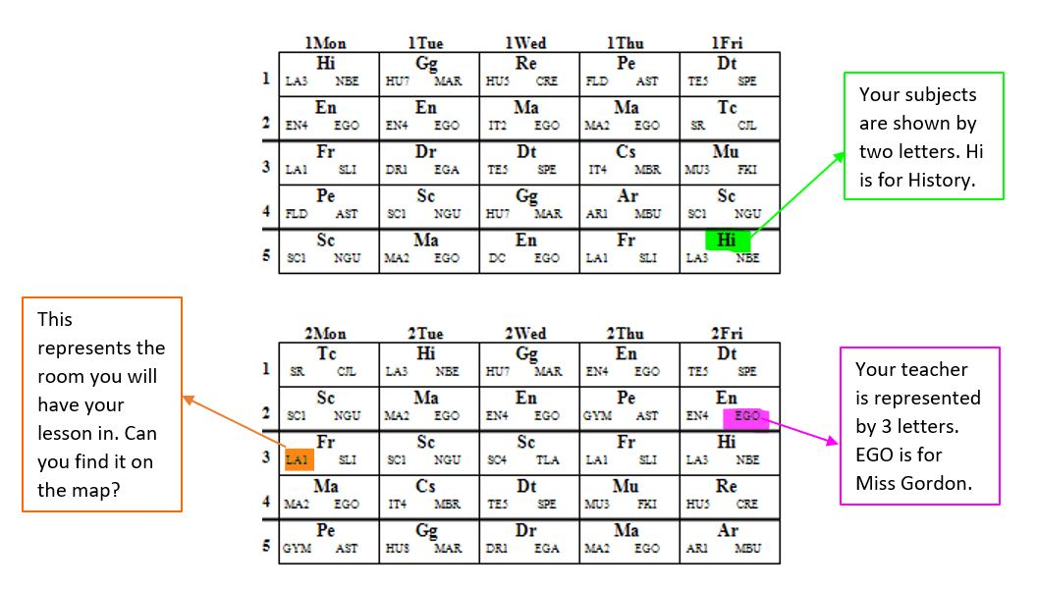
Dealing with a situation checklist

Talk through these scenarios and write down who you think would be best to help you in these situations.
Even if you don’t know everyone’s name yet write their role and when you start school you can write out you check list to keep in you journal.
Scenario | 1st who to go to | 2nd who to go to
If you can think of any more situations add them here.

Who can I speak to if….
I’m late for school?

Who can I speak to if….
I forget to hand my homework in?

Who can I speak to if….
I cannot find my way to a lesson?

Who can I speak to if….
I feel unwell?

Who can I speak to if….
I need help in class?

Who can I speak to if….
I don’t understand a lesson?

Who can I speak to if….
I do not understand my homework?

Who can I speak to if….
I find assembly too noisy and busy?

Who can I speak to if….
The other students are mean to me?

Who can I speak to if….
I Find the canteen too noisy?

Who can I speak to if….
I feel unhappy?

Who can I speak to if….
I am having a sensory overload?

Who can I speak to if….
I feel sad?

Who can I speak to if….
I feel anxious?

Who can I speak to if….
I feel angry?

The unexpected Grid
Sometimes things will happen that you are not expecting, and it could be overwhelming and confusing. Put this grid in your journal and log anything down that you weren’t prepared for or spoken to about. Then we can work on ways to stop it happening in the future, whether it’s you learning strategies or the school preparing you better.
Date | What happened | Where was it | Did you talk to anyone | How did you feel

EMERGENCY PACK

Make a small pack in your child school bag containing

- Spare bus fare
- Contact telephone numbers written down (in case phone dies)
- Which bus to catch information
- Front door key
- Back up pen & pencil
- Helping hand card for bus

Add anything your child may need to reassure them if something unexpected happens.

