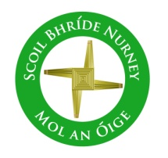
Scoil Bhríde
Nurney, Co. Kildare
Telephone: (045) 526767
www.nurneyns.com
sbnurney@gmail.com

14th December 2022
Dear Parents/Guardians
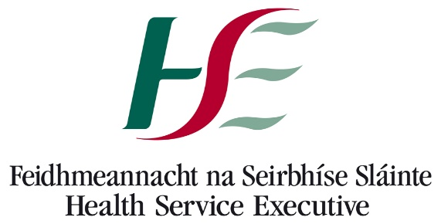

URGENT and ESSENTIAL Health information for all families!
Please find attached important correspondence and advice to all families from the HSE regarding the significant increase in viral infections among young children and young people this Winter.
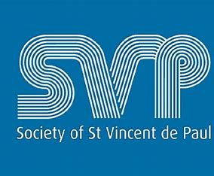

Our School’s Annual Winter Fest Hamper Raffle organized by 6th class for all pupils in memory of Catherine O’Donoghue late of Walterstown Nurney (partner of our great school caretaker Pat) begins this week. All donations go to ‘St. Vincent De Paul’

Tickets for the raffle will continue to be sold to pupils in the school by 6th class on Monday the 12th, Tuesday the 13th, Wednesday the 14th and Thursday the 15th of December. Tickets are 1 Euro per line.
Winners of the raffle will be announced at our December school assembly. The winner will get a hamper. There are two hampers. One for junior infants to 2nd class and one for 3rd to 6th class. All raffle ticket purchases are welcome and greatly appreciated. Thank you for supporting St. Vincent De Paul.

Drum lessons payment due – all pupils
A 4-week course of drumming classes for all pupils with a specialist instructor has now finished. To cover the cost a payment of 8 Euro is now due from each pupil. This can be paid online or by cash. Thank you to all who have paid in full to date.

Scoil Bhríde
Nurney, Co. Kildare
Telephone: (045) 526767
www.nurneyns.com
sbnurney@gmail.com

14th December 2022
Dear Parents/Guardians

URGENT and ESSENTIAL Health information for all families!
Please find attached important correspondence and advice to all families from the HSE regarding the significant increase in viral infections among young children and young people this Winter.

Our School’s Annual Winter Fest Hamper Raffle organized by 6th class for all pupils in memory of Catherine O’Donoghue late of Walterstown Nurney (partner of our great school caretaker Pat) begins this week. All donations go to ‘St. Vincent De Paul’

Tickets for the raffle will continue to be sold to pupils in the school by 6th class on Monday the 12th, Tuesday the 13th, Wednesday the 14th and Thursday the 15th of December. Tickets are 1 Euro per line.
Winners of the raffle will be announced at our December school assembly. The winner will get a hamper. There are two hampers. One for junior infants to 2nd class and one for 3rd to 6th class. All raffle ticket purchases are welcome and greatly appreciated. Thank you for supporting St. Vincent De Paul.

Drum lessons payment due – all pupils
A 4-week course of drumming classes for all pupils with a specialist instructor has now finished. To cover the cost a payment of 8 Euro is now due from each pupil. This can be paid online or by cash. Thank you to all who have paid in full to date.

5th class Swimming payment due!
A six-week course of swimming classes in K-Leisure Athy for 5th class finishes on Wednesday 14th December. Payment of 50 Euro from each 5th class pupil is now due. Thank you to all who have paid in full to date.

A six-week course of swimming in K-Leisure Athy for all other senior classes will start as follows:
4th class – February 22nd 2023
3rd class – April 26th 2023

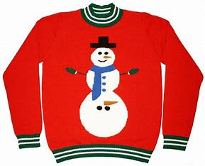
Christmas Jumper Day!
Wednesday, December 21st we invite all pupils, if they so wish, to wear a Christmas jumper in our school!

Home Learning page on our school website
If your child has to isolate and stay out of school due to RSV, COVID-19, Strep-A, or any other illness please go to the following link on our school website to access the school work they would be doing at that time in class https://www.nurneyns.com/home-learning

Dates for your diary
- School closes at 12:30pm on December 16th for all pupils as staff must attend Department of Education training in the New Primary Language Curriculum. The bus has been told.
- End of Term School Mass – Tuesday December 20th @ 11:40am. School Hall. Parents welcome. Very limited space. Standing only.
- School will close for Christmas on Wednesday December 21st for all pupils at 12.30pm. Buses have been told. The school will re-open on Thursday January 5th 2023 for all pupils at 9.20am
- School Book Fair – Spring 2023; risk assessment pending
- The Parish office wishes to inform you that Communion for families with children in 2nd class will be May 13th 2023 @ 11:30am in Nurney Church
- The Parish office wishes to inform you that Confirmation for families with children in 6th class will be March 25th @ 12 midday in Nurney Church

Wednesday Note and school information also available
on www.nurneyns.com
Thank you for your co-operation with the above.
__________________________
Dr. Vinny Thorpe – Principal
Ed.D (SL) M.Ed (SL), MA.Comp.Mus, H.Dip.Prim.Ed, H.Dip.Mus.Tech, P.Grad.Dip.Ed.St(SEN), B.Mus.Ed(H.Dip.Ed), Dip.Mus.Ed, T.Dip.ICT

5th class Swimming payment due!
A six-week course of swimming classes in K-Leisure Athy for 5th class finishes on Wednesday 14th December. Payment of 50 Euro from each 5th class pupil is now due. Thank you to all who have paid in full to date.

A six-week course of swimming in K-Leisure Athy for all other senior classes will start as follows:
4th class – February 22nd 2023
3rd class – April 26th 2023

Christmas Jumper Day!
Wednesday, December 21st we invite all pupils, if they so wish, to wear a Christmas jumper in our school!

Home Learning page on our school website
If your child has to isolate and stay out of school due to RSV, COVID-19, Strep-A, or any other illness please go to the following link on our school website to access the school work they would be doing at that time in class https://www.nurneyns.com/home-learning

Dates for your diary
- School closes at 12:30pm on December 16th for all pupils as staff must attend Department of Education training in the New Primary Language Curriculum. The bus has been told.
- End of Term School Mass – Tuesday December 20th @11:40am. School Hall. Parents welcome. Very limited space. Standing only.
- School will close for Christmas on Wednesday December 21st for all pupils at 12.30pm. Buses have been told. The school will re-open on Thursday January 5th 2023 for all pupils at 9.20am
- School Book Fair – Spring 2023; risk assessment pending
- The Parish office wishes to inform you that Communion for families with children in 2nd class will be May 13th 2023 @ 11:30am in Nurney Church
- The Parish office wishes to inform you that Confirmation for families with children in 6th class will be March 25th @ 12 midday in Nurney Church

Wednesday Note and school information also available
on www.nurneyns.com
Thank you for your co-operation with the above.
__________________________
Dr. Vinny Thorpe – Principal
Ed.D (SL) M.Ed (SL), MA.Comp.Mus, H.Dip.Prim.Ed, H.Dip.Mus.Tech, P.Grad.Dip.Ed.St(SEN), B.Mus.Ed(H.Dip.Ed), Dip.Mus.Ed, T.Dip.ICT

