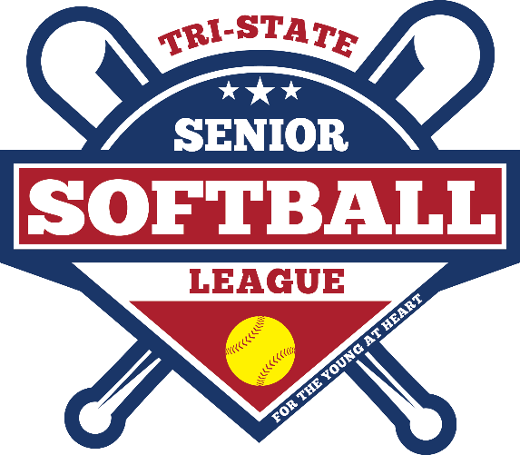
Registration for the Tri-State Senior Softball League is now open! Formerly the Washington County Senior Softball League, TSSSL is designed for men who are 50 years old and older; and women who are 35 years old and older. The TSSSL continues the 30+ year history of slo-pitch softball in our community. Games are played at Marty Snook Park in Halfway, MD. Registration fee is just $50 and you receive a jersey and hat, a 24-game season, social activities and more!
Join today and get ready for a great softball season.
Scan the QR Code to go to www.tsssl.org and download the registration form!

