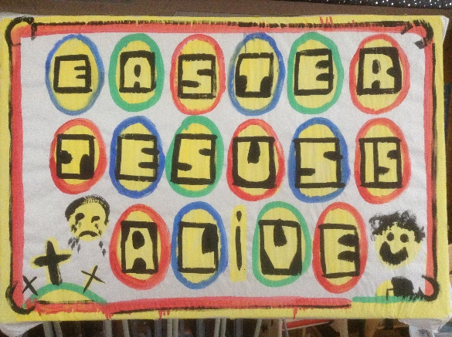

Service times at St Mary’s

Sunday: 10:30am Holy Communion
or Morning Prayer
Normally the first and third Sunday is Holy Communion with Morning on the second and fourth. Baptisms by arrangement with the Rector.

Tuesday: 10.00am Holy Communion
12.15pm Lunch-time Service

Readers contributions to the magazine are always welcome. Hard copy (hand written if easier) to the Rectory address or by email: to : st.marysstockport@gmail.com
Editorial discretion with regard to content and space available will apply.
St Mary’s in the Marketplace
St Mary’s Rectory, 24 Gorsey Mount Street,
Stockport, SK1 4DU.
0161 429 6564 www.stmarysinthemarketplace.com.

St Mary’s in the Marketplace
Parish Magazine
May 2014

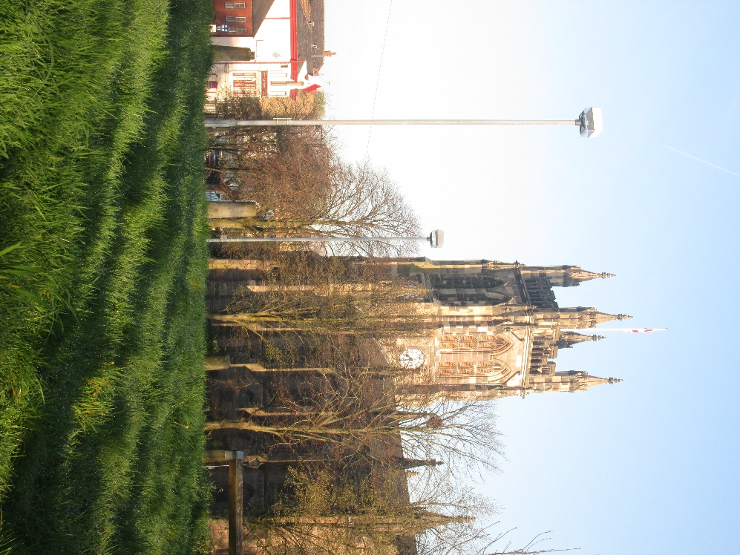

50p

From the Rector’s “ i-Pad”
Dear Reader
May 1st is the 90th Birthday of Marion Gordon, a much loved member of the congregation . We wish Marion a Very Happy Birthday and Many Happy Returns of the Day! ..
Marion has worked tirelessly in St. Mary's for many years, mostly out of sight, up in the galleries, trying to sort things out. Now , I don't like throwing things away, so it hasn't been easy for Marion working with someone like me, who thinks we should keep a piece of wood " because it might come in useful one day"! Despite everything Marion has managed to dispose of much accumulated rubbish , besides spending many hours and her much of own money on arrangements of artificial flowers when fresh flowers seemed out of fashion in church. Not only that, but also Marion took it upon herself to restore the tiled floor in as much of the church as she could get at, with a considerable degree of success, at the time. As we now see, events overtook her, with the total restoration of the church floors; but it was Marion who worked so hard to start the process. Furthermore Marion decided that the font needed cleaning, which is how it comes to look or bright and fresh now. Not only that , but also the brass rails which ran along the back pews, now gone, did not escape her attention, and were duly polished. Perhaps her most delightful contribution to the church's life has been the extraordinary display of hangings made of nuts and leaves and berries, which can be seen in the side chapel. They are a wonder to behold, and remain a lasting testimony of the gifted character of the lady who made them , Marion ! You will rarely if ever see Marion without her little dog, a Yorkshire terrier called Holly ,who is Marion's faithful companion and friend, and which has quite a bark for its diminutive size, and is as much fussed over in church as Marion is made welcome when she comes to church all the way from Hyde! .
.
Marion continues to make a significant, and much valued contribution to
Spring Fayre (April 2014)
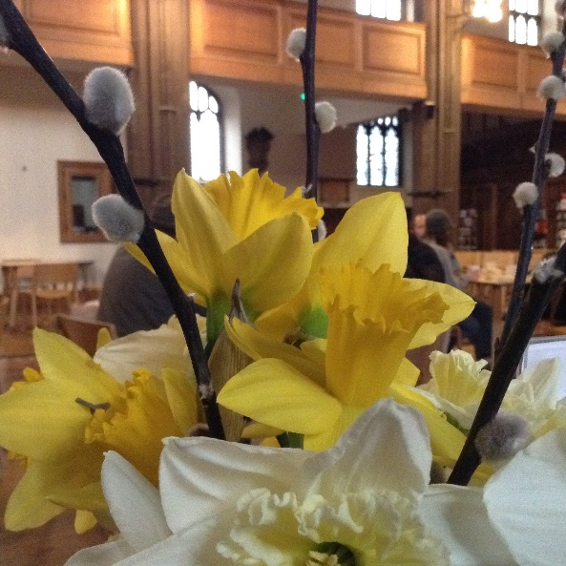
Many thanks to those involved in the Spring Fayre. We had a great range of goods on sale from cakes/jams to knitted hats.
These events are done for “fun” rather than “money” although we do want to raise funds for St Mary’s.
There were beautiful homemade goods and clearly a lot of time had been given making items for us to sell.
The event brought in £326.50 towards Church funds, unsold items having been mainly re-distributed to good causes – in particular Samaritans Purse (the Shoe Box Appeal). Other items will “re-appear” at later events!
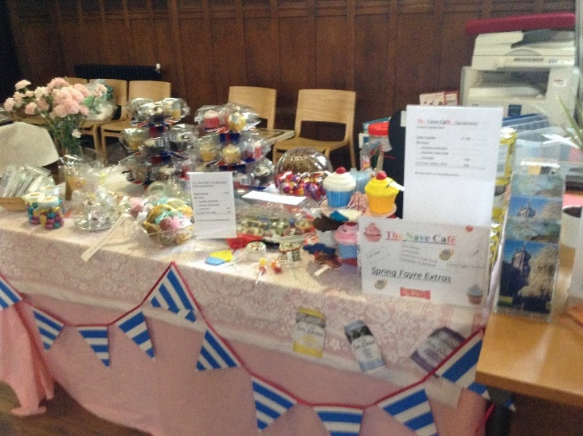
Our next venture of this type will be a Plant Sale to be held on the 24th May at St Mary’s. We hope that you will be able to come.
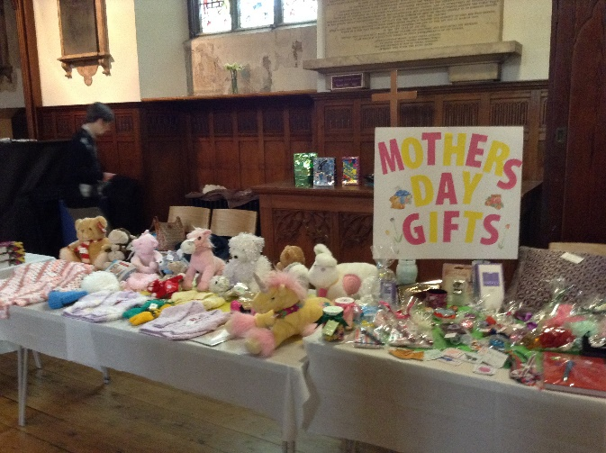

“Tuesdays at 12.15”

A lunchtime service with hymns.
During the next seven weeks the Bible teaching at this service will follow the theme of the saying of Jesus who said I AM in John’s Gospel

May 6 I AM The Bread if Life John 6:35
May 13 I AM The Light of the World John 8:12
May 20 I AM The Gate John 10:9
May 27 I AM The Good Shepherd John 10:11
June 3 I AM The Resurrection and the Life John 11:25
June 10 I AM The Way, the Truth and the Life John 14:6
June 17 I AM The True Vine John 15.1

After each service there will be a Bible Study group meeting in the chapel, to which all are welcome to discuss further the reading of the day.

Why not stay for lunch at our exciting Nave Café

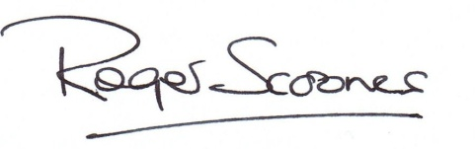

the life of St. Mary's and remains cheerful and always busy, despite various health set backs in recent years. There is a place for everyone in St. Mary's but especially for folk like Marion, celebrating her 90th birthday with us on May Day! .
On May 27 a very special occasion will take place at St. Mary's, one which I have been waiting for 17 years to be invited to host, the Archdeacon's Visitation. I am delighted that St. Mary's is now being seen, and used and appreciated by folk across the Diocese and that it will retain its role as a leading centre of church life in the years ahead. The Archdeacon requires all Churchwardens and sides persons to attend and to make a public commitment to serve the church under the authority of the Bishop. It is always a very meaningful and interesting service bringing together church members from across the Diocese in the Archdeaconry of Macclesfield. The new layout of a seating in church makes St. Mary's so much more flexible and user friendly, and people are beginning to see the building functioning in many different ways, never before possible. It will be better still when the final phase of work at ground floor level has been completed!
The celebration of birthdays in our church family is a reminder that none of us is getting any younger, and that we should be encouraging the younger generation to take on responsibility for the running of the church and giving it a new direction and dynamic. I hope that they will see this as a distinct probability, and not leave it too late! We must give them encouragement and support in this vital transition from the old to the new. If you love The Lord and St. Mary's I hope that you will make this your aim for the year ahead.
Yours, ageing gracefully, .
Rev. Roger Scoones
Rector,

Roger’s Sketch Board
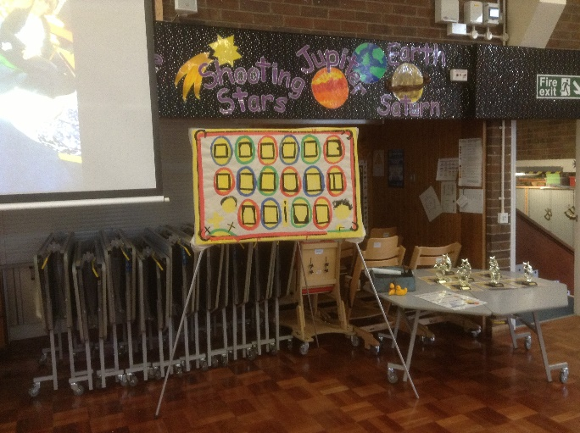
-Most of us are more than familiar with Roger’s boards and try and guess the words in advance.
There can’t be many children and adults around Stockport that attend/attended schools where Roger visits/visited that aren’t familiar with these and have remembered them (or will remember them). Add to the list then pupils at Lisburne Lane where Roger attended recently for their Easter Assembly.
The children love it of course, as Roger asks questions and they answer him – on many occasions guessing the letters and words before he gets to them – just like us in church!
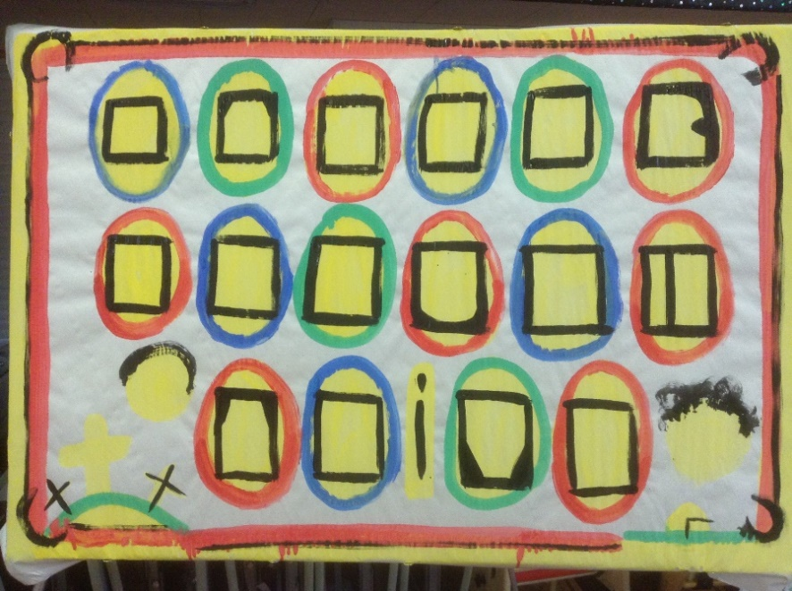
This is an Easter theme of course, well they are “easter eggs” that the letters are in - aren’t they! Roger’s completed board on can be seen on the back page – although you probably won’t need to look.

That is what's rather special about the I.C.S. seasonal chaplaincies. One chaplain follows another, and the mission, the work carries on.
The Winter Season is now over, the snow is melting, and the skiers have gone. The hotels are closed until the end of May , when tourists will return once again, to enjoy the beauty of the mountains and the Alpine spectacle of wild flowers in abundance. And then the summer chaplains will arrive, to continue to minister, in Jesus's Name, in Word and Sacrament. It is a privilege to have been called to this work, and I am grateful to you for your prayers and financial support.
Roger Scoones, Rector and Mission Chaplain

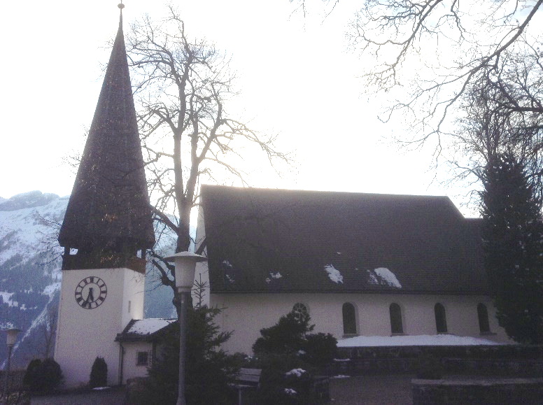
For further information about the work of the Intercontinental Church Society visit www.ics-uk.org or Google Wengen church
!

A Swiss Chaplaincy.
.
Some years ago I was invited to go skiing with a group of people on a very sunny and warm day. Instead of going to an expensive restaurant for lunch as I had expected , I found myself invited to share in a picnic with my new friends, sitting on the snow, under a tree on the edge of the ski run, the piste. It was a memorable unique and happy occasion. .
.
Shortly before leaving for Switzerland in March of this year, I learnt that those same friends had lost their daughter, aged 45, suddenly from a brain heamorage whilst staying in Wengen. The grieving parents had expressed the hope that I could help them with a small service in the English Church, before their daughter's ashes were scattered on the mountainside, near to where we had skiied that day all those years ago. As it happened I was already booked to stay a few extra days after my chaplaincy duties had ended, and so I was able to accept that invitation. The funeral took place on my last day in Wengen shortly before I left for England. It was attended by the family, including Alison's 11 year old son, and many friends who stay in Wengen in the winter. .
As a chaplain, one never quite knows how one's life is going to be inextricably linked with those of people one meets along the way, and in what way one may be invited to become involved in a family's life, such as this. It is a privilege and a huge responsibility, which I have shared with my fellow chaplains over the years. We each meet a different group of people, as the rota of chaplains changes fortnight by fortnight; and so the demands on the chaplain can vary greatly. The social and spiritual contacts made will be different too. .

On display at the Easter Egg Festival at St Thomas’ Church, Stockport
eggs from St Mary’s in the Marketplace & Stockport Heritage Trust
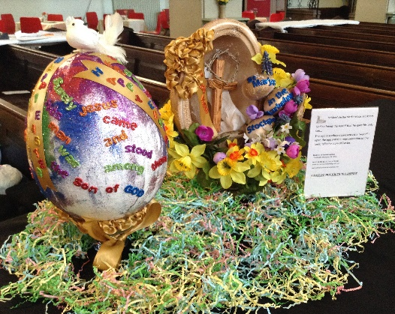

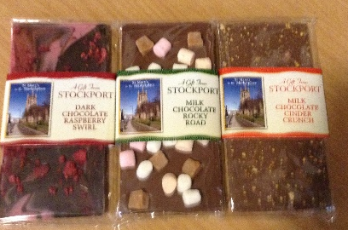
Our new range of confectionery etc. is now available for sale in the Stockport Heritage Trust shop area.
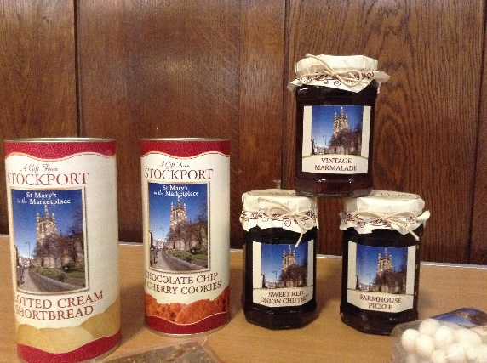
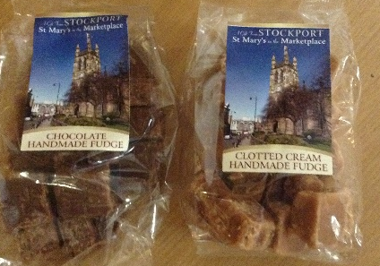
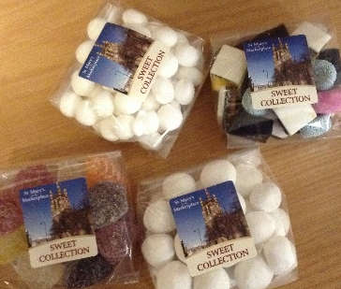

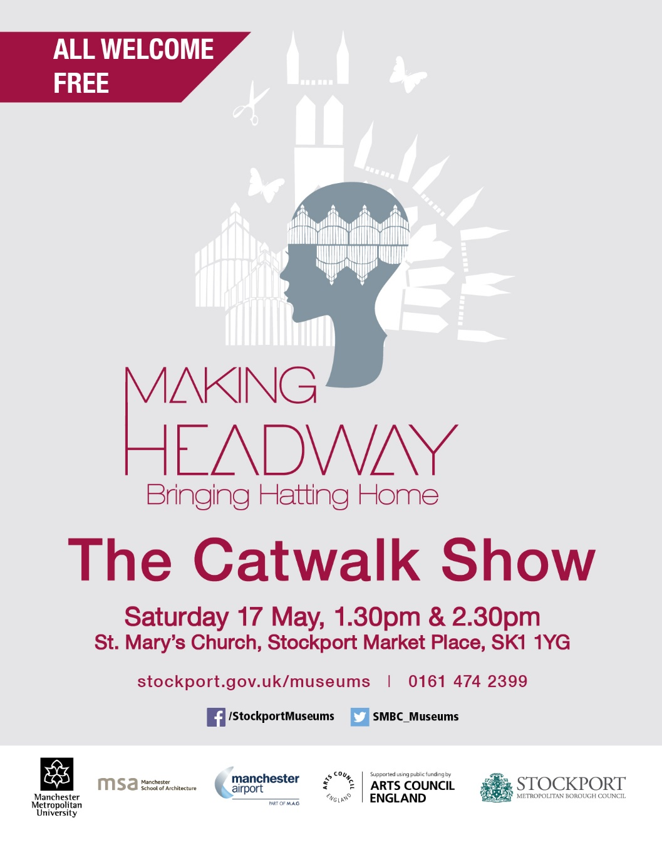
May Reminders…..
Roger’s “Afternoon Tea”
Sunday, 4th May St Mary’s Rectory 4.00pm

Stockport Creative Festival
Saturday, 17th May in and around the Market Hall and including a fashion event in St Mary’s [see advert]]
Plant Sale at St Mary’s 10.30am & Social Evening at the Nave Café 7.00pm
Saturday, 24th May Spanish Evening [sangria, tapas and the rest!]
Tickets £14.00

Tuesday, 27th May – Archdeacon’s Visitation
for Chadkirk, Mottram & Stockport
Please note that Church Wardens and Sides-persons MUST attend
St Mary’s in the Marketplace 7.30pm
While I was out in Wengen this year I became aware that there were not one but three families who have lost a daughter in adult life in recent years. Each couple are there, seemingly happy and enjoying the scenery and the ambience of a winter ski resort, and yet beneath the surface there is grief and very great sadness. The chaplain is always aware that at any time he or she might find themselves touching these people's lives, and offering spiritual help or comfort. It is not a holiday! .
For the last few years I have been aware that the pastor of the Swiss Reformed Church, who came to the village 16 or so years ago as a healthy man, with his young family, has become increasingly debilitated by the onset of Multiple Sclerosis. Pastor Jan is now wheelchair bound and hardly able to raise his arms, to feed himself. It is a pitiful sight. During my time as chaplain I was invited to attend a Lent lunch in his church rooms at which delicious soup and tasty bread was offered, followed by home made chocolate gateau, washed down with apple juice all in aid of a good cause.
Pastor Jan was their of course, surrounded by his flock, the local Swiss community. Later in the week he presided at a Taize service which he holds once a month, and at which he invites me to say the prayers when I am there. Working with his touch screen pad, he is very gracious and welcoming to all, and the epitome of the suffering servant of Christ, an inspirational figure. .
It is quite inappropriate and misleading to say that numbers in church relate in any way to who the chaplain or vicar may be at the time. However I was particularly encouraged this year to welcome to church on my first Sunday morning ,the largest congregation I have ever had at a morning service ! Well, that's not exactly true. We did have 100 when the village was threatened by an avalanche in 1999 ! On my first Sunday as chaplain 36 cheerful souls from all over the world turned up to church, and sang well and enjoyed fellowship over a hot chocolate at the nearby hotel after the service. I don't know where they all appeared from, but I'm sure they weren't there because of me! It was most encouraging and a very happy service, in which I was able to pay tribute to a fellow, and now past chaplain, who has served The Lord for far longer than me, in his parish in Woking, and as a seasonal chaplain in Wengen, for more than 30 years, both on the summer and in the winter seasons. This may well be his last visit in the winter as he is now 80, and thinks that his skiing days are probably over!!
Jeremy had been a barman for as long as I can remember, and not surprisingly our paths have crossed, at his bar in the Hotel Sunstar and more recently in his own little stublli, the Pickel Bar. My reason for popping into his bar at intervals during this chaplaincy, however, was not to have a drink, but to talk to him about the possibility of my baptising his child, with one on the way, in the English church in Wengen.This isn't as easy as it seems, and pastoral visiting in a far away country can appear disjointed. But I know that there are other chaplains, in the winter and the summer months, who are there for Jeremy and Clare when the time is right. My words of encouragement and advice are likely to be only a small part of the jigsaw of their lives… …………………………………………………………………………………………..
" Hello" I said, to a chap carrying his skiis on his shoulder, as he arrived for his holiday in Wengen , the day my chaplaincy finished. He looked English, and I have a habit of greeting everyone if they look English whether I know them or not! He and his wife walked on down the street, without replying! My companion said to me " he looks like the chaplain", and sure enough he was, as we found out later! Little did they know that we had only minutes before been tidying the chaplain's flat for their imminent arrival, and having lunch in the sun, on their balcony!

Meeting of Parishioners & Annual Parochial Church Meeting
13th April
Electioned as Churchwardens:
Gabrielle Baker & Isobel Clarkson
Elected as Lay Members of the Parochial Church Council:
Margaret Forster, Yvonne Ingham & Carol Taylor
Appointment of Sides-persons: Barbara Ashton, Gaby Baker,
Doreen Bowness, Isobel Clarkson, Margaret Forster, Frank Hamnett,
Irene Hamnett, Sue Heap, Roger Hulme, Adam Pinder, Catronia Smith
& Carol Taylor
Elected as Lay Members of Deanery Synod: Adam Pinder & Rita Waters

Copies of the Treasurer’s Report & Annual Report are still available on request, along with copies of the Rector’s Report to the APCM.
The first meeting of the new PCC will take place on Monday, 19th May at St Mary’s Rectory (7.30pm).
The appointment of Treasurer, Secretary, Electoral Roll Officer and Protection Officer will take place at that meeting along with the Co-option of those invited to join the PCC for the next twelve months.

In support of the Stockport Youth Orchestra.
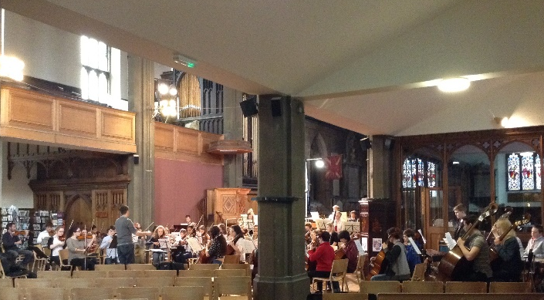
FULL HOUSE!
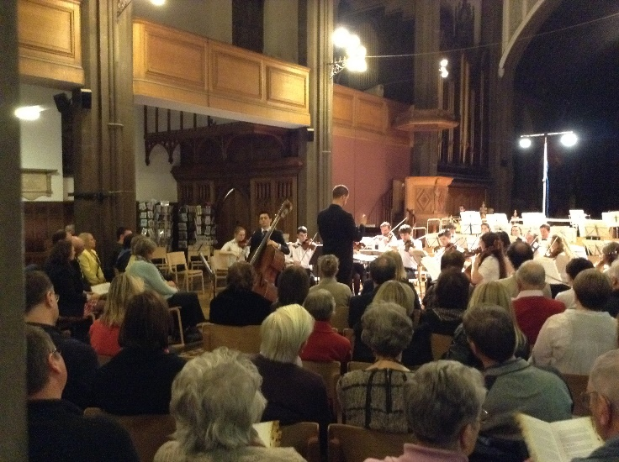
It was a wonderful evening and a pleasure to allow the Stockport Youth Orchestra use of St Mary’s for their latest concert.
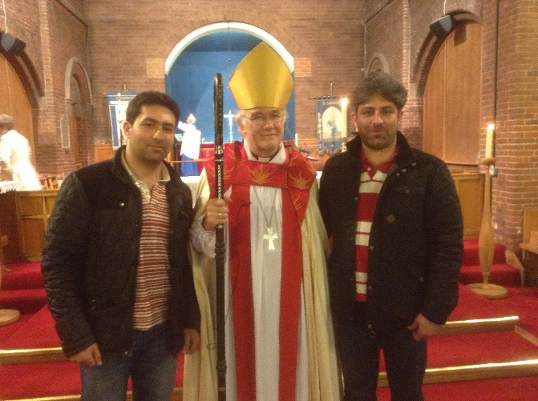
Rehearsals (as shown above) started at 2pm and continued during the afternoon with some members of the orchestra staying at St Mary’s for tea before the concert started at 7pm.
The programme started with the Symphony & Sinfonia playing the Overture Ruslan and Lyudmila which was a wonderful start to the evening. This was followed by the Symphony playing Capuzzi – Concerto for Double Bass and Orchestra; Allegro _ Andante Cantabile – Rondo (Allegro) and Donizetti – Sinfonia per la Monte di Capuzzi. They are all extremely good players, but what a delight to hear Alex Jones (Double Bass) playing the solo slot(s). Alex is a most talented young gentleman and who impressed us greatly when he came to St Mary’s days earlier to rehearse “on site” as it were. The Sinfonietta returned to the stage after the interval to play Kabalevsky (In the Gymnasium from Four Little Pieces Op14) Prokofiev (March from Musique denfants Op 65 and Kabalevsky (The Drummer from Four Little Pieces Op 14) and the Sinfonia playing music by Bartok – Romanian Folk Dances Sz.68 - Jocul cu bata (Stick

At the Confirmation Service in St Saviour's Great Moor, the vicar Canon Diane Cookson announced towards the end of the service that there would be an opportunity for candidates and anyone else who wanted to " to have their photo taken with the Bishop while he is still dressed.." She was unable, at that point to finish the sentence, owing to the peals of laughter which filled the church. The Canon retreated to her stall in confusion!
Rev. Roger Scoones .
Rector, St.Mary's Stockport

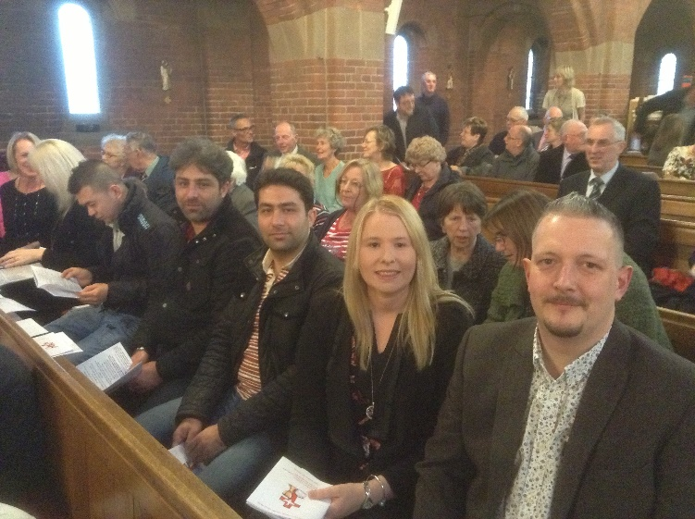

Crossword

Clues

Across
1 Sense of right and wrong (1 Corinthians 8:7) (10)
7 Coming (John 11:17) (7)
8 ‘All I have is — , and all you have is mine’ (John 17:10) (5)
10 Smarten (Acts 9:34) (4)
11 Hold back (Job 9:13) (8)
13 Member of the Society of Friends (6)
15 At ague (anag.) (6)
17 Citizen of the Greek capital (8)
18 So be it (Galatians 6:18) (4)
21 Twentieth-century poet and dramatist who wrote Murder in the Cathedral, T.S. — (5)
22 Empowers (Philippians 3:21) (7)
23 Imposing (1 Samuel 9:2) (10)

Down
1 Healed (Luke 7:21) (5)
2 Central space in a church (4)
3 Co-founder of Spring Harvest and General Secretary of the Evangelical Alliance 1983–97, Clive — (6)
4 Moses killed one when he saw him beating a Hebrew labourer (Exodus 2:12) (8)
5 Bravery (Acts 4:13) (7)
6 It interrupted Paul and Silas singing hymns in a Philippian jail (Acts 16:26) (10)
9 Transgression (Psalm 36:1) (10)
12 Irish province in which Dublin is situated (8)
14 Same hit (anag.) (7)
16 ‘The Spirit of God was hovering over the — ’ (Genesis 1:2) (6)
19 Author of the immortal stories of Winnie the Pooh, A.A. — (5)
20 Cab (4)

A HAPPY OCCASION.
On April 8 a joyful gathering of folk from the Stockport Deanery witnessed six Baptisms, twenty four Confirmations and a Renewal of Baptismal vows in a dignified service conducted by the Bishop of Chester. Among those confirmed were four people with special links to St. Mary's. Mohammad Ali known as Houman, and his younger brother Houmayoun, known as Jan, who have been associated with St.Mary's for more than two years and have been baptised at St. Mary's knelt respectfully and prayerfully before the Bishop to be confirmed in front of an admiring congregation , together with Danny Williams and his fiancé Janice Bristow, who are also preparing to be married in the autumn, in Greece. They all received a warm welcome and prolonged applause, and ended the evening with a photo call alongside a smiling Bishop, who obviously likes these occasions!
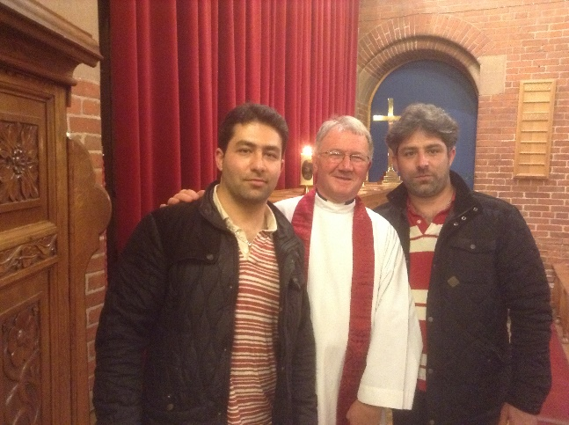

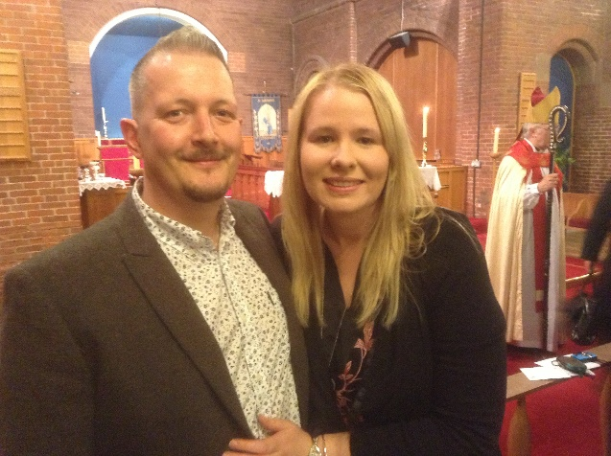

Dance) Braul (Sash Dance) Pe Lic (On One Spot) Buciumeana (Dance from Bucsum) Poarga Romaneaca (Romanian Polka) Matruntel (Fast Dance). Both groups rounded off the evening with Liadov )Kikimora. A most enjoyable evening all round.
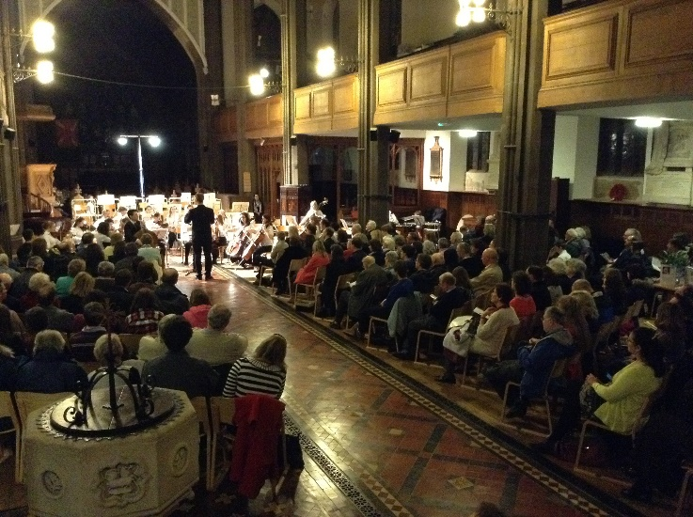
With Musical Director Tim Crooks and Assistant Musical Director Christoper Orton the Stockport Youth Orchestra was originally set up in 1956 and has gained an enviable reputation - not only for quality concerts, but also for the range of opportunities and orchestral training it provides for young people. It is now acknowledged as one of the leading amateur orchestras in the region. There are two complete symphony orchestras to cater for players of differing standards, and also the Sinfonietta for less experienced string and wind players. The orchestras meet each Friday evening at the Offerton School Campus The Fairway, Offerton, Stockport SK2 5DS during term-time to rehearse -coached by experienced professional instrumental tutors and performers. Advanced players are also encouraged to perform solo items with the orchestras in our series of concerts. Stockport Youth Orchestra encourages the development of musical talent by teaching people to perform to high standards. Many past members are now professional musicians themselves having left SYO to enter music college or university to study music whilst others have sought different professions yet continue to perform music as a hobby.
Whatever they move on to do in later life, they certainly deserve our support now. We hope that the SYO will return to us soon, meanwhile their next concert is at Stockport Town Hall on the 6th July.

In the kitchen….
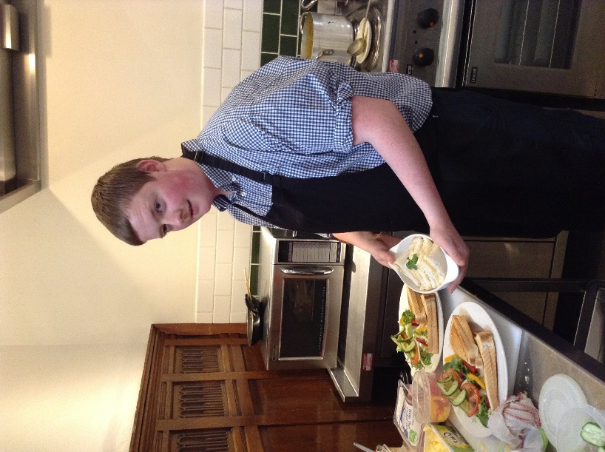

Two very capable young gentlemen have joined the Nave Café team recently and we are delighted to welcome them both.
Alex McCartan (left) works alongside Pure Innovations on a Friday (when not at College) returning to work with us on Saturday.
Luke Chappell (above) is a “Loaves & Fishes” volunteer who has taken a shine to catering generally and the Nave Café, joining us in the kitchen most Saturdays.
Both are keen, capable, hard working and a delight to have with us at St Mary’s.
