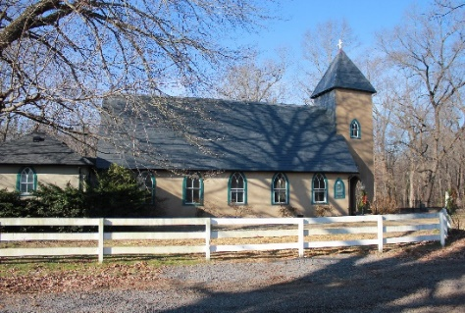
Grace Church Lane
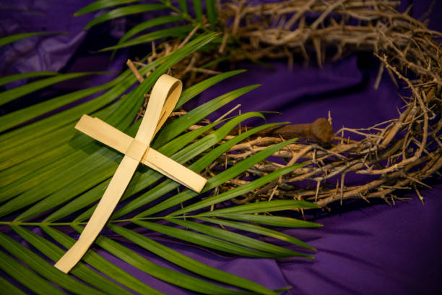
Grace Episcopal Church
Casanova, Virginia 20139
e-mail: gracechurchcasanova@gmail.com website: www.gracechurchcasanova.org

Dear Grace Church:
We are about to begin our second COVID-19 Lent! For me this is a vexing reality , for in many ways it is as if the first COVID-19 Lent has not yet ended. If, weather permitting (and recently weather has withheld permission), we are able to begin “drive in worship“ we will sit in our cars and let St Mark’s and St John’s gospel get us ready for Easter.
Lent is all about baptism. It began as a season of preparation for baptism and best practices now understand lent as a six-week period of reflection on the meaning of the baptism we once received. That baptism made us disciples who live our baptism drenched in resurrection hope even as COVID-19 still grips, grabs, and distorts abundant living.
I will do all I can to preach us through a holy Lent. But I need all of you to drive up and show up. I am so very humbled by the devotion of Grace Church. Our little band of disciples recently contributed $1700.00 for hunger relief in lower Fauquier. Despite the defining realities of COVID-19 we have tried to maintain worship, search for a priest, prepare the rectory, comfort the grieving, feed the hungry and be Christ’s body. It has not been easy, but you have been so faithful.
Who would have thought that Episcopalians would do drive in Church... but that is what is possible. We will hear God’s word in scripture, pray for our hurting world, be able to sing the churches Lenten hymns with our car windows rolled up so that only God will hear us (not all bad!) and depart to love and to serve. This weird Lenten discipline will I pray soon resolve in restored outdoor Eucharistic worship, then carefully planned indoor worship in our parish hall then back in the Church.
We will issue hymnals and prayer books for those who need them, tune up our speakers, put Michael on the organ bench and do our best. And (God knows I never would have imagined this old, quiet, traditional bishop saying this) we just might honk if we love Jesus!
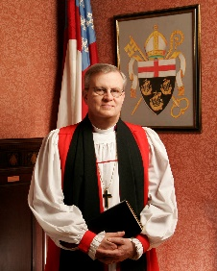
Bishop Ted
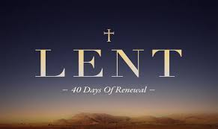
AN UPDATE FROM YOUR DISCERNMENT COMMITTEE
As explained in our monthly update, we’d like to keep you informed as we continue to work toward the goal of finding a new “sheepdog.” The normative process for transition is:
- Vestry converse with Diocese Transition Ministry Office
- All say goodbye to departing priest
- Vestry call an interim priest (see Senior Warden’s Report)

- Vestry call a Search Committee (referred to by the Diocese as a Discernment Committee (DC))
- DC perform self-study of the seeking church with input from all
- Publish a Vestry- and Bishop-approved Community Ministry Portfolio (overview of Grace church) [published for 8 weeks]
- Improve church website, where needed, and keep updated for the benefit of potential candidates
- DC receive names and select a finalist, based on Office of Transition Ministry vetting [posting will remain open for 8 weeks]
- Vestry vote on finalist and, if affirmed, Vestry extends a call
- Vestry and candidate negotiate terms and set out in a letter of agreement
- Senior Warden and Bishop sign letter of agreement
- Vestry and new priest conduct Mutual Ministry Review after first year of service
The date for our posting has closed. Now, we are waiting for inquiries/responses. The Diocese stated that often, responses come in the week that the posting closes. If we receive no responses, the posting will be extended. Thank you for your patience and prayers.
Sincere love and blessings,
Judy Ball, Pat Williams, Kathlene Bilger, Linda Winslow, Tom Bilger, & Mary Neal
Your Discernment Committee (DC) aka Search Committee

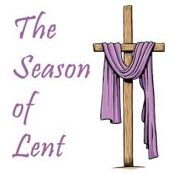
SENIOR WARDEN’S REPORT – FEBRUARY 2021
Dear Grace Family,
While the pandemic and the weather have kept things quiet in the church buildings, your Vestry has been hard at work behind the scenes. Four individuals stepped up to the challenge of completing our Vestry of six members. There were four vacancies. Obviously, we could not hold an annual meeting because of our gathering limitations, but we have posted our annual reports on the Grace Church website (see top of first page for web address) and mailed ballots for purposes of electing a Vestry. The results of the balloting were unanimous. Our new members are Mignonne Spellmeyer and Barbara Jacobs (three-year terms,) Mary Neal (completing two of the three years of a vacated term,) and Sharon Sweeney (completing one of the three years of a vacated term.) Thank you to all who agreed to run for Vestry and to all who cast a ballot.
In keeping with COVID-19 restrictions, we held a telecon Vestry meeting using reports and data transmitted to the Vestry via e-mail. Vestry Officers were elected as follows:

Sr. Warden – Mary Neal
Jr. Warden – Barbara Jacobs
Treasurer – Judy Ball
Register/Clerk – Diane Gulick
Diocesan Convention Delegate – Bryan Jacobs
Culpeper Region (previously known as Region 13) Delegate – Bryan Jacobs

We also discovered in our meeting that Grace Church has been approved to meet outdoors once again! By the time you receive this, we will have held one service (Ash Wednesday) with Bishop Ted using the speaker system, the congregation remaining in their cars, and Michael playing his beautiful organ music so that we were once again able to lift our voices in song without the fear of spreading disease! We will also have held a Sunday service by the time you receive this newsletter and are hopeful that the permission to gather will continue and only allow us to be closer once more to each other.

Our Rectory (aka Redlands) is in the process of being spruced up by a local contractor and friend, John Green. He is doing an outstanding job! A big thank you to Dee Garrett who, in her prior role as Jr. Warden, obtained John’s services.

Thanks to all who are helping to keep Grace alive, especially our Lord and Savior, Jesus Christ!
Blessings and love,
Mary

TREASURER’S REPORT – JANUARY 2021
Income for the month of January was $5,755.97; expenditures totaled $3,964.41, resulting in income for the month of $1,791.56. No budget has been adopted for 2021 at this time.
Interest earned on our Roof/Rectory Renovation Fund during the month of January was $0.07 and a disbursement of $4,058.00 was made to Green Services for renovation work on the Rectory. The balance in the fund at the end of the month was $8,363.23.

The book value of our endowment fund is $60,073.49.

Just a reminder that, since we are unable to have in-person worship at this time, it would be appreciated if you would mail your pledge check to the Church at PO Box 18, Casanova, VA 20139.

Please continue to pray for Grace Church that it will grow spiritually, financially, and numerically. If you have any questions about this report or any financial matter, please contact me.

Judy Ball, Treasurer
FEED MY SHEEP (FMS)
Thank you again for your generous support! Donations may be sent to Grace Episcopal Church, PO Box 18, Casanova, VA 20139-0018
Gods Peace, Carol Grove

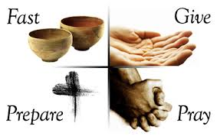
COVID-19 IN STATUS OF FAUQUIER
The local status of COVID-19 is being shared here for informational purposes.
Quoted & paraphrased from Fauquier Times news

Daily positive COVID-19 cases in Virginia dropped to 2,575 on February 14th and to only 1,539 the next day. On February 16th, 1,770 new cases were reported; according to that report from the Virginia Department of Health, there have been 553,308 total reported cases of COVID in Virginia. The seven-day average of new cases in the state is 2,742 per day.
On February 15th and 16th, Fauquier County added 18 new cases each day, for a total of 3,808 cases; the average number of new daily cases in the last seven days is 18.

A measure of how Virginia is managing the COVID-19 crisis, the seven-day positivity rate (total tests compared to positive tests) is at 9.1%. Before this most recent decline, the state positivity rate hadn’t dropped below 10% since November 29th. In the Rappahannock-Rapidan Health District, the positivity average is at 7.6%; it hasn’t been that low since December 6th.

As of February 16th, 1,399,221 doses of COVID-19 vaccine have been administered to Virginia residents. About 12.3% of the population has been vaccinated with at least one dose; 351,441 people have been fully vaccinated with both necessary doses. Thus far, 10,607 Fauquier residents have been vaccinated with at least one dose; 2,444 have been fully vaccinated.

The most doses in the state have gone to residents between 70 to 79 years old (234,859), followed by those 50 to 59 years old (225,612), 60 to 69 years old (223,999) and 40 to 49 years old (207,030). Residents older than 80 have received 173,109 doses.

The VHH’s new vaccine dashboard has been updated with more detailed information and can be found at https://www.vdh.virginia.gov/coronavirus/covid-19-vaccine-summary/

♣ ♣ ♣ ♣ ♣ ♣ ♣ ♣
MARCH BIRTHDAYS

Jeremy Jacobs | 8-Mar
Andrea Henry Whorton | 10-Mar
Miranda Rhoads | 12-Mar
Tammy Nofsinger | 13-Mar
Harper Fields | 14-Mar
Charlie Dawson Vaught | 16-Mar
Ronnie Shipe | 18-Mar
Carol Goshorn | 24-Mar
Stephanie Butler | 28-Mar
Parker Brumfield | 30-Mar

MARCH READING SCHEDULE
Third Sunday in Lent  March 7, 2021 | Exodus 20:1-17  Psalm 19  1 Corinthians 1:18-25  John 2:13-22 | Bryan Jacobs
Fourth Sunday in Lent  March 14, 2021 | Numbers 21:4-9  Psalm 107:1-3, 17-22  Ephesians 2:1-10  John 3:14-21 | Dee Garrett
Fifth Sunday in Lent  March 21, 2021 | Jeremiah 31:31-3  Psalm 51:1-12  Hebrews 5:5-10  John 12:20-33 | Judy Ball
Annunciation of the Lord  March 25,2021 | Isaiah 7:10-14  Psalm 45  Psalm 40:5-10  Hebrews 10:4-10  Luke 1:26-38 | Mary Neal
Liturgy of the Palms  March 28, 2021 | Psalm 118:1-2, 19-29 Mark 11:1-11 | Bryan Jacobs
Liturgy of the Passion  March 28, 2021 | Isaiah 50:4-9a  Psalm 31:9-16  Philippians 2:5-11  Mark 14:1-15:47 | Bryan Jacobs

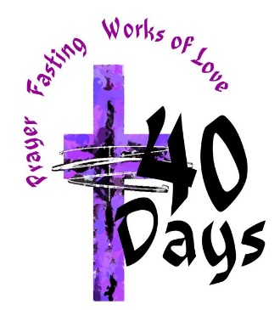

https://lectionary.library.vanderbilt.edu/lections.php?year=B&season=Lent

CHURCH DIRECTORY UPATE
Our Church Directory is now a year old. Time for an update! Please look at your directory and notify me if you have any changes. Thank you to all who have already provided updates! Please send all inquiries/corrections to maryneal2112@gmail.com.
Thanks!
Mary
Editor

† † † † † † † † † † † † †
Bible Verses About Lent _{KJV}
Genesis 3:19 - In the sweat of thy face shalt thou eat bread, till thou return unto the ground; for out of it wast thou taken: for dust thou [art], and unto dust shalt thou return.
Isaiah 43:25 - I, [even] I, [am] he that blotteth out thy transgressions for mine own sake, and will not remember thy sins.
Ezekiel 18:21 - But if the wicked will turn from all his sins that he hath committed, and keep all my statutes, and do that which is lawful and right, he shall surely live, he shall not die.
Daniel 9:3 - And I set my face unto the Lord God, to seek by prayer and supplications, with fasting, and sackcloth, and ashes:
Matthew 9:15 - And Jesus said unto them, Can the children of the bridechamber mourn, as long as the bridegroom is with them? but the days will come, when the bridegroom shall be taken from them, and then shall they fast.
Mark 1:15 - And saying, The time is fulfilled, and the kingdom of God is at hand: repent ye, and believe the gospel.
John 3:16 - For God so loved the world, that he gave his only begotten Son, that whosoever believeth in him should not perish, but have everlasting life.
Acts 15:9 - And put no difference between us and them, purifying their hearts by faith.
1 Peter 1:3 - Blessed [be] the God and Father of our Lord Jesus Christ, which according to his abundant mercy hath begotten us again unto a lively hope by the resurrection of Jesus Christ from the dead,
1 Peter 5:6 - Humble yourselves therefore under the mighty hand of God, that he may exalt you in due time

AMAZON SMILE
FOR GRACE CHURCH
Don’t forget to sign up with Amazon Smile to have 0.5% of the purchase price of eligible items given to Grace Church at no cost to you! You can also go to the Grace Church website home page and click on the link there.

*******AmazonSmile Shopping App for Android Users Now Available******
You can now support Grace in the Amazon shopping app on your Android device! Simply follow these instructions to turn on AmazonSmile and start generating donations to Grace from your Android device.
- If you have the latest version of the Amazon Shopping App, open the App on your Android device.
- View Settings and select AmazonSmile.
- Follow the in-App instructions to complete the process.
AmazonSmile is not currently available for IOS users – we’ll let you know when it becomes available.
~~~~~~~~~~~~~~~~~~~~~~~~~~~~~~~~~~~~~~~~~~
Sharing Words of Gratitude to Grace Church
Please see the four thank yous that follow.

