Amelia-Nottoway Technical Center News 11/20/2020
ANTC STUDENT SPOTLIGHT!
Daijah Walton, NHS Senior
Cosmetology II
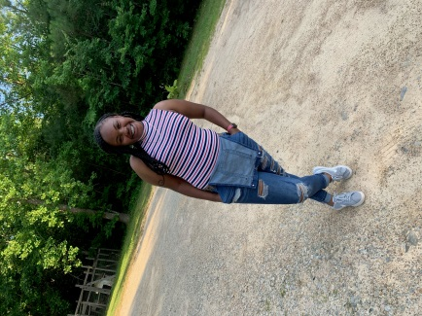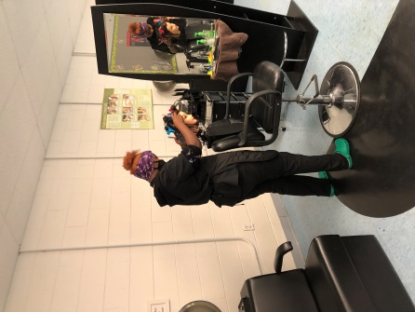
What brought you to ANTC? I always wanted to do something different in life so when I saw Cosmetology that was something I wanted to do.
What is your dream job? My dream job is to be a teacher and make extra money by doing hair.
What is your favorite class that you have taken so far? Why? Cosmetology, because I am actually learning something
What is the best advice you have been given by your instructor at ANTC? Follow your dreams and never give up
What is your favorite memory at ANTC? I have so many, I love everything about ANTC
What was the first feeling you had when you attended ANTC? I was a little nervous because we were in class with seniors.
What words of wisdom do you have for other students? When life or anything get tough, never give up keep trying.
ANTC ALUMNI HIGHLIGHT!
John Soto
High School: Amelia County High School 2020
ANTC Program: Auto Body
Career: Attending Nashville Auto Diesel College
Future Diesel Mechanic

DID YOU KNOW?
Mrs. Jodi Vronek
Current Position: Medical Assistant Instructor, ANTC
Previous Positions: Program Director for Medical Assisting at Centura and Virginia College, Practicum Coordinator at Bryant and Stratton, Certified Medical Assistant at Bon Secour Neurology, Certified Medical Assistant at Pediatric Primary Care, Certified Billing and Coding Specialist for HCA
Hobbies: Traveling, Amusement Parks, and Reading
Other Interest: Sloths
Family: Mrs. Vronek and her husband Nick, have one son, Brandon

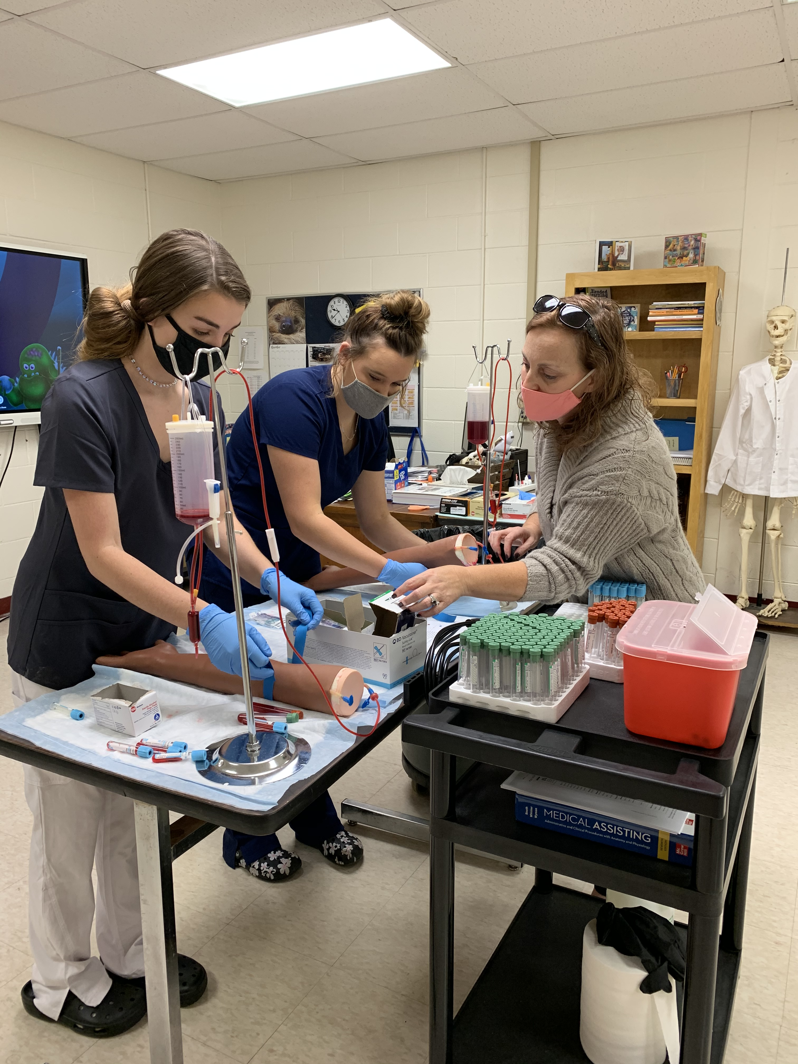

ANTC serving our Alumni!

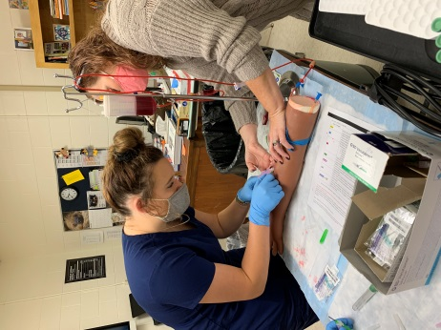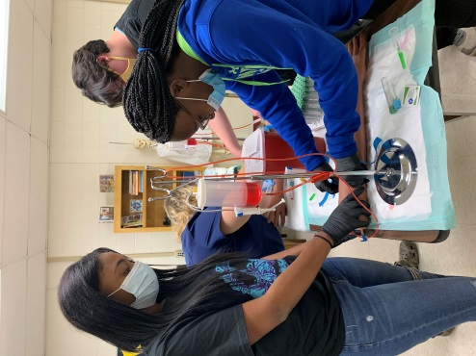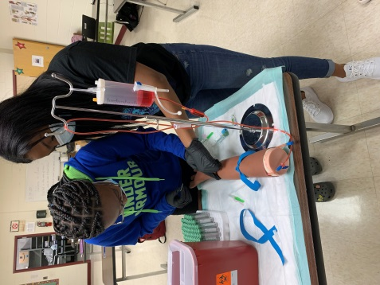
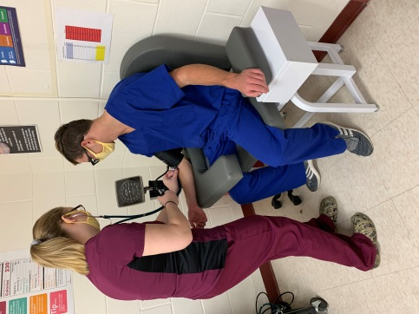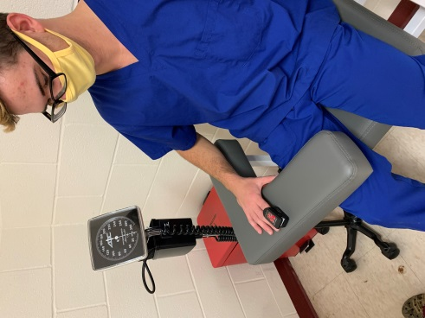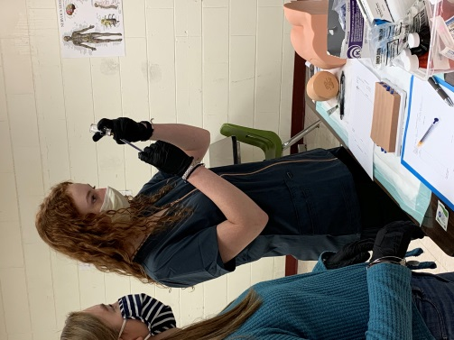

Current Program Feature: Cosmetology I & II, Amelia, Cumberland, and Nottoway High Schools

Skill(s): Describe the Characteristics of normal, healthy nails; Describe the nine basic parts of the nail; Discuss how the nail grow

Tasks/Competencies: Perform a hand, nail, and skin analysis; Perform basic manicure

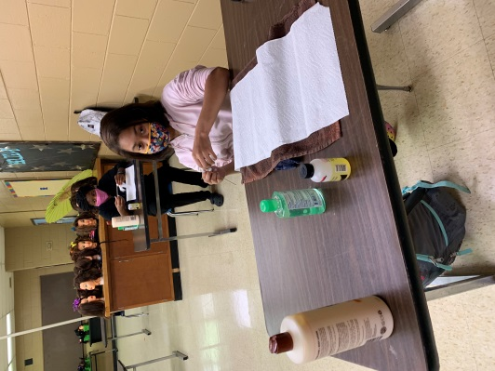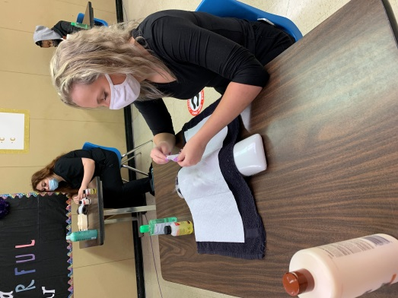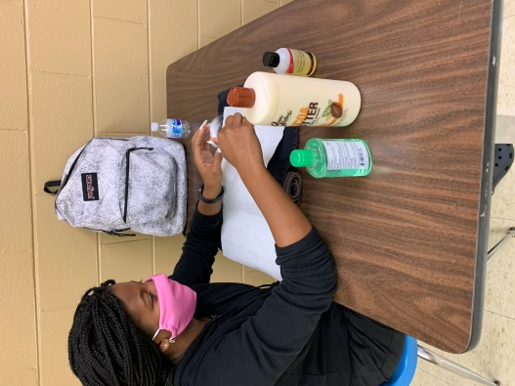

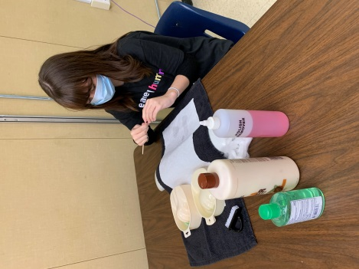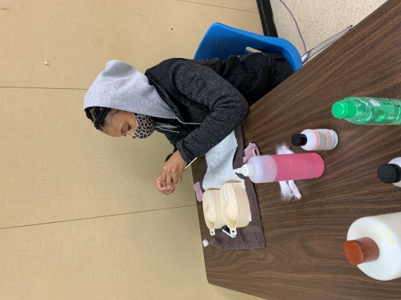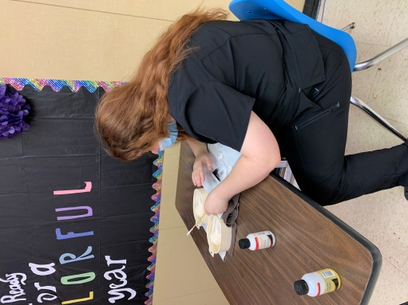

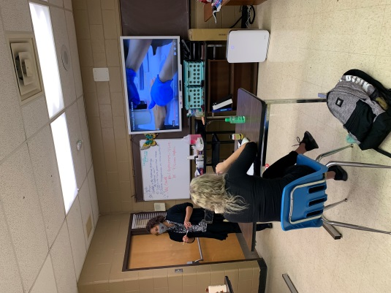
Current Program Feature: Auto Body I & II, Amelia County High School & Nottoway High School

Skills: What are the repercussions of unsafe working habits?
Tasks/Competencies: Proper use of Tools, Equipment, and Supplies Organization

