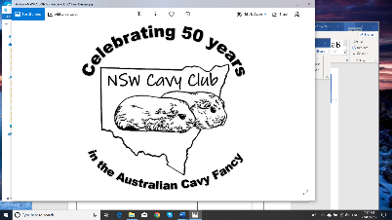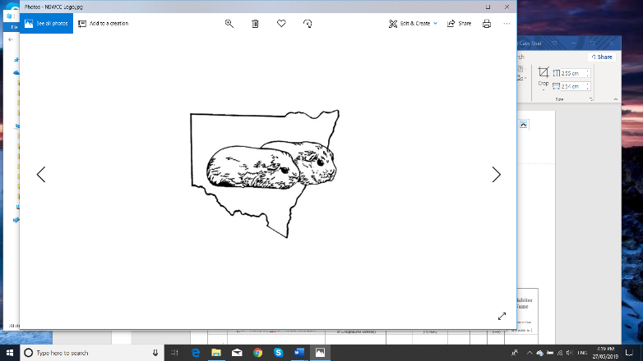**NSW Cavy Club Inc**

Revised March 2021

**OFFICIAL ENTRY FORM**

**SHOW & DATE** ____________________________________________________________

Please fill in ALL required information. Entries due Friday week before the show unless specified in show advertising Entries to: nswccentries@gmail.com

|  |  |  |  |  |  |  |  |  |
| --- | --- | --- | --- | --- | --- | --- | --- | --- |
|  | **CAVY NAME** |  |  | **SECTION** | **CLASSES** | | | **Exhibitor Name** |
| **EAR** | **BREED** | **DATE** | (A) Boar |
| **TAG** | **and** | **of** | (B) Sow | (Please numbers clearly) | | |
|  | **COLOUR** | **BIRTH** | (T) Inter | Gen |  | Jun |
| (office use) | Include any Championship Status | (not required for Coarse Coat |  | (C) Junior | Class | Pet | Ex | (if more than |
|  | ie Ch = Champion, Dbl Ch = Double Champion | or Longhaired Breeds) |  | (D) Baby |  |  | (tick) | one exhibitor) |
| 1 |  |  |  |  |  |  |  |  |
| 2 |  |  |  |  |  |  |  |  |
| 3 |  |  |  |  |  |  |  |  |
| 4 |  |  |  |  |  |  |  |  |
| 5 |  |  |  |  |  |  |  |  |
| 6 |  |  |  |  |  |  |  |  |
| 7 |  |  |  |  |  |  |  |  |
| 8 |  |  |  |  |  |  |  |  |
| 9 |  |  |  |  |  |  |  |  |
| 10 |  |  |  |  |  |  |  |  |
| 11 |  |  |  |  |  |  |  |  |
| 12 |  |  |  |  |  |  |  |  |
| 13 |  |  |  |  |  |  |  |  |

**EXHIBITOR FEE**

**NSW CAVY CLUB MEMBER** @ $10 = $________

**NON – NSWCC MEMBER** @ $15 = $________

**OUT OF STATE JUDGE (non-NSW judge) FEE** @ $5 = $________

**ENTRY FEE**

______ x **GENERAL CLASS** ENTRIES @ $2 each = $________

_______ x **MEMBERS PET** ENTRIES @ $2 each = $________

_______ x **JUNIOR EXHIBITOR** ENTRIES @ $2 each = $________

**DONATION** (Thank you) = $________

**TOTAL AMOUNT DUE: $ ____________**

**PAYMENT**

WILL **PAY ON DAY** (tick) _________

**DIRECT DEPOSIT** RECEIPT _______________________

Please make CHEQUES payable to NSW Cavy Club.

DIRECT DEPOSIT: BSB 032 123 ACC No 20 4093 Westpac

Fill in ALL information

**EXHIBITOR NAME/S:**

**_____________________________________________**

**STUD NAME/S:**

**_____________________________________________**

**CONTACT PHONE NUMBER(S):**

**_____________________________________________**

**CONTACT EMAIL:**

**______________________________________________**

**I / WE ARE MEMBERS OF ANCC AFFILIATE CLUB:**

**_____________________________________________**

Exhibitors who are not financial members of the NSW Cavy Club will be required to pay an additional $5 exhibitor fee

An additional $5 will be paid when an out of state judge is used

I /We the exhibitor, agree to abide by the rules set down by the NSW Cavy Club

and understand the NSW Cavy Club reserves the right to refuse any entry. Signed:_________________________________

**NSW Cavy Club Inc**

Revised March 2021

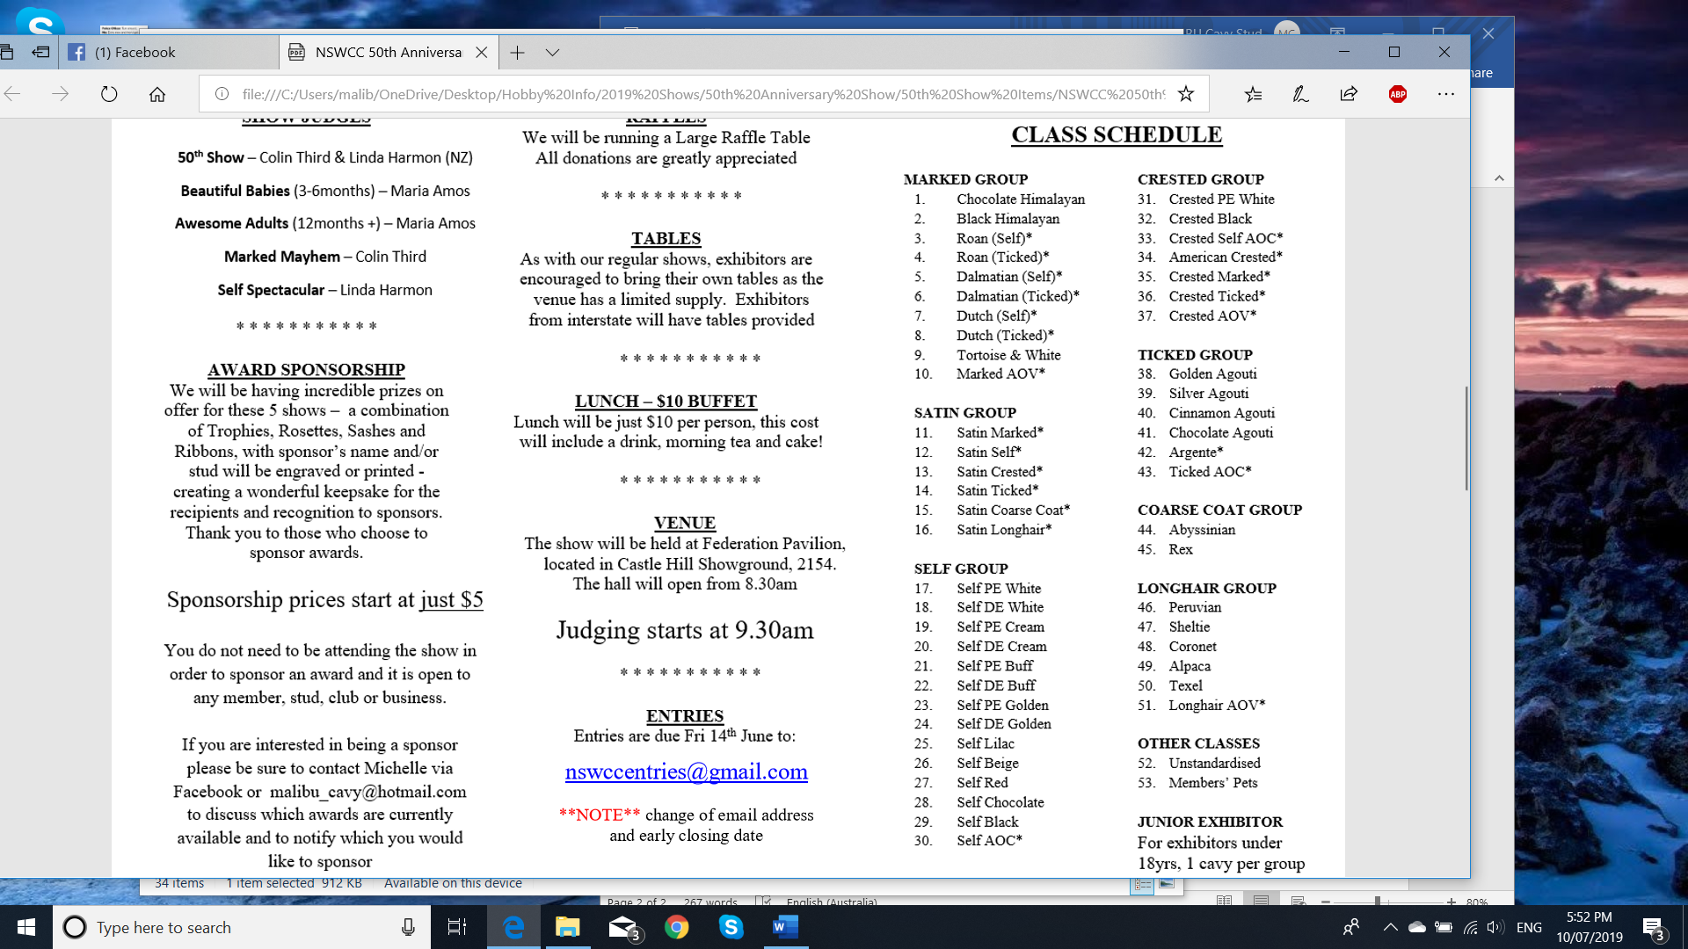

Please specify the breed/variety of cavy entered for classes marked with an asterix (*) - this includes eye and coat colour.

**SECTIONS**  A: Boars (12months +) B: Sows (12months +)

T: Intermediate (9-12months) C: Junior (6-9months) D: Baby (3-6months)