ACCESS CONTROL MANAGEMENT
Software Suite Guide

Release 6.8

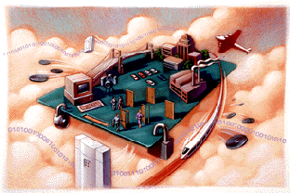

Nov, 17, 2008

CONTENTS

Preface 4
Purpose of this Document 4
Audience 4
Part 1 Setup and Remove applications 4
1.1 Setup applications 4
1.1.1 Setup Microsoft.Net 5
1.1.2 Setup Access Control software 7
1.2 Remove applications 9
Part 2 Login 11
Part 3 Adding and Editing Basic Configure 13
3.1 Add Department 13
3.2 Add and Edit a Personnel 14
3.3 Import customer's information from Excel 15
Part 4 Access Control 16
4.1 Configuration 16
4.1.1 Hardware Configure 16
4.1.2 Access Privilege 17
4.1.3 Rename Door 20
4.1.4 Set Open Delay 20
4.2 Basic Operate 21
4.2.1 Check controller’s Info 21
4.2.2 Upload Setting 22
4.2.3 Monitor 22
4.2.4 Download 24
4.2.5 Locate 25
4.2.6 Persons Inside 26
4.2.7 Query Records 26
Part 5 Tools 27
5.1 Lost Card register 27
5.2 Change Password 27
5.3 Operator Management 28
5.4 DB Compact/Repair 30
5.5 Interface Locked 30
5.6 Option 31
Part 6 Extended Function 32
6.1 Time profile 35
6.2 Peripheral control 38
6.3 PassWord Management 39
6.4 Anti-passback 41
6.5 InterLock 42
6.6 Activate Multi-card access 43
6.7 Timing auto-operation management 44
6.8 Timing collect data 45
6.9 Periodically Upload Privilege 46
6.10 Log Query 47
6.11 First Card Open 48
6.12 Monitoring Map 49
6.13 Camera Monitoring 50
6.14 Check Access Manger 54
6.15 Meeting Sign 57
Part 7 Module:Attendance 61
7.1 Normal shift configuration 61
7.2 Holiday 62
7.3 Leave/Business Trip 63
7.4 Manual Sign In 64
7.5 Report 65
Part 8 Module:Patrol 66
8.1 Patrol Configure 67
8.2 Patrolman 67
8.3 Patrol Point 68
8.4 Patrol Route 69
8.5 Patrol Task 70
8.6 Patrol Report 71
8.7 Patrol Statistics Report 71
Part 9 Const meal 72
9.1 Meal setup 72
9.1.1 Readers for Meal 72
9.1.2 Meal Rules 73
9.1.3 Meal Period 73
9.2 Meal Report 74
Part 10 Excursus: 75
10.1 RS232/RS485 75
10.2 TCP/IP 76
10.3 Complex network 76

Preface

Purpose of this Document
The Software Suite Guide provides the procedures and information necessary to use Version 6.8 of the Access Control System. These procedures guide you to use the following groups of functions:

Badging
Hardware configuration
Database configuration
Monitoring
Reporting
Administration

Audience
This direction is written for two kind of readers .Part 1 is opened for actual operation Access Control System’s user,such as security personnel .Part 2 is opened for an administrator who first configures the system.

Part 1 Setup and Remove applications

1.1 Setup applications

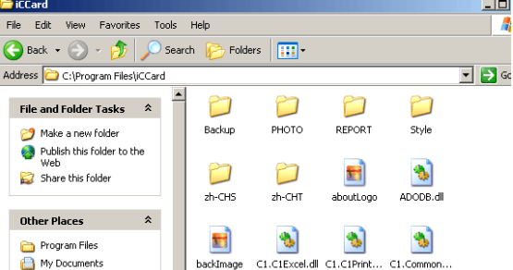
First puts in the CD to CD-ROM, then run the applications of setup () .

1.1.1 Setup Microsoft.Net
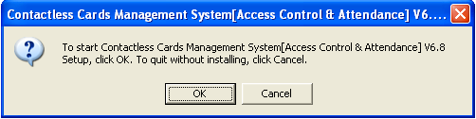
When in your computer has not installed Microsoft.NET Framework, The system can from next step for you to install Microsoft.NET Framework 1.1.
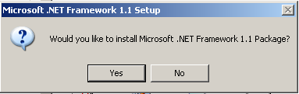
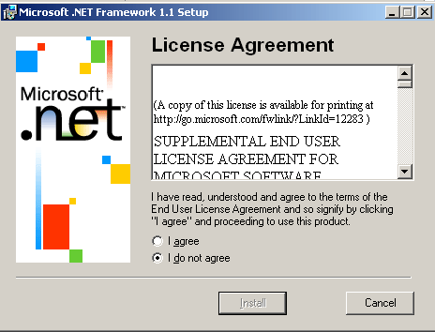
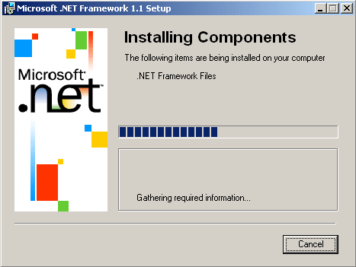

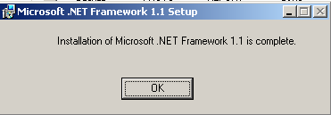
If your computer has installed Microsoft.NET Framework, The system will from next step for you to install Access Control System.

Setup Access Control software
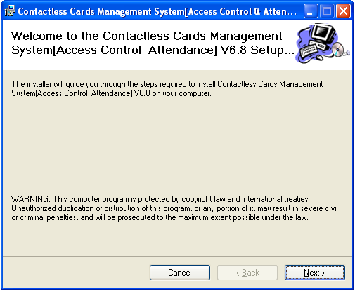
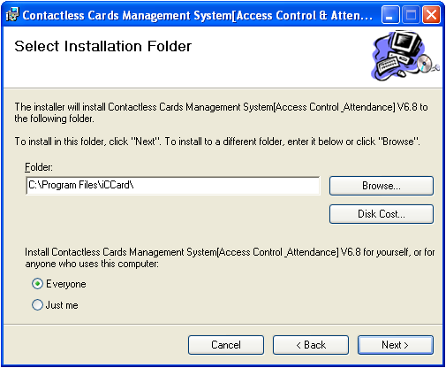

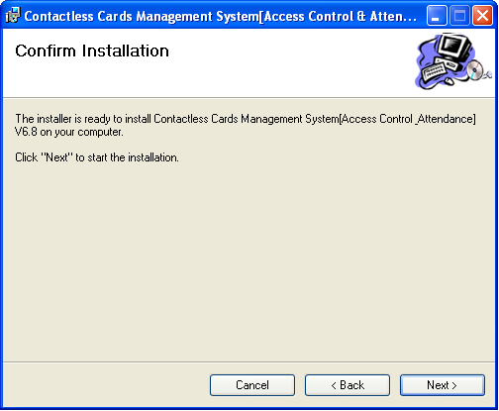
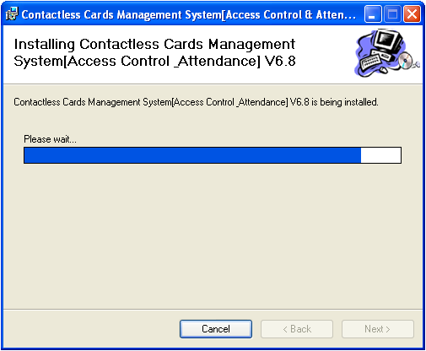
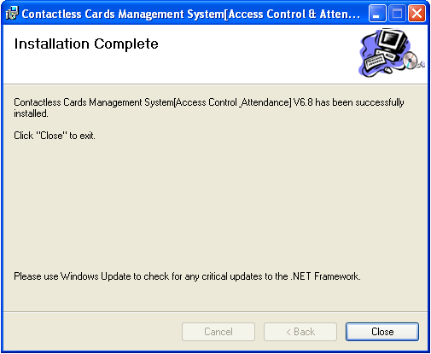
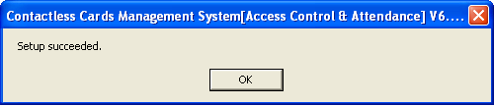
After the installment completes, the desktop automatically will create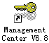.

1.2 Remove applications

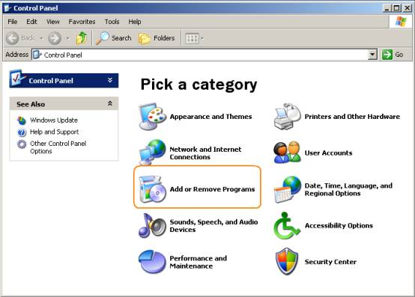
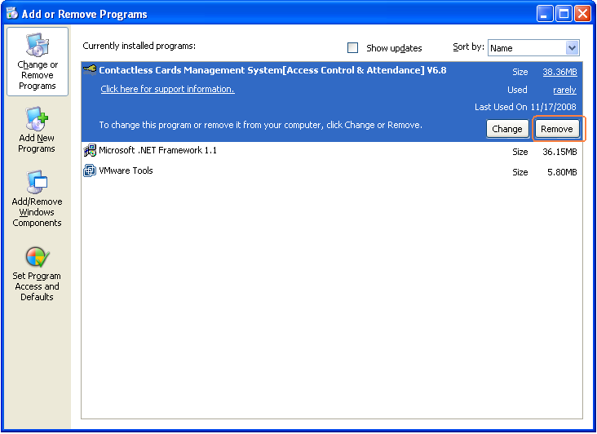
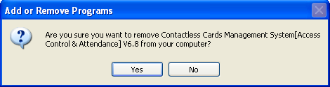
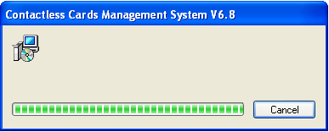

Part 2 Login

Click the or run All Programs << iccard << Access Control & Attendance V6.8.
It will open up the Login windows .As follows:
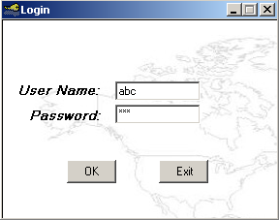
By default, the user name required is “ abc ”, the password required is “123”.
It is recommend to change the name and password at the first use.

After login , It will show the main windows . as follows:

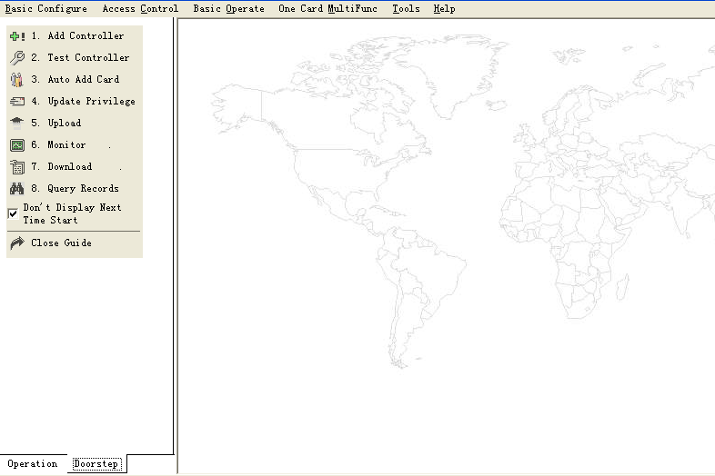
At you first login ,it will shows a basic guide. If you do not have the experience, you may complete the basic operation and the establishment under this guide's direction. But, we suggested that you’d better close the basic guide ,at the same time you should read the manual carefully to familiar with the operation of software.

After close the " basic guide", the operation windows as follows.
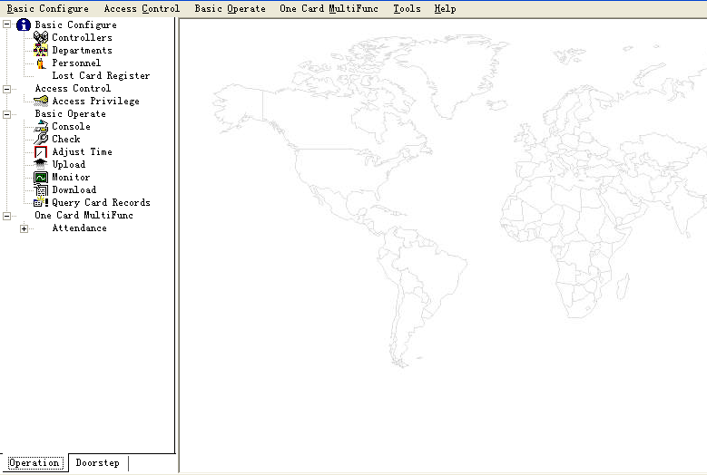

Part 3 Adding and Editing Basic Configure

3.1 Add Department
Select Basic Configure > Departments from the menu bar
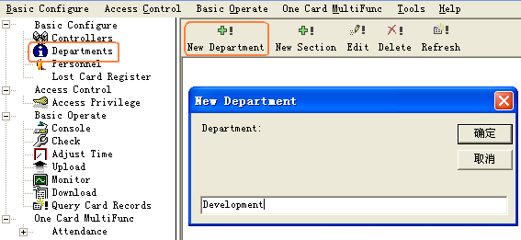
click the 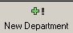 to create a new department.
Click the 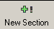 to add a new section under a department.
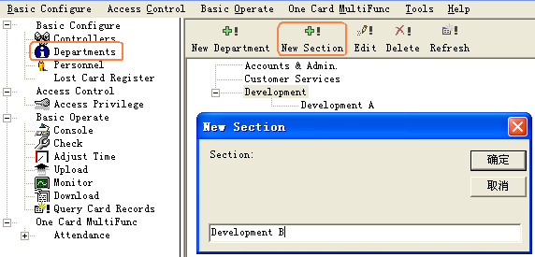
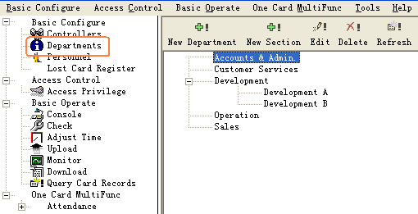

3.2 Add and Edit a Personnel
Select Basic Configure > Personnel from the menu bar
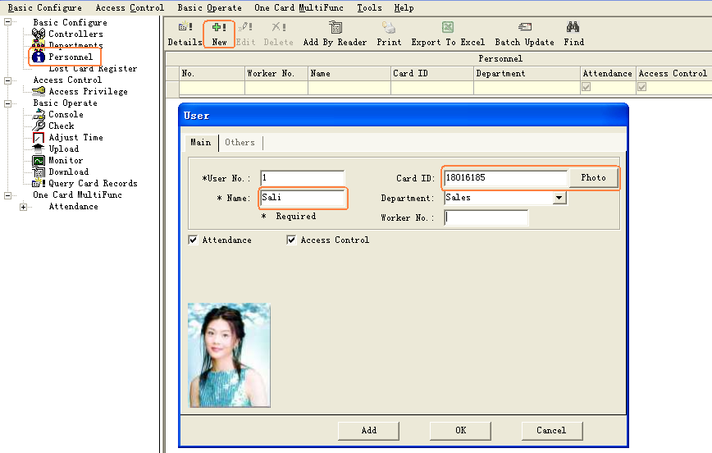
After you input all information about the user, click this button, the system had add a user .At the same time ,it will remain show the user windows and wait for you input the next user’s information .
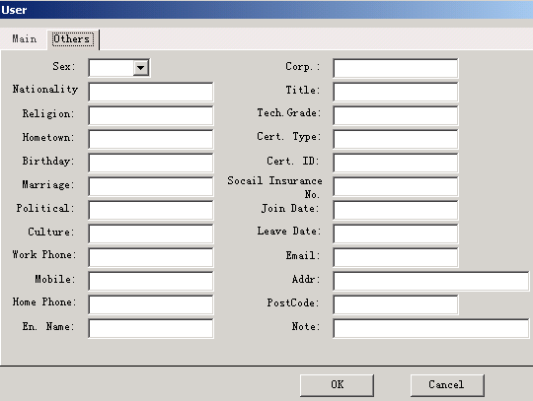
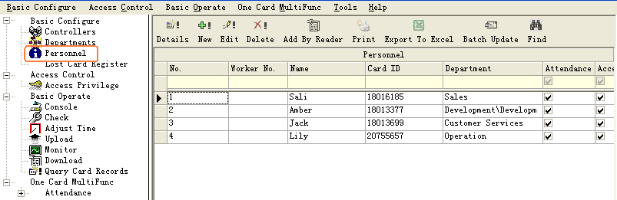

3.3 Import customer's information from Excel
Select Personnel << Ctrl + Shift + Q << Import From Excel
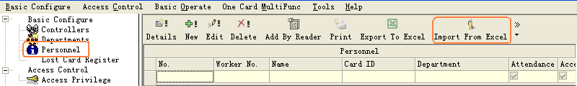
If you want to use Excel importing customer’s information, please edit the document of userinfo.xls first., the userinfo.xls document is located on the control at gate manages software (C:\Program Files\iCCard),showing as this:
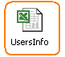

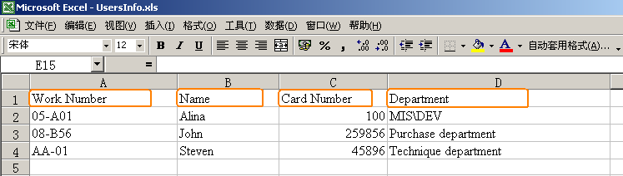
Remark: The card number must be more than three numbers, department and section can with"\" for box off a sign. For example: MIS\DEV
Import customer's information from Excel was successfully, information hints, click an assurance .
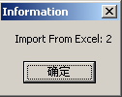

Part 4 Access Control

4.1 Configuration
Your organization can prevent material or information robbery, by limiting / supervising the access to all or part of your facility (lab, computer room, or storage areas) to authorized persons, during specific time periods.
Smart multi-technology controllers, linked to advance identification systems, are programmed to control "who is going where and when". Each person is equipped with a personalised card or
another ID that controls access.
When a badge holder needs permission to access a particular area, the information is relayed
from the reader to the controller. The controller either grants or refuses access according to the
parameters defined (access authorization, time zones, etc.) The operations are then sent to the
PC and listed in the backlog and the journal.
Access control parameters are mainly defined in the “ Parameter” section of the application.

4.1.1 Hardware Configure
Select Basic Configure << Controllers from the menu bar
click the 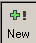 to add the controllers into system.
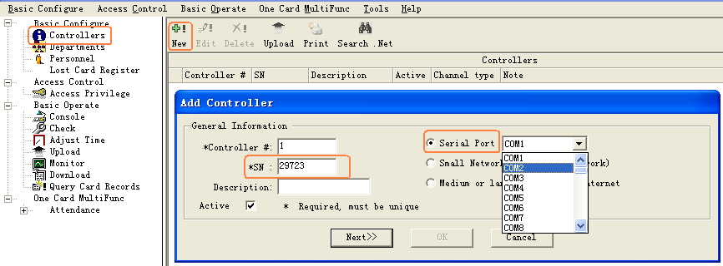
The product S/N (namely each controller serial number) may check on the PCB’s label S/N:***** of the controller . please fills that five numerals.
Note: If the product S/N you fills and the PCB's label S/N:***** are different ,it will cause the software can't communicate with the controllers.
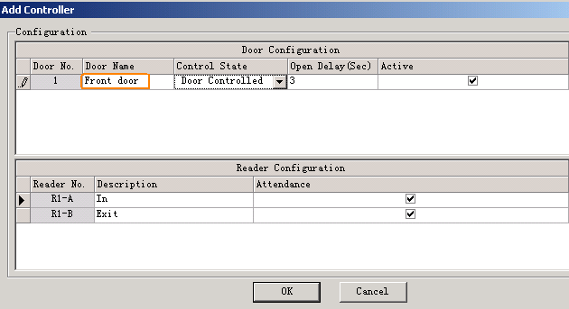
If you want to see the setting details , please consult the Excursus .
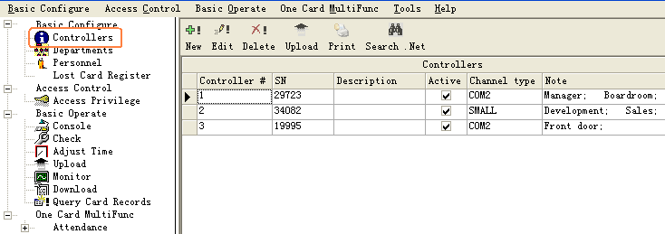

4.1.2 Access Privilege
Select Access Control << Access Privilege from the menu bar or shortcut.
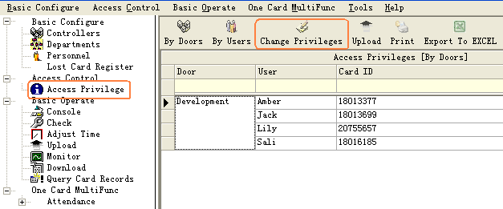
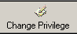
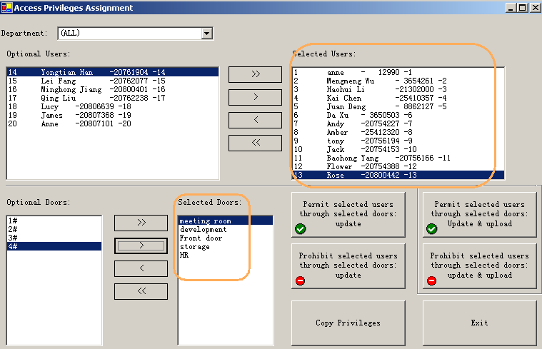
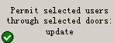 After you click this button ,and then basic operate << upload ,the selected users can through selected doors .
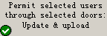 After you click this button, the selected users can through selected doors .

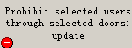 After you click this button ,and then basic operate << upload ,the selected users can’t through selected doors .
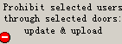 After you click this button , the selected users can’t through selected doors .
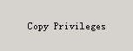: If user A and the user B have the same privileges, we can copy user A’s privileges to user B.
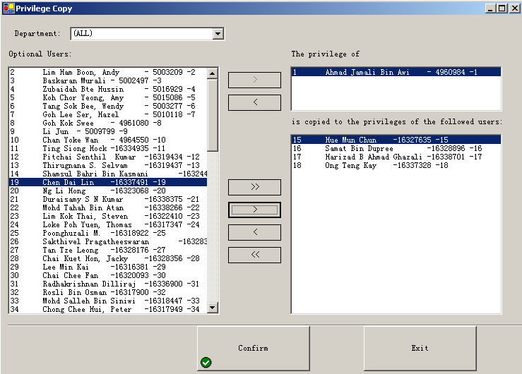
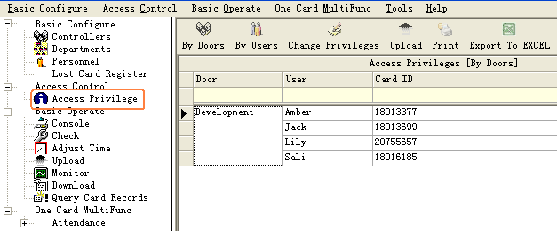
After you add the all privilege into the system ,you must go to the basic operate << upload to Upload Setting(Part 4.2.2).

4.1.3 Rename Door

Select Basic Operate << Console ,
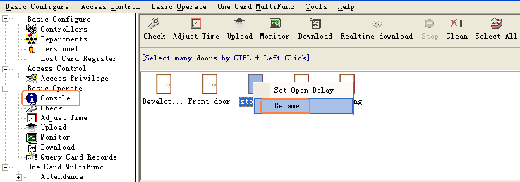
Select the door first and then Right Click pop-up menu.
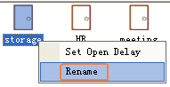

4.1.4 Set Open Delay
Select Basic Operate << Console
Select the door first and then Right Click pop-up menu.
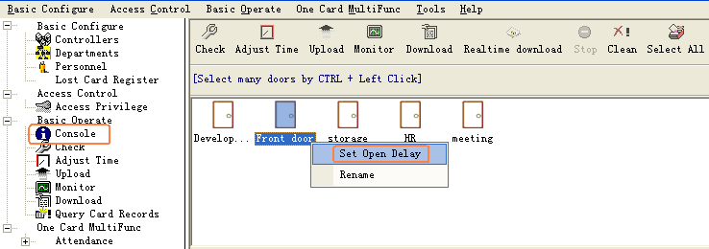

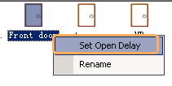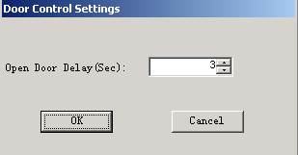

4.2 Basic Operate
Select Basic Operate << Console from the menu bar .The console windows contain many basic operate for controller .For example ,check info Adjust Time Upload Monitor Collect Data etc.

4.2.1 Check controller’s Info
Select Basic Operate << Console from the menu bar or the shortcut of Basic Operate << Check
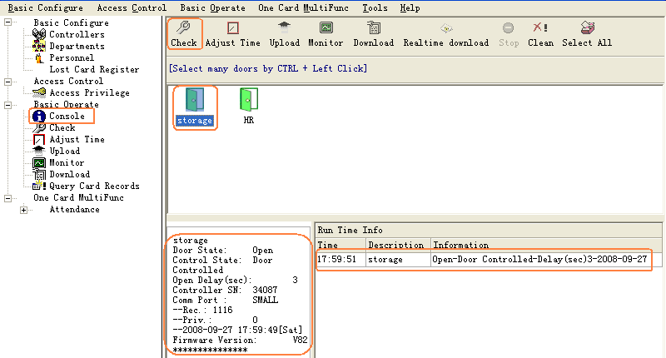

It will show the control’s basic information .such as the amount of records and privileges ,door state ,control state ,open delay(sec) .If the controller is good Communicate with computer , the door label’s color is green , otherwise the door label’s color is red .
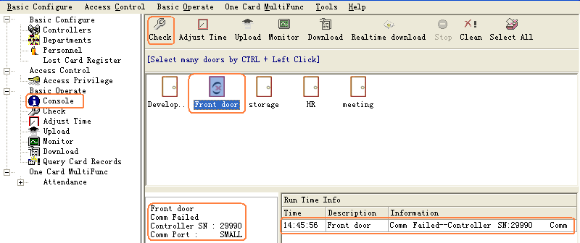

4.2.2 Upload Setting
Select Basic Operate << Console from the menu bar or shortcut of Basic Operate << Upload
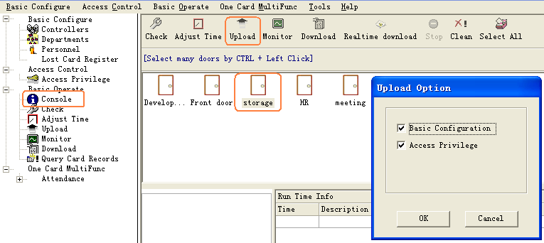
After you set the access controller’s information , you must upload the database’ configuration to access controllers.
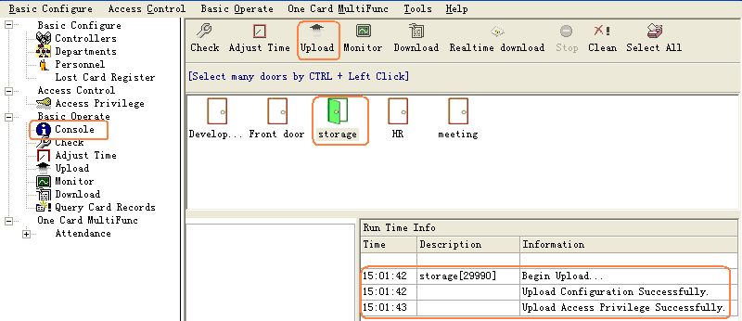

4.2.3 Monitor
Select Basic Operate << Console from the menu bar or shortcut of Basic Operate << Monitor
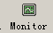
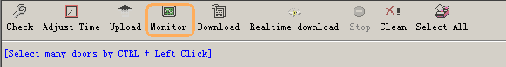
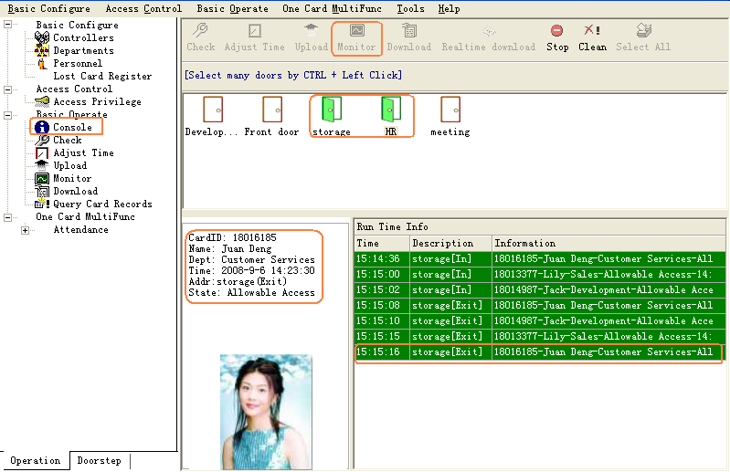

Attention : how to display user’s photo at Monitor
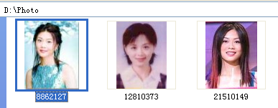
First: You must rename the user’s photo name with his or her Card Number.
For example: the photo name is 8862127.jpg. In actual 8862127 is Card Number.
Second: When you adding user, the user’s Card Id is the photo name just what you renamed .For example: 8862127 is the photo’s name.
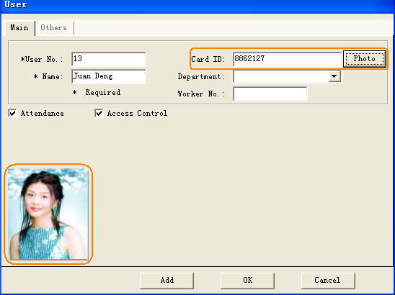
At the monitor window
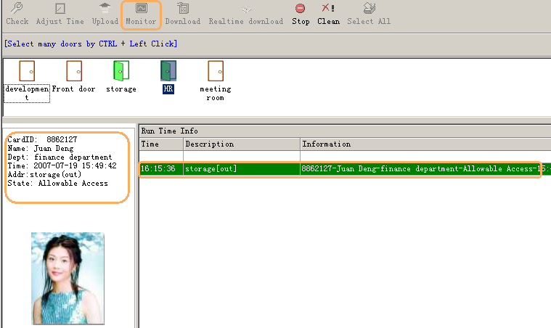
When the user swiping card, the monitor window could show the user’s photo at the same time.

4.2.4 Download
Select Basic Operate << Console from the menu bar or shortcut of Basic Operate << Download

: Gather the access controller’s records to database.
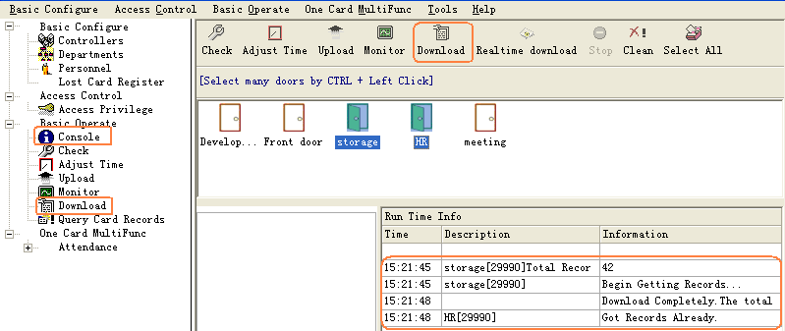

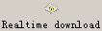 = +
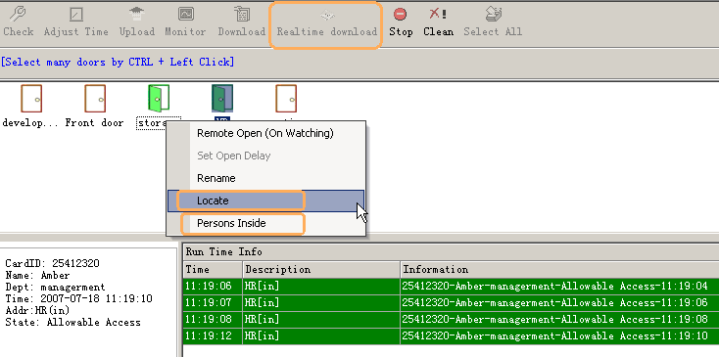

4.2.5 Locate
At the Realtime download window, Select the door first and then Right Click pop-up menu, then choose Locate .you can carry out Personnel localization.

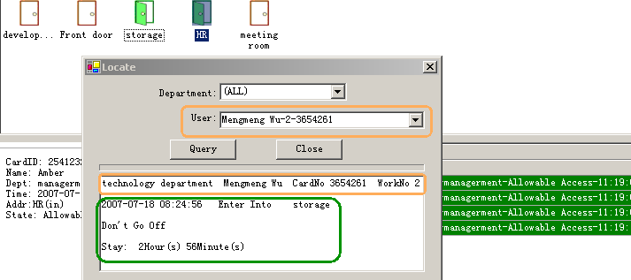
You can input the user’s Name or Card ID or Worker No into the User textbox ,it will indicate this person the latest record that what’s time which door the person entered. So you can know the place of this person at present.

4.2.6 Persons Inside
At the Realtime download, Select the door first and then Right Click pop-up menu .,then choose Persons Inside ,it will show the window of Persons Inside the door.
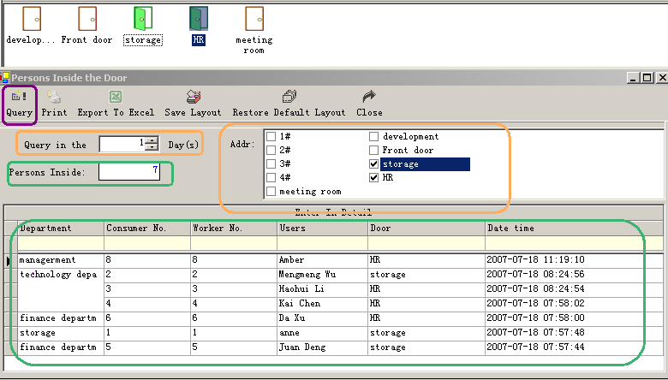

4.2.7 Query Records
Select Basic Operate << Query Card Records from the menu bar or the shortcut of Basic Operate << Query Card Records
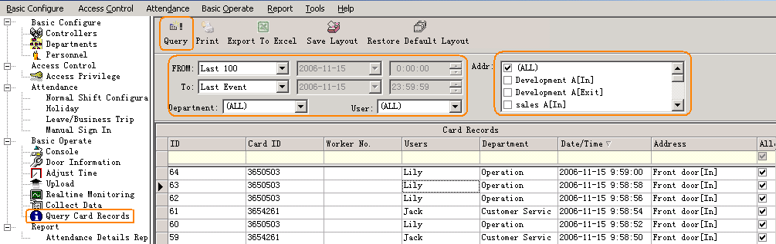

Part 5 Tools

5.1 Lost Card register
When someone has lost him or her card, you must carry on the loss registration to the old card , and then redistributes a new card to someone .The steps as follows:
Select Basic Configure<<Lost Card register
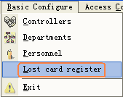
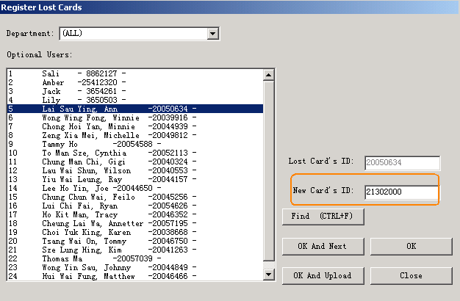

5.2 Change Password
Change operator’s password.
Select Tools<< Change Password
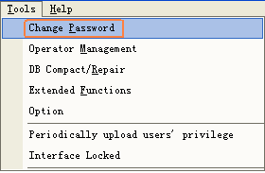
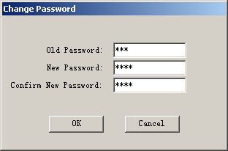

5.3 Operator Management
Select Tools<< operator Management
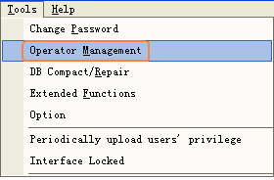
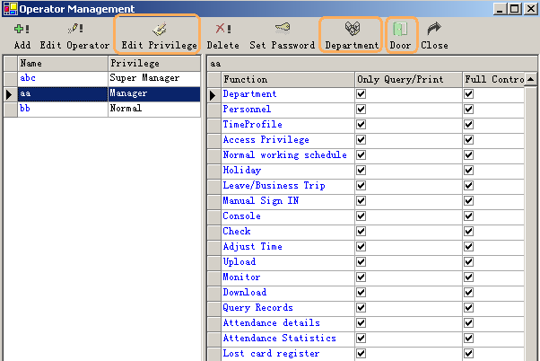
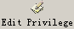: assign the executable operation and function to operators
: assign the Department that the operator can manage.
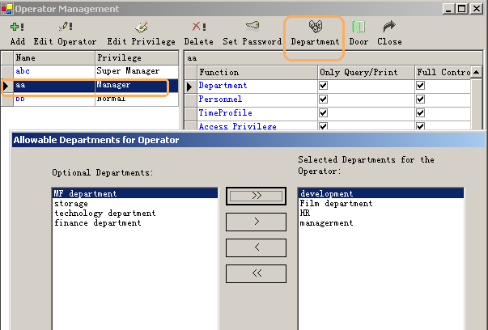
: assign the Door that the operator can manage.
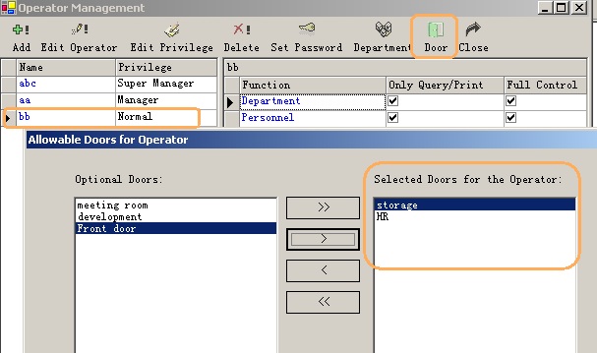

5.4 DB Compact/Repair
Select Tools<< DB Compact/Repair
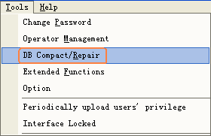

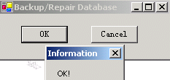

5.5 Interface Locked
The operator is afraid of someone will operate the software after she or he left ,he can interface locked the window ,the application run as also.
Select Tools<< Interface Locked
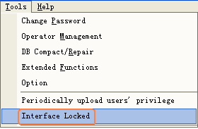
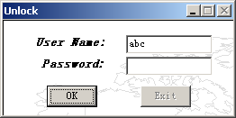
After he or she comes back , he or she inputs the password all right.

5.6 Option
Tools<< Option
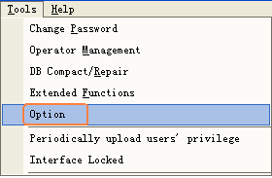
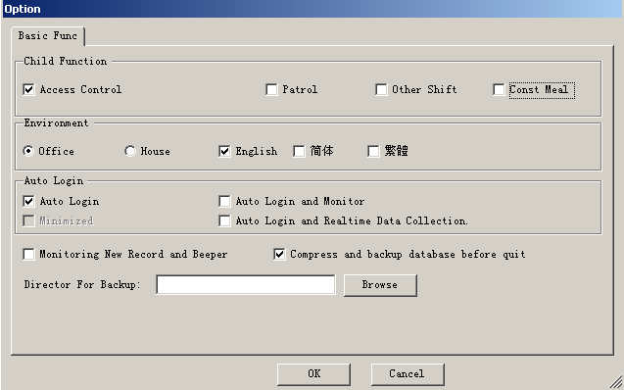
Select Child Function (Access Control, Patrol, Other Shift Const Meal)
Select Environment(Office ,House)
Select language (English,Chinese)
Set Auto Login
Set Director of Backup

Part 6 Extended Function
Select 【tools】<<【Extended Functions】 from the menu bar
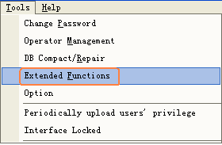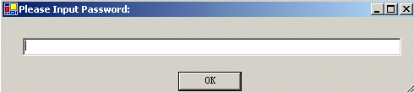
If you want to Activate the Extended Function . please input the password .
Please ask provider for password.
The extended function as follows:
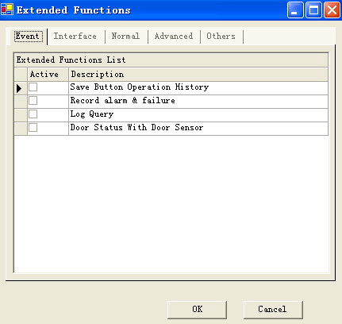
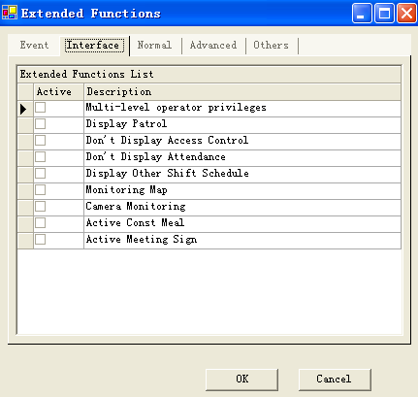
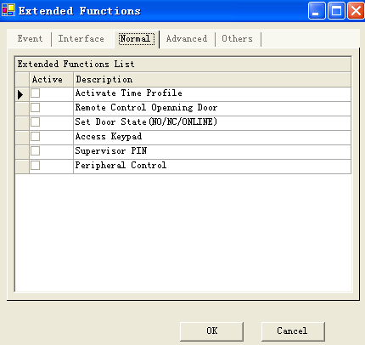
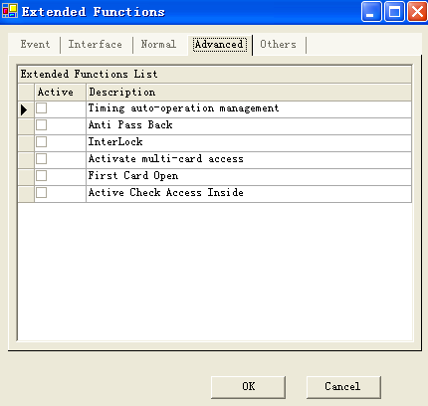
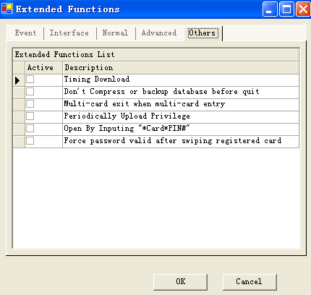

6.1 Time profile
【Extended Functions】<<【Normal】<<【Active Time Profile】
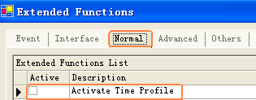
Select Access Control << Time Profile
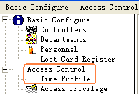
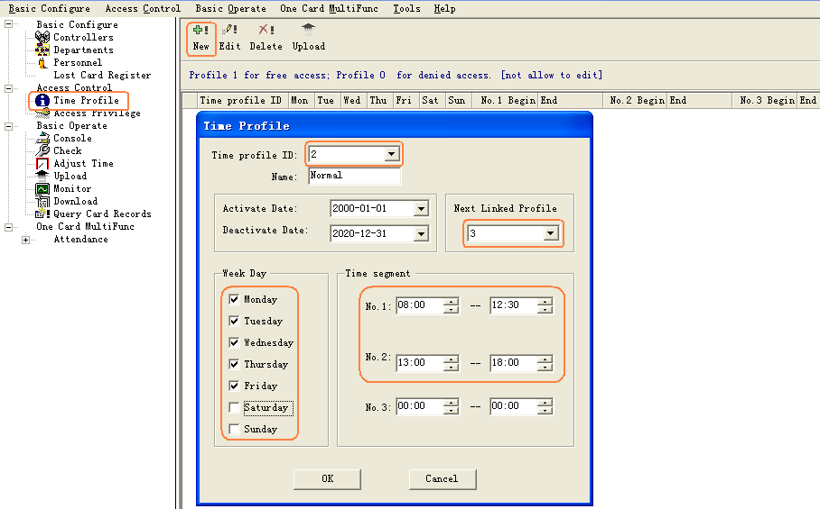
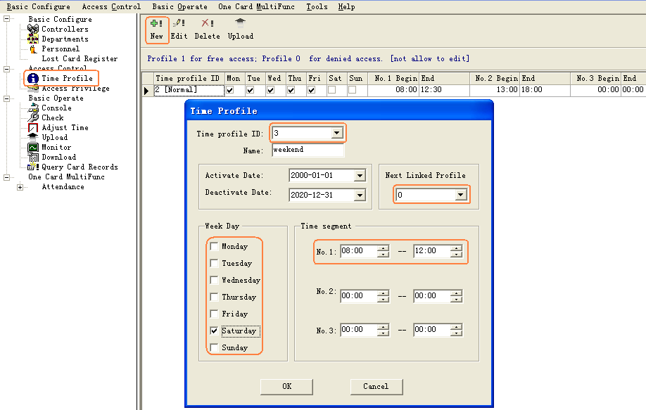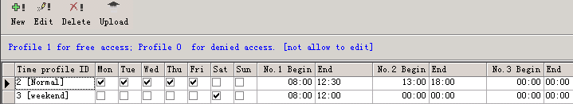

Select Basic Configure<<Access Control << Access Privilege << Change Privilege

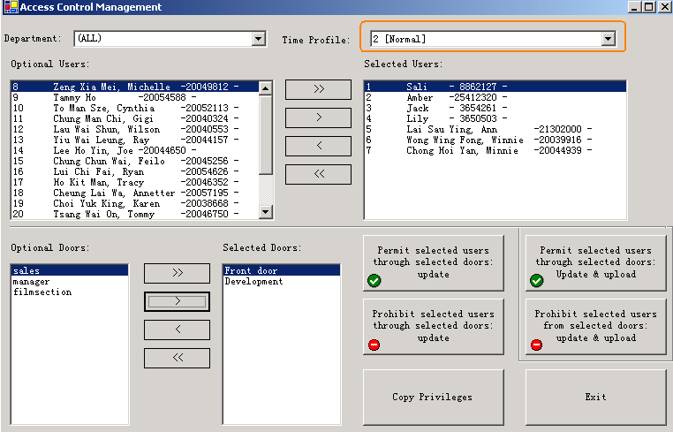

6.2 Peripheral control
【Extended Functions】<<【Normal】<<【Peripheral control】
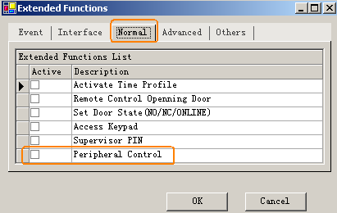
Select Basic Configure << Access Control << Peripheral control
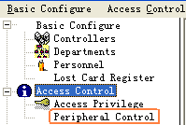
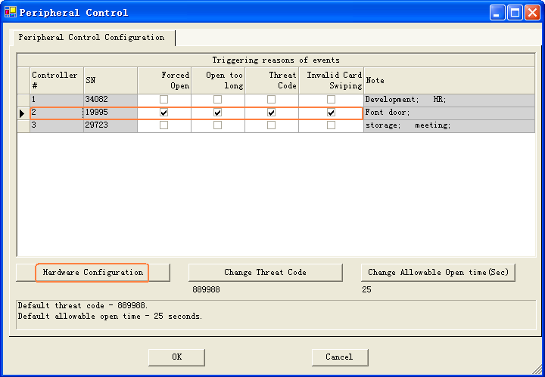
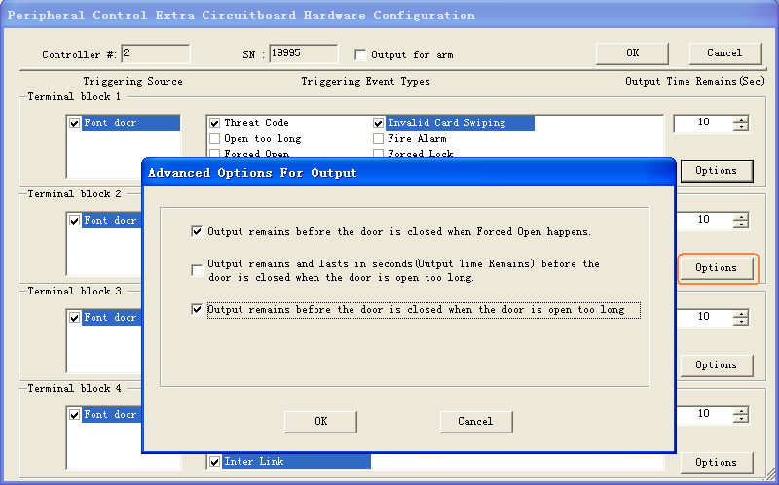

6.3 PassWord Management
【Extended Functions】<<【Normal】<<【Access Keypad】
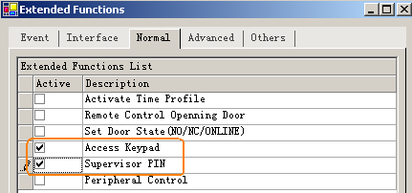
Select Basic Configure<<Access Control<<Password Management
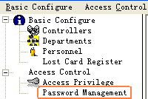
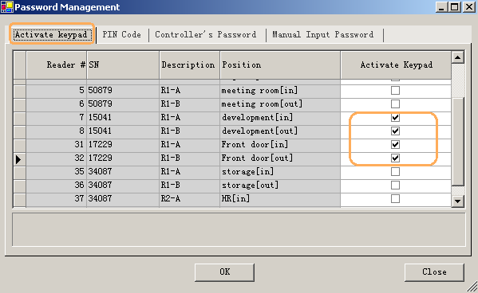
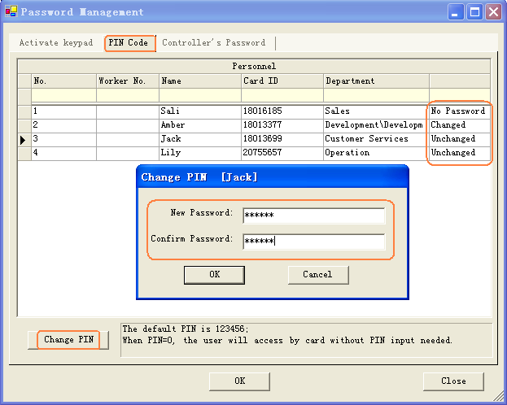

【Extended Functions】<<【Normal】<<【Supervisor PIN】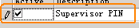
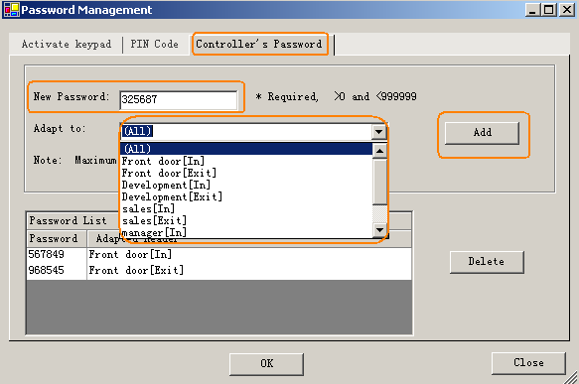【Extended Functions】<<【Others】<<【Supervisor PIN】
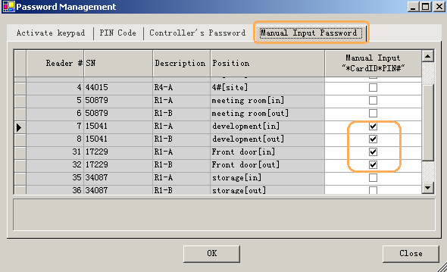

6.4 Anti-passback
【Extended Functions】<<【Advanced】<<【Anti-pass back】
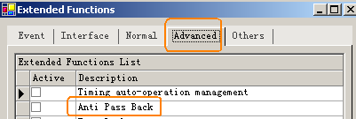
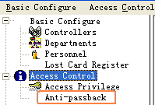

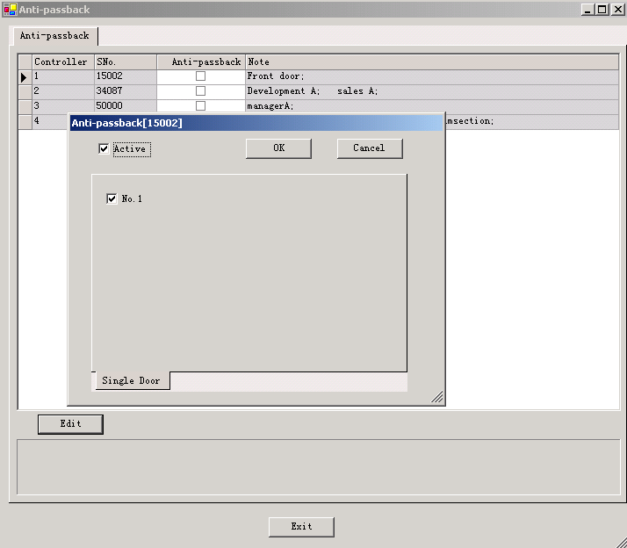

6.5 InterLock
【Extended Functions】<<【Advanced】<<【InterLock】
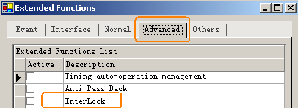
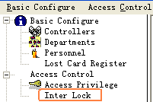
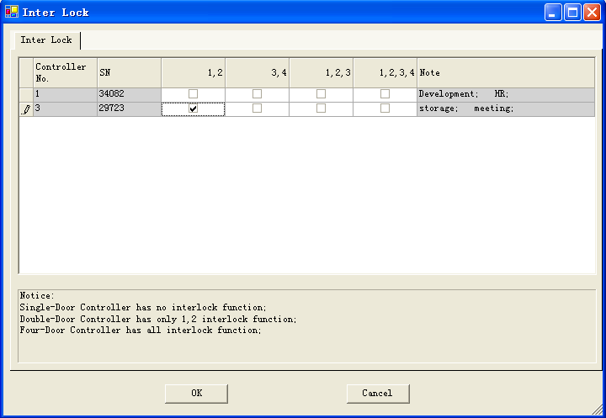

6.6 Activate Multi-card access
【Extended Functions】<<【Advanced】<<【Activate Multi-card access】
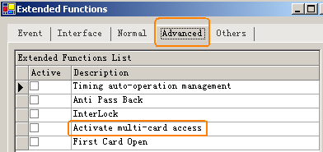

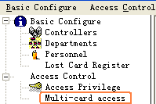

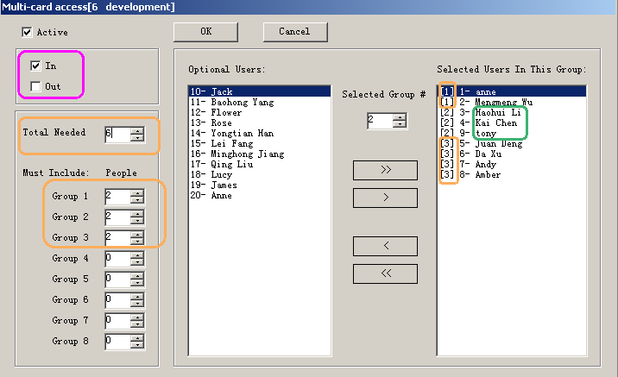
The first group has two peoples the second group has two people , the third group has four people . each group comes two people to be allowed to open the door.

6.7 Timing auto-operation management
【Extended Functions】<<【Advanced】<<【Timing auto-operation management】
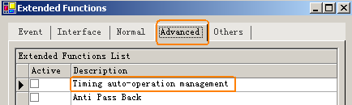
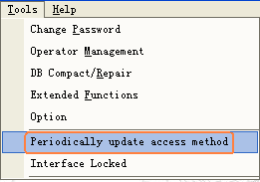
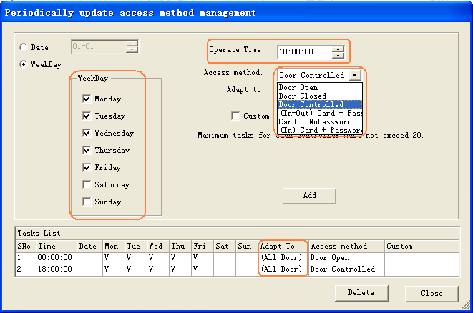

6.8 Timing collect data
【Extended Functions】<<【Others】<<【Timing Download】
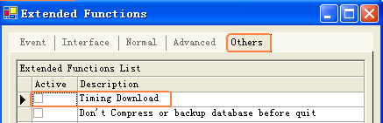

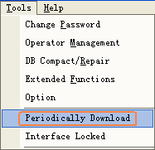
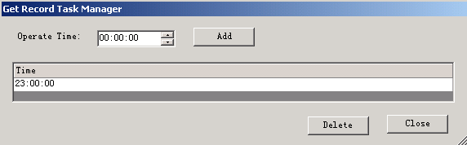

6.9 Periodically Upload Privilege
【Extended Functions】<<【Others】<<【Periodically Upload Privilege】
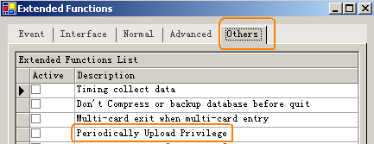

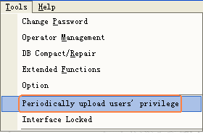
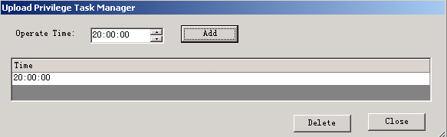

6.10 Log Query
【Extended Functions】<<【Event】<<【Log Query】
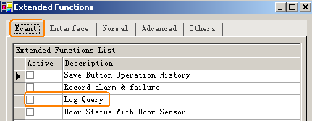
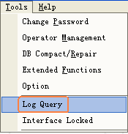
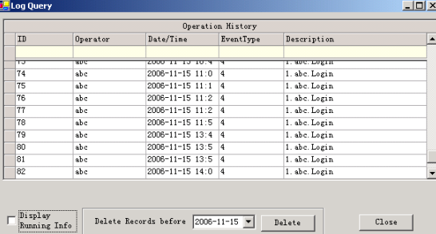
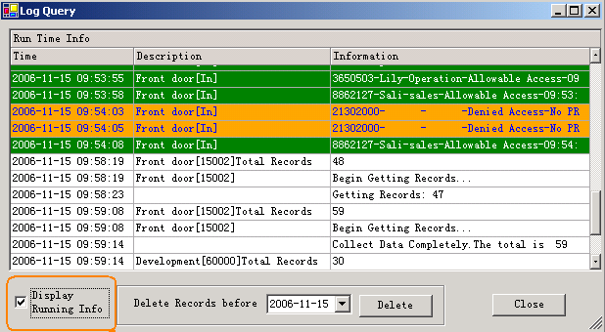

6.11 First Card Open
【Extended Functions】<<【Advanced】<<【First Card Open】
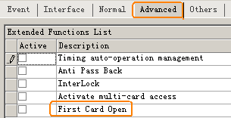

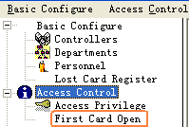
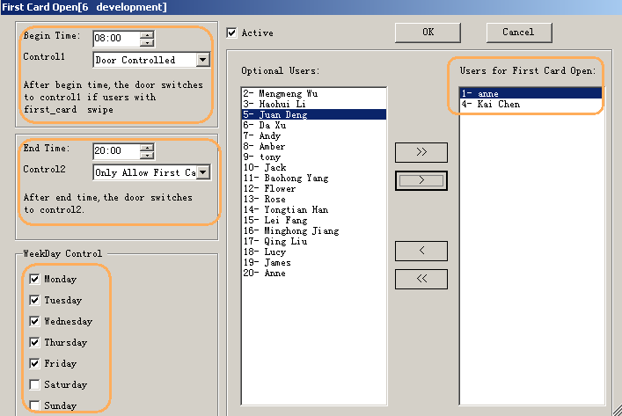

6.12 Monitoring Map
【Extended Functions】<<【Interface】<<【Monitoring Map】
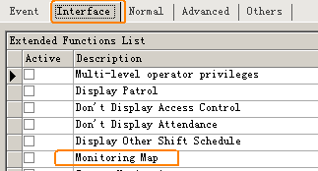
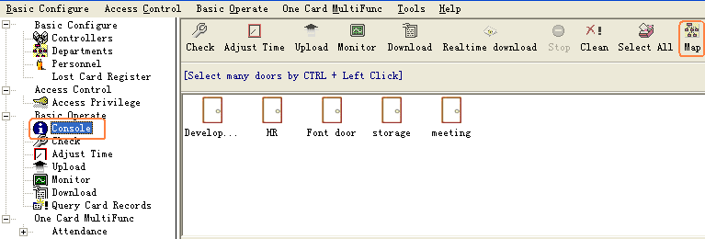
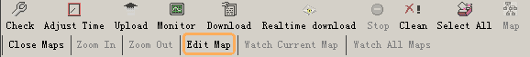

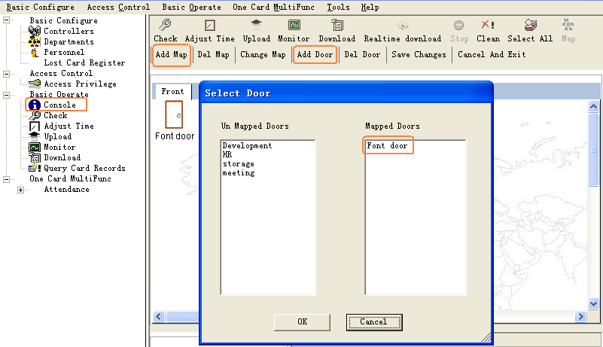

6.13 Camera Monitoring
【Extended Functions】<<【Interface】<<【Camera Monitoring】
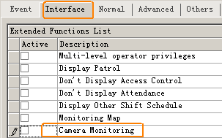
Select 【Tools】<<【Camera Management】
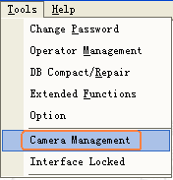
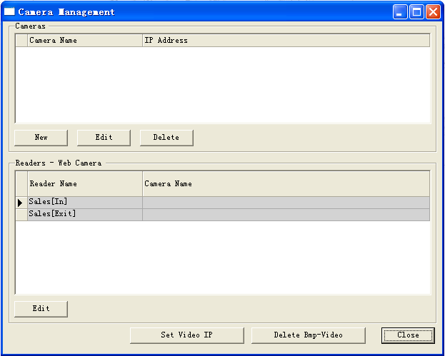
Add camera, click “New”, as shown:
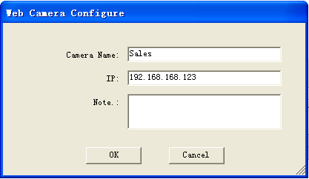
Set the Readers corresponding Web Camera
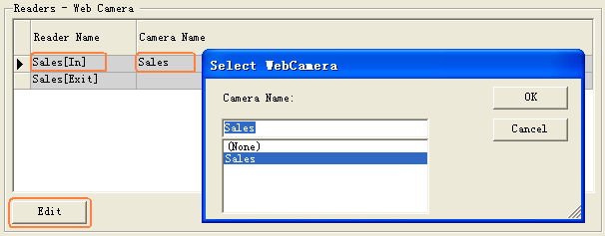
Display Photo Compare Window. Please【Console】<<【Camera】
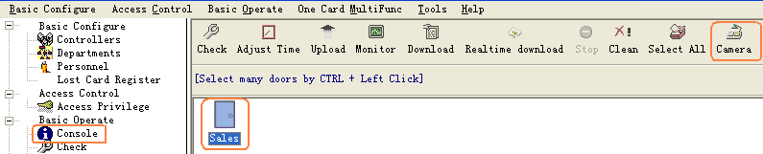
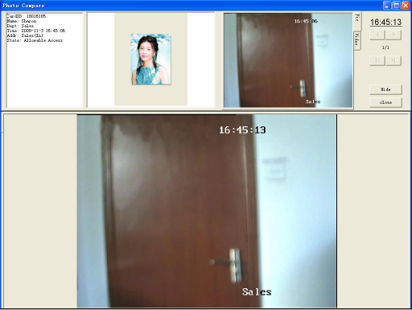
If you want to delete snap pictures and video files, please 【Tools】<<【Camera Management】<<【Delete Bmp-Video】.
If you want to set up video server's IP address, please 【Tools】<<【Camera Management】<<【Set Video IP】,as shown:
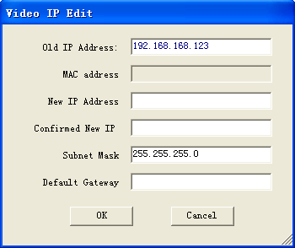
Please input "New IP Address" and re-input “Confirmed New IP”. Information for the show:

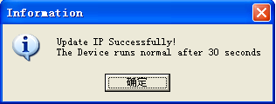

Set Video IP Successfully.
If the Information Display:
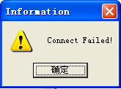
Set Video IP Failed.

Query Camera View, Select 【Query Card Records】<<【Camera View】
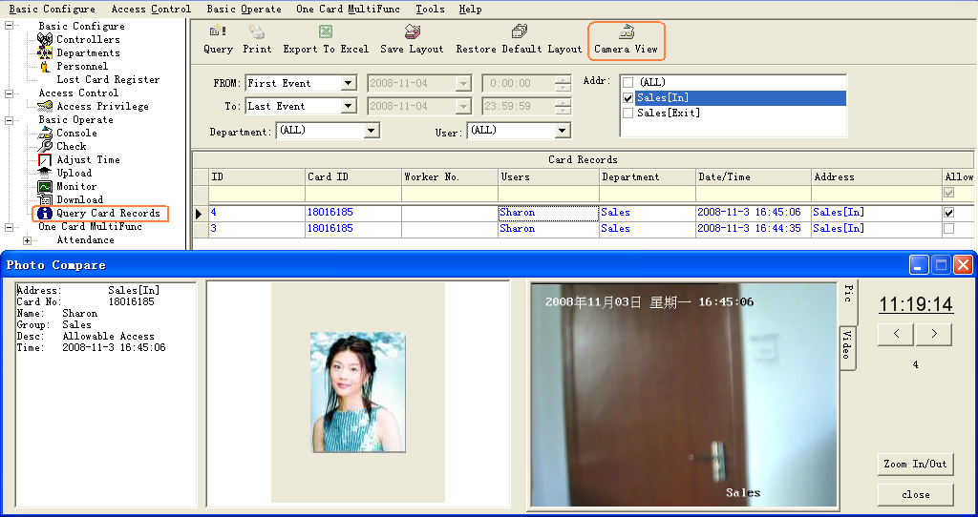

6.14 Check Access Manger
【Extended Functions】<<【Advanced】<<【Active Check Access Inside】
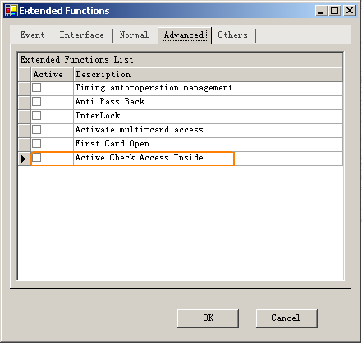
Select Tools << Check Access Manager
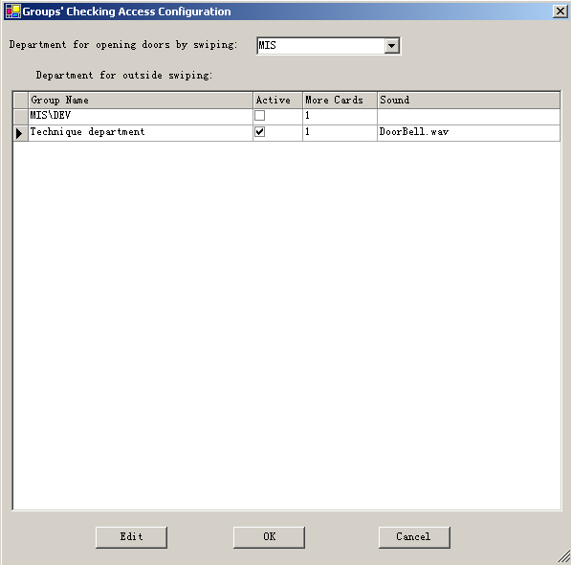
Set the department for opening doors by swpiping.
Set the deparments for outside swiping.
click “Edit”.
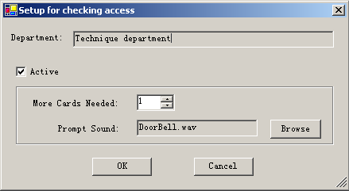
In the console “realtime-download”, external swipings will active pop-up message box, as followed:

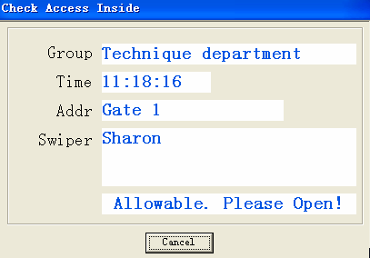

6.15 Meeting Sign
【Extended Functions】<<【Interface】<<【Active Meeting Sign】
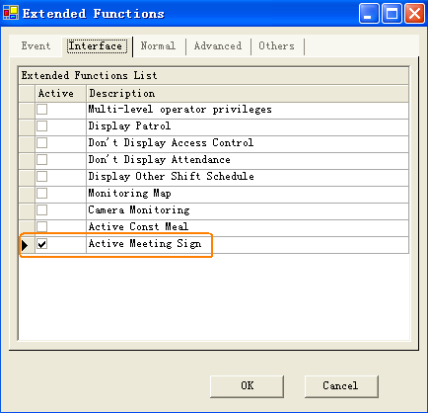
Select Meeting << Meeting Sign

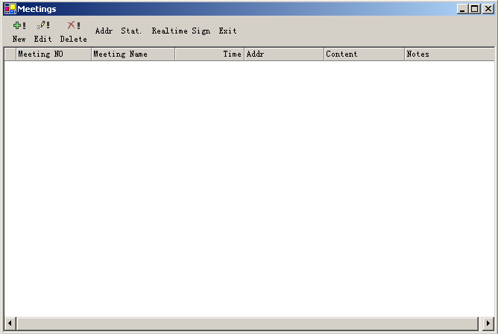
Add the meeting, please click 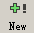,
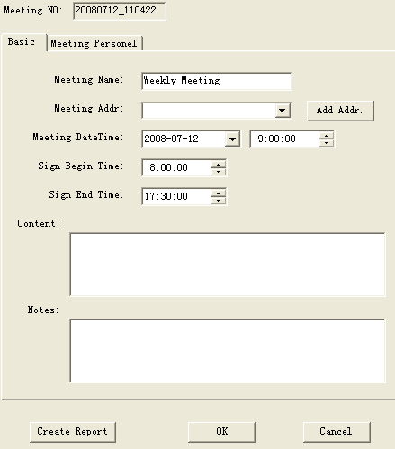

Click  , modify the meeting.
Click 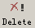 to delete the meeting.

click "Add Addr", as shown:
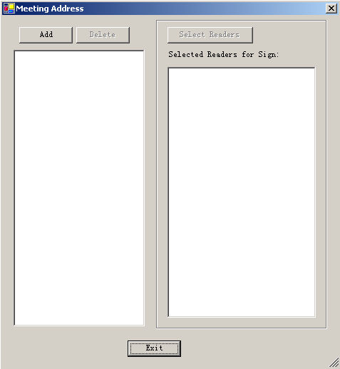
click "Add" ,

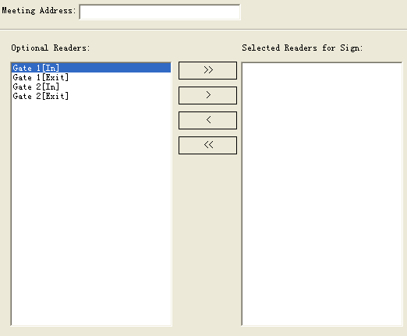
Click “Stat.”:
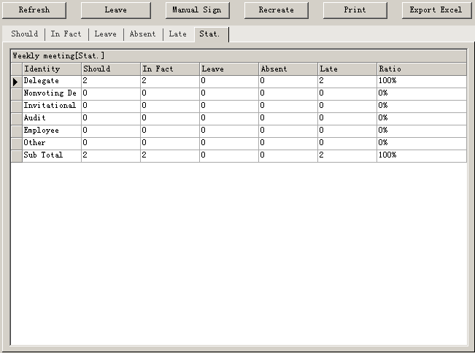
Click “Real-time Sign”:
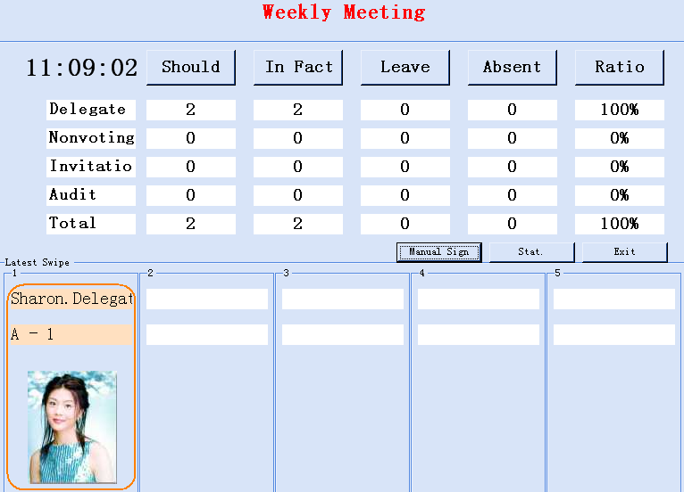

Part 7 Module:Attendance
The Access Control System had Activated the Attendance by default. If you want cancel this function ,please select 【Extended Functions】<<【Interface】<<【Don’t Display Attendance】
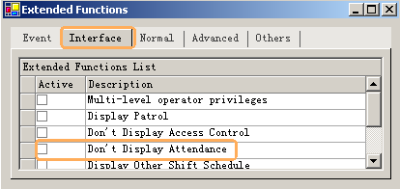

7.1 Normal shift configuration
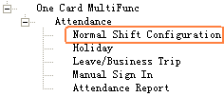

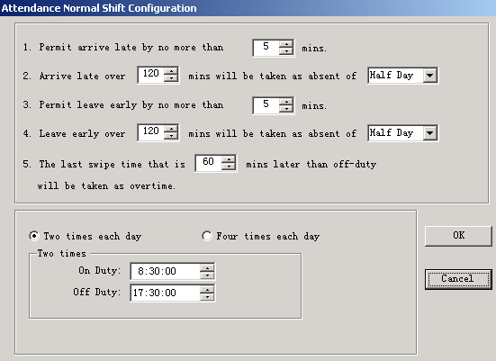

7.2 Holiday

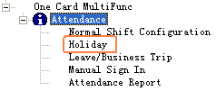
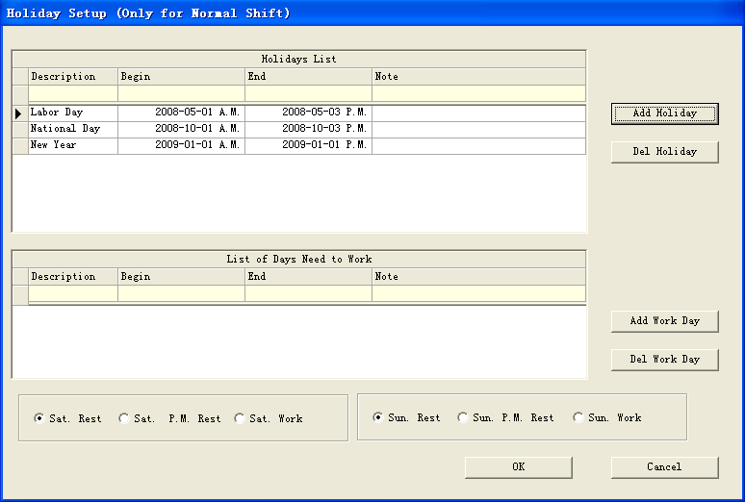

7.3 Leave/Business Trip

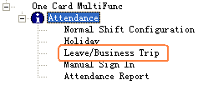

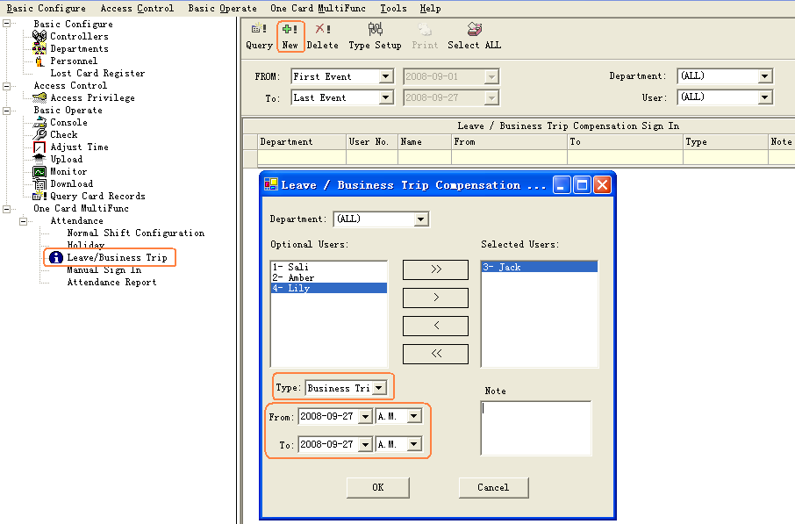

7.4 Manual Sign In
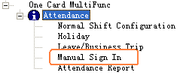

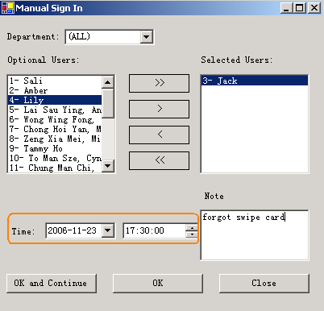

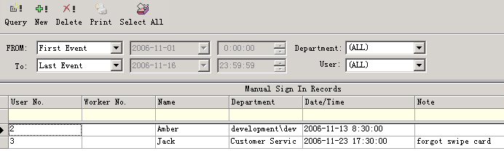

7.5 Report
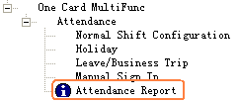

Attendance Detail

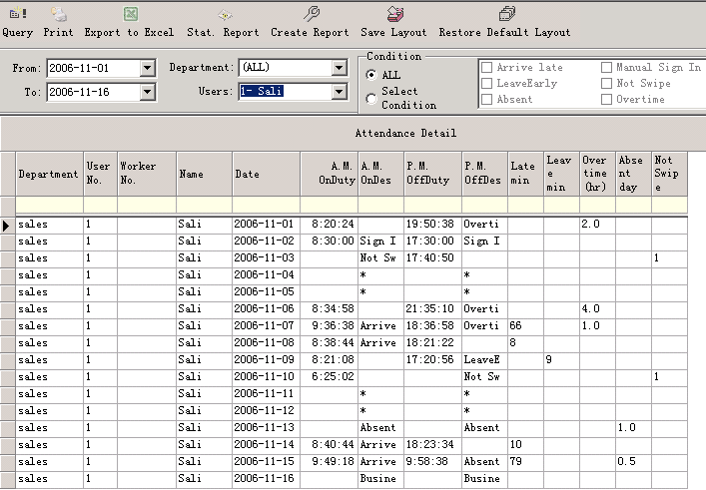

Attendance Statistics Report

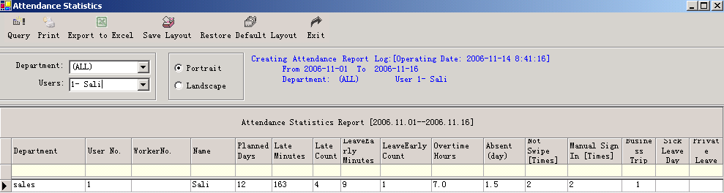

Part 8 Module:Patrol
【Extended Functions】<<【Interface】<<【Display Patrol】
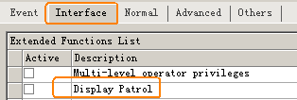
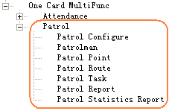

8.1 Patrol Configure
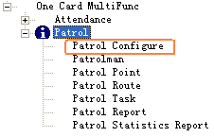

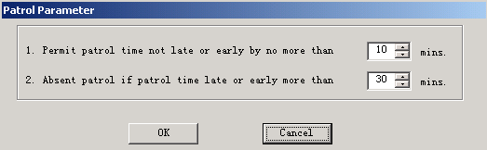

8.2 Patrolman
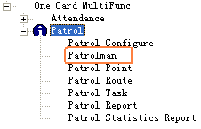
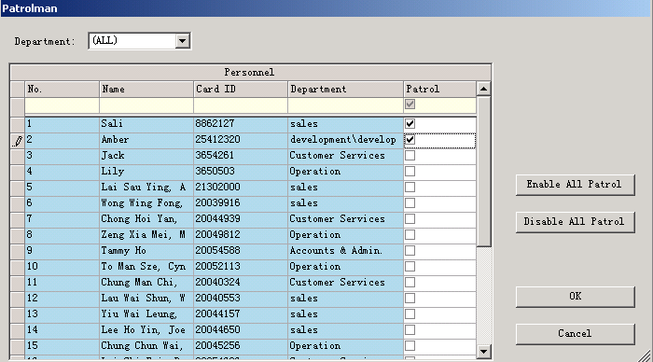

8.3 Patrol Point
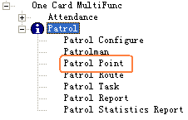
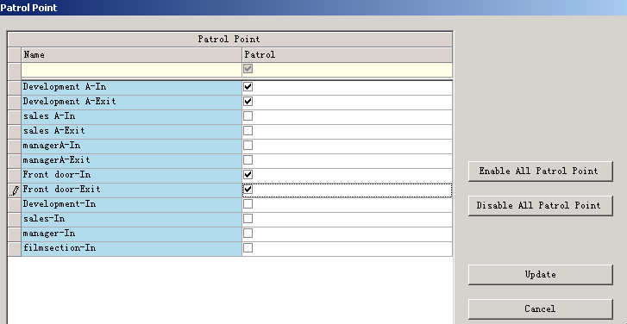

8.4 Patrol Route
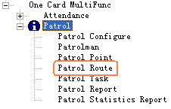
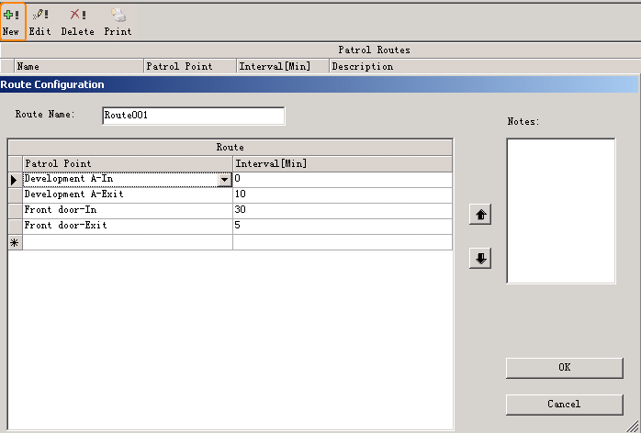
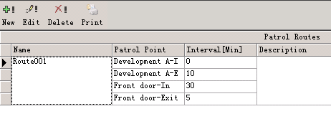

8.5 Patrol Task
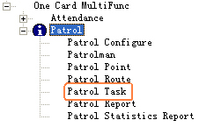
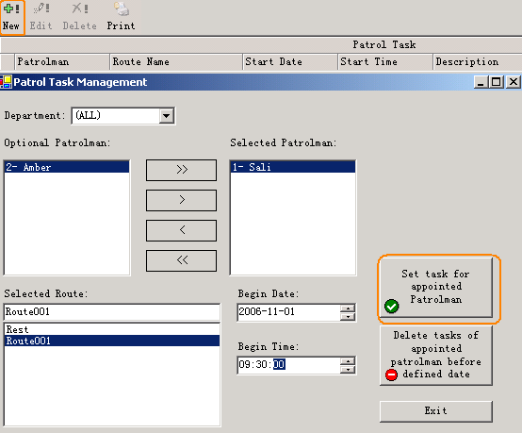

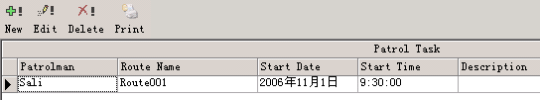

8.6 Patrol Report
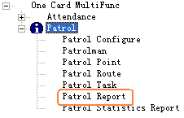

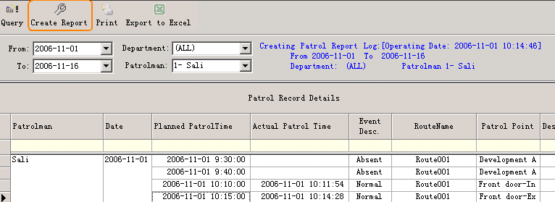

8.7 Patrol Statistics Report
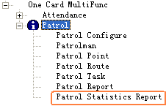

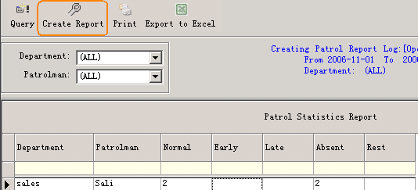

Part 9 Const meal
【Extended Functions】<<【Interface】<<【Const meal】
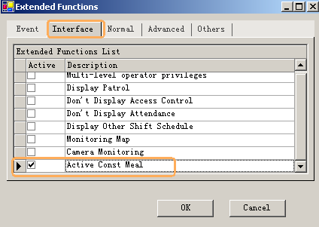

9.1 Meal setup
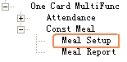

9.1.1 Readers for Meal
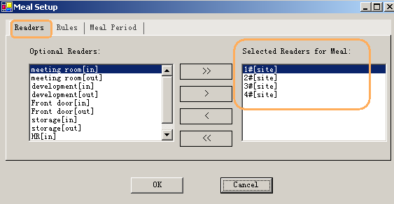
Select Readers for Meal from Optional Readers

9.1.2 Meal Rules
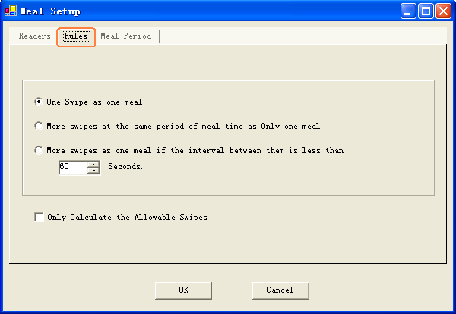

9.1.3 Meal Period
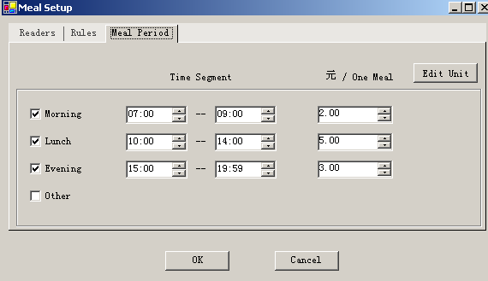

9.2 Meal Report
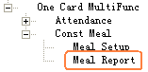
Meal Details Report
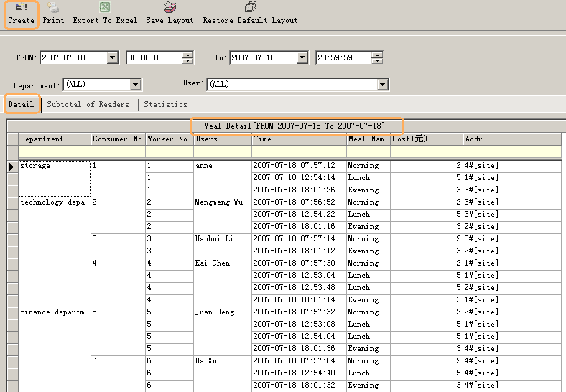
Meal Stat. report of Readers for Meal
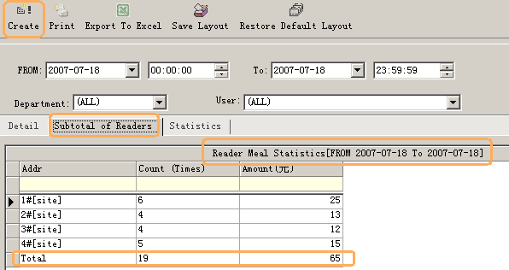

Meal Stat. report of Users
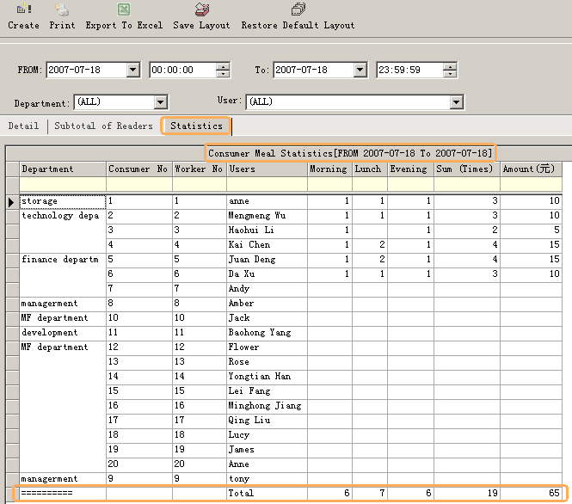

Part 10 Excursus:

10.1 RS232/RS485
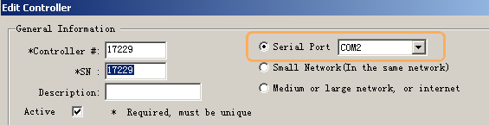
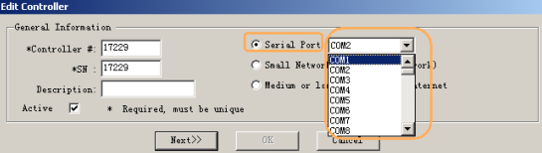

10.2 TCP/IP
all controllers are in the same network..
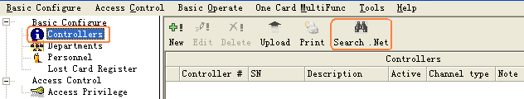

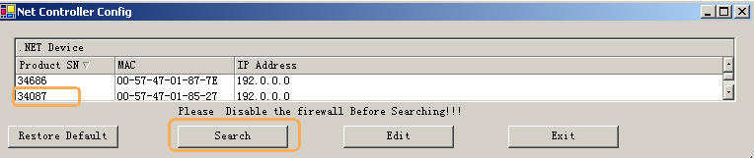

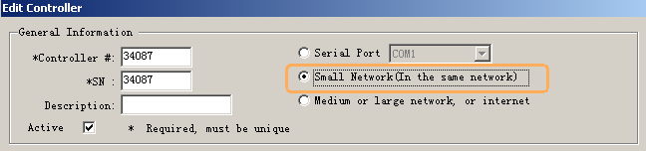

10.3 Complex network
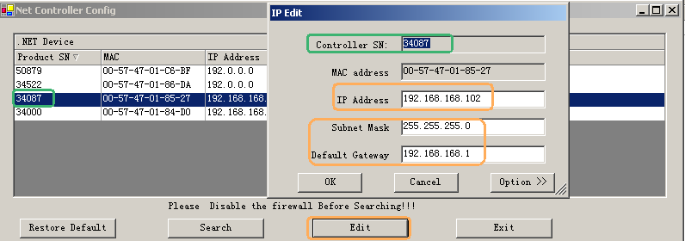
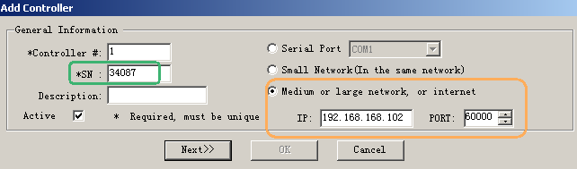
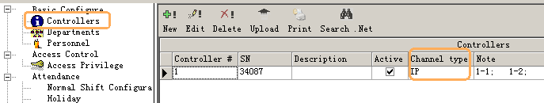

The controllers are separated into different network . Each controller must be assigned a unique IP address .
