THE TEST
One Step LH Urine Ovulation Test is fast and easy-to-use. It is a qualitative test that can predict when there is a LH (luteinizing hormone) surge, and in turn when you are likely to ovulate.

Your Cycle Length | Start To Test On
21 days | Day 6
22 days | Day 6
23 days | Day 7
24 days | Day 7
25 days | Day 8
26 days | Day 9
27 days | Day 10
28 days | Day 11
29 days | Day 12
30 days | Day 13
31 days | Day 14
32 days | Day 15
33 days | Day 16
34 days | Day 17
35 days | Day 18
36 days | Day 19
37 days | Day 20
38 days | Day 21

WHEN TO BEGIN TESTING
First, you must determine the length of your menstrual cycle. This is the number of days from the first day of your menstrual bleeding to the day before your next bleeding begins again. Please refer to the chart to determine when you should start testing. If your cycle is shorter than 21 days or longer than 38 days, consult your doctor. If you do not know your cycle length, you may begin the test 11 days after your first period since the average cycle length is 28 days. Perform 1 test each day over a 5 day period or until the LH surge has been detected.

URINE COLLECTION
- Do not use first morning urine samples as LH is synthesized in your body early in the morning. It will not show up in your urine until later in the day.
- The best time to collect your urine is between 10am - 8pm.
- Collect urine at about the same time each day.
- Reduce liquid intake about 2 hours before collecting your urine as a diluted urine sample can prevent the test from detecting LH surge.

TEST PROCEDURE
- 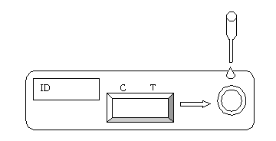Allow the sealed LH Cassette test pouch, patient’s urine sample and control solution to reach room temperature (18-30°C).
- Remove the LH Cassette test device from the sealed pouch.
- Draw urine sample to the urine dropper provided.
- Hold the urine dropper upright about 1/2 inch above the urine well of the device. Add 5 drops of urine to this well.
- Lay the test device on a flat surface with the result window facing up. Wait for colored bands to appear. Depending on the concentration of LH in the test specimen, positive results may be observed in as short as 40 seconds. However, to confirm negative results, the complete reaction time (10 minutes) is required. Do not read results after 30 minutes.

INTERPRETATION OF RESULTS
- No LH Surge: Only one color band appears on the control (C) region or the test (T) band is lighter than the control band. There is no LH surge.
- LH Surge: If two color bands are visible and the test (T) band is equal to or darker than the control (C) band, one will probably ovulate in the next 24-48 hours. If one wants to be pregnant, the best time to have intercourse is after 24 but before 48 hours.
- 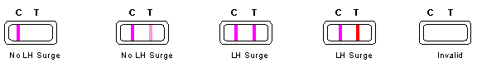Invalid: No visible band at all. Repeat test with a new test kit.

Latest revision 09.05.2011

ATLAS LINK, INC USA Headquarters:
No. 811 Zeyang Plaza, No.166 Fushi Road 10758-A Ambassador Drive
Shijingshan Dist., Beijing 100043, China MANASSAS, VA 20109 USA
Tel: 86-10-88909112 Fax: 86-10-88909115 Tel: 703-3663851

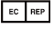
CIRIANO GLOBAL S.L. (UNILATEX GROUP)
CIF: B50927532 C/Blancas 4-6, 1 B Oficina 1
50001 Zaragoza Spain
Tel: 34-976910399

