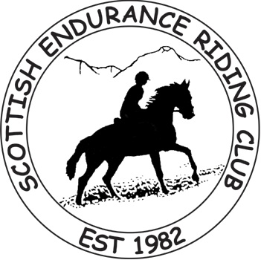


BRC TEAM ENDURANCE EVENT

DECLARATION FORM (V1.3)

RIDING CLUB NAME:
SPORT UK REGION (if known): | South East

HORSE NAME

Sire (if known)

Dam (if known)
Colour |  | Sex (M, G, S) |  | Height |  | Yr Foaled

Is this horse registered with EGB, SERC or ILDRA (please circle YES or NO)? | YES / NO | If YES, then what is its Log Book Number?

RIDER (that is, the person who will be riding the above horse in the BRC Team Endurance Event)
BRC Member Number |  |  |  | Member Number if a member of EGB, SERC or ILDRA

Name

Address L1
L2

L3
L4
Postcode
Phone |  |  |  |  | Mobile
Email
Is this Rider also the Team Manager? Yes/No |  |  | If the Team Manager is NOT one of the riders, then please complete a separate Declaration Form for the Team Manager, with "TEAM MANAGER" written clearly in the HORSE NAME box and then complete all the "rider" contact details only (Name, Address, Postcode, Phone & EMAIL). Note that all communication with the squad by the national organisers will be directed to the Team Manager (ideally by email).

Date of Birth of Rider: Please provide your date of birth if you are 25 years old or under to help us contribute to the PE & Sports Strategy for Young People. You must provide your date of birth if you are a Junior (8 to 13 years old inclusive) or Young Rider (14 to 21 years old inclusive). A Veteran Rider is 60 years old or over. Please only tick ONE of the Junior, Young or Veteran Rider boxes below, if applicable.

Please tick one of the following Rider Categories IF APPLICABLE (see above) | Junior  Rider |  | Young  Rider |  | Veteran  Rider

You can email the completed forms for your squad to johnhudson@endurancegb.co.uk , all in a one email please, quoting your Club Name in the subject line of the email, OR

post them, all in one envelope please, to:

Jane Hudson, Springdale, Cove, TIVERTON, Devon, EX16 7RT

