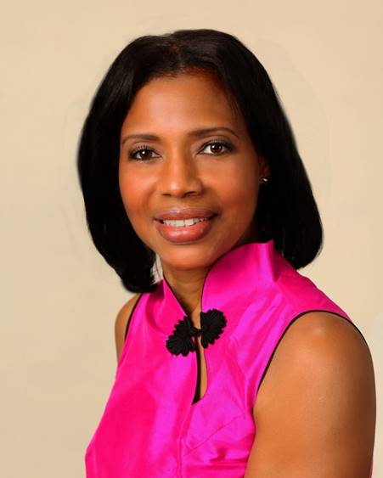

LOVE LIGHT NewsLetter

I am excited to host my VoiceAmerica Empowerment Show-LOVE LIGHT with amazing Guests to cultivate a lifestyle of love and wholehearted connections through worthiness. My show is aligned with my mission to live an altruistic and heart centered life.

MEET LOVE LIGHT GUEST

CRISSY BUTTS
Happiness Coach, Team-Building Educator, Author, Speaker

“CULTIVATING A HAPPY LIFE”

JULY 10, 2020

ABOUT Crissy Butts

Crissy Butts, Happiness Coach, reminds men and women that they were MADE to SHINE, and how to Engage, Connect & Thrive. Her works include Amazon International Bestseller: You Choose Your Path, The Sunshine Strategy, 21 Day Happiness Challenge, The Workplace Power Hour, & The Family Power Hour. Crissy is preparing for a TedTalk and has had articles on Global Happiness featured in International Focus Magazine. After living in Alaska in a one room cabin with 4 boys with an outhouse, her family grew a million dollar limousine company. “Be careful what you wish for”, is a reminder she often shares. Crissy has lost several family members and friends to suicide and self-destructive behaviors which has inspired her work to help others. Crissy has been married 30+ years to Desmon Butts who is a Captain with Mesa Airlines. She is a mom to 5 and mimi to 16.

https://www.happytribe.com

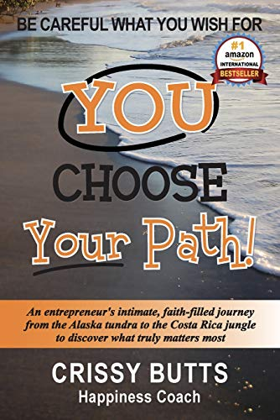

“An empowered self is a loving self and keep your love light shining”

