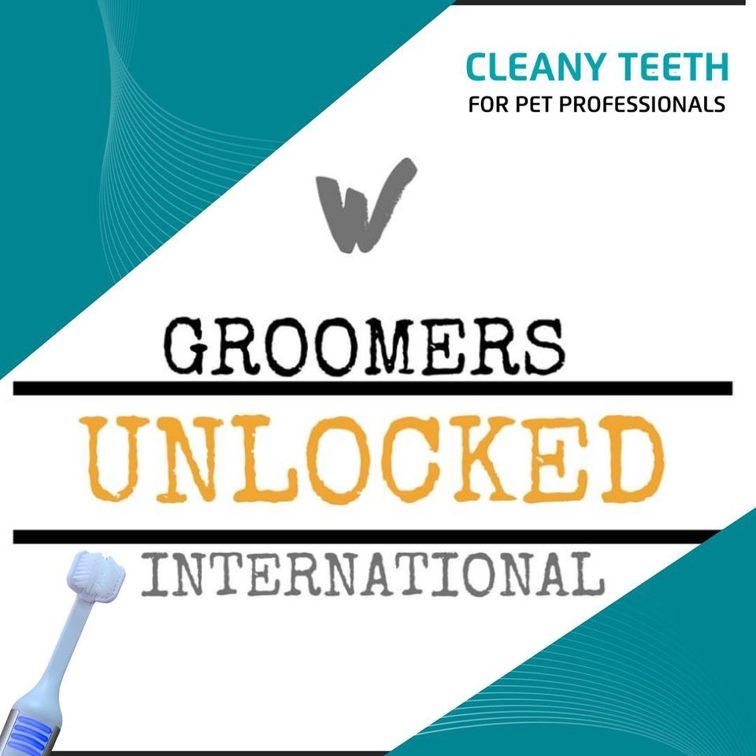
Owner Details
Full Name:
Contact Number:
Dog Details
Name:
Breed:
Date of Birth:
Health conditions (past & present):

*Please Read & Confirm you understand the following, before signing.
I allow the staff at Woof Love Dog Grooming to use the Cleany Teeth Ultrasound toothbrush on my dog. I understand this has no manual movement or noise & that the staff will provide before & after photos of my dog’s dental health progress.
I understand the progress may vary depending on my dog’s current dental health, previous dental cleanings & behaviour.
The process being carried out will gradually remove, bacteria, tartar, plaque & stains from my dog’s teeth with the gentle use of additional tools if required to aid this process.
I understand some blood from the gum line may be apparent during & for a short time after the session as the tartar / plaque are cleaned having been lifted away from the tooth.
I allow & understand the staff to stop the session if the following issues becoming apparent & if advised I will seek veterinary care as soon as possible.
- Loose or damaged teeth are found.
- Abnormalities including but not limited to, tumours, ulcers, abscesses, oral warts, foreign bodies, or injuries.
- My dog’s behaviour shows aggression or excessive stress.

I …………………………………………………………………………...……… (Owners name here) Declare that;
I understand this teeth cleaning service is not a substitute for veterinary medical care or diagnosis. And that the staff are by law not able to diagnose suspected conditions.
I agree to pay the full amount of the session due, if my dog’s session is stopped due to the reasons stated above.
I am NOT aware of any medical reasons this session should not be carried out.
*I as the legal owner of this dog, understand & consent to all stated above.

