Trinity Times
Volume 10, Issue 3-4
March & April 2022

God has been good to me and I have been greatly blessed my entire life. Life brings us mountains and valleys, darkness and light. It brings us joy and it brings us sadness. It brings us good times and it brings us bad. The bible tells us there is a time and a season for everything but through it all God is always with us.

Carrie and I are now entering a valley of life, a troubled time that we know will be difficult. Beginning Monday, February 28th, we will be in Charleston as I undergo 7 weeks of Chemo and radiation treatment at MUSC.

As we enter this period, we do so knowing that God has provided for us love, prayers, and support from you and from our family. We are grateful to God for bringing each of you into our lives. Somehow the words thank you for your love and support seem so inadequate.

As I look at the world around me, I can quickly see that my troubles are so minor compared to others and I ask that we continue to pray for those we may not know who face challenges in their lives.

Please pray for Carrie and our family, that they might find peace. Carrie and I love you all so very much and we can’t wait to return to Trinity and New Chapel. You are all very special to us. Thanks to you and thanks to God from whom all good blessings flow.

doug

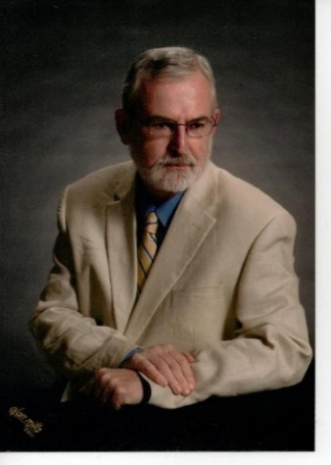

Pastor Doug Benton

Editor’s Note: Pastor Doug is such a humble man. As you notice, he asked for prayer for everyone but himself. He has told me that he is at peace no matter what happens and that “God’s Will” will be done. I ask that you pray diligently for Pastor Doug. Pray specifically that his medical team can find a way to ease his pain, that he will be able to undergo the treatments planned with no complications whatsoever, and that the treatments will be successful. Let us pray these things in God’s name.
Trinity United Methodist Church

1160 Trinity Church Road
Newberry, SC 29108
803-276-1245 Office
803-542-0082 Pastor Cell
dobenton@umcsc.net
trinityumcnewberry@gmail.com
www.trinityumcnewberry.net
PLEASE VISIT OUR WEBSITE
AS OFTEN AS YOU CAN!

Peggy Bogart, Church Secretary
Head Usher: Harry Longshore
Choir Director:
Organist: Eddie Welborn
Alternate Organist: Phyllis Sanders
Video Board: Josh Pitts, Foster Senn, Bryan Waldrop
Acolytes/Cross Bearers Coordinator: Kelly Morris
Newsletter Editor: Harriet Stevenson

We are a caring church and want to share your concerns. Let us know if you or someone you know would like to share a prayer request with us. We will be happy to pray for you. To add or remove names, contact Peggy Bogart, Church Secretary, or Harriet Stevenson.
Nursing Home: Gloria Brehmer (Springfield Place); Gerry Johnson (Greenwood Rehab)
Continued Prayers: Shirley Berry, Boyd Hendrix, Jane and Robert Pollard, Jeannette Poag, Pastor Doug and Carrie, Faye Senn, Phyllis Sanders
Family and Friends of Trinity: Homer Bowles, Neil Thomas, Francis Leopard, Kinsley Bouknight, Janna Longshore, Phillip Sanders, Woody and Connie Kreuzinger (Carrie’s parents), Ron Stevenson, Freddie Bundrick

1- David Morris 14 -Kella Armstrong
1 – Ralph D. Waldrop III 15 – Jane Pollard
3 – Grady Senn 15 - Joan Morris
5 - Ken Morris 15 – Gavin Wilson
5 – Jenny Senn 15 – Wyatt Wilson
6 – Cheryl Longshore 16 – Kevin Bundrick
7 - Charles Wilbanks 21 – Wade Pitts
8 – Joyce Suber 25 – Harriet Stevenson
10 – Barbara Rogers 26 – Wilson Senn
10 – Wayne Black
12 – Roger Longshore
13 – June Pitts

14- Bill Lominack
2 - Steve Morris 15- Bridget Bouknight
5 – Mia Kate Brehmer 17 – Suzana Pruitt
7- Foster Senn 19- Lauryn Wilson
8 - Terry Woodward 22- James Poag
10- Henry Senn 22- Melissa Spicer
11- Sylvia Holmes 28- Nancy Pitts
11- Diane Waldrop
13- Charlie Rogers

For March and April

March 6 – Jane Woodward
March 13 – Linda Lominack
March 20 - John Pollard
March 27- Watkins Martin

April 3 - Clarissa Hendrix
April 10 – Phyllis Sanders
April 17 – Myrtle Longshore
April 24 - Sylvia Holmes

Greeters be in Narthex by 10:40 a.m.

March 6 – Harriet Stevenson
March 13 – Dixie Waldrop
March 20 – Frieda Kesler
March 27 – Lynn Mohler

April 3 – Josh Pitts
April 10 – Betty Way
April 17 – Kelly Morris
April 24 – Phyllis Sanders

Acolyte Schedule
March 6 – Wyatt Pitts
March 13 – C. J. Griffen
March 20 – Taylor Bouknight
March 27 – Noah Mohler

April 3 – Dalton Morris
April 10 – Kelly Morris
April 17 – Sylvia Holmes
April 24 – Kruz Bouknight
ACOLYTES: Be robed and in narthex by 10:50 a.m.

Contact Kelly Morris (803) 924-5715 or
Peggy Bogart, Church Secretary (803) 944-1769
if you are unable to serve or if you need to switch
with someone, so they can make changes in bulletin.
Readers, you will receive a bulletin in the mail with scripture included for your assigned Sunday.
TRINITY WOMEN’S CLUB - The TWC sponsored Soup Sunday on January 30. It was a huge success! Thanks to all those who contributed financially as well as those women who made soup, sandwiches, corn muffins and pound cake! Wow, we have some awesome cooks at Trinity.

We collected over $400 and made a significant donation to GAAP (God’s Abundance for All People) Food Bank at O’Neal Street Church. Sharon Baughman volunteers at this Food Bank.

Our next meeting is Monday, March 7, at 5:00 p .m. in the Fellowship Hall. Dues are $12.00/year and are due now.

SILVER AND GOLD – The Silver and Gold travelled to Clinton to eat at Dempsey’s for the first time in quite a while. We all enjoyed the fellowship and the PIZZA!
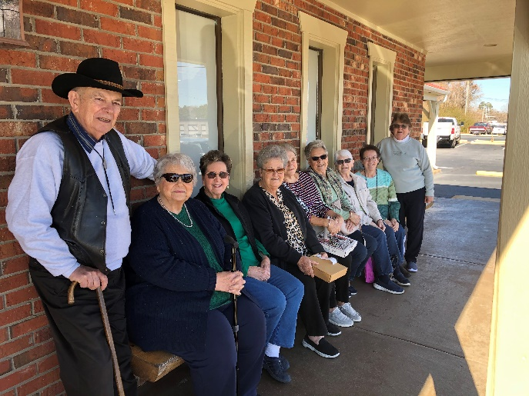
We will meet again on March 9 for a baked potato and salad bar lunch. We will meet in the Fellowship Hall. You will be notified by Harriet of what you need to bring. Meeting time: 11:30 a.m. We will also play Bingo.

Thanks to WAYNE BLACK for purchasing a Keurig for the church and new blinds for the kitchen. We appreciate and love you, Wayne!

Trinity Men’s Club – The Trinity Men’s Club will meet on Wednesday, March 2. Cooks will be Johnnie Pitts, Michael Bouknight, Kruz Bouknight, William Johnson and Boo Johnson.

Thanks to the Men’s Club for providing hygiene boxes to those individuals getting out of prison in Newberry County.

METHODIST YOUTH FELLOWSHIP (MYF) – Josh and Erin Pitts, Leaders
The MYF will have their monthly meetings on March13th and April 10th. They will meet at the church at 6:30 p.m. The MYF collected $250.00 and a huge box of non-perishable food items for the Souper Bowl of Caring. All donations will go to the Pomaria Food Bank. The youth will be delivering these donations and volunteering at the Food Bank on March 5. The MYF wasn’t able to snow tube on Feb. 19 so they went bowling in Greer instead and had a great time. They will go roller skating on March 27th and have a Movie Night at the church on April 24th.
MYF Bowling Outing

Calendar for and 2022

March 2 Ash Wednesday – No service at Trinity – Feel free to visit another church.
March 2 Men’s Club Meeting & Dinner @ 7:30 p.m.
March 5 MYF volunteering at Pomaria Food Bank
March 7 Trinity Women’s Club @ 5:00 p.m.
March 9 Silver and Gold – 11:30 a.m. Fellowship Hall – Baked Potato/Salad Bar
March 13 Daylight Saving Time Starts at 2:00 a.m.
March 13 MYF meeting at the church @ 6:30 p.m.
March 13 Pastor Ken Carter will deliver sermon at 11:00 a.m. service
March 14 Administrative Council Meeting @ 6:30 p.m.
March 15 Deadline to apply for Frank Sr. and Audrey Senn Academic Scholarship
March 17 St. Patrick’s Day
March 20 First Day of Spring
March 27 MYF goes roller skating after church service – returns at 5:00 p.m.
March 28 Palm Sunday – Service at 11:00 a.m.
March 28 MYF meets at church @ 5:30 p.m.
April 4 Trinity Women’s Club @ 5:00 p.m.
April 6 Men’s Club @ 7:30 p.m.
April 10 Palm Sunday
April10 MYF meeting at the church @ 6:30 p.m.
April 11 Administrative Council Meeting @ 6:30 p.m.
April 14 Maundy Thursday – information on service at Trinity TBA
April 15 Good Friday – information on service at New Chapel TBA
April 17 Easter – information on service at Trinity TBA
April 24 MYF Movie Night at church from 5:00 – 7:30 p.m.

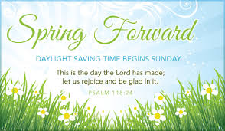
Daylight Savings time begins at 2:00 a.m. on Sunday, March 13. Don’t forget to spring forward. If you don’t you’ll miss Pastor Ken and Barbara!

When Is Holy Week?
Here are the dates for Holy Week for 2022:
Sunday, April 10 - Saturday, April 16. Easter is on Sunday, April 17.
Important Dates of Lent | Significance | 2022 Dates
Palm Sunday | Celebrates Jesus's triumphant entry into Jerusalem | April 10, 2022 -11:00 a.m. Service at Trinity
Holy Week | The week leading up to Easter | April 10 – April 16, 2021  NOTE: Holy Week does not include Easter
Maundy Thursday | Commemorates the foot washing and Last Supper of Jesus Christ with the Apostles | April 14, 2022- Service at Trinity TBD
Good Friday | Commemorates the crucifixion of Jesus and his death at Calvary | April 15, 2022
Holy Saturday | Commemorates Jesus' body resting in the tomb | April 16, 2022
Easter Sunday | Celebrates the resurrection of Jesus from the dead and his victory over sin and death. Easter Sunday is  not a part of Holy Week. | April 17, 2022- Service time at Trinity TBA
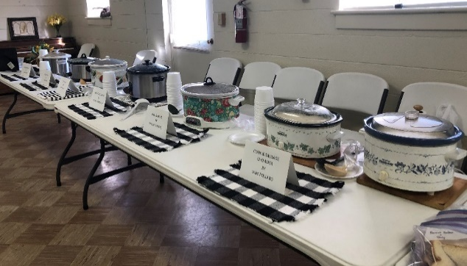
Soup makers were Joan Morris, June Pitts, Harriet Stevenson, Phyllis Sanders, Jane Pollard, and Frieda Kesler. Dixie Waldrop, Myrtle Longshore and Jane Woodward made the pound cake. All other members made sandwiches and corn muffins.
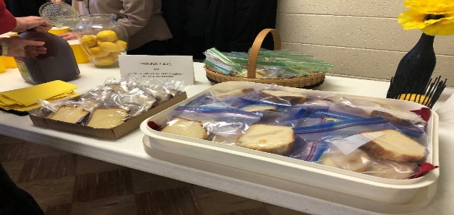
SOUP
SUNDAY
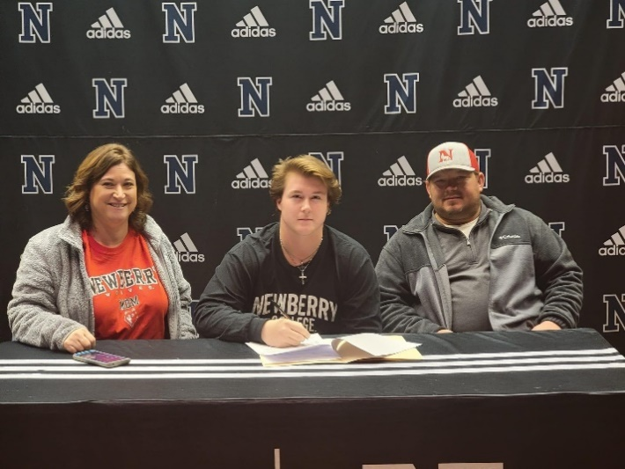
Congratulations to Coye Cutshall who signed his letter of intent to play football at Newberry College this fall. Pictured below are Coye and his parents, Mark and Ashley Cutshall.

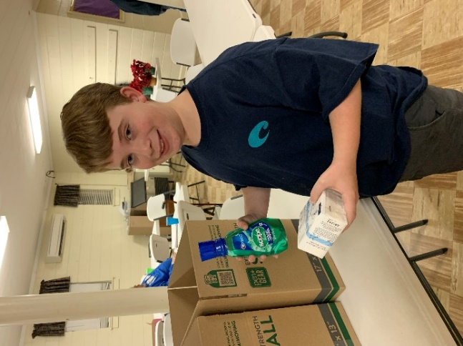
Kruz packs hygiene supplies for Kella Battiste and Kathryn Armstrong
individuals in Newberry County danced in the Newbery Ballet Guild’s
who are getting paroled. These performance of The Jungle Book in January.
supplies help with their re-entry This was Kathryn’s first performance with.
into society. This was a mission the Ballet Guild.
project of the Men’s Club.

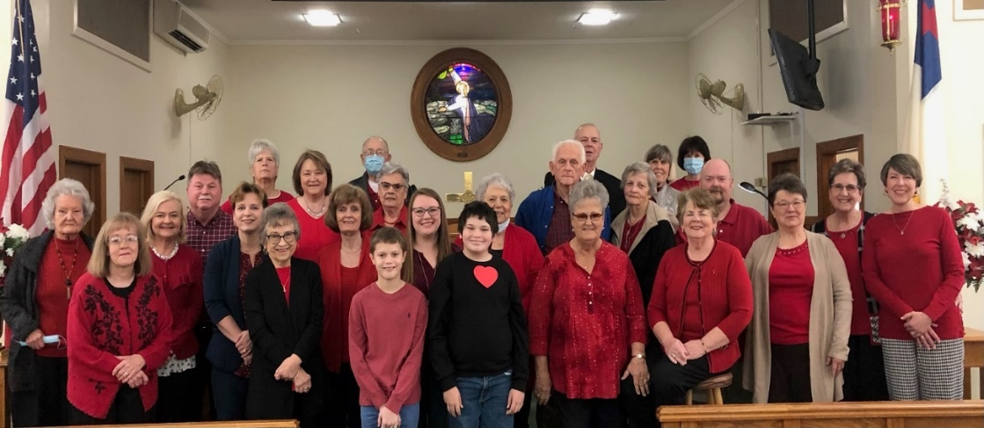
Wear Red Sunday and Recognition of American Hearth Month - Feb. 13, 2022 – This photo and an article appeared in the March 2022 issue of the United Methodist Advocate newspaper. Thanks to all who supported this important outreach ministry.

PHOTOS FROM TRINITY MEMBERS WHO “CHALKED THEIR DOORS” FOR EPIPHANY! Jane and Robert Pollard, Kelly Rogers, Harriet Stevenson, Barbara Rogers, Joan Morris. The church also chalked their doors. Information on Chalking your door was in the January/February issue of the Trinity Times.

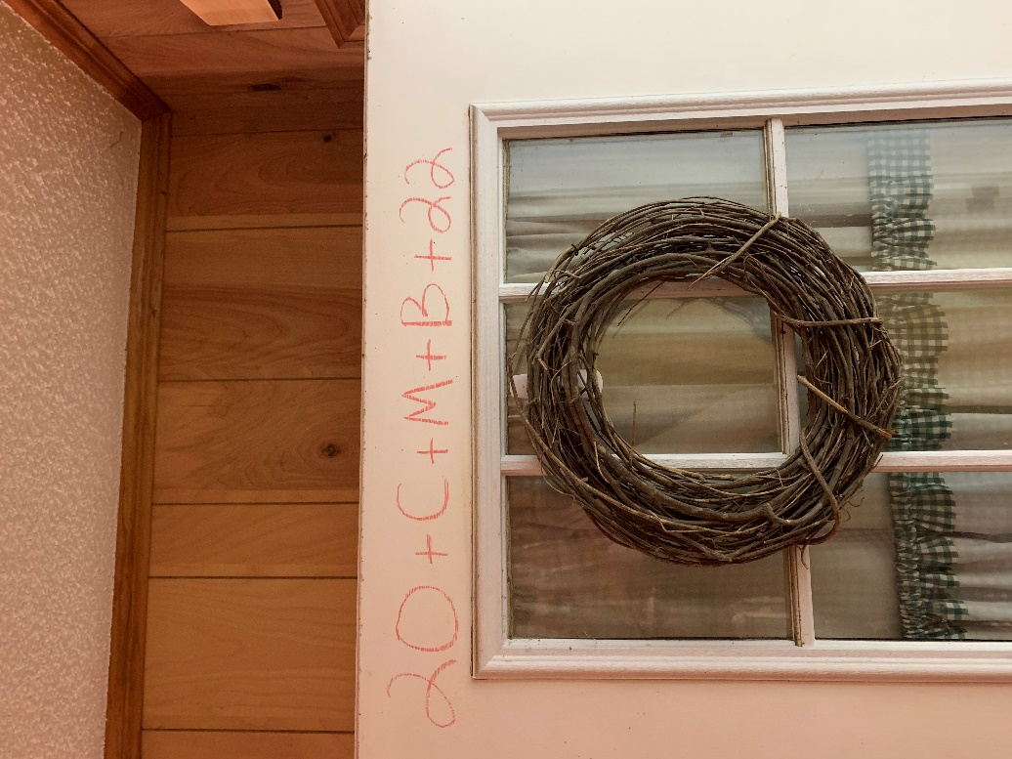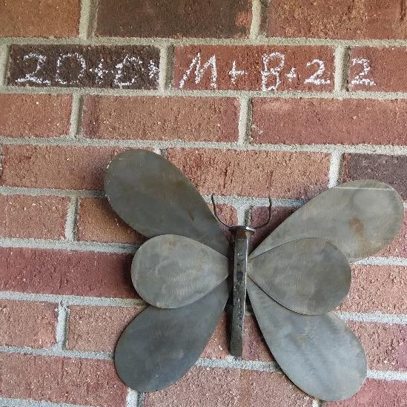
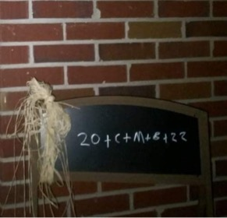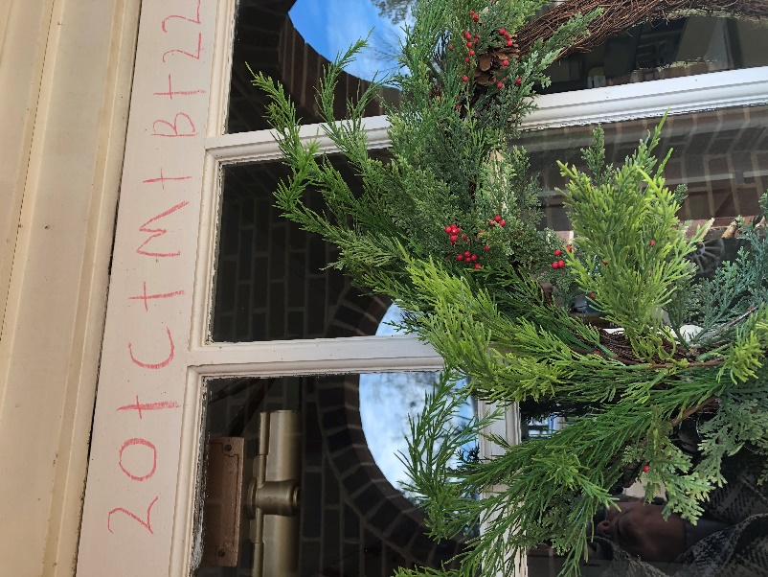

.

Trinity United Methodist Church
1160 Trinity Church Road
Newberry, SC 29108

