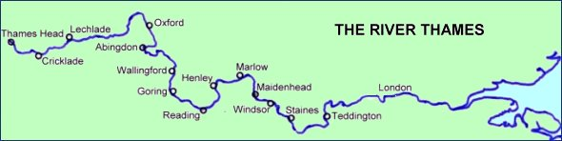

Thames Path Walk for RDA

- Who: Mike Clark, resident of May Tree Close

- What: I'm planning on walking 170 miles of the Thames Path to raise funds for Watershed RDA; https://watershedrda.co.uk/ where I am a volunteer.

- When: Friday 6th May – 12th May

- Where: Coates (source of the Thames) to London Bridge

- How to take part: I've split the walk into 20 stages, if you are keen to do a stage or a full day's walking to raise money for Watershed RDA please send me an email: mikeclark32@hotmail.co.uk

- How to donate: If you'd like to support, but don't fancy the walk; this is my JustGiving page: justgiving.com/fundraising/michael-clark64

I'm aiming to raise £1700 (£10 / mile walked)

Watershed Riding for the Disabled in Coates, Near Cirencester has been offering riding therapy since 1993, and is a thriving and successful group of the National RDA.
Riding and interaction with horses is known to provide profound benefits for people of all ages, particularly for those whose lives may be limited or challenged through disability.