Peptic or Duodenal Ulcers

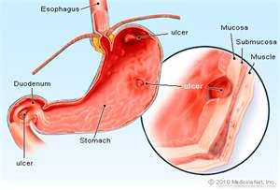
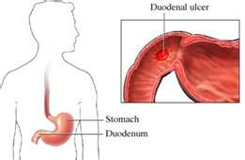

- Ulcers are a spot on the lining of the stomach or the duodenum where the lining or the lining and underlying muscle has been eroded, leaving an open wound. The surrounding tissue usually swells and becomes irritated.
- Ulcers can occur anywhere along the gastrointestinal tract, but the most common are gastric or peptic ulcers in the stomach, and duodenal ulcers in the duodenum (the section of the small intestine just below the stomach).

Symptoms:
- Chronic burning or gnawing pain
- This can cause an individual to awaken in the middle of the night.
- Lower back pain
- Headaches, a choking sensation
- Possible nausea or vomiting

Cause:
- Helicobacter pylori (bacteria)
- Insufficient mucus lining in the stomach
- Stress
- Excess stomach acid
- Steroids, Aspirin and NSAID drugs increase stomach acid
- Smoking

Recommendations:
- For rapid relief of pain, drink a large glass of water … this dilutes the digestive juices in the stomach (works for peptic ulcers, not for duodenal ulcers)
- Eat lots of green vegetables
- Avoid caffeine and alcohol
- Since helicobacter pylori is a common cause, it is recommended to take one bottle of pepto bismol as directed on the bottle. This helps to kill helicobacter pylori
- Alfalfa supports the repair of ulcers
- Vitamin E helps to promote healing
- Optiflora (microflora for the intestinal tract)
- To reduce stress, use Stress Relief Complex and B Complex
- OmegaGuard – protects the stomach & intestinal lining from acid
- Zinc promotes healing
- Drink fresh made cabbage juice daily

