New Jersey

Family Career and Community Leaders of America

2023 Friend of New Jersey FCCLA Award

Application Due by: March 1, 2023

Purpose
To honor people whose professional responsibilities are not directly related to Family, Career, and Community Leaders of America, who have made outstanding contributions and who have given continual service to the New Jersey FCCLA state organization.

Eligibility
Examples of those eligible for this honorarium are chief school officials, vocational directors, deans and department heads of Family and Consumer Sciences, retired Family and Consumer Sciences professionals, elected officials, and educational, civic, or business leaders.

Criterion
Nominees will be judged on their contributions in one or more of the following areas:
- Outstanding and continuing services that contribute to the achievement of the goals of Family, Career, and Community Leaders of America. (50)
- An effective public relations program that has helped interpret FCCLA state-wide. (10)
- Assistance in developing or carrying out FCCLA projects state-wide. (20)
- Authored publications of value to youth in working toward career and FCCLA goals. (10)
- Achieved state, national, or international recognition in Family and Consumer Sciences that has helped gain prestige or helped promote the FCCLA programs. (10)

Policies
Nominations for "Friend of NJ FCCLA" may be submitted by:
- The state executive Council
- NJ FCCLA Alumni and Associates Members
- An Affiliated Chapter

Additional Support Materials
A letter of recommendation in support of the nominee must be submitted with the official nomination form.

Return completed application to:
New Jersey FCCLA State Office
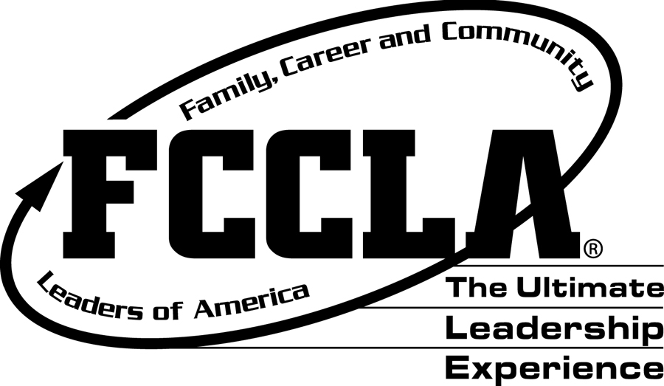
c/o Patricia DiGioia-Laird
NJ FCCLA State Adviser
855 Grove Avenue
Edison, New Jersey 08820-2200

New Jersey
Family, Career and Community Leaders of America
2023 Friend of New Jersey FCCLA Award
Nomination Form
Application Due by: March 1, 2023

Name of Nominee:_________________________________________________________________________
Home Address:____________________________________________________________________________
Telephone Number :_______________________________________________________________________
Business Address:_________________________________________________________________________
Business Telephone Number:______________________________________________________________
E-Mail Address: ___________________________________________________________________________

Nominees will be judged based on their contributions to FCCLA in the following areas:
(Please use attachments as needed.)

- Outstanding and continuing services that contributes to the achievement of FCCLA goals.

- Assisted in an effective public relations program that has helped interpret FCCLA state-wide.

- Assistance in developing or carrying out FCCLA projects state-wide.

- Authored publications of value to youth in working toward homemaking, & FCCLA goals.

- Achieved state, national, or international recognition that has helped gain prestige for, or helped promote the FCCLA programs.

Person/Chapter who initiated this nomination:____________________________________________

Contact Information: _____________________________________________________________________

