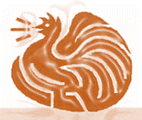
The Chook Run
May 2021

Birthday wishes to all birthdays in May

As the weather gets cooler, breezier and you sit in front of the fire with that warm drink, think about your chooks.
Keeping us all warm.
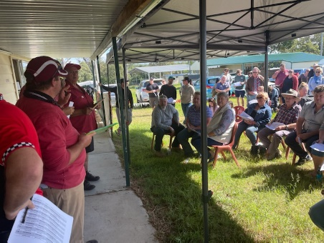
Auction Report
First event. I wish to thank all that attended our auction.
Thanks to the setup flock getting it ready to go.
I hope the sellers are happy with the price of their birds. I did hear that some said they were happy with what they got and others would of like to see the prices be a bit higher. Buyers weren’t as plenty as normal but it was a great day. The auction was held outside due to covid. Buyers walked in the shed for viewing before assembling outside. Birds were displayed on screen for buyers.
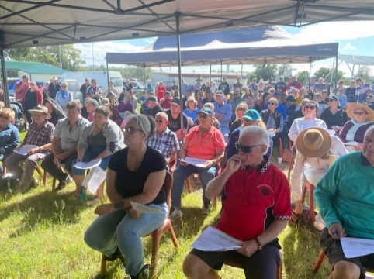

Rare Breed, Rare Colour and Waterfowl Show (29/05/2021)
Disaster relief moved out, after using the shed to contain their tools to assist with people affected by the floods. As we setup the shed for the next show. Entries slowly coming in. Thank you to the exhibitor’s that have replied that they aren’t attending.

Postage
As I have posted over 100 schedules. I thought about the address and names that I was writing on the envelope. I fixed the ones that I know that had moved and the ones that the individuals had send to me or the club. Some schedules returned not at this address. The club would like to update our list. I will start with the entry form for the show. If you send email with your details, also can you add if you would like to get schedules from Ag Show (run by Show society), Rare breeds, Rare colour and Waterfowl Show, Annual Show. The club keeps the list separate so the right exhibit gets the right form. It’s ok if you like to show at all the shows.

How to tell what a sick chook looks like.
As we have new member’s I thought that adding info about looking for signs of sick poultry.
Info from Backyard Poultry.

A Guide to Sick Chicken Symptoms

It's Good to Know Chicken Disease Symptoms and Treatments
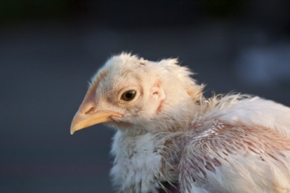

First, let’s explore what a healthy chicken looks and acts like.

How Does the Chicken Look and Act?
A healthy chicken is a busy chicken. It is aware of what the other chickens are doing. The healthy chicken is pecking the ground, scratching the dirt, and chasing others away from a tasty morsel. When you first open the coop in the morning, the chickens should eagerly exit the building, raring to start a new day. They should be happy to see food added to the bowls or feeders and start eating. Any chickens who stay on the roost, or worse, are hiding in a dark corner should be immediately and gently checked over.
When you look at a healthy chicken it looks – healthy! Feathers are glossy and in place, the comb and wattles are waxy looking and full of colour, and the eyes are bright and clear.

Healthy Chickens are Communicating
Chickens talk to each other during the day and some chickens talk a lot! When you spend time with your chickens you will start to recognize certain sounds that are made repeatedly. While my chickens are free ranging, I am often doing cleaning chores around the barnyard. But sometimes I hear a certain sound coming from my chickens and I just know it is an alarm of some sort. Whether they saw a predator, noticed a hawk in the sky, or were injured by another flock member, the sound is unmistakably alarming. It differs greatly from the regular clucking and squawking that they make. Another alarming sound is any respiratory sound. Coughing, heavy breathing sounds and raspy sounds are signs of serious illness and should be evaluated quickly. With the current wave of avian influenza sweeping the country, it would be good to familiarize yourself with avian influenza symptoms. Always isolate the bird with sick chicken symptoms and reduce the chances of any contagious disease spreading through the flock.

Healthy Chickens have Healthy Droppings
Some may feel this goes a bit too far but notice the chicken’s droppings. There are two basic types of droppings that are excreted daily. One type is often seen first thing in the morning. It is firmer and capped with white urine salts. Less frequently, the chicken will expel a runnier brown or green, fecal dropping. While both of these droppings will have a slight odor, you should note if the odor is extremely bad or if the appearance is really out of the normal range for your flock. Keep in mind that certain vegetables, such as beet greens may turn the droppings a different color temporarily, without the chicken appearing ill.

Healthy Chickens Have Healthy Appetites
Chickens who are unwell do not eat much. Sometimes they stop eating completely. This is another reason it is good to observe your flock when you are feeding. If a chicken does not come for food, stays off to itself, and is not pecking at the ground for insects or morsels, something could definitely be wrong. What follows next is weight loss, another sign of illness. Young chickens are continually growing and maturing. A young chicken who does not eat enough will not gain weight like the others in the flock. The young birds continue to fill out in size for the first 6 months. Even after egg laying begins, some growth and weight gain can still be occurring. Older hens and roosters should be able to maintain their weight. The older hen that begins to look scrawny and small, may be suffering from an undetected illness. Some of my chickens prefer to eat from the feeder and some prefer to free range while I am supervising. Knowing what is normal for them is also a good indication of how they are doing health wise.

Healthy Young Hens are Laying Eggs
Many factors can influence egg laying, including age, molt, weather, stressful environment, and placement of nesting boxes. If you reliably get an egg a day from a good laying hen, and then she stops laying, you may wonder why have my chickens stopped laying? The quality of the eggshell can also be a sign of problems. Thin, weak shells can be caused by inadequate nutrition or inadequate mineral absorption. Knowing what to feed chickens will help you avoid any illnesses due to inadequate nutrition.
Chicken diseases and illness can be caused by a number of things. Viruses, bacteria, moulds, fungus, and parasites are the infectious type of illness. Often, if one of these occur, more than one bird will be affected. Some sick chicken symptoms are mild, leading to a day or two of not feeling up to par and exhibiting a low appetite. Other diseases, such as avian influenza can and will wipe out the flock in a matter of days. My recommendation is to not panic when sick chicken symptoms are observed. Assess the bird’s overall health, using the sick chicken symptoms listed here. First, isolate the sick chicken, to help prevent the spread of any possible contagious illness.

Sick Chicken Symptoms
- Is the bird active or listless?
- Is the bird grooming or is it unkempt with ruffled feathers?
- Is the bird interested in eating?
- Is the bird coughing or expelling fluid?
- Is the bird able to stand on its own?
- Is the hen still laying eggs?
- Is the bird excreting normal or abnormal droppings?

Preventing Illness
As is the case with all types of animals, prevention and a healthy life will go a long way to preventing serious illness. Feeding an appropriate healthy diet, supplementing with herbs, and treating the chickens with probiotic-rich foods will help them ward off many minor illnesses. Fermented feed, apple cider vinegar (2 tablespoons in a gallon of water) and garlic powder added to the feed (sprinkled on top) will all help build a strong immune system in your flock. Clean and sanitary conditions are also important. Removing droppings that attract flies, keeping the coop dry and well ventilated and replacing soiled wet bedding immediately will all help the birds stay healthy.
https://backyardpoultry.iamcountryside.com

Dates to Remember
27/06/2021 Annual Show
04/06/2021 Meeting
01/08/2021 Meeting
TBA/08/2021 Pure Bred Auction

Changer’s to the Pavilion
The Poultry Shed (inside) will be renovated after the shows and auction is finished. Hopefully to be completed by the Ag Show 2022.
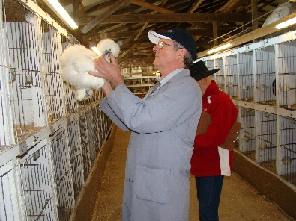
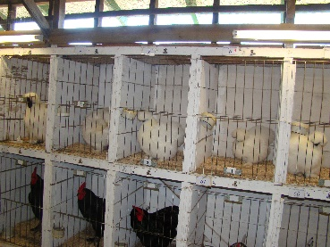

Picture of the old cages

