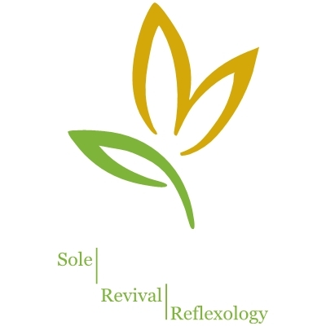
Sheri Price, NBCR
425 443 1609
Sherip67@gmail.com

Sole Revival Reflexology
Client Intake form

Date______________________
Name___________________________________________________ Birth Date__________________ Age______
Address_________________________________________________ Phone________________________________
City, State, Zip______________________________________________________
Email Address_________________________________________________________
• Have you had reflexology before? Yes / No • How did you hear about me? _________________________
• What is your primary goal for today’s session?______________________________________________________
• How would you rate the present state of your health? Please circle: Excellent Good Fair Poor
• Are you currently under a doctor’s care? If so, please explain___________________________________________
______________________________________________________________________________________________
• For women, are you pregnant? Yes / No If yes, how long?_____________________________________________
• Please list any major illnesses, broken bones, surgeries, hospitalizations and your age when they occurred: ______________________________________________________________________________________________
______________________________________________________________________________________________
• List any medications or herbs you are taking_________________________________________________________
______________________________________________________________________________________________
• List other therapies (besides conventional medicine) you are currently receiving_____________________________
______________________________________________________________________________________________
• Where is the tension most evident in your body (i.e. neck, shoulders, stomach)?_____________________________
• Circle any that apply today: Fever Infection Cold/flu Inflammation Pain (where?________________________)
• Circle any that apply today: Are you experiencing any problems with your feet? Yes / No • Right / Left / Both
Plantar fasciitis Neuroma Gout Plantar warts Athlete's foot Bone spur Bunion Toenail fungus
Other (please describe) ___________________________________________________________________________
• What size shoe do you wear? ___________ • Shoe style worn most often?___________________________
• Please mark “C” next to all current or chronic issues and mark a “P” next to those you’ve had in the past:
Heart problems Bladder ailments Chronic pain Respiratory issues Joint disorders
Blood pressure Constipation Neck injury Asthma Arthritis
Embolism Ulcerated colon Spinal injury Allergies/hay fever Bursitis/tendonitis
Thrombosis Irritable bowel Sciatica Sinusitis TMJ
Phlebitis Hemorrhoids Lumbago Skin disorders Drug dependence
Varicose veins Menstrual issues Osteoporosis Eczema Alcohol dependence
Diabetes Ovarian issues Migraines/headaches Psoriasis Caffeine dependence
Kidney ailments Prostate issues Eye strain/ailments Thyroid disorders Nicotine dependence Other______________________________________________________________________________________
The above information is accurate and true to the best of my knowledge. I understand that no diagnosis is implied or offered. I agree to give 24 hours notice if I must cancel an appointment, and understand that I will be charged the session price without such notice.
Signed_____________________________________________ Date________________
Foot Measurement
Right: Left: TH_____ TH_____ BH_____ BH_____
W_____ W_____

Disclaimer
To the Clients of Sheri Price, NBCR:

You need to know that:
- I am not a medical doctor.
- I do not practice medicine.
- I do not diagnose or treat for a specific illness.
- I do not prescribe or adjust medication.
- Reflexology is not a substitute for medical treatment, but is a complement to most types of therapy.

What is reflexology?
Reflexology is based on the premise that there are reflex points and areas in the feet, hands and ears which correspond to all body parts and systems. The physical act of applying specific pressure using thumb, finger and hand techniques results in stress reduction which causes physiological changes in the body. A primary benefit of reflexology is relaxation, which may help the body to balance any kind of stress it is experiencing.

What does reflexology do?
- Reflexology promotes balance and normalization of the body naturally;
- Reflexology reduces stress and brings about relaxation;
- Reflexology improves circulation and the delivery of oxygen and nutrients to cells.
During sessions some clients like to talk and others prefer to be meditative. Both are welcomed. I believe when people talk about their burdens there can be release and insights. The body always remembers and energy work can be freeing. A relaxed space aids in a therapeutic release. The choice is always yours.

By signing this form, I give my consent to receive reflexology sessions. I understand that I may discontinue a session at any time. If I have been diagnosed by a licensed health professional as having any disease, injury, or other physical or mental condition, I understand that I should inform the person who made the diagnosis about the reflexology sessions I will be receiving, and whether or not I intend to discontinue any treatment or therapy which has been previously ordered, prescribed or recommended by a licensed health care professional. I understand that by discontinuing any such treatment or therapy, I assume responsibility for any negative outcome resulting from discontinuing that treatment or therapy.

Signature_________________________________________________ Date______________

Print Name___________________________________________________________________

