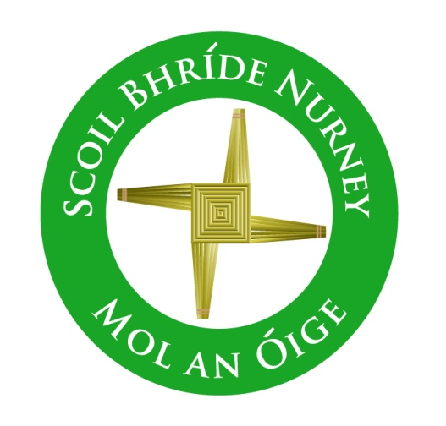
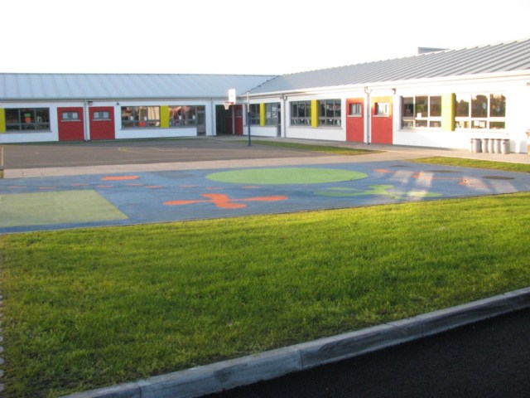
Scoil Bhríde
Handwriting Policy
2020+

Board of Management Scoil Bhríde Nurney
2020+

Handwriting Policy

Introductory Statement & Rationale:
This policy is formulated in line with the Primary Language Curriculum and it will be implemented with immediate effect.
In Scoil Bhríde Nurney we acknowledge that the developments of handwriting skills are important in our pupils’ education. We support the current research, which outlines the benefits of teaching cursive handwriting. These include that it:
- Prevents reversals and confusion of letters
- Enhances spelling ability
- Diminishes potential for errors
- Enforces the skills for patterns in reading and writing
- Prevents erratic spaces between letters and words
- Helps left-handed children
- Is quicker and easier to use than print.

Relationship to School Ethos:
Scoil Bhríde is committed to the full and rounded education of each child and the effective delivery of the Primary Curriculum. This includes fostering the child's capacity to question and enquiry critically about their world.

Aims of the Handwriting Policy:
- To develop and improve fine motor skills in the early years
- To ensure good letter formation from Junior Infants to Sixth Class
- To encourage that all children are using the correct pencil grip
- To ensure legibility and neat presentation of all written work
- To help develop speed, accuracy and writing fluency
- To ensure uniformity and consistency in letter formation from class to class
- To provide children with a relevant life skill
- To help in the improvement of spelling.

General Writing Guidelines:
Children will be encouraged to remember the Four P’s- Preparation, Pencil Grip, Posture and Practice.

All classrooms should have a continuous cursive handwriting frieze displayed in their room. All classrooms should have a Literacy/Numeracy presentation sample displayed in their room.

All children should hold the pen or pencil at least 2 cm away from the tip so that they can see what they are writing. For left-handers, writing from left to right can be difficult. It is important that the class teacher ensures that the child is seated on the left side of the desk.

Triangular grip pencils are to be used in the infant classes.
Regular grip pencils are to be used in 1st – 4th class.
Pens are to be used in 5th – 6th class.
In all classes, pencil must be used to complete all Maths activities.

Teachers should model good hand writing at all times.

Handwriting Programme:
Scoil Bhríde Nurney has adopted the EDCO Handwriting scheme “Ready to Write” as follows:

Junior Infants
- Develop muscle control through strong hand activities and fine motor skill activities e.g. threading, clothes peg games, playdough, tearing, cutting and a range of other activities
- Encourage to scribble and draw with crayon.

- Complete various prewriting patterns to strengthen fingers and hands. These patterns will also create awareness of left-right, top bottom orientation.
- Encourage to find a pencil grip that is comfortable and allows good writing.

- Introduced to pre-cursive writing. They learn the letter name and formation in tandem. Learning letter formation involves:
- Learning the rhyme, exploring, watching and practising the pre-cursive script on whiteboards
- Rehearsing the rhyme; tracing and independently forming the script. Relevant rhymes for the letter formation are used. A number of other techniques are used, such as finger tracing on the table, in the air or in sand.

Junior Infants start by using chubby crayons. They progress onto the chublets (skinny crayons) during the year depending on readiness. The children will write with triangular grip pencils.

Children in Junior Infants should begin handwriting lessons with warm up exercises.

Teachers model good handwriting for the children in daily activities.

Senior Infants
- Children revise the formation of the lower-case letters and they are introduced to the correct letter formation of upper-case letters.
- Children are made aware of the importance of putting a finger space between all words and are expected to keep all writing on the line.
- By the end of Senior Infants, children are expected to be able to write using capital letters where appropriate in the style outlined above, using correct letter formation.
- Children are encouraged to engage in free writing.

First Class
- Consolidation and reinforcement of Senior Infant work.
- There is a greater emphasis on proper letter formation, pencil grip, writing posture and on the quality of presentation.
- Children are expected to be able to use capital letters and full stops when writing.
- Teachers may use handwriting copies or software to create further worksheets to enable further practice of the letter formations and the joins.

Second Class to Fourth Class
- In Second/Third/Fourth Class the children continue using pencils.
- In Third Class the children are introduced to using red pen when underlining, correcting or ruling their work.
- Pupils may use their handwriting copies to practise their handwriting.
- All children should be using cursive script from 3rd class (although depending on the teachers discretion and professional judgement it may be introduced at the end of 2nd class if deemed suitable and appropriate)
- Pupils will write titles and dates at the top of the page.

Fifth and Sixth Class
- Consolidation and reinforcement of handwriting skills.
- In Fifth Class, children are allowed use a pen for writing exercises.
- By Fifth & Sixth Class the children will have been introduced to using pen. Children must continue to complete Maths activities in pencil.

Copies for Literacy and Numeracy

Class | Literacy | Numeracy
6th | Normal lined | Small square
5th | Normal lined | Small square
4th | Normal lined | Small square
3rd | Normal lined | Small square
2nd | Normal lined | 1cm sq.
1st | Thick lined (15mm J09) moving to Normal lined | 1cm sq.
Senior infants | - Project copies 15A  - Thick lined (15mm J09) | 20mm square
Junior infants | - Blue project copies (preformed)  - Plain project copies (no lines) | Maths folder

Children with Special Needs
This handwriting policy aims to meet the needs of all the children in the school. This will be achieved by teachers differentiating the content, outcome and process to ensure learning for all pupils. The requirements of children with special needs will be taken into account when planning class lessons and related activities.

Pencil Grip
The pencil is grasped between the tips of the thumb and the index finger and is supported against the side of the middle finger (tripod grip). The last two fingers are curved and rested against the table surfaces. The wrist is bent back slightly and the pencil is held about 2cm’’ from the tip (slightly more for left-handed children). The ‘counter held in the palm of the hand whilst writing’ technique can be used.

Assessment and Success Criteria
- There will be constant teacher observation of pupils’ handwriting in copy books at school and also in homework copies.
- There will be a focus on continual improvement.
- Teacher should display the children’s writing – emphasis should be placed on improvement made in handwriting. Children should be encouraged to write final pieces of work in their best handwriting.
- The end of year handwriting should be compared with the handwriting the child was producing at the beginning of the year, for assessment purposes and for possible School Report comment.

Resources
- Ready to Write (cursive) EDCO
- EDCO online handwriting resources
- Jolly Phonics (reading alphabet)
- Sounds in Action (Folens)
- Jolly Phonics software
- Sounds like Phonics (Fallons)
- Cursive Handwriting Alphabet Wall Frieze
- Handwriting copies
- Triangular pencils, regular pencils and pens
- Presentation Wall Frieze for Literacy and Numeracy (in every class, in the same place/position if possible)

THE FOLLOWING APPENDICES MAY ALSO BE OF SOME USE AND ARE ONLY SUGGESTED RESOURCES

Appendix 1

Letter formation of Lower-Case Letters
- Some letters should be made in one movement- without lifting the pencil from the page – c,o,a,d,g,r,n,m,h,b,p,u,y,v,w,l,k,s,z,e, while others require two movements of the pencil – i,j,t,x.

Cursive Script Upper Case Letters
- The capital letters are slightly different. They need plenty of practice.
- Some capital letters have a join loop while others don’t.

Appendix 2

Useful letter Formation Rhymes (INFANTS TO FIRST CLASS)
- GIRAFFE letters are tall and reach the top line: h l t b d
- MONKEY letters have a tail that hangs under the line: g j p q y
- TURTLE letters are small and crawl along the ground: a c e n s o

Letter Formation Rhyme
a  a is a small letter | Start near the top, go up and around like a ‘c’ shape, go back up and down again. Finish with a kick.
b  b is a tall shape  d  d is a tall letter  e  e is a small letter  f  f is a different letter  g  g is a low letter  h  h is a tall letter  i  i is a small letter  j  j is a low letter  k  k is a tall letter  l  l is tall letter  m  m is a small letter  n  n is a small letter  o  o is a small letter  p  p is a low letter  q  q is a low letter  qu  qu ‘ is a low letter and a small letter  r  r is a small letter  s  s is a small letter  t  t is a different letter  u  u is a small letter  v  v is a small letter  w  w is a small letter  x  x is a small letter  y  y is a low letter  z  z is a small letter  ng  ng is a small letter and a low letter.  ai  ai are small letters and are joined together.  When two vowels go walking the first does the talking.  ar  ar are small letters and are joined together.  ee  ee are small letters  When two vowels go walking the first does the talking.  er  er are small letters  ie  ie are small letters  When two vowels go walking the first does the talking.  oa  oa are small letters  When two vowels go walking the first does the talking.  oi  oi are small letters  oo  oo are small letters  or  or are small letters  ou  ou are small letters  ue  ue is a small letter  When two vowels go walking the first does the talking.  ch  ch is a small and tall letter  Tall letters are joined about halfway up, not at the top or not at the bottom.  sh  sh is a small and tall letter  Tall letters are joined about halfway up, not at the top or not at the bottom.  th  th is a different letter and a tall letter.  Remember all tall letters join about halfway.  ng  ng is a small letter and a low letter. | Start at the top, go down, back up to half way, then out and around  Start like a, go up and around, up to the top, then back down. Finish with a kick.  Straight line out from the middle and go around like a ‘c’ in one motion.  Start a little to the right near the top and go around and down, finish with a curly tail. Lift your pencil and do a stroke across your letter.  Start like a ‘c’ go up and around, up and back down below the line and finish with a curly tail  Start at the top, go all the way down and back up to half way, out, around and down.  Finish with a kick.  Start at the top, go all the way down to the line. Finish with a kick. Lift the pencil to put the dot on.  Start at the top and continue down and finish with a curly tail. Lift the pencil to put a dot on.  Start at the top, go down, back up to half way, go out, around and in, then back out.  Finish with a kick.  Start at the top and go all the way down.  Finish with a kick.  Start at the top, go down, back up, out and around. Then go down, back up, out and around and back down. Finish with a kick.  Start at the top go all the way down to the  line, come back up, go out, around and down.  Finish with a kick.  Start a little from the top and go around until you meet the place you started.  Start at the top, go down, back up, out and around.  Start at the top, go up and around like a ‘c’ shape, go up and down under the line. Finish with a kick.  q is always followed by u. The letter q borrows the sounds K and W.  Start at the top, go up and around like a ‘c’shape, go up and down under the line and kick. Continue the kick to the top of the u.Then go down, around and back up and down again, finish with a kick.  Start at the top, go all the way down to the line, go back up, out and around.  Start near the top, go up around, and around again.  Start near the top and continue to the end and finish with a curly tail. Lift the pencil to cross the t.  Start at the top and go down, around and back up and down again, finish with a kick.  Start at the top and go down diagonally and then back up.  Start at the top and go down and up, down and up diagonally.  Start at the top and go down diagonally. Lift your pencil and start at the top and go down again diagonally.  Start at the top and go down, around and back up and down under the line. Finish with a curly tail.  Start at the top, go straight across, down diagonally and then straight across the line.  Start at the top go all the way down to the line, come back up, go out, around, down and kick. Continue the kick to the start of the g then go up and around, up and back down below the line and finish with a curly tail.  Start at the top, go up and around like a ‘c’  shape, go back up, down again and kick.  Continue the kick to the top of the i then go  all the way down to the line. Finish with a  kick. Lift the pencil to put the dot on.  Start at the top, go up and around like a ‘c’  shape, go back up, down again and kick.  Continue the kick to the top of the r then go  all the way down to the line, go back up, out  and around.  Straight line out from the middle and go around like a ‘c’ in one motion. Continue the kick to the middle of the next e and go around like a ‘c’ in one motion  Straight line out from the middle and go around like a ‘c’ in one motion. Continue the kick to the top of the r then go all the way down to the line, go back up, out and around.  Start at the top, go all the way down to the line and kick. Continue the kick to the middle of the ‘e’ then make a straight line out from the middle and go around like a ‘c’ in one motion. Lift the pencil to put the dot on the i.  Start a little from the top and go up and around until you meet the place you started.  Continue straight across to the top of the ‘a’ then go around like a ‘c’ shape, go back up and down again. Finish with a kick.  Start a little from the top and go up and around until you meet the place you started. Continue straight across to the top of the ‘i’ then go all the way down to the line and finish with a kick.  Start a little from the top and go up and around until you meet the place you started. Continue straight across to the top of the ‘o’ and go around until you meet the place you started.  Start a little from the top and go up and around until you meet the place you started.  Continue straight across to the top of the ‘r’  then go all the way down to the line, go back  up, out and around.  Start a little from the top and go up and around until you meet the place you started.  Continue straight across to the top of the ‘u’  then go down, around and back up and down again, finish with a kick.  Start at the top and go down, around and back up and down again and kick. Continue the kick to the middle of the ‘e’ then make a straight line out from the middle and go around like a ‘c’ in one motion  Start near the top and go up and around in one movement. Continue the movement to halfway up on the ‘h’. Go up to the top then  go all the way down and back up to half way, out, around and down. Finish with a kick.  Start near the top, go up around, and around again, kick forward to halfway up the ‘h’. Go up to the top then go all the way down and back up to half way, out, around and down.  Finish with a kick.  Start near the top and continue to the end and finish with a curly tail. Continue curly tail to halfway up the ‘h’. Go up to the top then go all the way down and back up to half way, out, around and down. Finish with a kick. Lift the pencil to cross the t.  Start at the top go all the way down to the line, come back up, go out, around, down and kick. Continue the kick to the start of the g then go up and around, up and back down below the line and finish with a curly tail

Appendix 3
Capital Letter Formation (Infants to First Class)

A | Start at the top, go down diagonally to the bottom line.  Lift and go down diagonally and finish with a line across the middle.
B | Start at the top. Go straight down and lift. Jump back up to the top around and around again
C | Start near the top and go up and around in one movement
D | Start at the top. Go straight down and lift. Jump back up to the top and around.
E | Start at the top, go down, lift and do three short lines at the top, middle and bottom.
F | Start at the top. Go straight down and lift. Jump back up to the top and do 2 short lines at top and middle.
G | Start near the top and go up and around in one movement, lift and finish with a straight line over the end point.
H | Start at the top go down lift and draw another line parrel. Finish by drawing a line across the two lines to join then halfway.
I | Start at the top. Go straight down and lift. Jump back up to the top.
J | Start at the top. Go straight down and lift. Jump back up to the top and finish with a short line across the top.
K | Start at the top. Go straight down, go up diagonally from the halfway mark and finish by going down diagonally to the bottom line.
L | Start at the top, go down to the end of the line and finish by continuing on the line.
M | Start at the top. Go straight down, lift and jump back up, down diagonally, back up diagonally and finish by going down to the line.
N | Start at the top. Go straight down, lift and jump back up, down diagonally and finish by going up to the line.
O | Start at the top. Go around until you meet the place you started.
P | Start at the top. Go straight down and lift. Jump back up to the top. Go out and around.
Q | Start at the top. Go around until you meet the place you started. Lift, finish with a dash.
R | Start at the top. Go straight down and lift. Jump back up to the top.Go out and around, finish by going down diagonally to the bottom line.
S | Start near the top, go up around, and around again.
T | Start at the top. Go straight down and lift. Jump back up to the top and finish with a straight line across the top.
u | Start at the top and go down, around and back up and down again, finish with a tail
V | Start at the top and go down diagonally and then back up
W | Start at the top and go down and up, down and up diagonally.
X | Start at the top and go down diagonally. Lift your pencil and start at the top and go down again diagonally.
Y | Start at the top, go down diagonally to halfway, lift and go down diagonally to the bottom line.
Z | Start at the top, go straight across, down diagonally and then straight across the line

Appendix 4
Cursive Script Letter Formation Guide 2nd to 6th Class

Cursive Script Lower Case Letters
Small Letters:

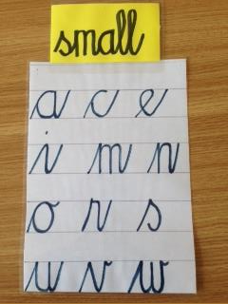

- When children are learning to write in cursive style they should try to get the size, slope and the join correct. They should not lift the pencil.
- All of these small letters start on the line, then each begins with an upstroke and these letters finish with an upward stroke to the top of the next letter. The letters “o, v and w” finish with a curve to the top to the next letter. The join is a shallow horizontal curve. It must be the right length to keep the space between the letters the same.
- When “e” follows a letter which finishes in an up-stroke, the up stroke is continued up and around to form the e.
- When “s” is the last letter of a word, it does not need the upstroke.

- “r” begins like “s” with an upstroke that goes a little bit above the top blue line.

Low letters:

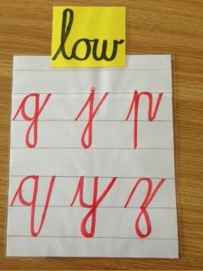

- All of these low letters start on the line, each begins with an upstroke to the top of the letter and then go beneath the line. “P” and “q” are not looped while all the others are looped. The loop crosses on the bottom line and this continues to the finish which is an upward stroke to the top of the next letter.

Tall Letters:
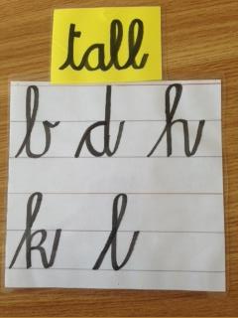

- All of these tall letters start on the line, each begins with an upstroke to the top of the letter.
The loop join comes half way up the length of the letter. Each letter ends with an upward stroke to the top of the next letter.

Different Letters:

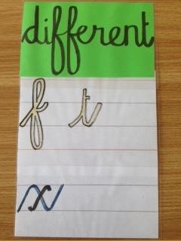
- All of these tall letters start on the on the line, “f and t” begin with an upstroke to the top of the letter – “t” does not go to the top of the line.
- In “f” the loop join comes half way up the length of the letter. The line continues
- down to half way to the line beneath it. Then the line loops back up to the first loop. The “f” finishes with a curved line to the next letter
- In “t” the letter begins with an upward stroke to the top of the “t” and finishes with
- an upstroke to the top of the next letter. Remember to cross the “t” when you finish the word.
- The letter “x” begins with an upstroke, then a diagonal stroke down to the
- baseline, and then another upstroke. To finish the letter, lift your pencil and draw a
- backward cross through the middle of the diagonal stroke.

Appendix 5
Cursive Script Upper Case Letters

- The capital letters are slightly different. They need plenty of practice.
- Some capital letters have a join loop while others don’t.

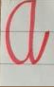 | This letter is formed like the lowercase letter and it finished with an upstroke.
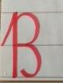 | B is formed differently to the lower case letter. B begin with an upstroke. This letter does not join to other letters.
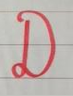 | C is like the lowercase letter.  D is formed differently to the lowercase letters. D does not join with other letters.
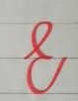 | E is formed differently to the lowercase letter. E begins with an upstroke from the mid line to form a loop and finishes with an upstroke at the top the next letter or mid-way between lines.
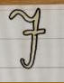 | F is formed differently to the lowercase letter. Lift your pencil to cross the f after you have finished the letter. F does not join with other letters.
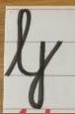 | G is formed differently to the lowercase letter. Capitals G begins with an upstroke and finishes with a joining stroke. G forms a loop at the bottom line and finsihes with an upstroke at the top line.
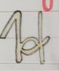 | H is formed differently to the lowercase letter. When writing the H you will need to lift your pencil.  I is formed differently to the lowercase letter. The Capital letter I does not join to other letters.
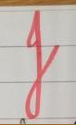 | J is formed differently to the lowercase letter. The Capital letter J join to other letters.
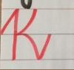 | K is formed differently to the lowercase letter. The Capital K begins with an upstroke and finishes with a joining stroke. You must lift your pencil when forming K.
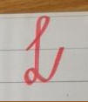  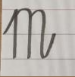 | L is formed differently to the lowercase letter.L begins with an upstroke from the bottom line to form a loop. L forms a small loop at the bottom line and finishes with an upstroke at the top of the next letter.  M is formed like the lowercase letters. It starts with an upstroke. The M begin with an upstroke and finish with a joining stroke.
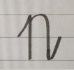 | N is formed like the lowercase letters. It starts with an upstroke. The N begins with an upstroke and finishes with a joining stroke.
O is formed like the lowercase letters.
The Capital letter O does not join to other letters.

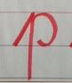 | P is formed differently to the lowercase letter. The Capital P begins with an upstroke and finishes with a joining stroke.
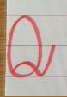  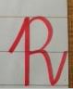 | Q is formed differently to the lowercase letter. Form an O and then at the start point draw a curved line up and around to outside the Q and finish with a kick to the next letter.  R is formed differently to the lowercase letter.Start with a stroke up tp the top of the letter. Go down and up, go around to helfway and go around and down finishing with a kick to the next letter.
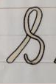 | S does not join to other letters. The S  starts with an upstroke to the top of the S.
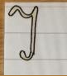 | T is different to the lowercase letter. T does not join to other letters.
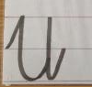 | U is formed like the lowercase letter. Some start with an upstroke and finish with a joining stroke to the next letter.
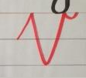  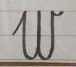 | V is formed like the lowercase letters. V begins with an upstroke and end with a little curve at the top line. V does not form joins to other letters.  W begins with an upstroke and ends with a little curve at the top line. It does not join to other letters.
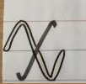 | X is formed like the lowercase letter. Some start with an upstroke. X finishes with a joining stroke. You must lift your pencil when forming X and K.
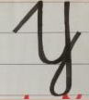 | Y is formed like the lowercase letter. Some start with an upstroke. Y starts with an upstroke and finishes with a joining stroke.
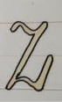 | Z is formed like the lowercase letter and Z ends with an upstroke.

Appendix 6
10 Benefits of Teaching Cursive Handwriting

- Relative ease in introducing cursive penmanship to preschoolers.
Contrary to common beliefs. It is very easy to teach cursive handwriting. It only requires 3 movements; undercurve, over curve and up and down. Print handwriting necessitates and even more complex stroke of straight lines and perfect circles.
- Prevents reversals and confusion of letters
The letters “b and d”, “f and t”, “g, q and p” are confusing for young children. In cursive, writing the letter “b and d” require a huge difference in directionality.
- Enhances spelling ability
In cursive, children learn to spell correctly since hand movements create some muscle memory that retains the spelling patterns.
- Develops Internal control systems that can be used as tool for learning
In cursive writing, the incorporation of movement, pressure and visual processing is a bit multifaceted. These augment visual special and coordination skills. In writing lowercase letters in print, six strokes are required against three movements in cursive writing. Fluent movement is developed. With cursive writing practice, the neuron connections in the brain, responsible for organizing other kinds of information and skills, are greatly strengthened.
- Potential for errors are diminished
Cursive handwriting reduces errors because of the continuous flow of writing. In print, the child picks up the pencil from the paper to start a new letter in a word, thus the potential for mistakes is higher.
- Improved reading skills
The goal is reading is to read words instead of letters at a time. Cursive writing promotes reading words, instead of a distinct letter. After words, reading will move to sentences. Thus, remedial support for comprehension and reading of words occur less often. The child reads what he or she writes as “whole words” rather than an individual letter.
- Enforces the skills for patterns in reading and writing
Unlike print writing, lower case cursive writing starts from the same beginning point. In print, various letter start form the top, down, middle and many different positions. Letter inversions and reversals are eliminated.
- Prevents erratic spaces between letters and words
In cursive, the flow of writing moves from left to right. It teaches spatial discipline. In print, the child’s handwritings are difficult to discern. The spaces between words are so tight. It is hard to tell where the words begin and end.
- Helps left-handed Children
In print, the left-handed child proceeds to write printing from left to right but will cover what he has written with is arms. This is called the hook position. In cursive writing, the left-handed child learns to write from bottom up and turns the paper clockwise causing great comfort and legibility.
- Use as a tool to put thoughts on paper quickly and easily
Mastery of cursive will be to the advantage of any student in the long-run. The child will be able to write faster.

Appendix 7
Number Formation Guide

Number Formation

1 | Start at the top and go straight down
2 | Start at the top, around, down diagonally to a point and straight across.
3 | Start at the top and go around anti- clockwise to half way then go around again to the finish.
4 | Start at the top, go straight down and straight out. Lift your pencil and cross it.
5 | Start at the top, go down and out and around to make a ‘belly’, then lift your pencil to put a hat on it.
6 | Start at the top, go down in a curve and back up and around.
7 | Start at the top, go straight across and then down diagonally.
8 | Start at the top like an “S” and then go back up and around.

Appendix 8

Number Formation Rhymes

The following number formation rhymes are used in Junior and Senior Infants to help teach the children number formation:

1. Number 1 is like a stick, a straight line down, that’s very quick!
2. Number 2 go right around, then make a line across the ground!
3. Number 3 go right around, what will it be? Go around again to make a 3!
4. Down and over and down some more, that’s the way to make a 4!
5. Go down and around and then you stop, finish the 5 with a line on top!
6. Make a curve and then a loop, you’ve made a 6, so join the troop!
7. Across the sky and down from heaven, that’s the way to make a 7!
8. Make an “S” and then don’t wait, climb up again to make an 8!
9. Make a loop and then a line, that’s the way to make a 9!
10. Make a 1 and then an 0, 10 are all your fingers you know!

Appendix 9

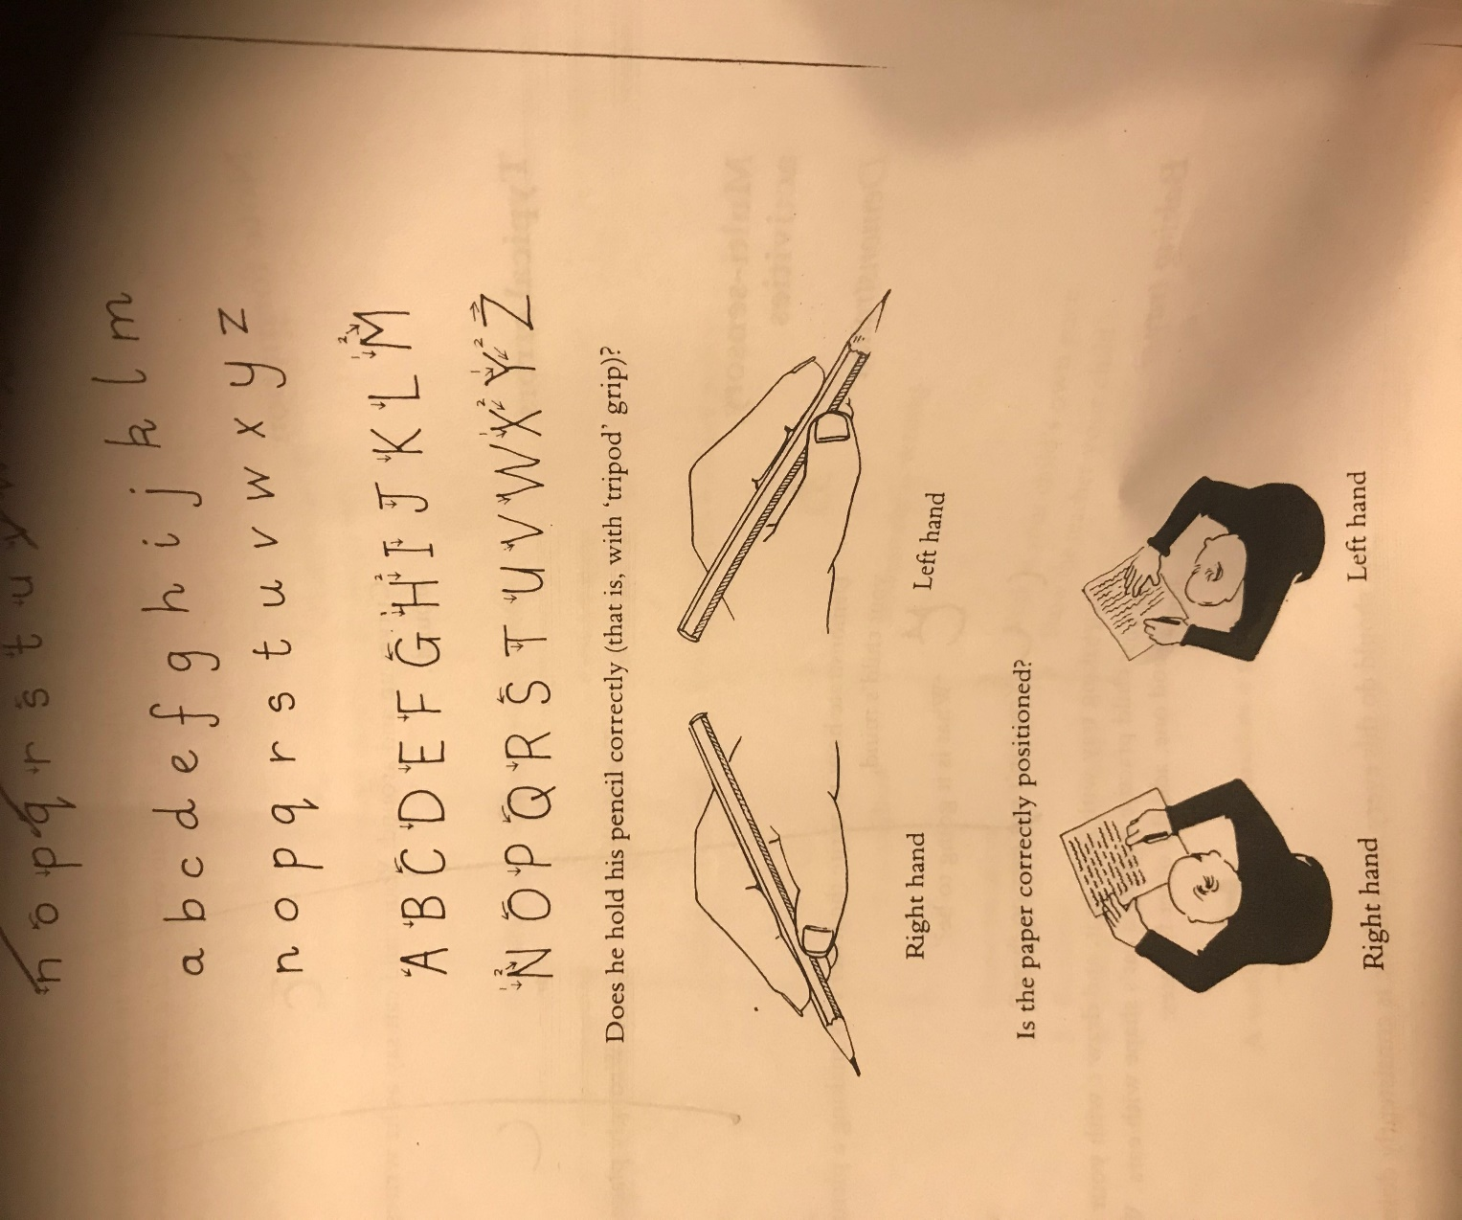

Ratification of Handwriting Policy

This policy was adopted by the Board of Management on _________________

Signed: _________________________ Signed: __________________________
Chairperson of Board of Management Principal

Date: __________________________ Date: __________________________

Date of next review: __________________

