Loan Officer Disclosure Cash to Close Check 08/1/2022
- First click on the cash to close button at the bottom of the LE Fees Tab
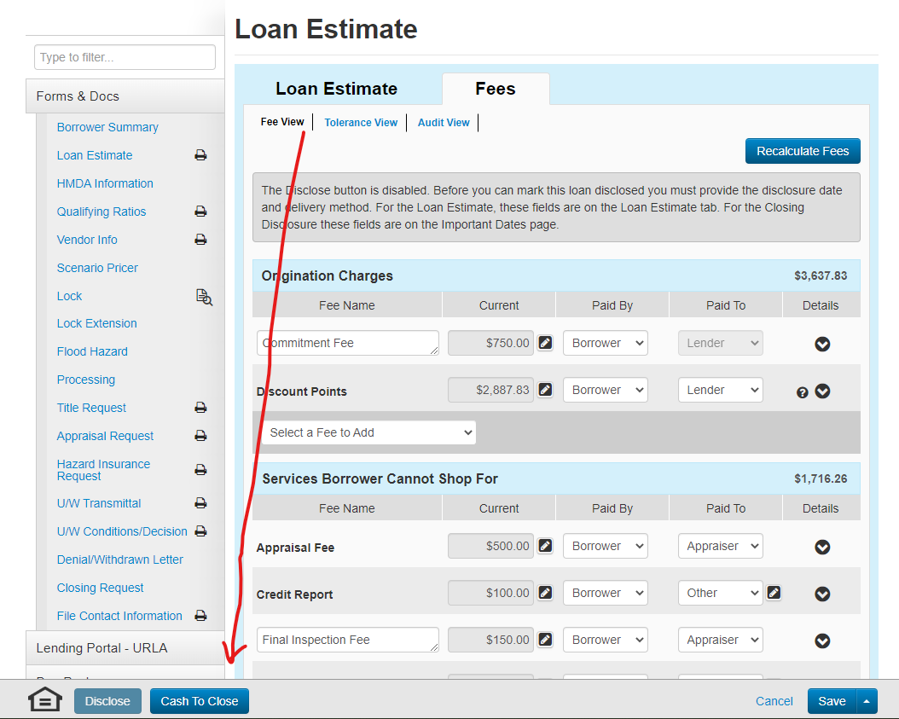

SEE NEXT PAGE

- Next Click on the Adobe version of the LE.
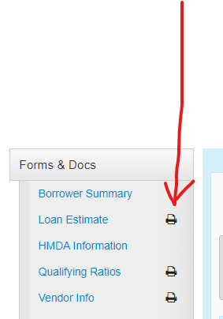

SEE NEXT PAGE

- Compare LE Cash to Close Vs. MBOT Fees Tab. If this does not match email compliancecondtions@flanaganstatebank.com for further help.

