Prostate Cancer
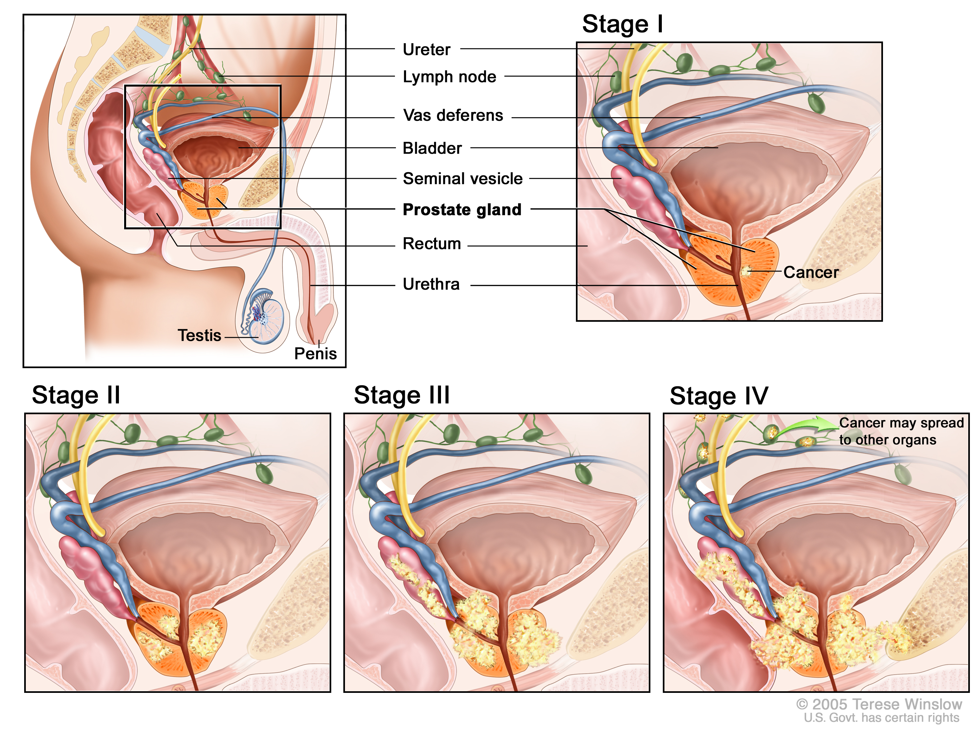

What is Prostate Cancer? It is a malignancy where the cells multiply and spread

Four Main Causes of Prostate Cancer:
- Lack of Detoxification
- Malnutrition (especially antioxidant vitamins)
- Heated Oil consumption (trans fatty acids)
- Hormonal Imbalance

How does a Cancer Cell Develop?
A cancer cell develops when the chromosomes of a normal cell have been altered by “carcinogens”. Lack of detoxification allows inappropriate substances to remain in the cellular tissue and the cell stores more toxins than it can safely hold. This sets up a vicious cycle:
- The accumulation of toxins reduces the cell’s ability to detoxify, causing “intoxication”.
- Intoxication causes cellular irritation, interference with cellular function, and premature degeneration of the cellular tissue.
- This leads to damaged cellular DNA, which results in the abnormal growth and multiplication of the cell, that we know as “cancer”.

Other Causes of Cancer are:
  - Weak immune system
  - Allergies
  - Environmental toxins
  - Stress
  - Faulty Digestive System
  - Hormonal Imbalance
  - Trans Fatty Acid consumption
  - Parasites
  - Genetics (but genetics do not have to express themselves unless the cellular environment becomes weakened)

CANCER is a major “Red Flag”. Cancer will occur in the weakest area of the body. It tells you that your own immune system (your internal police force) could not do its job. Traditional medical treatment involves surgery, chemo or radiation (cut out, burn, or poison the area affected by cancer). However, this DOES NOT address the root cause …
- What caused caner to develop in the first place? …..
- Why was your own immune system TOO WEAK to defend itself?
If you choose to do one of the recommended traditional treatments, DO NOT presume that now the cancer is gone and I can just move ahead in life. You have not addressed root causes …… where do you want the “Red Flag” to show up next? Take this wake-up call seriously and implement the “Optimal Health” recommendations in Appendix I.

Optimal Health
Optimal Health is a result of addressing THREE areas of wellness:
- Functional Wellness; 2. Dietary Wellness; 3. Lifestyle Wellness
(See details in Appendix I, attached.)

Disease Principles:
There are NO guarantees against disease. However, there are HEALTH PRINCIPLES:
- We reap what we sow …. if we ignore our health, it will go away. Your health is your responsibility …. PRAY and DO what is wise!
- Poor nutrition gives you a poor immune system AND Optimal nutrition gives you the very best chance for an optimal immune response.
- The body has the innate wisdom to heal itself. It just must have what it needs to do so.
- Optimum nutrition is ESSENTIAL for recovery from any disease …. After chronic degenerative disease has progressed, even the best therapy will FAIL if optimized nutrition is NOT met!
- It takes 6 to 7 times the normal amount of nutrition to rebuild and repair than to simply maintain health. Acknowledge the importance of TIME! Nothing (but a miracle from God) heals the human body in less than three months …. Then add on one month for every year of illness.
Disappointment is usually experienced if ALL of these four principles are NOT taken seriously. You NEVER kill a monster with a pellet gun …. you bring in the big guns!
The likelihood of the body repairing and healing itself will usually only happen if aggressive, therapeutic measures are consistently followed in order to
- bring the body back to balance, and
- strengthen the body’s defense system

Your Food is Your Fuel
Get serious about your health. Your food is your fuel …. choose it wisely as if your life depended on it ….. for it does!!!! Follow the Healthy Body Diet listed in Appendix III

Hormonal Fluctuations:
Men go through male menopause (a shift in hormones) just like women go through female menopause. However, with men it is a silent process and therefore it can be ignored or misunderstood. Appendix IV shows a chart that demonstrates what causes the enlargement of the prostate in an aging man. It explains why some of the nutrients described are essential to prevent Benign Prostate Hyperplasia which is a VERY common malady with men. These nutrients are essential for PROSTATE WELLNESS, regardless of whether the cells are benign or have become cancerous.

Recommended Reading & Learning: (call 905-871-4281)
- Ask us for a small booklet called “Prostate Health” by Dr. Bruce Miller …. It is very informative and information EVERY man should know
- Ask to borrow a video called “Prostate Wellness” by Dr. Richard Brouse

Appendix I

Optimal Health
is a result of addressing ALL areas of Wellness,
starting with “Functional Wellness”

- Functional Wellness:
  - Bowel Frequency: Bulk-in should equal Bulk-out. Also, it is recommended that EVERYONE alive use a Bowel Conditioner to nourish the mucosal lining of the bowel. (This dramatically reduces the risk of bowel cancer caused by the high level of environmental pollutants we are exposed to.)

  - Bowel Microflora: An adult should maintain 3 to 5 pounds of “friendly bacteria” in the bowels at all times. (This is impossible to accomplish in an environmentally polluted world without supplementation of intestinal microflora.)

  - Liver Detoxification: The liver filters the blood, and it must be maintained just like any filter (eg: car oil filter, furnace filter). In order to accomplish this it is recommended to:
    - Use a Liver Detoxifier herbal formula (DTX) on a DAILY basis.
    - Do two liver cleanses a year, one in the spring and one in the fall.

  - Parasites: Do a parasite cleanse once a year.

  - Digestive System: If a person experiences a lot of burp, belch, bloat symptoms, the digestive system must be assisted in order to prevent malabsorption of nutrients.

  - Hormonal Balance: Saliva testing should be done annually to monitor hormonal imbalances. Some hormones feed cancer cells like putting gasoline on a fire.

  - Blood Flow: The blood carries nutrients, hormones, oxygen, etc., plus it carries the waste away from the cells. It is really the smorgasbord table of the body. It is essential to provide excellent blood flow to remain healthy.

- Dietary Wellness:
  - Diet (Eat according to the Healthy Body Diet – Appendix III)
    - 50% of your diet should be raw foods
    - Eat foods as close to nature as possible (avoid processed foods)
    - Ensure adequate protein: (3/4 gm of protein per pound of body weight daily).
      - One serving of raw soy powder is recommended in everyone’s diet daily, due to its anti-cancer properties.
      - Quality whey protein contains an amino acid CYSTEINE which is known for its role in enhancing the production of glutathione, a powerful antioxidant, immune booster and detoxifier.
    - Avoid foods you are allergic to
    - Avoid heated plant oils (roasted nuts/seeds, roasted soy beans, margarine, deep fried foods)

  - Water: Drink purified water (reverse osmosis is best) – ½ ounce per pound of water daily.

  - Fibre: Make sure you get adequate fibre daily from both groups:
    - Insoluble – bran, etc. (provides bulk and absorbs toxins and removes in waste)
    - Soluble – oat bran, apples, cabbage, etc. (provides bulk and absorbs cholesterol and blood fats and removes in waste)

  - Supplements: Some people believe if they eat a well-balanced diet they don’t need supplements. This is a myth in this day and age.
    - To begin with, many people do not eat a well balanced diet EVERY day, 365 days of the year.
    - According to agricultural reports, due to devitalized soils, our food contains about 1/8 of the nutrients it contained at the turn of the century.

  - Antioxidants: Due to the high levels of environmental pollutants, we require more antioxidant vitamins (the protectors) than our grandparents ever did, so supplementing with higher levels of Vitamin C, Vitamin E, and CarotoMax (Carotonoid Complex) is recommended

- Lifestyle Wellness:
  - Rest: We must get adequate rest to enable the body to repair the wear and tear and stresses of the day. No lifestyle factors such as a good diet, supplements, or exercise can replace rest. It is ESSENTIAL for emotional and physical wellness.

  - Exercise: Exercise is vital to every system of the body, in particular: the immune system, the circulatory system and the structural system.
    - The Immune System: It forces the lymph fluid in the lymphatics. It produces hormones called beta endorphins which stimulate the natural killer cells’ ability to destroy invaders by an average of 63%. (Natural killer cells are the ones that go after cancer cells and viral infected cells.)
    - The Circulatory System: It helps maintain the elasticity of the circulatory system, thereby preventing many forms of heart disease.
    - The Structural System: Exercise, especially weight-bearing exercise, stimulates the development of bone density.
CAUTION:
    - Exercise is essential and has wonderful health benefits, BUT it increases the need of antioxidant vitamins due to the additional oxygen that is pulled into the lungs due to deeper breathing. If these additional nutrients are not provided in the diet, the immune system WILL BE challenged.
    - Large amounts of minerals are lost in perspiration during exercise, especially exercise that causes prolonged sweating. If additional calcium and electrolytes are not provided, this too will have a devastating affect on the body as a whole.

  - Eliminating Substance Abuse:
    - The obvious: When it comes to substance abuse, the obvious are drugs, cigarettes and alcohol
    - The less obvious: There are many other substances that have devastating affects on the body:
      - Caffeine
      - Aspartame
      - White Sugar
      - White Flour
      - Fluoride
  - Stress Management: Stress is a killer, and wise stress management principles must be implemented in order to regain health.

  - Use ONLY Toxin-Free Cleaners: The human body is being poisoned daily by exposure to toxic chemicals contained in cleaners either by breathing the fumes, or by the toxins being absorbed directly into the bloodstream through the skin. There is a residue of chemicals left in fabric after the wash cycle in a washing machine. Within 90 seconds of putting the clothes on and the fabric begins to rub against the skin, this toxic residue begins to leach into the skin.

  - Use ONLY Toxin-Free Personal Care Products: Most people have no idea what the ingredients are in their personal care products such as toothpaste, shampoo, soaps, and skin care products. Most people presume that because they are legally sold on the marketplace they must be safe. This is NOT true. Many products contain substances that are toxic to the human tissue cell, and are readily absorbed through the skin and scalp as we use them daily. Switch to Toxin-Free products TODAY!

Appendix II
Suggested Protocol:
It is FAR WISER to be proactive and prevent cancer. It is a monster to fight!

A. Who wish to REDUCE THEIR RISK of developing Cancer:
In keeping with the “Optimal Health” principles listed in Appendix I, the following supplements are recommended DAILY
- 1 Shaklee Vitalizer
- 1 teaspoon Vivix
- 3 Tablespoons Shaklee Soy Protein
- 1 Shaklee Carotomax
- 2 tablespoons milled flaxseed or 3 Omega-3 capsules
- ½ teaspoon Optiflora Powder (to feed the friendly bacteria in the bowel)
- Milk thistle formula for the Liver (1 Shaklee DTX)
- 2 NutriFeron
- Bowel Conditioner Daily: Herb Lax
- 1 Shaklee Zinc
- 1 Shaklee Saw Palmetto Formula
- Optimize Vitamin D3

B. Who have developed Cancer & wish to Strengthen the body’s defenses:
Follow the protocol above but add:
- Double or triple NutriFeron
- Double Vivix
- An additional 3 tablespoons Shaklee Soy Protein
- 5 Vitamin C (powerful antioxidant the speeds up T-Killer cells … immune cells that kill cancer cells)
- 1 Vitamin E 400 I.U. (powerful antioxidant)
- 1 Optiflora pearl (strengthens the immune system)
- 1 CarotoMax (powerful antioxidant)
- 2 FlavoMax
- 3 Garlic (helps the immune system reduce cancer growth)
- 9 Alfalfa (alkaline mineral bouquet which slows cancer growth)

C. Who have developed Cancer & wish to follow a more aggressive approach to Wellness:
Health is like “Life Insurance”…… each person has to decide how much to invest in it. If you wish to be very aggressive in a more therapeutic approach initially (for approximately a four month period) the following protocol is recommended:
- Follow protocol A and B above
- Add the following:
  - 3 Vitamin C (total of 9 or more per day)
  - 1 or 2 DTX
  - 1 CarotoMax
  - 3 to 9 Omega-3 (EFAs slow down cancer growth)
  - Extra NutriFeron – up to 12

Appendix III
Healthy Body Diet

Choose Foods from this List
Fowl with skin removed
Ocean Fish …. at least three times a week
Low-fat dairy products (fermented products such as yogurt, cottage cheese, etc. are better
than milk)
All the veggies you want
Lots of fruit
Legumes – Beans, Lentils, Peas, etc.
Whole grain products – pasta, cereal, etc.
RAW nuts & seeds
Cold-processed vegetable oils ONLY
Always choose foods made with whole, natural ingredients whenever possible
Use stevia, honey, molasses, pure maple syrup, or fructose when a sweetener is needed
Drink a minimum of 8 glasses of water per day (purified water only)

Reduce / Eliminate
Red meat …. Limit to once a week if eaten at all
Processed meat of any kind
Organ meats … liver, kidney, brains, and such
Skin of fowl
Fried foods
High-fat dairy products
ROASTED nuts and seeds
All heat-pressed vegetable oils
Alcohol
Caffeine (coffee and black tea)
White sugar
White flour
Heavily processed foods
Pre-salted prepared foods
Non-prescription, street drugs, or self medications
Soft drinks / phosphate seltzers / mineral waters
Limit salt intake (use sea salt in moderation)

Notes:
- 51% of your diet should be RAW
- Provide variety in your food choices
- Eat food as close to nature as possible (unprocessed and unrefined)
- Consume ADEQUATE protein on a daily basis
- Avoid foods you are allergic to

Appendix IV

What Causes Prostate Enlargement

Three Stages of the Male Prostate Gland
- As a child, the prostate is about the size of a marble
- When the male hormones kick in at puberty, it grows to ping-pong ball size.
- About mid-life, due to the fluctuation of hormones of male menopause, the prostate begins to grow again. As it enlarges it compresses the urethra, which can cause urinary problems if a man does not get serious about good prostate health care. The technical name for this new growth is “benign prostatic hyperplasia” or “BPH” for short.
If a man has been careless with his diet and not provided adequate antioxidant vitamins as well as following a wise detoxification process, the cells of the prostate can become cancerous.

Male Menopause – Hormonal Fluctuations
The early signs of menopause begin to show up around 40 years old in a man. The outward indicators are when more hair than normal begins to grow in the nostrils & ears.
- Step 1:
  - Testosterone DECREASES
  - This hormonal fluctuation causes an INCREASE in prolactin, estradiol, LH, and other hormones
There are FIVE things a man can do to “slow-up” this Step 1 process:
- Increase Zinc intake
- Increase B Complex intake
- Guarantee RAW nut & seed oils daily (flax is a good start)
- Avoid Alcohol & Caffeine (they flush away Zinc & B Complex)
- Avoid Stress (it increases prolactin)

- Step 2:
The increase of prolactin, estradiol, LH, etc. from Step 1 causes an increase in an
enzyme called 5-alpha-reductase which causes prostate enlargement.
- Soy Protein prevents 5-alpha-reductace from forming DHT
- Raw nut and seed oils prevent the 5-alpha-reductace from binding to the receptor sites in the prostate, plus they act like a natural anti-inflammatory to the enlarged tissue. This is a good thing. The three best plant oils for this purpose are: 1) Saw Palmetto Oil from the berries of the Saw Palmetto palm tree, 2) Pumpkin Seed Oil, and 3) Beta Sitosteral (from Soy Beans)
(Shaklee’s “Saw Palmetto” formula includes all three of these oils, manufactured properly in a cold process without hexane.)

- Step 3:
High levels of 5-alpha-reductase convert “good” testosterone into “bad” testosterone called “dihydro-testerone” or “DHT” for short, which causes the prostate to enlarge and thicken. ZINC blocks the formation of DHT.

