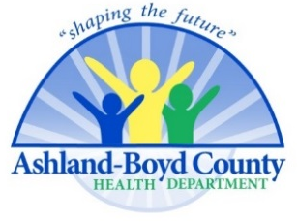
What If?—Without Public Health Guidelines
And Compliance
03-27-20

CORRECTED

This is what could happen in Boyd County Kentucky, in a few short weeks if enough people do not follow public health guidelines?

Boyd Co., Kentucky | People
Population (U.S. Census Estimate 7/01/2019) | 46,718
40% will get COVID-19 | 18,687
- 80% are going to be “just fine” and might not even know they have it | 14,950
- 20% will need hospital care | 3737
- 2% of those hospitalized will need a ventilator to breathe | 75
- 2.5% (Kentucky Mortality Rate) will die no matter what is done for them | 467
Based on KY data as of 03-24-20

