ACROSS: 1, Wickedness. 7, Harpist. 8, Teach. 10, Side. 11, Impostor. 13, Encamp. 15, Saddle. 17, Ignorant. 18, Tent. 21, Grass. 22, Olivier. 23, Wrongdoers.

DOWN: 1, World. 2, Crib. 3, Entomb. 4, National. 5, Started. 6, Whispering. 9, Harvesters. 12, Imprison. 14, Centaur. 16, Unload. 19, Evils, 20, Give.

C:\Users\sue\Downloads\jun13_wordsearch_solution.tif

Readers contributions to the magazine are always welcome. Hard copy (hand written if easier) to the Rectory address or by email: to : [**st.marysstockport@gmail.com**](mailto:st.marysstockport@gmail.com)

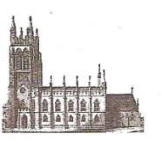Editorial discretion with regard to content and space available will apply.

**St Mary’s in the Marketplace**  
St Mary’s Rectory, 24 Gorsey Mount Street,  
Stockport, SK1 4DU.   
0161 429 6564 [www.stmarysinthemarketplace.com](http://www.stmarysinthemarketplace.com)

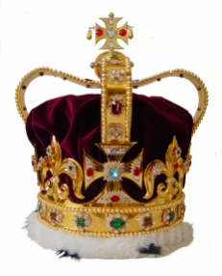

St Mary’s in the Marketplace   
“SECURING THE FUTURE FOR THE NEXT 100 YEARS” 50p

**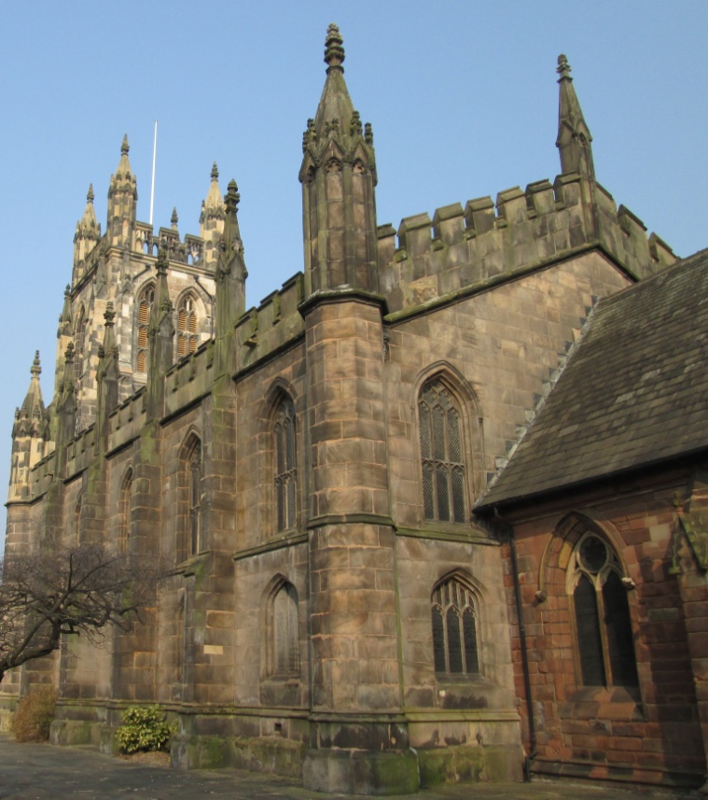**

****From the Rector’s Desk

Dear Reader .  
 .   
Coronation Day 1953. .

Where were you? Of course you have to be a certain age to remember Coronation Day. I was just 5 years old and my brother was nearly 4. Our mother dressed us up in white shirts and blue shorts, with little white socks and shiny black shoes, and I imagine a Coronation tie. Very few people had television in those days, and those who did were often kind enough to invite friends and neighbours round for the day to watch the amazing live coverage on a tiny little screen.

In all honesty I cannot really say I remember much if anything of the day. My mother recalled that it was very long, and that the children would do what most children do at a party, dash around the house. What was more memorable was that sometime during the months or year that followed a splendid colour film was made and all the children of the town, Burnham-on-Sea, went to the Odeon Cinema and saw the Coronation there. I’m sure that was more interesting for a little boy than a little “black and white screen”.

Again, at about the time of the Coronation all the children whom I knew were invited to a special party which I’m sure was fun. But a 5 year old doesn’t take much in and so the memories are really rather scant, and supported by what one was told had happened. Sadly, Queen Mary had died only recently – or was it just after the Coronation - and my little brother and I certainly marked that sad occasion, by processing round the garden with a washing basket. How we knew about the funeral, I do not know!

It is a truly wonderful and heartening fact that our queen has been given such a long life and reign, in out time, and that she has always held before

The last few pieces of the jig-saw are finally being put in place – the handrail for the Heritage Centre, the glazing-in of the memorial chapel and the creation of the second chair store.

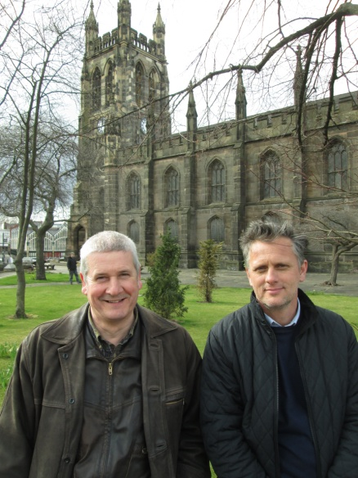Approaching the final handover is an exciting time for all of us, including I suspect John Prichard (Lloyd, Evans, Prichard our Architects) and Adrian Walker (Lambert Walker Restoration and Conservation) seen here following a site visit to St Mary’s.

The finishing touches for this part of the re-ordering, the arrival of the cushions for the remain pews, new deeper-filled kneelers for the communion rail and the new award winning Chorus Theo chairs – all coming during June. We are a little behind schedule, but we’re getting there!

The clock has been repaired, the bell chamber cleaned and the bells oiled and ready to ring out again over Stockport. Before we do that though, we will just inform the neighbours – some of them may never have heard our bells before.

Next, the purchase of kitchen equipment, crockery etc. for the Nave Café as negotiations continue to partner the management of the kitchen/café with Pure Innovations Ltd.

Then there is the subject of “volunteers” and our recruitment drive …..

Watch this space (as they say)!

C:\Users\sue\Downloads\jun13_wordsearch_grid (1).tif

Wordsearch - The 24 June the Church remembers the birth of John the Baptist. (Luke 1) In the days when Herod was king of Judea, there was a priest named Zechariah who served in the temple. One day the angel Gabriel appeared to him. Gabriel said that Elizabeth, Zechariah’s barren, elderly wife, would give birth to a son who would have a unique role in history. Zechariah did not cope very well with the news: he laughed in disbelief. Nevertheless, a baby was born: John, whose amazing role in life was to announce the coming of the Messiah: “he will turn many of the children of Israel to the Lord their God” (Lk 1:16) John’s role was unique, but all over the world Christians today are in ministry for exactly the same purpose: “...to make ready for the Lord a people prepared”.

**John; Zechariah; Incense; Angel; Laugh; Disbelief; Children; Prepare; Announce; Messiah; Ministry; Barren; Wife; Elderly; Gabriel; baby; Herod; Temple; Dumb; Unique; Coming.**

**Civic Sunday  
9th June 2013 10.30am**

**In the presence of   
The Worshipful the Mayor & Mayoress  
 of Stockport**

**Councillor Chris Murphy and Dot Murphy**

**Preacher:**The Rt Revd Dr Peter Forster, Bishop of Chester

Chaplain to the Mayor of Stockport

When you see the Mayor exercising Mayoral duties around the Borough you do not expect to see a clergy person, following a few steps behind saying prayers, looking holy, or carrying smelling salts and a Bible! In fact you will rarely, if ever, see the Mayor’s Chaplain, except perhaps at the Civic Service (though not always then) and at Mayor-making in the Council Chamber. In reality the Mayor’s Chaplain would appear to have little to do in the Mayoral year. However the Mayor is free to chose someone as their Chaplain, and what they then make of the Chaplain’s availability is up to them. Roger has been invited for the second year running, to be Chaplain to the Mayor, and is looking forward to fulfilling his “duties” as much as he did to last year’s Mayor, Councillor Wendy Meikle who was by all accounts very appreciative of his ministry.

**The Mercian Regiment will parade through Stockport on Thursday 13th June.**

The 1st Battalion of the Mercian Regiment (Cheshire) has recently returned from a tour of duty in Afghanistan. .  
   
The Homecoming March, commanded by Lieutenant Colonel Phil Kimber MBE, will comprise approximately 200 personnel, including a number from Stockport, and the Band of The Royal Logistic Corps.  
Stockport Council is encouraging people to cheer on the Regiment.  
   
The parade will assemble in Stockport town centre, in the historic Market Place near St Mary’s Church.  The Mayor of Stockport will present medals to soldiers from Stockport who have completed their first tour of duty in Afghanistan. .  
   
From the Market Place, the parade route is along Millgate, Corporation Street, Warren Street, Bridge Street, Great Underbank, Chestergate, Mersey Street, St Peter’s Square, St Petersgate, and Wellington Road South (A6) past Stockport Town Hall where it will take the salute from the Mayor.  The parade ends at Stockport Armoury on Greek Street.  
    
The Mercian Regiment paraded through the town three years ago when it received the Freedom of the Borough of Stockport.

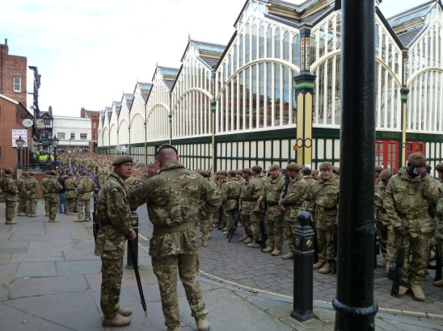

independence we may lose our way and then have to admit our mistakes and confess our failings.

Sometimes our trouble and pain can be caused by our own deliberate fault and in our hopeless condition we need someone greater than ourselves to come to our aid.

When Jesus draws alongside us the situation changes. He doesn’t condemn us. He comes to save us. Jesus is the only one who can enter our lives to put things right. Jesus says to each one of us, “Come, follow Me. I’m taking you to My Home.”

============================================================

“SECURING THE FUTURE FOR THE NEXT 100 YEARS”

Multi-purpose use…

Our first official booking - for a meeting to be held in the privacy of the glazed-in Memorial Chapel (with display area in the south aisle) - will take place towards the end of this month. We were delighted to be able offer our facilities to members of the Chester Diocesan Advisory Committee (DAC) who have chosen St Mary’s as the venue for their June meeting.

The office of the Diocesan Advisory Commitee has responsibility for progressing faculty applications and providing policy advice on church building matters.

You will have heard us talk about the DAC at various stages of our faculty applications for both internal and external works This is of course a wonderful opportunity to invite them to see for themselves just what they have approved and assisted us to achieve in recent years.



Rotary Club of Stockport

On behalf of the Rotary Club of Stockport could I thank everyone who has given us empty tins for use by students at Parrs Wood High School and Sixth Form. We will continue to collect these, if not for this term but in readiness for the new academic year.

#### For our next appeal…

We are also looking for support in our efforts to assist the Chelwood Food Bank**. We are looking for good quality crockery, cutlery, drinking glasses and pans. Also required are small electrical items (such as toasters and kettles) as well as kitchen implements. All must be in good condition (useable) and not chipped, cracked or broken.** They will also accept microwaves – but by arrangement only please.

Chelwood will of course accept the gift of food – not fresh, chilled or frozen (as no appropriate storage facilities are available). Donations are of course always welcome – I feel another charity lunch coming on!

It is wonderful that we are able to work in partnership with local community groups and to see local charities supporting each other. The Wellspring have been able to supply some excess food to Chelwood, who in turn have been able to provide food to the Pure Innovations “café project”. Working together to make Stockport a better place.

And finally…….. Pure Innovations “Pure Insight” project are looking for luggage suitable for use by young persons packing together their belongings ready to moving into their own accommodation. Cases, ruck-sacks, hold-alls or sports bags (of good quality please – all zips etc working).

her this high calling from God to serve us as Queen, with all her heart. Her Christmas messages have become more and more expressive of the Christian faith and of her personal faith in Christ, which for all of us whether Christian or not should be a clear indication that as the only crowned head in Europe she is fulfilling her duty to God as of first importance, and then to us as her subjects.

The day of the Coronation was a very wet one by all accounts, but it did not dampen the spirits of those who attended (most notably the Queen of Tonga, who insisted on riding in an open carriage) and of the vast crowds who waited so patiently for the great pomp and ceremony to parade past, and the great State Coach to roll by (as I have seen for myself on the occasion of the Queens 25th Anniversary in 1977) carrying its precious occupants the Queen and the newly created Duke of Edinburgh.

As we recall that happy day 60 years ago, whether or not we were alive at the time to witness it, let alone remember it, let us thank God for giving us such a remarkable person, as our Queen, and continue to proclaim with cheers of loyalty goodwill, and prayerful

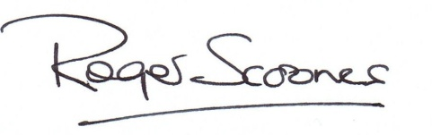

God Save the Queen!

Long Live the Queen!

Long may she reign!

For the record:

**24th March 1953: Queen Mary dies peacefully after illness.** Her Majesty Queen Mary, the Queen's grandmother, died peacefully in her sleep. A simple bulletin posted outside Marlborough House at 2315 GMT announced her death. It said: "While sleeping peacefully, Queen Mary died at twenty minutes past ten o'clock." The BBC interrupted the Light and Third programmes at 1125 GMT to break the news of her death. Programmes afterwards ended, except for news and weather forecasts.

C:\Users\sue\Downloads\jun13_xword_grid.tifAcross

1 Evil (Genesis 6:5) (10)

7 Musician called for by Elisha when he met the kings of Israel, Judah and Edom (2 Kings 3:15) (7)

8 The request that led to the institution of the Lord’s Prayer: ‘Lord, — us to pray’ (Luke 11:1) (5)

10 ‘We are hard pressed on every—’(2Corinthians4:8)(4)

11 Fraud (2Corinthians6:8)(8)

13 ‘His troops advance in force; they build a siege ramp against me and — around my tent’ (Job 19:12) (6)

15 Where Rachel hid Laban’s household gods when he searched his daughter’s tent (Genesis 31:34) (6)

17 ‘Now about spiritual gifts,brothers,I do not want you to be—’ (1 Corinthians 12:1) (8)

18 Nomadic dwelling(Genesis26:25)(4)

21 ‘As for man,his days are like—,he flourishes like a flower of the field’ (Psalm 103:15) (5)

22 Or I live (anag.)(7)

23 Those guilty of 1 Across(Romans13:4)(10)

Down

1 ‘God so loved the — that he gave his one and only Son’ (John 3:16) (5)

2 ‘Away in a manger, no — for a bed’ (4)

3 Mob ten (anag.) (6)

4 ‘Each — group made its own gods in several towns where they settled’ (2 Kings 17:29) (8)

5 Began (Luke 9:46) (7)

6 Speaking very softly (John 7:32) (10)

9 Workers Ruth joined when she arrived in Bethlehem with her mother-in-law Naomi (Ruth 2:3) (10) 12 Put in jail(Acts22:19)(8)

14 Aceturn(anag.)(7)

16 Discharge(Acts21:3)(6)

19 ‘All these—come from inside and make a man “unclean”’ (Mark 7:23) (5)

20 ‘Let us rejoice and be glad and — him glory!’(Revelation19:7)(4)

**The Journey**

Fred and Hilda were given good advice, but they ignored it. They thought they knew better. Confidently, they drove off in their car without a map or any navigation system. Fred said he knew the way, and Hilda didn’t pack any food or drink, assuming these could be bought later.

This couple were ill-prepared for their long journey and soon their holiday drive turned into a nightmare. Fred couldn’t cope with the adverse road conditions and without any prior car maintenance checks the car began to overheat. Hilda was now hungry and thirsty.

As night fell the weather turned inclement and Fred confessed they were lost. The car ran out of fuel and they stopped in a damp and deserted place. Without a mobile phone between them they were stranded. Their journey had been a big mistake and they didn’t know what to do.

Suddenly, a large van appeared and parked beside them. The driver stepped out, smiled and offered his assistance. He gave them something to eat, checked the car engine, put in petrol. Soon, Fred and Hilda’s car was roadworthy once more.

This friendly man never once reprimanded Fred and Hilda for their lack of foresight. Instead, he made them feel at ease, safe and secure. “Where do we go from here?” asked Fred. The man smiled, “Come, my friends. I’m taking you home.”

Sometimes in our lives, we can embark on a course of action for which we are ill-prepared. We may disregard sound advice and then, sooner or later, we end up in trouble. At these times we need a person who can rescue us. We need someone to set us on the right road again; someone who will support and encourage us.

Our lives are like a journey. Sometimes, we may think we can get along without God. We may try to ignore his guidance. In our quest for

**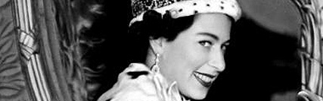**

6 February 2013 marked the 61st anniversary of The Queen's Accession to the throne. After her marriage in 1947, Princess Elizabeth paid formal visits with The Duke of Edinburgh to France and Greece, and in autumn 1951 they toured Canada.

Princess Elizabeth also visited Malta four times while Prince Philip was stationed there on naval duties, and enjoyed the life of a naval wife and young mother. This way of life was not to last long, as her father's health was deteriorating. In 1952, King George VI's illness forced him to abandon his proposed visit to Australia and New Zealand. The Princess, accompanied by Prince Philip, took his place.

On Wednesday, 6 February 1952, Princess Elizabeth received the news of her father's death and her own accession to the throne, while staying in a remote part of Kenya. The tour had to be abandoned, and the young Princess flew back to Britain as Queen. She was greeted by Prime Minister Winston Churchill and other officials at the airport.

The Coronation took place in Westminster Abbey on 2 June 1953. It was a solemn ceremony conducted by Dr Geoffrey Fisher, Archbishop of Canterbury. Representatives of the peers, the Commons and all the great public interests in Britain, the Prime Ministers and leading citizens of the other Commonwealth countries, and representatives of foreign states were present.

Crowds of people viewed the procession all along the route, despite heavy rain. The ceremony was also broadcast on radio around the world and, at The Queen's request, on television for the first time.   
Television brought home to hundreds of thousands of people around the Commonwealth the splendour and significance of the Coronation in a way never before possible. The Coronation was followed by drives through every part of London, a review of the fleet at Spithead, and visits to Scotland, Northern Ireland and Wales.

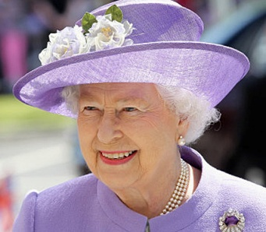

Her Majesty The Queen  
 - Supreme Governor of the Church of England.

This year marks the 60th anniversary of the Coronation of Her Majesty the Queen - which was [held in Westminster Abbey on Tuesday, June 2nd, 1953](http://www.westminster-abbey.org/our-history/royals/coronations/elizabeth-ii).

Thousands of churches are celebrating with [special services and events](http://www.churchofengland.org/clergy-office-holders/themed-services-and-events/celebrating-the-reign-of-her-majesty-the-queen/the-60th-anniversary-of-the-coronation/celebratory-events.aspx), **many taking part in**[**The Big Lunch**](http://www.churchofengland.org/clergy-office-holders/themed-services-and-events/celebrating-the-reign-of-her-majesty-the-queen/the-60th-anniversary-of-the-coronation/the-big-lunch.aspx) **on Sunday, June 2nd**. A special televised [Service of Thanksgiving](http://www.churchofengland.org/clergy-office-holders/themed-services-and-events/celebrating-the-reign-of-her-majesty-the-queen/the-60th-anniversary-of-the-coronation/service-of-thanksgiving.aspx) is to be held in Westminster Abbey on Tuesday, June 4th, at 11am





**Join us for our celebrations – the theme for “the BIG lunch” on Sunday, 2nd June 2013 at St Mary’s in the Marketplace. 1.30pm**

£6.00 per meal served (£4 children’s party meal pack) (other items as individually priced)

Christian Aid week

Café-Church “super soup lunch”

Thank you to everyone who supported our charity “super soup lunch”.

No expenses are being deducted for food items/ingredients or disposable items used – all have been donated - so all monies raised (including donations received) are being given to Christian Aid. In total the sum of £75.00

A special thanks to Rita for making the home-made soup (a choice of leak and potato or vegetable) and to Eileen, Edna and Isobel who assisted me in the kitchen. Thanks David for helping put the tables/chairs away.

Even if not yet fully equipped – to use the cooker for the first time and of course… the dishwasher was a joy!

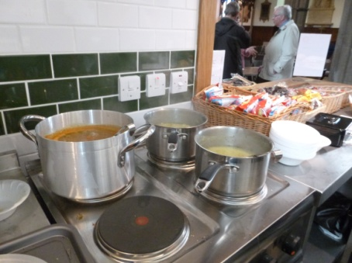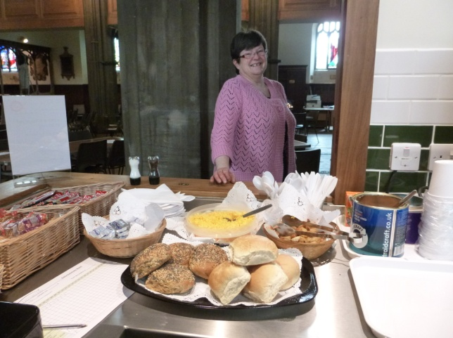

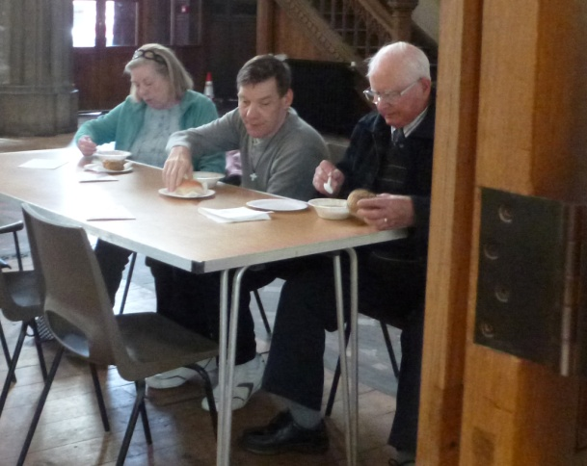

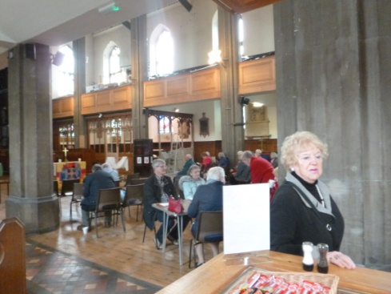

“Getting Married in Church”

The first wedding to take place in the totally re-ordered St Mary’s was judged by all present to be a successful and happy occasion. Andy and Lorna were surrounded by family and friends who nearly filled the Church, which looked fantastic with floral candlearbras provided by Cheshire Flowers.

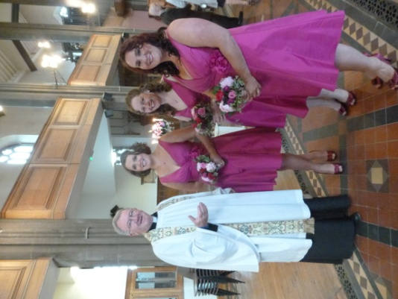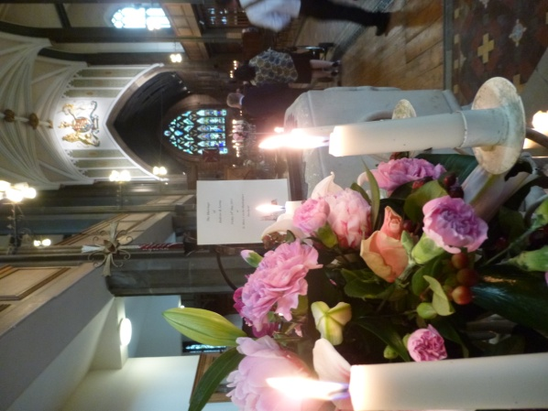

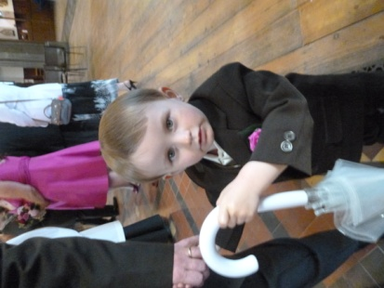

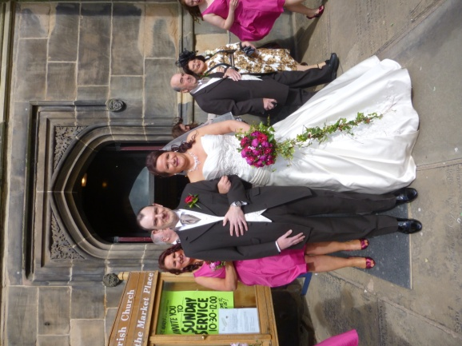With members of the Affinity Show Choir, Andy’s Barber Shop Quartet and friends from the Welsh Valleys present, the singing of great hymns was uplifting and glorious to listen to. And the sun shone, which always helps at a wedding.

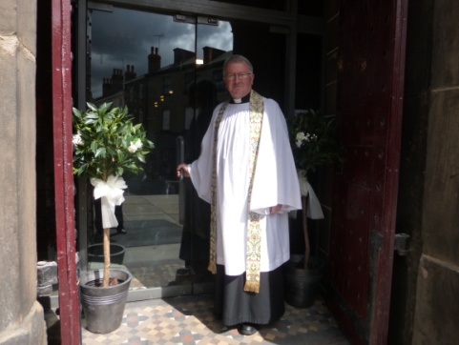

Diocesan Triennial Conference

The Bishop of Chester, the Rt Revd Dr Peter Forster has created a warm, healthy, positive and friendly ethos within the Diocese of Chester over the past 15 years. This has made the Diocesan Conference, to which all the clergy are expected to attend, with a three line whip, no excuses good enough for absences, more than attractive so that attending isn’t dreaded by the clergy as much as it might have been in the past. The Rector, Roger, tried to wiggle out of it three years ago, but failed, and in doing so became butt of much ribaldry at the opening session by the Bishop of Chester. The clergy will be encouraged to worship in fellowship and to have fun together in the three days in June, at a fine well established Conference Centre in Swanwick, which has hosted

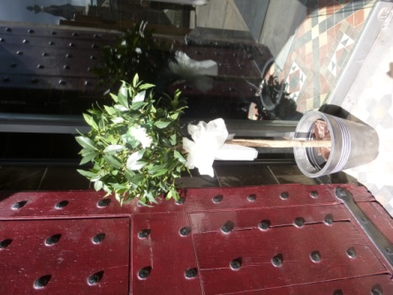 CHESHIRE WEDDINGS   
AT:CHESHIRE FLOWERS   
461 BUXTON ROAD   
GREAT MOOR   
STOCKPORT   
CHESHIRE   
SK2 7HE   
  
TELEPHONE 0161 483 3923

## Located on the main A6 near Stepping Hill hospital

July Wedding

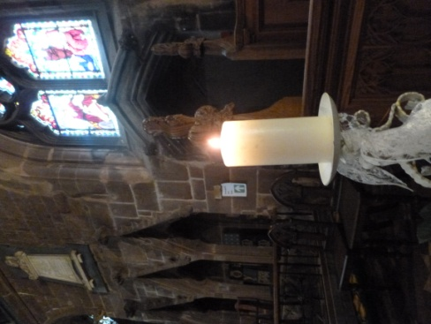On the 27th of next month Sam and Rebecca will be getting married at St Mary’s and we wish them a happy day. Although they live outside the Parish now, Sam was baptised at St Mary’s and lived at Rectory Fields. The Church’s rules and regulations have made it possible for these “family” links to allow Parish Churches to marry couples who would otherwise have difficulty being married in the Church of their choice to do so.

“To be ordained Priest”

On Saturday, 8th June Myles Owen, now Curate at Bowden Parish Church, and for a number of years a member of St Mary’s wider congregation, will be ordained Priest in Chester Cathedral.

Myles has had a busy first year in his parish, focussing particularly on the administration of the Church Centre, while at the same time taking a keen interest in the work with young people in the parish. The activities of the chair and in leading worship. He is undoubtedly looking forward to the awesome day of his Ordination into the Priesthood, in which St Mary’s has played an important part in his life and preparation for ministry. We wish Myles God’s richest blessing at this special time in his life!