October Holiday Club Programme |  |  | The Greenfield Club is a non-profit making charity, set up in 1996 to provide out of school care, for children aged 4-11 years. We are open from 7:45am until 6pm every week day during the school holidays, except for Bank Holidays. We are accepting children who have started Reception class in September so please come along and visit us to book your sessions!
October | Mon 25th | Tues 26th | Weds 27th | Thurs 28th | Fri 29th
Open 7:45am | 10.30am-11.30am  Fromeside Gym Session  £1 per child | Please arrive no later than 9.15am as we are taking two groups via a mini bus one after another  £10.00 per child |  | 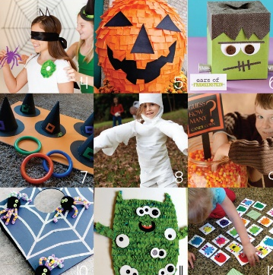  Gruesome Games | Spooky Pom Pom Designs
9:30am  10:30am |  |  | Pin the Tail Games |  | Terrifying Tennis
12:00pm | 12pm Lunch | Design a Horror Biscuit | Healthy packed lunch with ice pack for 12pm dinner each day please!
 | Pumpkin Carving |  | Creepy Cupcake Making | Trick or Treats
1:00pm |  |  |  |  | Eyeball Dig
2:30pm | Outdoor Fun | “Monster Consequences”  1.30pm-2.30pm  With James Parkyn - freelance sculptor and model maker for Aardman Animations for over 20 years  https://www.jimparkyn.com/ | Batty Basketball
4:00pm  Close 6pm |  |  |  | Spooky Penalty Shoot Out | Witches Potion Making
Don’t miss out! …
The booking deadline is Friday 15th October

October 2021 Holiday Club Booking Form
Date  Please tick your selected sessions | Morning Session  (7:45am-1pm)  £15.00 |  |  | Afternoon Session  (1pm-6pm)  £15.00 |  |  | All Day Care  (7:45am-6pm)  £25.00
Mon 25th | £1 Gym Session
Tues 26th | £10 AirHop
Weds 27th
Thurs 28th
Fri 29th
Please note that trips are compulsory and there will not be an option of staying at Club.
We welcome suggestions for competitively priced trips and visitors to continue to keep fees low.

By booking certain dates, you are giving your consent for The Greenfield Club staff to take your child/children off Club premises, to travel by mini-bus/coach, to the stated trip destination or take part in a particular activity.
Name/s of Children: |  |  |  |  | Age/s during the October Holidays:
Name of parent/carer: |  |  |  |  | Telephone number:
Home Address:
(House number & Post-code)
Email address: |  |  |  |  | School:
Please circle payment type: |  | BACS | Childcare Vouchers |  | Cash no longer accepted | Cheques no longer accepted
Signature: |  |  |  |  | Date:

The booking deadline is Friday 15th October - Don’t miss it!

