  November/December, 2021
Thanksgiving is now past and at the present hour, “it’s beginning to look a lot like Christmas…..” Well, we are at that time of the year once again! For most, it was still a difficult year, but we hope that there will be some “light at the end of the tunnel” for 2022!
Hoping each of you had a pleasant Thanksgiving holiday & wishing you & your families a peaceful, happy and healthy upcoming holiday season!

Reunion Planning Has Begun
Fellow alumni have already volunteered in forming a committee to begin planning the Class of ’67’s 55th reunion which will most likely be held in August of 2022. Their first meeting was held November 8th and discussions are leaning toward a casual affair with keeping costs to a minimum. Therefore, jot yourself a note on your new calendar for those festivities to happen during that month. More news will be posted in the upcoming newsletters!

Speaking of reunions, the committee has reached out via this newsletter asking if alumni reading it could provide some feedback as to whether you would attend this casual reunion. Kindly email your thoughts to Jane Mencel Lapointe at janie8749@gmail.com and insert GHHS REUNION in subject line.


Alumni “On the Go”: Some of our alums did a bit of traveling these past two months: Linda Maciaszek Fauble was in Maine in October; in early November, Candice Coneglio Frantz visited friends in Nashville, TN, and Sharon Travagliante Weitzman traveled with her family to Oceanside, Temecula and Palm Springs, CA, where she, too, surprised friends, and December 5th had Stan Slempa in the holiday spirit seeing the festive lighting of New York City!

In Our Thoughts: Several of our alumni have had some health issues these past few months, so we want those folks to know that we are thinking of them & hoping they have had a quick recovery! They are: Randy Stakes who has been in and out of the hospital with heart issues; Jim Spatny who had a trip to the hospital & their ICU for pneumonia; Linda Wike Calkins who had a case of Shingles even though she had the vaccine for it; and Marlene Krzywkowski Sooy who had a cardiac heart ablation in November, a procedure that can last anywhere from 3 to 6 hours!
We know that there are probably other alums who are having or have had health issues that are unknown to the rest of us. In a true Bulldog spirit, we would like to also reach out to you and hope that those conditions can be managed to a full recovery!
Kudos! Several more alums shared wedding anniversaries the last two months. Those folks are:
Ken & Kathy Schneider Nowack who celebrated their 50th anniversary on November 27th; Linda Reed Strauss & husband, Tom, shared 49 years of marriage on December 15th, and Jan Graber Parsons with hubby, Mike, also celebrated 50 years together on December 18th!
Congratulations and wishing you many more years together!

Connie Tortorici Smolko is proud to tell us that her oldest grandson, Andrew, who teaches & coaches at Cuyahoga Falls is returning to school – Kent State University and entering their Sports Administration program. Good luck in this new endeavor, Andrew!
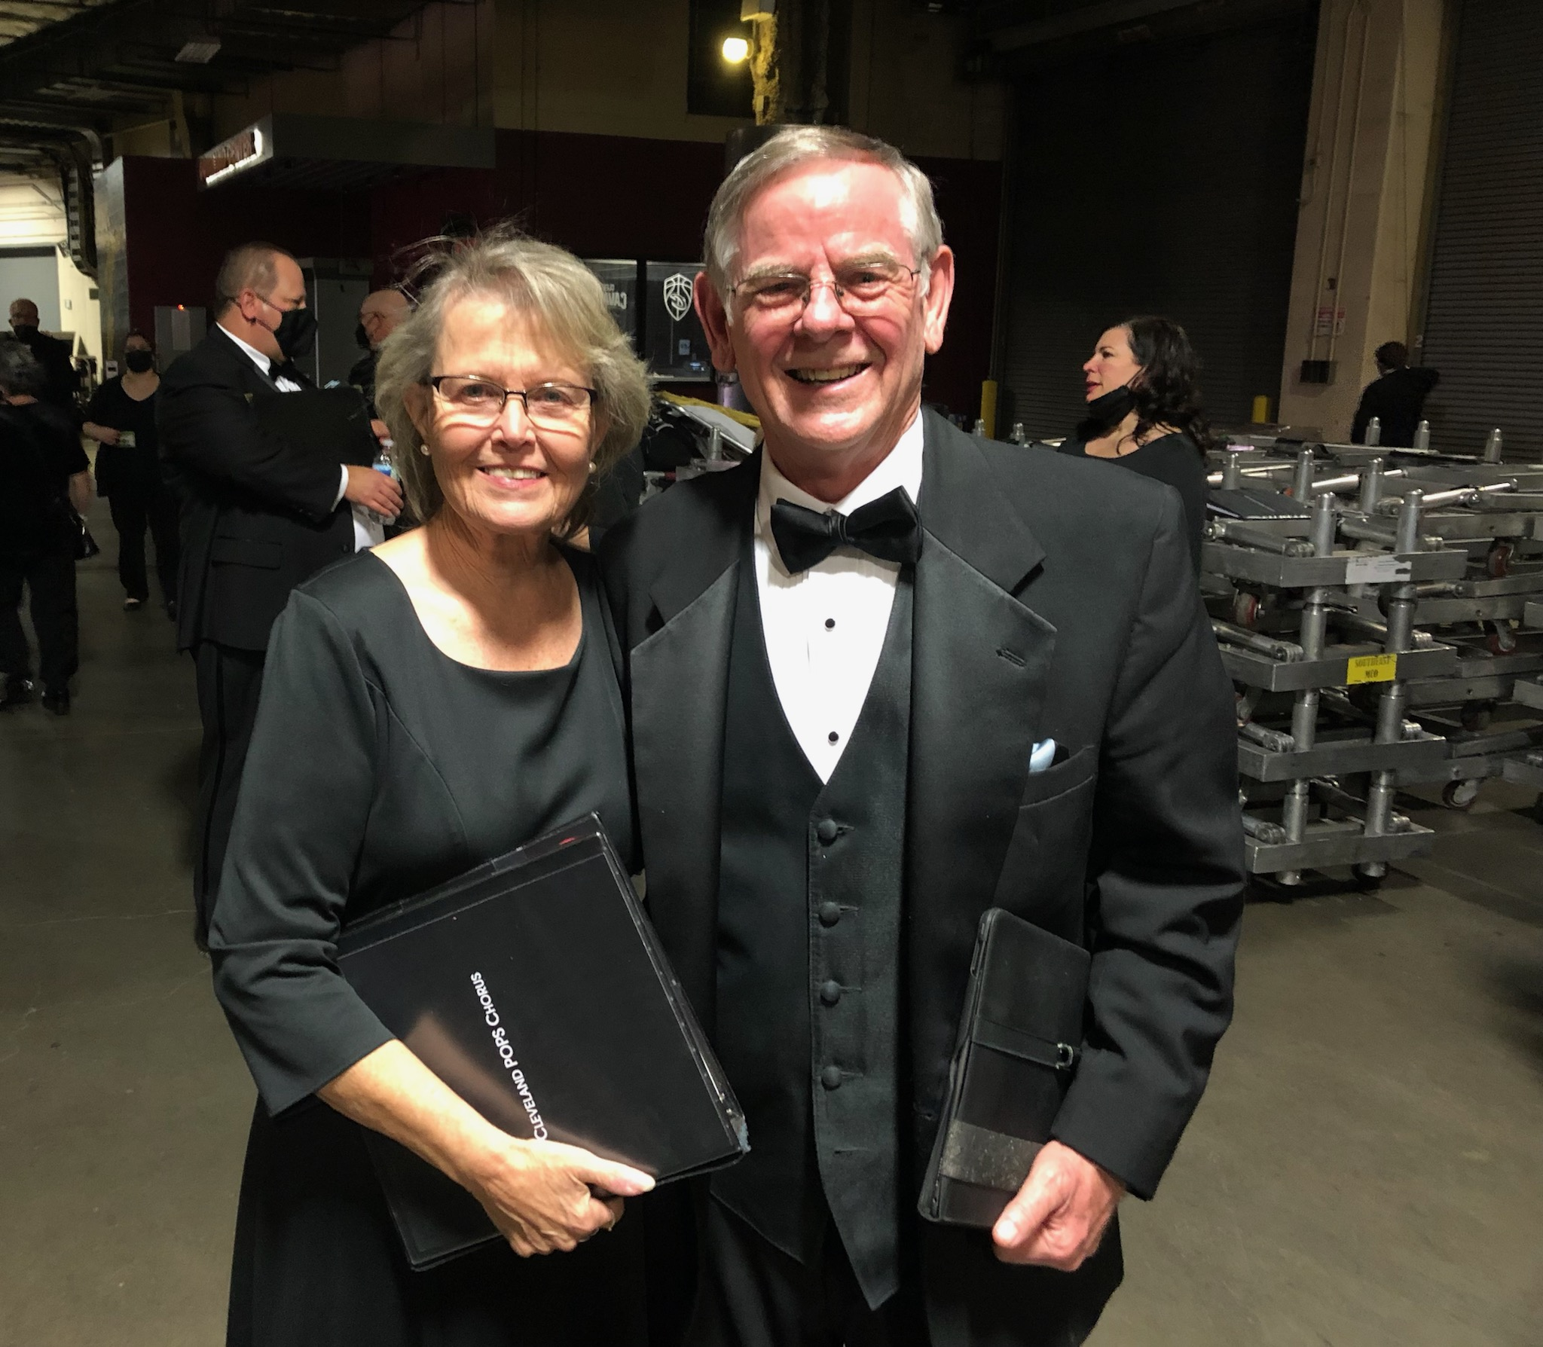
And, Doug Day with wife, Jackie, performed with the Cleveland Pops Chorus who sang with Andrea Bocelli when he came to town December 2nd. “Two hours of goosebumps”, according to Doug. This is the second time the Cleveland Pops Chorus performed with Bocelli (2017), both concerts being an incredible musical experience. And from this picture, Doug & Jackie look pretty “pumped”! Congratulations!

Condolences to: Jack Wimsett and wife, Gayle, upon the death of Jack’s son, Robert Michael Wimsett, 50, from a heart attack on October 25, 2021. “Bobby” was a father to two children, a grandfather of one, brother to three siblings, step-brother to one, fiancé to Jo Ann Parker, and a fabulous uncle. He enjoyed creating bonfires that melted the siding off of houses, fishing, fish fries, pets, online gaming, camping & aggravating his three brothers. He was a good man and a great friend to all.
To Susan Pustai Harmacek upon the loss of her sister, Vicki Lynn Pustai Bowens, 66, who passed away also in late October. Vicki was mother of two, grandmother of four, and was a proud retired Registered Nurse,
To Linda Carile Plumb upon the death November 10th of her significant other of 17 years, Richard “Butch/Dick” Green,
And, to Joe Grattino and family upon the passing of Joe’s brother, John A. Grattino, age 76 , after a short battle with lung cancer in early December. John served in the U.S. Navy from 1964-1969. He was father of 3 children and Grandfather of three. Surviving brothers include Mike, William & Joe. As a child, John played pick-up baseball with Ken Zach. John also played baseball in the Garfield Heights Little Leage at Memorial Field and in his last year at the age of 12, he beat out Steve Huntz for the triple crown. Steve went on to play Major League Baseball as an infielder between 1967 & 1975 for the St. Louis Cardinals, Chicago White Sox and San Diego Padres. He was born December 3, 1945 in Cleveland, OH, and is now 76 years old.
Our sympathies are extended to all families and friends. Each loved one will certainly be missed!

Newsy Reflections & Tidbits: The “Lady Bulldogs” held their November luncheon on the 6th and their “Ugly Christmas Sweater” luncheon on December 11th. Both were at 1pm at Danny Boys in Broadview Heights. The photos below show these ladies having a wonderful time:
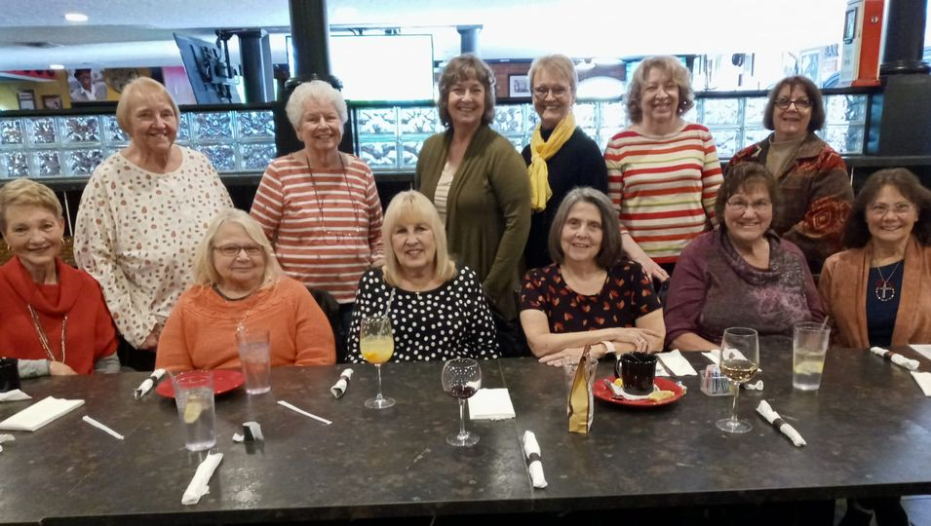
At the November lunch:
Leslie Mroz Readinger, Amy Roman Kostka, Helen Steblinski Cejer, Pamela Poveroni Conrad, Marlene Krzywkowski Sooy, Valerie Schwonek Blazey, Kathy Schneider Nowack, Sue Baranovic Slesnick, Audrey Sopko, Gayle Glowick Konet, Janice Wroblewski Hola, and Karen Soika Palker.
Marleen was in town from Pennsylvania and donated a bag of Hershey Kisses! Hershey is located close to where Marlene resides.

Attendees at the “Ugly Sweater” luncheon:
Kathy Schneider Nowack, Helen Steblinski Cejer, Gayle Glowick Konet, Karen Soika Palker, Rosie Martinovich Spatney, Amy Roman Kostka, Linda Maciaszek Fauble, Ruth Mendala Thompson, Audrey Sopko, Linda Wike Calkins & Nancy Levis Knowlton
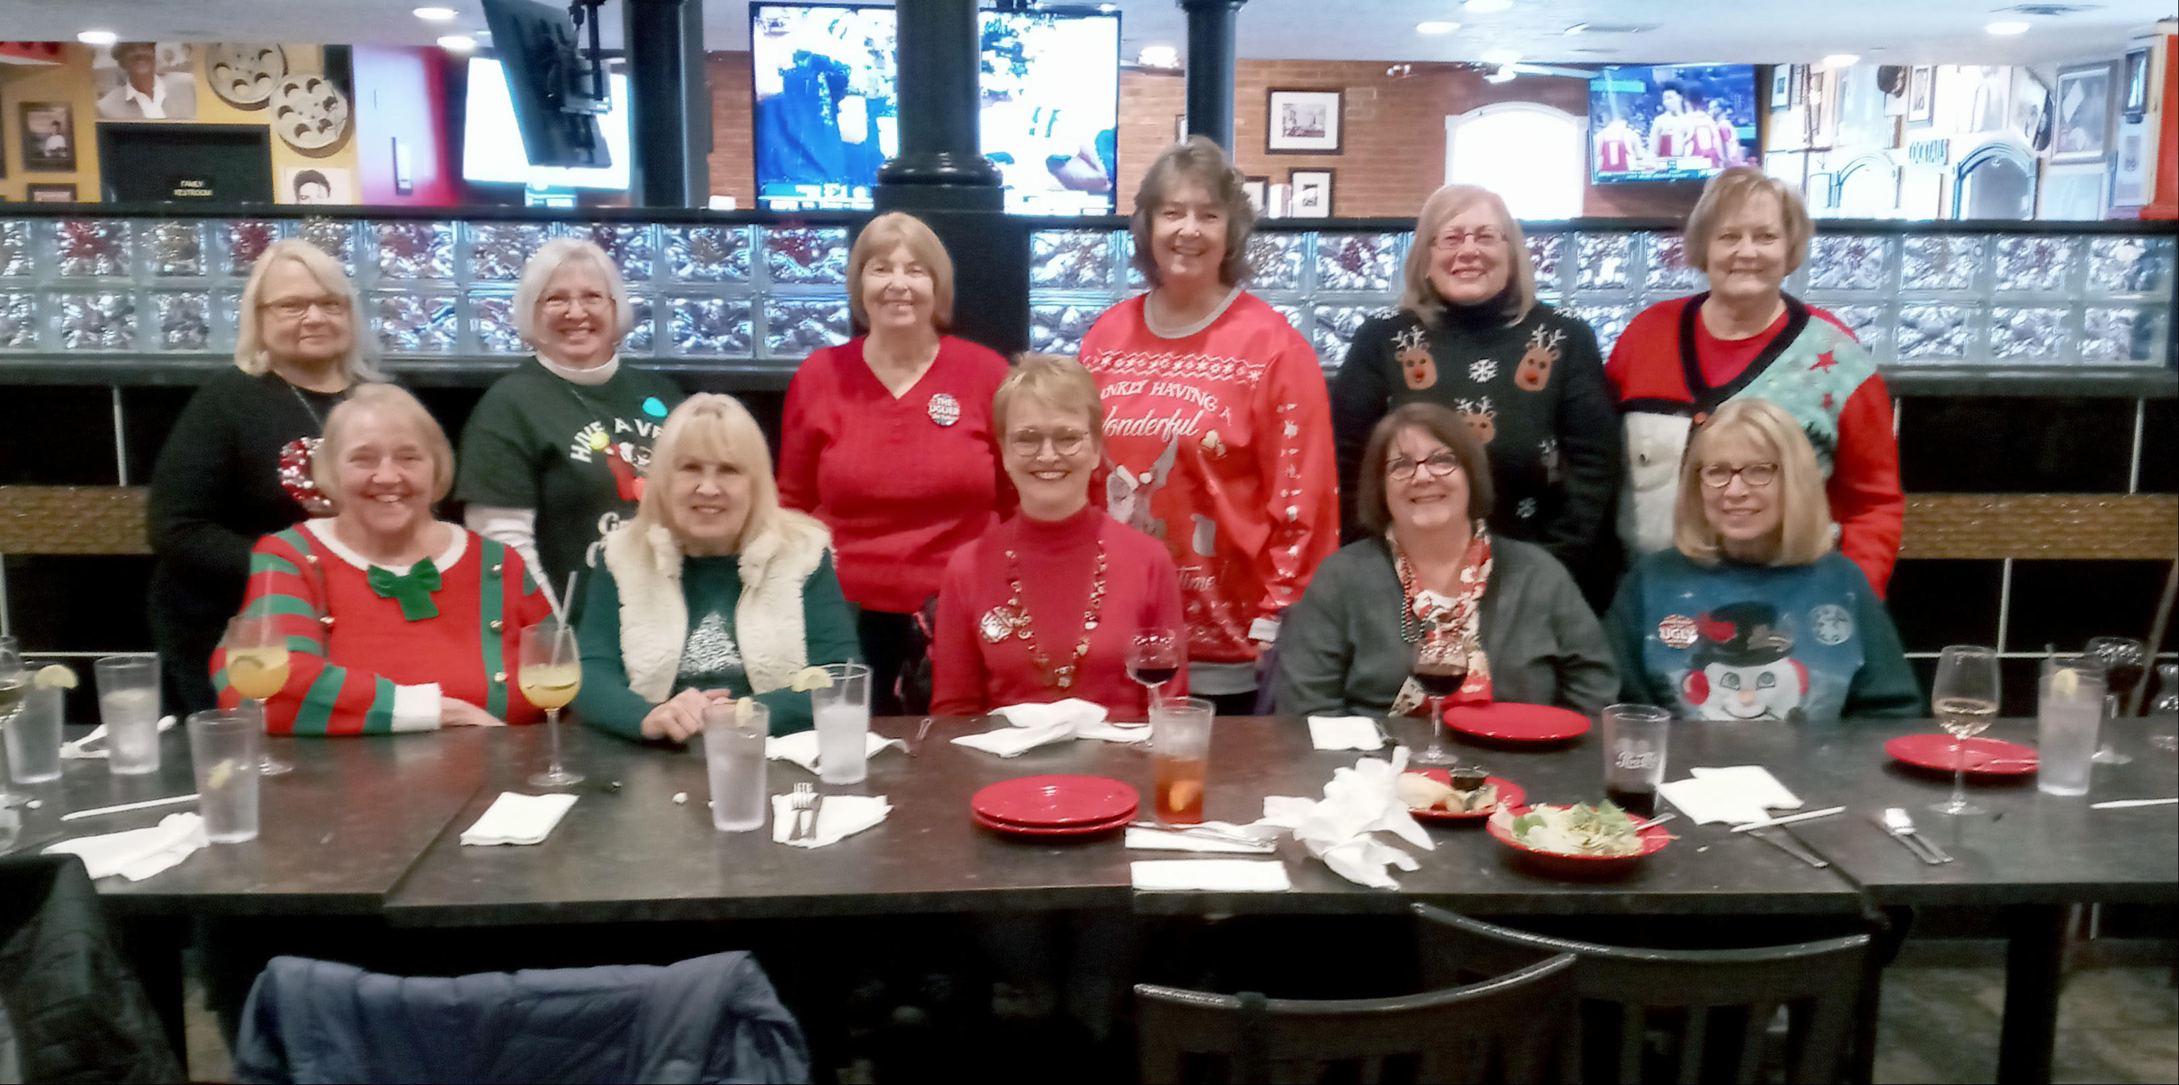
The next luncheon will be January 22nd. Check the facebook page (Class of ’67 GHHS Lady Bulldogs) for details concerning it. Join us if you can!

Well, that’s about all the news for now, but here is a little funny that might be true if you are helping assemble gifts for grandchildren, etc. Enjoy the holidays!

Until the next issue, Go Bulldogs!!!

Your loyal editor,
Gail Russler Meyer

