Between November 1932 and the next January, the Virgin Mary appeared a total of 33 times to five children between 9 and 15 in the small Belgian town of Beauraing.
The lady, dressed in a long white robe, said she was the Immaculate Virgin, requested that a chapel be built at the site of her apparition, and asked the children – and everybody – to pray. During one of the last visitations, she revealed her golden heart.

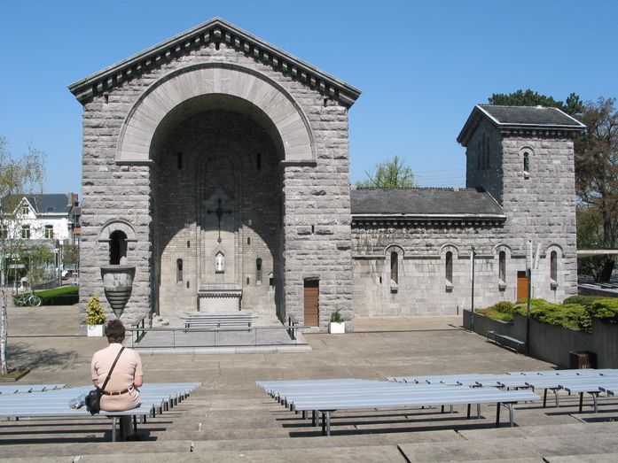

Chapel of Our Lady in Beauraing.
Image: Jean-Pol Grandmont, CC BY 3.0

