KRISTINA

O’NEILL

Graphic Designer
PROFILE  As a Graphic Designer, I realize how important a creative, clean layout is to get clients attention. My goal is to utilize my organization and communication skills to work with a team or solo, to create amazing designs to fit with your company’s image.  CONTACT  PHONE:  602-363-8446  WEBSITE:  GraphicDesignbyKristina.com  EMAIL:  kristina.oneill@rmcad.edu  kristinamarieoneill@hotmail.com  HOBBIES  - Painting  - Sketching  - Drawing  - Sports  - Camping  - Hiking  - Photography  - Travel  - Art  - Landscape Design  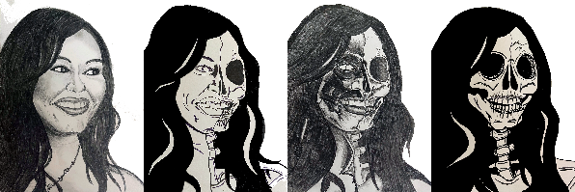  Semi- finalist in self-portrait contest 2022  Jerry’s Artarama | EDUCATION  Rocky Mountain College of Art and Design  2021  Bachelor of Fine Arts, with a major in Graphic Design  Blue Heron Academy of the Healing Arts and Science  2006  Medical Massage Therapy Certification  Western Michigan University  2005  Child Development Associates  Lake Michigan College  2003  Associates of General Studies  WORK EXPERIENCE  Planet Art (Seasonal)  October 2022 – December 2022  Photo Editing, order processing  Yard Time Publishing  2020- present  Intern  Design book covers, advertisements for various social media, create fonts to fit the book description  Massage by KO, Owner and Operator  Scheduling, menus, business cards, flyers, and general operations.  2019 – present  Mosaik Skin and Body  2014 – 2019  Manager, Lead Massage Therapist  Scheduling, menus, business cards, flyers, and general operations  New Serenity Spa  2013 – 2014  Manager, Lead Massage Therapist  Scheduling, menus, business cards, flyers, and general operations  Elements Therapeutic Massage  2012 – 2013  Manager, Lead Massage Therapist  Scheduling, menus, business cards, flyers, and general operations  Dolce Salon  2011 – 2012  Massage Therapist  Massage Therapy  Beaux Cheveux  2010 – 2011  Lead Massage Therapist  Massage Therapy  Lighthouse Chiropractic, Dr Jon Foti  2008 – 2011  Lead Massage Therapist  Scheduling, Massage Therapy  Czars 505 Live Music Club  2001 – 2011  Bartender  Coloma Community Schools, Little Learners Preschool  2000 – 2010  Assistant Preschool Teacher  SKILLS  - Adobe Photoshop  - Adobe Illustrator  - Adobe Premier Pro  - Adobe InDesign  - Adobe Light Room  - Adobe Dreamweaver  - Adobe After Effects  - Adobe Media Encoder  - Excel

