New Jersey
Family Career and Community Leaders of America

2023 Scholarship Application

Application Due by: March 1, 2023

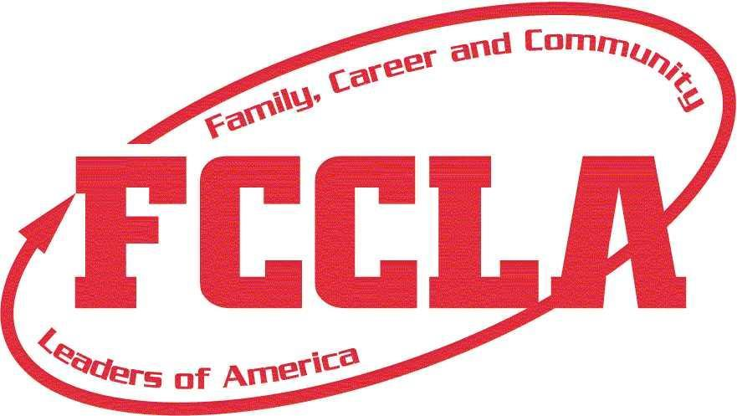
NOTE: There is no limit to the number of eligible members that may apply from a chapter or school.

Please submit to the NJ FCCLA state headquarters no later than March 1, 2023. The selection committee will include an executive committee member of NJAFCS and a member of EFACS-NJ, as well as an alumni member of FCCLA. The FCCLA State Adviser will be an ex-officio member of the committee. Please be sure to check the appropriate scholarships of which you will be applying and to answer all questions.

NJ FCCLA Scholarship Application

A maximum of two $500 scholarships will be awarded. The first will recognize a student pursuing a career in a Family and Consumer Sciences Related Occupation, and the second to a student with outstanding leadership abilities. The criteria are as follows:
- Must be a twelfth-grade student and an active FCCLA member for the current school year.
- Must be a member who has been involved in community activities.
- Must submit a transcript.
- Must submit written references from the guidance counselor and FCCLA chapter adviser.
- Must submit proof of application to post-secondary education with guidance counselor’s recommendation.

New Jersey
Family, Career and Community Leaders of America
2023 Scholarship Application
Application Due by: March 1, 2023

Name _____________________________________________________________________________
Address ___________________________________________________________________________
City/State/Zip ____________________________________________________________________

Home Phone ______________________________________________________________________ .
School ____________________________________________________________________________

Chapter Name _____________________________________________________________________
Chapter Adviser ____________________________________________________________________

Cumulative Grade Point Average _________________
Colleges Applied/Attending ________________________________________________________
________________________________________________________________________________________________________________________________________________________________________
Have you been accepted? • yes • no

Intended course of study ___________________________________________________________
Career to be pursued ______________________________________________________________
Grades involved as a FCCLA member
• 6th • 7th • 8th • 9th • 10th • 11th • 12th

List leadership activities:

List community service activities:

List local, regional, state, North-Atlantic region, cluster, and/or national FCCLA participation (including offices and awards):

List school activities:

Additional honors and awards:

Check grades in which you were enrolled in a Family and Consumer Sciences Course:
• 6th • 7th • 8th • 9th • 10th • 11th • 12th

List Courses taken in Family and Consumer Sciences _________________________________________________________________________________________________________________________________________________________________________________________________________________________________________________________________________________
Scholarship Statement
Answer the following question(s) on a separate sheet of paper, with a response of approximately 300-500 words.

NJ FCCLA Scholarship
1. Describe how FCCLA has developed your leadership qualities.

Additional Support Materials
All two scholarships require a recommendation from a chapter adviser and your guidance counselor. Please remember to attach the appropriate recommendations for each scholarship.

Please also enclose a copy of a high school transcript, as well as verification of application to post-secondary schools. (copy of acceptance/application)

I verify that the above information is true.

Signature of Applicant Date

Signature of Chapter Adviser Date

Signature of Guidance Counselor Date

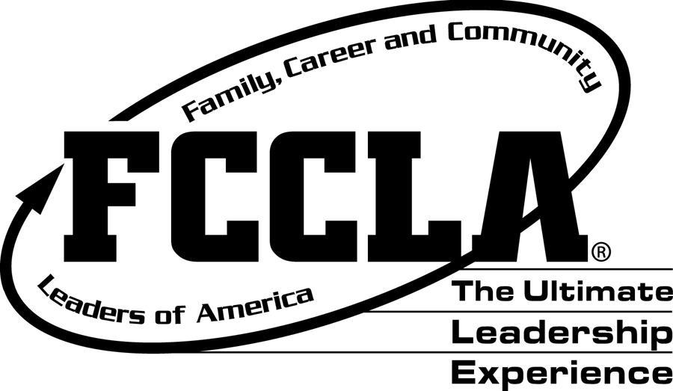
Return completed application to:
New Jersey FCCLA State Office
c/o Patricia DiGioia-Laird
NJ FCCLA State Adviser
855 Grove Avenue
Edison, New Jersey 08820-2200

Application Due by: March 1, 2023

