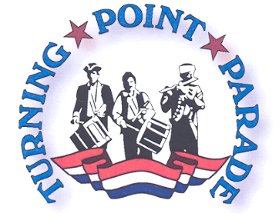August 2, 2020
1:00 p.m.
Parade Unit Response Form

____ YES, we will participate in the 2020 Turning Point Parade in Schuylerville, NY on August 2nd
(detailed information regarding the parade is available at http://www.turningpointparade.com/)
** IF YOUR RESPONSE IS YES, PLEASE COMPLETE THE INFORMATION BELOW **

____ NO, we will not be available for the Turning Point Parade this year
** IF YOUR RESPONSE IS NO, PLEASE INDICATE IF YOU WOULD LIKE TO BE CONTACTED FOR NEXT YEAR’S PARADE: _____ YES _____ NO

Name of Unit: _______________________________________________________

Point of Contact: _____________________________________________________

Address: ___________________________________________________________

Phone: ____________________________________________________________

Email address: _______________________________________________________

Vehicle(s) and descriptions ~ (please add a brief description and include approx. length of all vehicles combined, if possible. This information is used for parade formation purposes.) _________________________________________________________________

Please add any other relevant information pertaining to your organization’s history, service area, members or vehicles: _________________________________________________________________

** Please forward your response, whether YES or NO to: **
turningpointparade@hotmail.com
Or you may FAX your completed form to: (518) 695- 3112
Or mail it to: Turning Point Parade 20 Broad St. Schuylerville, New York 12871
Or drop it off at the courtesy desk in Byron’s Market at the above address

