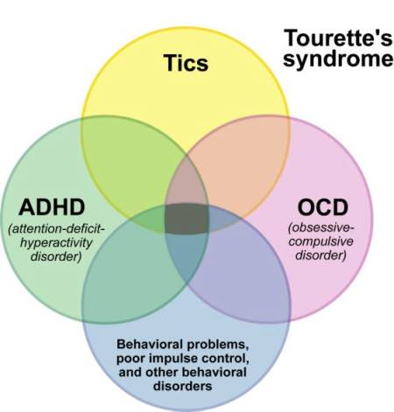

Tourette’s Syndrome is an neuropsychiatric disorder with onset in childhood, characterized by repetitive, stereotyped, involuntary movements and vocalizations called tics.
Many individuals with TS experience additional neurobehavioral problems that often cause more impairment than the tics themselves. These include inattention, hyperactivity and impulsivity (attention deficit hyperactivity disorder—ADHD); problems with reading, writing, and arithmetic; and obsessive-compulsive symptoms such as intrusive thoughts/worries and repetitive behaviours. For example, worries about dirt and germs may be associated with repetitive hand-washing, and concerns about bad things happening may be associated with ritualistic behaviours such as counting, repeating, or ordering and arranging. People with TS have also reported problems with depression or anxiety disorders.
Natural Support:
- Get thorough Elisa Allergy Testing done and remove all offending foods
- Have a Hair Analysis done to determine if there are accumulated heavy metals. If they are present, chelation suppositories are recommended.
- Remove soda pop, coffee, fried foods, junk food, sugar, and any other unwise food choices. Include lots of raw fruits and vegetables.
- Use only toxin-free cleaners in the home & laundry
- Include Shaklee Soy Protein daily in your diet to provide a guaranteed supply of all of the nine essential amino acids on a daily basis (needed to produce healthy balanced hormones in the brain)
- Supplement with optimal levels of: OmegaGuard, B Complex, Vita Lea, Alfalfa, Calcium/Magnesium, Vitamin D3
- Provide Pre- and Pro-biotics every day
- Do a Parasite Cleanse every year

