

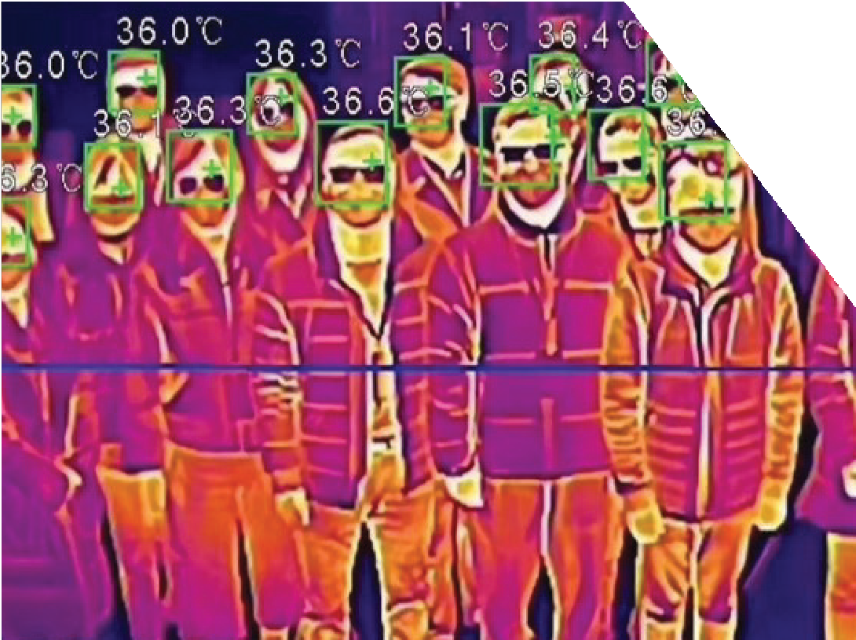
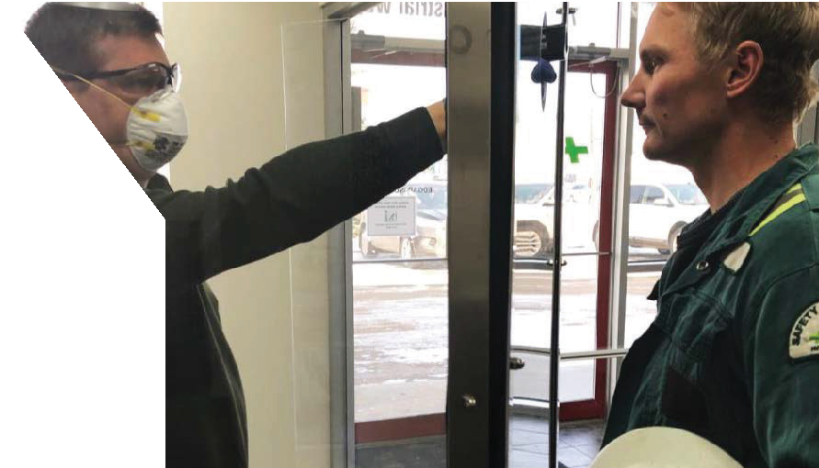
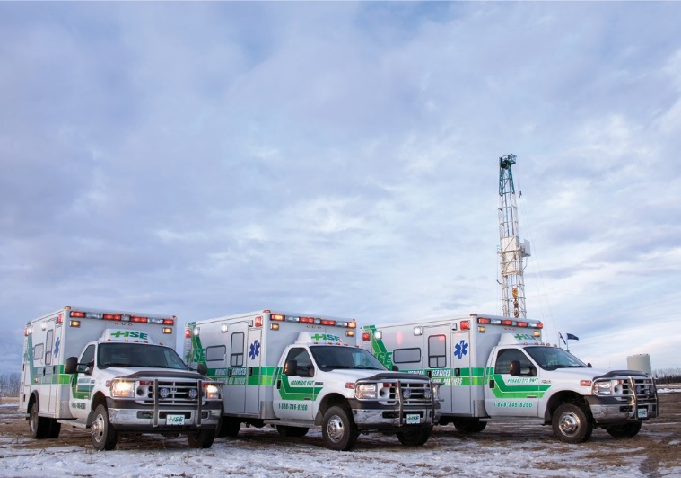
C.H&S

COVID-19 SCREENINGS - Protect Yourself and your Organization

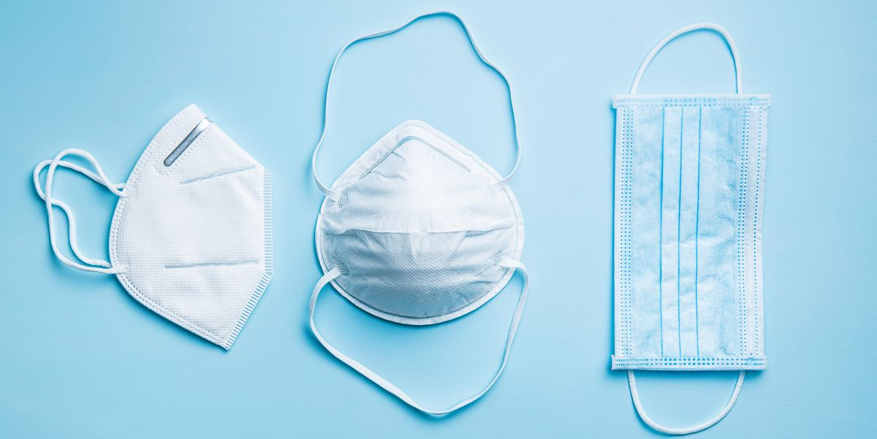

Corporate Health and Safety-CHS continues to provide critical and essential services through the COVID-19 outbreak. The safety and well-being of employees is the most importance. In order to improve confidence that there is a low risk of infection for people while working at worksites, we are implementing pre-entry questioning and where equipment is available, personal temperature screening. However, if you already have approved covid19 vaccination, you must wear mask.
CHS PROVIDES

PROVIDES
- On-site screening
- Infra-red cameras reading
- No contact temperature reading COVID 19 Rapid Test (Pending Health Canada approval)
- Patient transport
- Pre-access screening

Contact us for more information | 1-833-507-0800 https://corporatehealthsafety.ca

