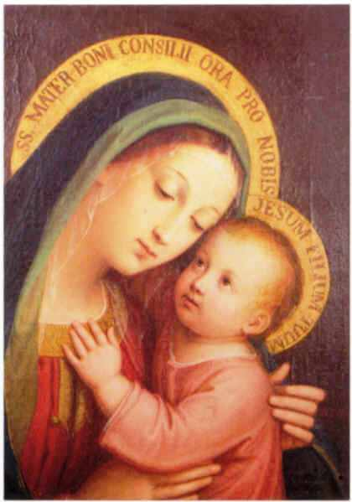**Celebrate with the Council of Catholic Women** October is Council of Catholic Women (CCW) Month!

Take the opportunity to learn more about Council, who we are, what we do, and the difference we make in our Parishes and communities.   There is something each and every woman has to offer, even in a small way.  As part of this organization, we are joined by our faith, help those in need and make our voices heard.

Our mission is to support, empower, and educate all Catholic women in promoting Gospel values. There is something for everyone, as our commissions cover every facet of life.  We are involved in so many worthy events and projects.  Please check out our website: ***hdccw.webs.com*** to view our quarterly newsletter “HDCCW Happenings” and much more about the Council of Catholic Women.

We are proud of all our great accomplishments, but we need your support to continue this important mission.  The Council welcomes your talents, thoughts and suggestions. We look forward to you becoming an active part of this faith and joy filled organization!

.