***** THIS FORM MUST BE COMPLETED, SIGNED, AND DATED BY A DENTIST School Year: ____________________

HIGHLAND COUNTY BOARD OF DD

HILLS AND DALES EARLY CHILDHOOD CENTER

8919 US 50 E.
Hillsboro, Ohio 45133
Phone (937) 393- 4237 Fax (937) 393-5871

CHILD ENROLLEE DENTAL EXAM

Name: ______________________________________________ Date of Birth: __________________

Telephone: ___________________________________________ Sex:  Male  Female

Address: ______________________________________________________________________________

Family Contact: _______________________________________ Telephone: ____________________

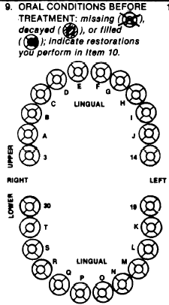

❒ No treatment needed at this time.
❒ Treatment completed.
Description of treatment:

DATE OF EVALUATION: ____________________

_____________________________________________ _______________________________________________
Physician’s Signature Physician’s Name (Please Print or Type)

_____________________________________________ _______________________________________________
Date Address

_____________________________________________ _______________________________________________
Phone Number City, State, Zip Code

