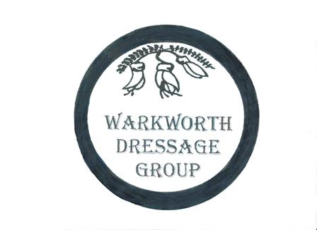
WARKWORTH DRESSAGE GROUP
REFUND REQUEST FORM
Today’s date: Date of competition:
Refund requested by: Name of Rider:
Email: Telephone #:
Address:

Classes entered: Name of Horse(s):
Yard Fees:
Total fees Paid: $
Reason for requesting Refund:
Certificate included with your refund:
Signed:
How would you like your refund Direct Credit or Credit against your next WWDG entry?
Bank account details for refund:
Bank: Bank A/c #:
Post to: Christine Monaghan, 8 Pigeon Place, RD6 Campbells Beach, Warkworth 0986
Or email this form to:Musicalkur@gmail.com
Conditions of refund:
Requests must be received within 14 days of the competition.
Refunds requests will only be considered when accompanied by a vet, farrier or doctor certificate or at the discretion of the committee.
All refunds are minus the administration fee

