TRINITY UNITED METHODIST CHURCH
Pastor Doug Benton ___ Minister
July 18, 2021 Color: Green
EIGHTH SUNDAY AFTER PENTECOST
"We welcome you to our service this morning and pray that your time with us will be a blessing to you"
THE ORDER FOR WORSHIP
Prelude Eddie Welborn
Let us silently prepare our hearts and minds for worship.
Welcome and Announcements Grady Senn
Chiming of the Hour Eddie Welborn
Candle Lighting and Processional
“Stool Time with Pastor doug”
Call to Worship Pastor Benton
Opening Prayer Pastor Benton
Children’s Time Pastor Benton
Hymn of Adoration: “O How I Love Jesus” Page 170
*Apostles Creed Page 881
*Gloria Patri: “Glory Be to the Father”
Praises, Concerns and Prayers Grady Senn
Pastoral Prayer/Lord’s Prayer Pastor Benton
Tithes and Offering Ushers / Grady Senn
*Doxology: “Praise God From Whom All Blessings Flow”
*Hymn of Preparation: “A Mighty Fortress Is Our God” Page 110
First Reading: 2 Samuel 7:1-14 Sharon Baughman
Second Reading: Psalm 14 Sharon Baughman
Sermon Scripture: Mark 6:30-34, 53-56 Pastor Benton
Transitional Music
Sermon: “Give Me a Break” Pastor Benton
*Hymn of Service: “O God, Our Help in Ages Past” Page 117
*Returning of the Light

*The Benediction Pastor Benton

*Three-Fold Amen Eddie Welborn
*Going Forth Eddie Welborn
*Stand if able. God’s altar is open to you following the sermon.
Technician: Caroline Senn

The Altar Flowers are to the Glory of God.

Next Sunday – July 25

Altar Flowers: Open; Scripture Reader: Dixie Waldrop; Technician: Bryan Waldrop

Our Faithfulness

Worship Attendance for July 11 2021: 51
Total Budget for 2021: $ 149,647.00
Weekly Offering Needed: $ 2,877.83
Offering Received July 11, 2021: $ 2,109.00
2021 Average Weekly Offering YTD: $ 2,273 .00

The Concerns of Trinity
Our Known Hospitalized:
Recent Hospitalizations and/or Surgeries: James Poag, Robert Pollard
Nursing Home: Gloria Brehmer (Springfield Place)
Continued Prayers: Jeanette Poag, Cheryl Longshore, Shirley Berry, Rebecca Bundrick,, Frieda Kesler, Wayne Black, Ashley Wilson

Family and Friends of Trinity: Blake Hendrix, Phillip Sanders, Wilson Bowles, Charlotte Berry, Megan Wainwright, Diane Merchant, Neil Thomas, Francis Leopard,
Sal Welborn

Thank You
Trinity would like to recognize John Pollard for the new sign and
Harry Longshore for the church’s new cross.
Thank you for all you do for Trinity.

Available in the Narthex:
Please be advised that a 2021 Altar Flowers Chart can be found
on the wall closest to the choir robes. Please notify Peggy Bogart
with the wording you wish to have printed.

WELCOME VISITORS

Thank you for coming today! We are delighted you are here! We hope
you will join us again as we continue to discover the difference God’s love makes in our lives. If you have questions or desire to become a member of Trinity UMC, please speak to pastor. We are blessed because you’re here.

Trinity United Methodist Church Please visit our website for bulletins & newsletters:
1160 Trinity Church Road www.trinityumcnewberry.net
Newberry, SC 29108
Rev. doug benton, Pastor
803-276-1245 (Church Office)
803-768-7687 (Church’s cellphone)
803-543-0082 (Pastor’s Cell)
Upcoming Events at Trinity

July 20 & 21: VBS - Barnyard Roundup - Please see information sheet in Narthex.
August 2: Trinity Women’s Club – 6:30 pm
August 4: Trinity Men’s Club – 7:30 pm
August 9: Administrative Council meeting – 6:30 pm in the Fellowship Hall

dobenton@umcsc.net
Trinity
United
Methodist
Church

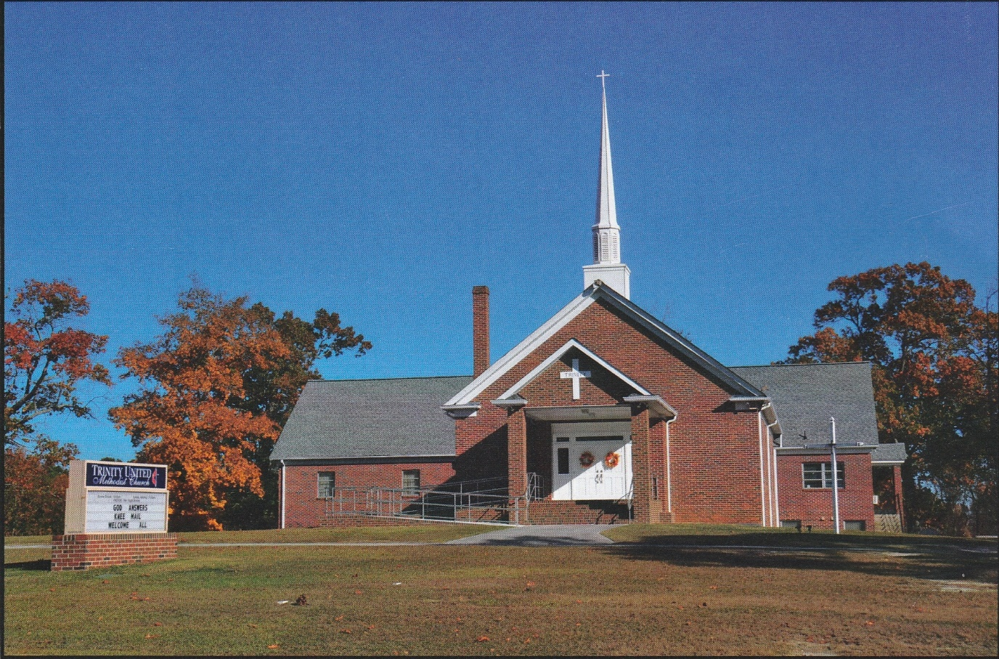

1160 Trinity Church Road
Newberry, SC 29108
Trinityumcnewberry@gmail.com

