Prostate Cancer
Prostate Cancer is a malignancy where the cells multiply and spread

Four Main Causes of Prostate Cancer:
- Lack of Detoxification
- Nutritional Deficiencies (especially antioxidant vitamins)
- Heated Oil consumption (trans fatty acids)
- Hormonal Imbalance
Other Causes of Cancer are:
  - Weak immune system
  - Allergies
  - Environmental toxins
  - Stress
  - Faulty Digestive System
  - Parasites
  - Genetics (but genetics do not have to express themselves unless the cellular environment becomes weakened)

CANCER is a major “Red Flag”. Cancer will occur in the weakest area of the body. It tells you that your own immune system (your internal police force) could not do its job. Traditional medical treatment involves surgery, chemo or radiation (cut out, burn, or poison the area affected by cancer). However, this DOES NOT address the root cause …
- What caused cancer to develop in the first place? …..
- Why was your own immune system TOO WEAK to defend itself?
If you choose to do one of the recommended traditional treatments, DO NOT presume that now the cancer is gone and I can just move ahead in life. You have not addressed root causes …… where do you want the “Red Flag” to show up next? Take this wake-up call seriously and implement the “Optimal Health” recommendations, including lifestyle wellness, dietary wellness, and functional wellness.

How to Reduce Premature and/or Accelerated Aging ... or Disease of the Prostate
- Maintain a whole food diet, including high fibre foods
- Use only cold-pressed oils in salad dressings
- Consume only RAW nuts and seeds (not roasted)
- Consume more RAW vegetables & fruits
- Avoid refined carbohydrates, coffee, black tea & alcohol
- Reduce animal fat intake
- Include RAW soy protein in your diet daily
- Drink enough water (1/2 ounce per pound of body weight daily)
- Choose a wise supplement program, including optimal zinc

Martha Willmore ... 905-871-4281 ... hoop@inter-pc.com
PROSTATE HEALTH
Three Main Problems to AVOID!

Statistics Canada indicates that women can expect to live longer than men. One of the reasons is that women are more likely to discuss their physical and emotional problems with health professionals, whereas men tend to ignore that anything is wrong. This is due, possibly to society’s attitudes and expectations of the tough, strong male which are well entrenched by the age of six, as well as pride, fear, embarrassment, lack of health education, or a reluctance to admit illness and expose vulnerability.

In the last several years, researchers, physicians, the media, and men in general have been paying a growing amount of attention to the prostate. Prostate cells are embryologically equivalent to a woman’s uterus, & are just as highly sensitive to hormonal changes and emotional stress as the uterus.

Get educated on the three most common prostate problems, and take appropriate proactive measures to prevent them ...

- Benign Prostatic Hyperplasia: is a non-malignant condition, that causes prostate enlargement, and tends to impact men over the age of 40. Statistics show that it affects 60% of men from the age of 40 to 59, and by age 80, 90% of men have problems. Symptoms are having to strain to start urination, a weak urination stream, starting and stopping during urination, frequent urination, night time urination, urgent urination signals, & dribbling after urination is complete.

- Prostatitis: A benign condition - an inflammation of the prostate that is usually caused by a fungal or bacterial infection. It can occur in men of any age, and generally responds to wise immune system treatment. Symptoms are pain between the scrotum and rectum, fever (infection often in the bladder), blood or pus in the urine, frequent urination accompanied by a burning sensation, and in advanced prostatitis, urination becomes more difficult. Long-term prostatitis can cause damage to the prostate gland.

- Prostate Cancer is the #1 cause of cancer in men, and the rate is escalating. Some statistics show us that by age 51-60 … up to 46% of men have the beginning stages of prostate cancer;… by age 61-70 … up to 70%; and by age 71-80 … up to 83%. Men have the same risk of prostate cancer as women for breast cancer. Symptoms are blood in the urine, or reddish or pink urine, a burning sensation during urination, difficulty in starting urination, increasing frequency of arising at night to pass urine, and/or a high PSA blood test (PSA means Prostate Specific Antigen). The PSA test is recommended every three years for men 40 to 65, and annually for men over 65. The results should be <4, but the lower the better.
Benign Prostate Hyperplasia

Three Stages of the Male Prostate Gland
- As a child, the prostate is about the size of a marble
- When the male hormones kick in at puberty, it grows to ping-pong ball size.
- About mid-life, due to the fluctuation of hormones of male andropause, the prostate begins to grow again. As it enlarges it compresses the urethra, which can cause urinary problems if a man does not get serious about good prostate health care. The technical name for this new growth is “benign prostatic hyperplasia” or “BPH” for short.
If a man has been careless with his diet and not provided adequate antioxidant vitamins as well as following a wise detoxification process, the cells of the prostate can become cancerous.

Male Androopause – Hormonal Fluctuations
The early signs of menopause begin to show up around 40 years old in a man. The outward indicators are when more hair than normal begins to grow in the nostrils & ears.
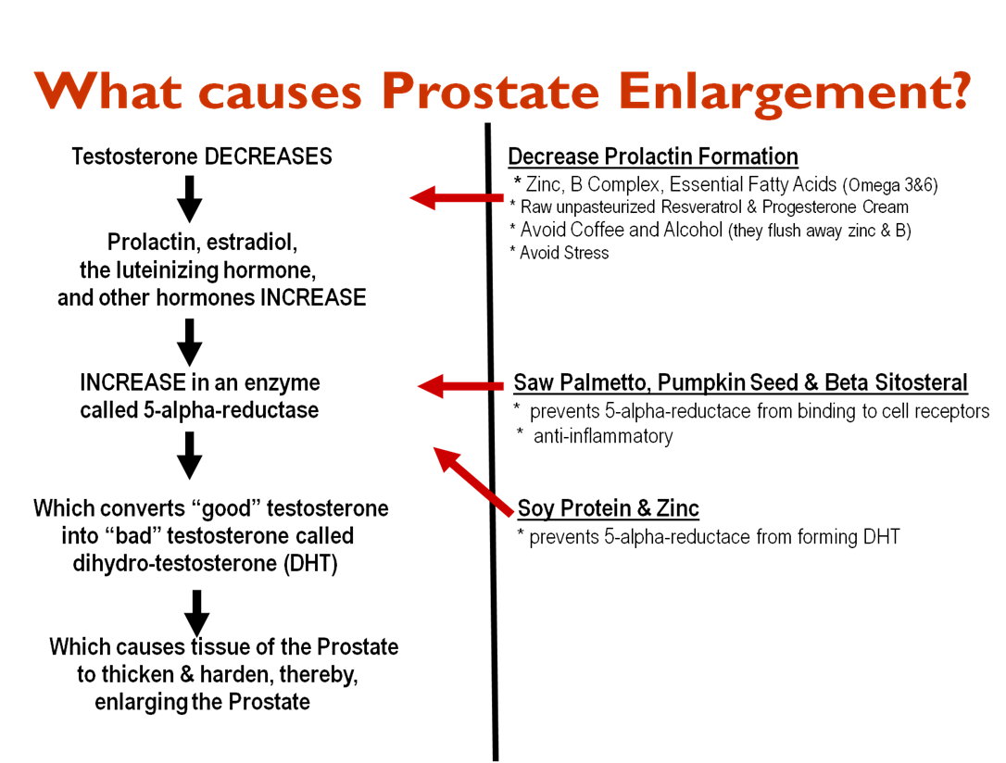

- Step 1:
  - Testosterone DECREASES
  - This hormonal fluctuation causes an INCREASE in prolactin, estradiol, LH, and other hormones
There are 5 things a man can do to “slow-up” this Step 1 process:
- Increase Zinc intake
- Increase B Complex intake
- Guarantee RAW nut & seed oils daily (flax is a good start)
- Avoid Alcohol & Coffee & Black Tea (they flush away Zinc & B Complex)
- Reduce Stress (stress increases prolactin)

- Step 2:
The increase of prolactin, estradiol, LH, etc. from Step 1 causes an
increase in an enzyme called 5-alpha-reductase which causes
prostate enlargement.
- Soy Protein prevents 5-alpha-reductace from forming DHT
- Raw nut and seed oils prevent the 5-alpha-reductace from binding to the receptor sites in the prostate, plus they act like a natural anti-inflammatory to the enlarged tissue. This is a good thing. The three best plant oils for this purpose are: 1) Saw Palmetto Oil from the berries of the Saw Palmetto palm tree,
2) Pumpkin Seed Oil; and 3) Beta Sitosteral (from Soy Beans)
(It is critical that these oils be RAW processed without the use of a chemical called “hexane”).

- Step 3:
High levels of 5-alpha-reductase convert “good” testosterone into “bad” testosterone called “dihydro-testerone” or “DHT” for short, which causes the prostate to enlarge and thicken. ZINC blocks the formation of DHT.

Prostatitis

There are three forms of prostatitis:
- acute bacterial prostatitis
- chronic bacterial prostatitis
- chronic pelvic pain syndrome
  - Non-bacterial prostatitis & prostatodynia
  - Also called Chronic Pelvic Pain Syndrome (CPPS)

Traditional treatment involves antibiotics. This treatment may successfully kill the infection, but it weakens the immune system even more, so that a man is far more prone to future infections. Chronic prostatitis can cause prostate damage.

Many men choose to be as drug-free as possible, and use both nutrient & herbal therapy to strengthen the body’s own defence system (including natures antibiotics ... echinacea & garlic. Choosing RAW soy protein, and optimizing antioxidant levels, as well as Vitamin D3 and Probiotics, have clearly supported more optimal prostate tissue health.

