COVID Parent Handbook
Last updated January 1st, 2021

In light of the COVID-19 global pandemic, we feel it is important to clarify what Dr. Bonnie Henry has confirmed and encourages childcare centres to remain open.

Wee Childcare will continue to follow all updated protocols and procedures as outlined by the Health Authorities and CDC. This can be found at the following link: https://www2.gov.bc.ca/assets/gov/family-and-social-supports/covid-19qa_covid19_childcare_settings_mar_24_2020.pdf

Given these important requirements, it is imperative that we are resolute in our health policy, and that all parents understand and agree to the following additional requirements.

Provision of Care

We are grouping children in “shared social distancing bubbles”. Essentially, this will mean that children will be attending childcare, and be placed in a group, this limits the number of people outside of your family that your child is exposed to.

We are reminding families that having your child attend childcare does mean that your entire family has a larger shared social distance bubble. Please behave responsibly and follow Dr. Henry’s recommendations if you are attending childcare as well as socially interacting with individuals outside of your household. At this time, your “shared social distance bubble” includes all individuals that any member of your family interacts with, including your child.

Provision of Care during staff illness

As staff are also required to stay home when exhibiting illness symptoms, until they have received a negative Covid-19 test, and we are ensuring small group care bubbles, this presents a significant limitation to our operation in the event of staff illness. If staff are exposed, they must monitor and get tested 7 days after the exposure. We simply cannot have illness spread throughout the staff team. We will be addressing staff illness in the following way:

1. For groups running with TWO staff: the group will be provided a staff-illness rotation list, and children will be able to attend alternating days, at a 2:8 ratio (3-5 programs) or 1:4 ration (infant-toddler programs).

2. For groups running with ONE staff: the group will not be able to operate until the negative Covid result is received. In the unlikely event we have a staff available who can cover for several days, we will temporarily put in the substitute staff. It is more likely that this will not be possible, and as such, the group will be unable to operate until the staff test is completed and the staff is able to return to work.

Illness and Attendance

Children may not attend Wee programs if they exhibit any symptoms of respiratory illness, rash or fever, these may very well be caused by allergies or teething however there is a zero tolerance for any signs of unwell, we simply cannot take any chances. Our pandemic health & wellness policy is attached. There are no exceptions to this illness policy. This policy will be remaining in place indefinitely. As such, parents are encouraged to think through how they will work from home/care for children who are required to stay home until they are symptom free. Little ones get sick a significant amount in their first year of daycare; it is imperative to have an accessible plan B until the COVID-19 vaccine is available.

Individuals residing in the household with any child attending Wee Childcare are to be taking all precautions possible to limit their exposure to COVID-19. If someone in the household is ill or has been exposed to COVID-19, the children cannot attend childcare for the duration of 7-10 days.

Fees are not being refunded due to illness - be it a staff or child illness. Our withdrawal policies are listed below.

Withdrawal Policy

Regular withdrawal notice is required. Parents must follow the regular policy of withdrawal by giving two calendar months' notice as tuition will be required whether the child attends or not.

Arrival & Pick-Up Protocol

Parents are not currently allowed to access inside the daycare rooms.

ARRIVAL (LIMIT ONE FAMILY MEMBER)

· ​PARENTS ARE NOT CURRENTLY PERMITTED IN THE CENTRE
· HAVE ​WASHED HANDS UPON ARRIVAL, PARENTS INCLUDED
· ​KNOCK ON DAYCARE DOOR
· ​YOUR CAREGIVER WILL BE WITH YOU SHORTLY
· ​PLEASE DO NOT ENTER THE DAYCARE ROOM
· ​MAINTAIN SOCIAL DISTANCING WHILE YOU WAIT
· ​TAKE TEMPERATURE BEFORE ARRIVING
· ANSWER​ HEALTH CHECK QUESTIONS, A STAFF WILL SIGN YOUR CHILD IN

PICK UP
· ​PARENTS ARRIVE WITH WASHED HANDS
(WE WILL WASH YOUR CHILDS HANDS)
· ​KNOCK ON DOOR AND WAIT
· ​MAINTAIN SOCIAL DISTANCING WHILE YOU WAIT
· ​PLEASE DO NOT ENTER THE DAYCARE ROOM
· ​A CAREGIVER WILL BRING YOUR CHILD AND BELONGINGS TO YOU
· A STAFF MEMBER WILL ​SIGN YOUR CHILD OUT

Cleaning and Sanitization

Following the current health authority guidelines for sanitization and care:

A. Inside the classroom, including all accessible materials, will be disinfected twice per day when used full day. Disinfection must be completed using a health authority approved sanitizer. We respect that some families prefer us not to use these, and feel they are “unnatural” cleaning products. Unfortunately, these are the only options we will use for disinfection, as per the CDC.
B. The washroom is disinfected after every child use.
C. Child bags must be plastic and on arrival will be sprayed with the disinfectant solution upon being brought into the classroom. Please plan your child’s bag accordingly.
D. Children MUST HAVE DAYCARE ONLY SHOES. We ask that you send shoes that will be easily disinfected and align with weather outdoor needs - we highly recommend natives or similar rubber/plastic based summer shoes that will work outdoors at and can easily be cleaned and rubber boots for the winter time. For inside shoes we recommend runners with Velcro or slip on shoes (not slippers).
E. When eating outdoors, we place a tablecloth on the table, and disinfect the tablecloth. Hands are washed with soap and water, prior to eating.

Snacks
Snacks need to be provided in disposable containers. For example, plastic wrap, ziploc bags, etc.

Lunch
Please send all lunch / snack items in a plastic bag. It is helpful to separate lunch and snacks into different bags. You must add an ice pack. Lunches may be brought in reusable, wipeable containers.

Sunscreen
In order to reduce possible spread of illness, we want to refrain from applying sunscreen on every child. Please lather your child with sunscreen before arrival and provide a SPRAY sunscreen for staff to reapply when necessary.

Child/Staff Interactions
• Avoid getting down to child’s face level ie: bend only part way when zipping up coats vs: kneeling in front of the child
• Find alternate ways to show affection such as air hugs, big waves, air kisses
• Carry infants facing away from you whenever possible
• Maintain 6 feet social distancing with parents
• Encourage children to maintain a “personal bubble” and encourage them to use own toys or ask staff to wash if they would like to share
• Use glove when wiping child’s nose

Communication
• Ensure that all information from families is communicated in timely fashion to Manager
• Be firm at ensuring everyone is adhering to policies, but sensitive to how things are stated as pandemic has created heightened anxiety
• When a parent calls in to say their child will be absent, be sure you find out why. If sick, be sure you document their symptoms in DC sign in communication book. Be sure you inform Management immediately of any suspect Covid19 cases
• After using center phone wipe with alcohol swab immediately.
• Staff are to avoid sharing items as much as possible (have own pens, etc)
• Manager to contact Health Unit to report any potential case

Nap Room
• Space children out as much as possible, min 2m (use as much of the room as possible
• Cots are placed head to toe
• Ensure beds are bleached weekly
• Ensure all bedding (including PT children) is washed and recorded weekly (Avoid shaking when making or laundering)

Outside
• Staff are encouraged to spend as much time outside as possible – Minimum 4 hours would be ideal (summer avoid 10-2)
• Children may go for walks but avoid going out places that public frequents/gathers
• Children may use our playground, public playgrounds are not permitted
• Wipe down with bleach cloth high touch items as necessary ie: bike handles, swing chain, playground railings, slide sides, talk tubes (avoid spraying bleach as may rust)

Tables
• Large tables seat max 4 and small seat max 2 (less at each if possible)
• When two staff are present split the group in half
• Be sure to clean and sanitize after meals and sweep floor

Art/Sensory/Baking
• Limit children to two at small table and 4 at large table (less at each if possible)
• Give each child personal art supplies, wipe with bleach when done
• Give individual playdoh in bag with child’s name and do not permit sharing, store in baggie with name
• Baking with children for consumption is to be avoided

Play Areas/Toys
• Two to Three children may play together in each area (preferably each with own toys)
• Toy Bins will be placed out for children to play with and then put away with date (may sit for 7 days or be bleached prior to using)
• Avoid using toys that can not be easily washed
• No soft items will be out (dress up, puppets, stuffed animals)
• Avoid sharing of toys as much as possible by having children playing parallel (toys can be separated by giving half to two children beside each other)
• Puzzles once used will be placed away with date (avoid use for 7 days)
• Limit play food (depending on children present it may need to be removed)
• Books may be left out as low risk (wipe down periodically)
• Wash toys that have been put in child’s mouth

Bathroom
• Avoid children lining up
• Adult will remain in bathroom to “teach” proper handwashing, tap off with towel etc.
• Children may sing song while washing for 20 seconds
• Adult will teach children to close toilet prior to flushing (as Covid may be transmitted through feces)
• Adult must wear gloves when changing diapers when BM, not needed with urine
Handwashing
• Staff Wash hands frequently with soap and water (hand sanitizer on occasion or when outside)
o Upon arrival
o When visibly dirty
o Before/After touching face
o After close physical contact with a child or their personal belongings: first aid, wiping nose, sunscreen, wiping tears,
o After you have coughed or sneezed into tissue or hands
o After going to washroom, diapering or assisting child in washroom
o After cleaning tasks & taking out the garbage
o Before handling food or clean dishes
o Before feeding children, food prep or making bottles
o Before and after eating
o After removing gloves
o After having been outside

Children Wash hands frequently with soap and water (hand sanitizer only if outside)
o Upon arrival
o When visibly dirty
o After touching nose or fingers in mouth
o After you have coughed or sneezed into tissue or hands
o After going to washroom
o Before and after eating
o After having been outside

Mid Day Health Check/Sick Children
• Staff will take children’s temperature prior to nap time
• If a child is sick, they will be in separate area until picked up
• Staff are to maintain a safe distance of 2 meters if possible
• Sanitize area thoroughly as soon as possible
• Instruct parents to keep Manager up to date with info

Illness policy
Recognizing that childcare programs may be the only option for essential service workers to secure childcare in order to work, our program has elected to remain open (with reduced hours) to families at this time. Please remember that the Covid-19 public health emergency is rapidly changing, and our ability to remain open may change without notice.

Dr. Henry maintains that childcare centres can safely care for children if they are following the prescribed health protocols.

We do not recommend that children with underlying health concerns, or children who live within a household with any underlying health concerns that are considered to be an additional risk for Covid-19, attend child care programs during the Covid-19 pandemic.

Accordingly, please note the following Covid-19 Health and Wellness policy, which applies to all staff and children within this facility.

Parents will additionally be asked health questions each morning, confirming that their child is symptom free and that their child has not been given acetaminophen or ibuprofen in the last 12 hours. In the event that a parent is found to be not answering this statement truthfully or withholding important medical information, childcare will no longer be provided to that family. If a child develops any illness after drop off, the child will be separated immediately and parents must pick up within 30 minutes.

Symptoms to Watch For

Updated illness policy as per our Provincial Health Officers recommendations. The biggest change is for runny nose and watching for a combination of symptoms. We thank you for your amazing support, we knew change would come in September, we are happy restrictions are easing slightly to avoid children being absent for extended amounts of time. You will note below that the “10 day” restrictions are no longer in place.

Please note we do not require a doctor’s note for common illness to return to daycare, doctor's notes are for clearing a child of an illness that is beyond the norm. We do not follow doctor recommendations regarding length of time a child can return to daycare, as more often they do not coincide with our own policies. We also do not accept self diagnoses of an illness.

The following list is a minimum of 2 days symptom free. We will stay in touch with families as the symptoms change and evaluate at the time when they are able to return. Please do not assume your child may return without talking to us beforehand.

If your child needs to be picked up, please have a plan in place so it does not take more than 30 minutes, we do not have a "sick room".

Any combination of the symptoms will need further review of return date after 48 hours.

48 Hours
- Fever: child must be free from fever (without being medicated) for 48 hours before discussing return to childcare. It is required that no other symptoms have appeared within that 48 hours.
- Vomiting: may return to care after 48 hours free and clear of vomiting
- Diarrhea: if a child has regular movements that are loose, clear
- Cough: any onset of a persistent cough, wet or hacking cough
- Difficulty in breathing: wheezing or persistent cough
- Pain: any unexplained or undiagnosed pain
- Sore throat or troubles swallowing
- Rash: any rash of any kind, can return once the rash is cleared up
- Cold Sore: any undiagnosed sores on the lips, around the mouth, blisters, can return once cleared up
- Sneezing, watery eyes, obvious signs of falling ill due to a cold
- Upset/sour stomach: not eating
- Infected skin or eyes (mucus/pus draining), Pink Eye, viral or bacterial, can return once 24 hours after drops have been started

24 Hours
- Runny nose: children will need to be sent home for 1 day, if no other symptoms appear, they can return with a slight runny nose

14 Days
- Children who have, or children with others living in the same home who have been identified as at-risk of potential Covid-19 exposure may return after self-isolating for 14 days and being symptom free. A COVID test is recommended.

If a child is sent home or contracts one of the symptoms listed above, they must stay home for 48 hours. Please contact us after 48 hours to discuss symptoms and determine a return time.

If a child is sent home with a runny nose, please contact us after 24 hours to determine the child’s wellness to attend the center.

For example:
If your child is sent home Monday morning at 10:30 am, they are not to return Tuesday at 10:30 am as they need a day of rest. After the assessment period, speaking with daycare staff to confirm no other symptoms have presented, the child may return to daycare on Wednesday.

***Parents are required to inform staff of any illness or communicable /contagious disease (with their child or within their family) within 24 hours to allow other families within the childcare centre to be alerted. We will never share names.

(Reference: Health Authority memo; COVID19 in childcare)

International Travel:
- If someone from your household has travelled outside of Canada and has returned back, the child must stay home for the duration of the mandatory 14-day quarantine.

For the well-being of children, staff and families, open transparency and candor is required around all the above requirements. Although this may lead to some challenging conversations, staff and families need to acknowledge and respect their necessity and their intention of care during the pandemic. We sincerely appreciate your compliance and understanding!

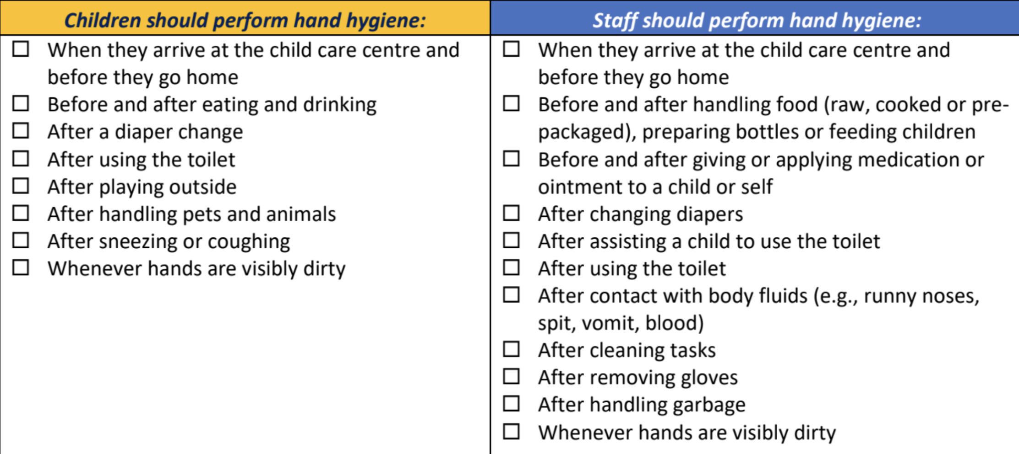

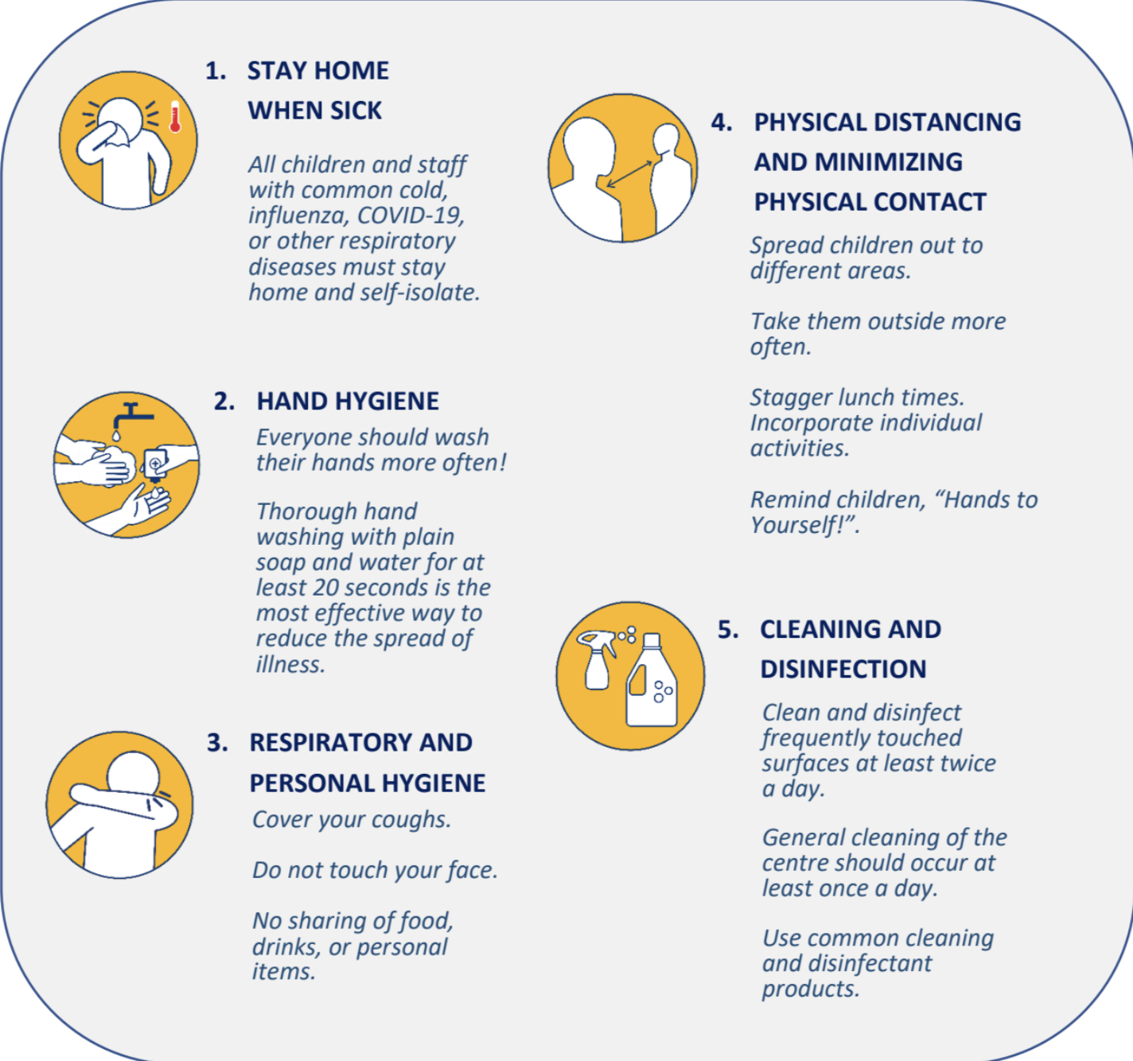

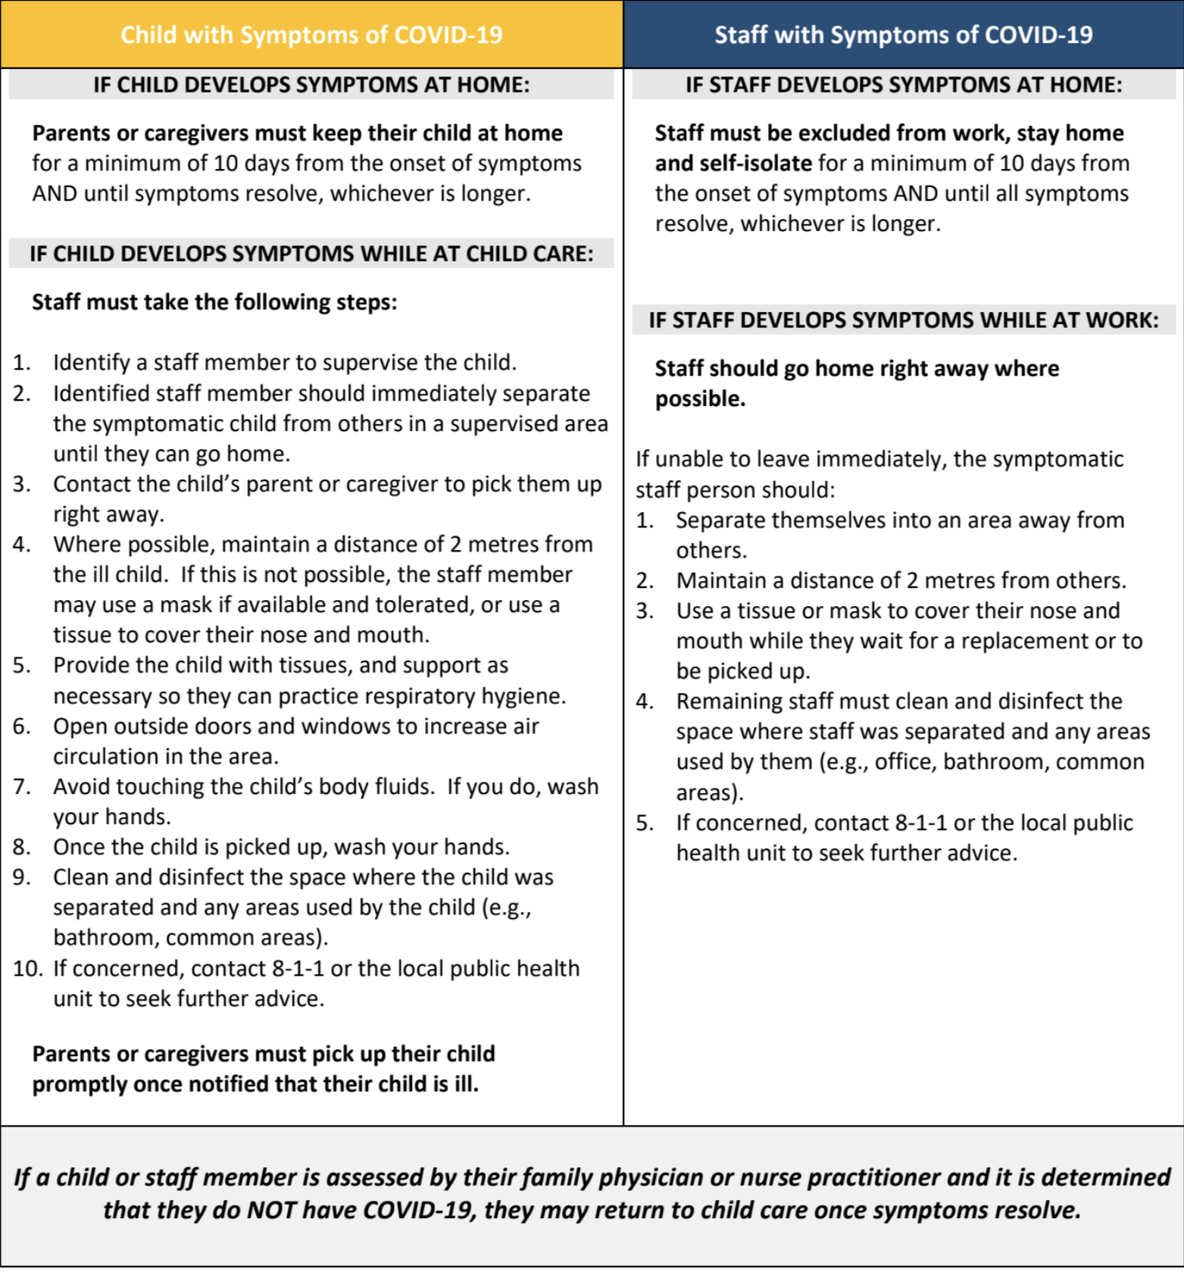

Anticipated Questions
*Will I be notified if my child has been exposed to any illness?
Yes, we always let families know if they have been exposed to an illness.
*Can I find out the name of the child that was ill?
No we never share a name of a child that has been ill.
*Will I really have to keep my child home for 10 days? You may need to depending on symptoms.
*What am I going to do if I have to keep my child home? Now more than ever you must have a Plan B.
*If someone in my household is sick can my child still attend? No
*It’s been almost 48 hours since my child had any symptoms of illness, can they attend? Please review our Covid policy on our website, it is updated regularly and is the best place to get information in a timely manner.
*How long are the new protocols and policies going to be in place?
We are the same as any other public business, Doctors offices, Dentist offices, restaurants...we have to follow protocols until the pandemic is over or controlled. We ask for understanding, we would never question why the Dentist has new protocols as they know what’s best for their office. We are doing everything asked of us by WCB, CDC, and MCF along with our knowledge of what’s best for the centre.
*My boss is not understanding.
We understand how frustrating this time is for everyone, ourselves included. This is a time for empathy and understanding, we all have a responsibility to keep our community safe and healthy. We have strict policies we must follow or we can be shut down, taking months to be able to reopen, unfortunately everyone needs to understand that.
*What if my child has allergies?
The children are with us often for more than 9 hours a day, we know their personalities and can judge the difference between unwell and allergies. If you anticipate allergies let us know now!
*If I reduce the amount of days, we come will you hold the spot? Unfortunately, we cannot.

*Will any of your policies change?
They may change as we work through Covid and as we are assured no one tries to ignore our current protocols. Honest and transparent communication is needed now more than ever. Please stay updated by looking at our website.
*How long are you going to ask the health questions? As long as needed.
*Will you close for 14 days?
We are doing everything in our power to avoid short term closures, keeping a child home who is sick or has a family member that is sick will help avoid a closure.
*Do I have to pay my fees if my child is away?
Yes all fees are due if you keep your child home or if the centre temporarily closes for 15 days or less.
*I don’t get a response over text or seesaw when I ask a question.
We don’t respond once we close or on weekends. We answer all texts and seesaw messages during our working hours. Responding to messages takes a staff off the floor, so we try to monitor as best we can but have more time to respond during nap time between 12-2.
*Does my child need to stay home because of allergies?
Maybe, if your child’s symptoms are unclear, for example your child has a rash, excessive discharge from nose or eyes.
*My child’s upset when the other children participate in soccer or taekwondo.
The children that do not participate have their own fun adventures during this time. Please remember the children pick up on what you as parents are saying, feeling or projecting. For example “were you upset you didn’t have taekwondo?” a child’s natural response can often be “yes”. We make sure children never feel left out of programs at the centre and if they are exhibiting signs they are we will let you know.
*This really affects my job!
We understand this is a trying time, but a childcare setting is not an environment that can afford to ignore protocols, we must put the health and safety of everyone first. Please share the letter we provided with your employer so they have a clear understanding of protocols childcare providers must follow and understand if we follow these protocols we can avoid a longer closure.
*Can my child return after 48 hours symptom free?
With everything changing daily we will touch base with each family before returning.
*How are you keeping the daycare safe?
We are cleaning throughout the day all toys and high touch surfaces, we are using a fogger for disinfecting as an added layer of protecting, children are following our hand washing guidelines and we are communicating with families as much as possible stressing the importance of having your child stay home if they appear unwell or if a member of their household is unwell.
Infectious diseases expert Dr. Isaac Bogoch gives safety tips and information about keeping children and teachers safe during the pandemic.
“This is the time to not send your kid to school or daycare, if your kid has symptoms,” he said, adding that even if they don’t have COVID-19, it is better to be safe.
“This means a parent has to stay home as well,” he said. “Employers need to have tremendous leniency...”
Incase of an unexpected short term closure due to Covid please go Canada.ca and look for Canada Recovery Caregiver Benefit (CRCB) This has been created for parents if they must stay home and care for a child under 12 because of exposure or illness.

