Dandruff
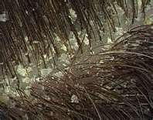
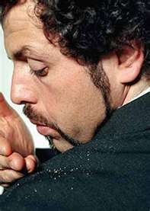

- Common scalp condition that occurs when dead skin is shed

- Produces irritating and embarrassing white flakes

Causes:
- Lack of essential fatty acids (Omega 3 & Omega 6)
- Deficiency of nutrients … in particular B Complex & Selenium
- Accumulation of internal toxins which can trigger seborrhoea, an inflammatory scaling skin disease caused by a disorder of the sebaceous (oil-secreting glands)
- Trauma or chronic stress
- Excessive intake of carbohydrates or sugar
- Hormonal imbalances
- Illness

Suggestions:
- Choose a shampoo that feeds the scalp … Shaklee ProSanté Hair Care is recommended.
- Supplement wisely: Choose from the supplements below, or to simplify matters, just take Shaklee Vitalizer + extra ground flaxseed daily

  - Step 1
    - Multivitamin/mineral supplement (Shaklee Vita Lea)
    - Essential Fatty Acids … there are several good oils
      - Omega 6 (Shaklee GLA)
      - Omega 3 (Shaklee OmegaGuard)
      - Flaxseed oil (ground flaxseed or Shaklee Flaxseed Oil Capsules)
      - Lecithin – oil for soybean (Shaklee Lecithin)
    - B Complex – all eight B’s (Shaklee B Complex)

  - Step 2
    - Vitamin E + Selenium
    - Extra Zinc
    - Carotenoid Complex ... CarotoMax

