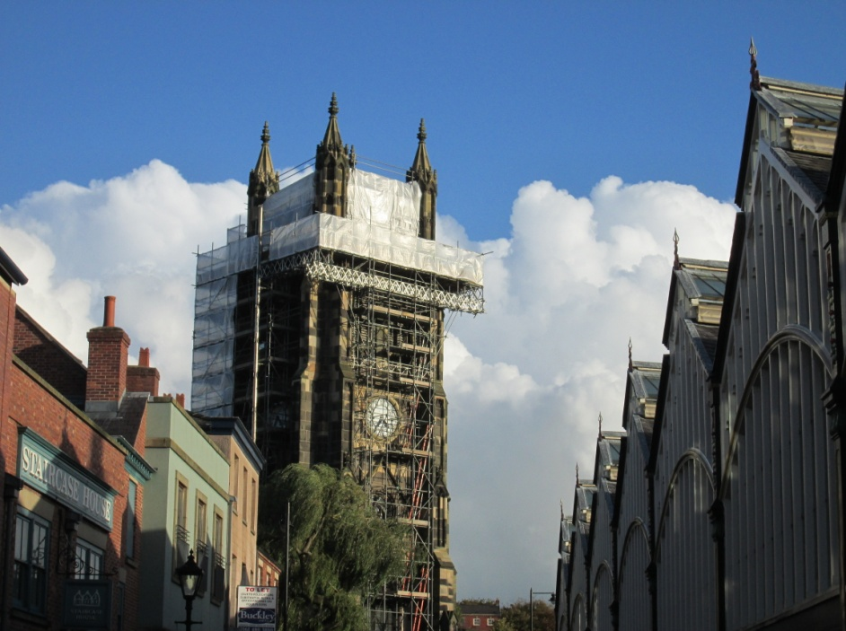

Scaffolding gets everywhere – and as if there isn’t enough of it at St Mary’s in the Marketplace it has now sprung up at St Mary’s Rectory.
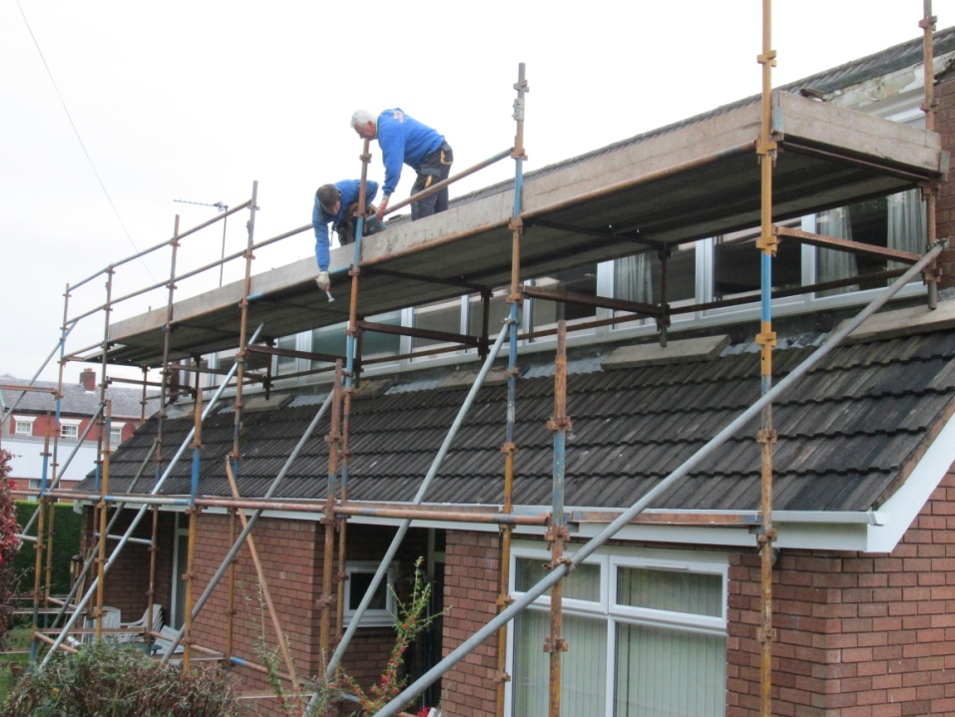
Some essential maintenance – roof repairs, replacement fascias and other roofline work with a paint can and brush! . .

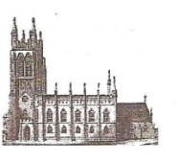
St Mary’s in the Marketplace.
Issue No 15 (28th October 2012)

“Securing the future for the next 100 years”
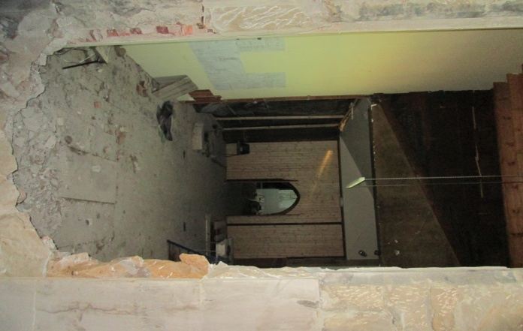
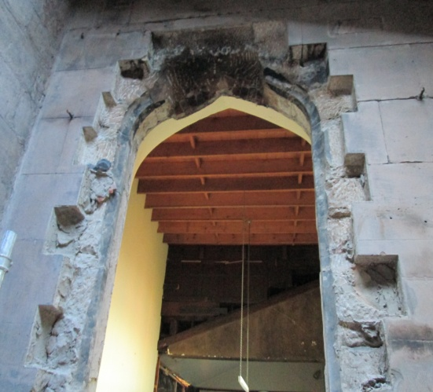
We have break-through – the window and
stonework below it have now been taken
away - opening up the area from the old
church office into to the Choir Vestry. The
surprise find of a little mummified sparrow
adding a little interest to the task of cutting
up and removing the large and heavy stones.

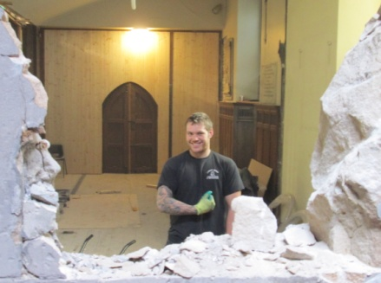

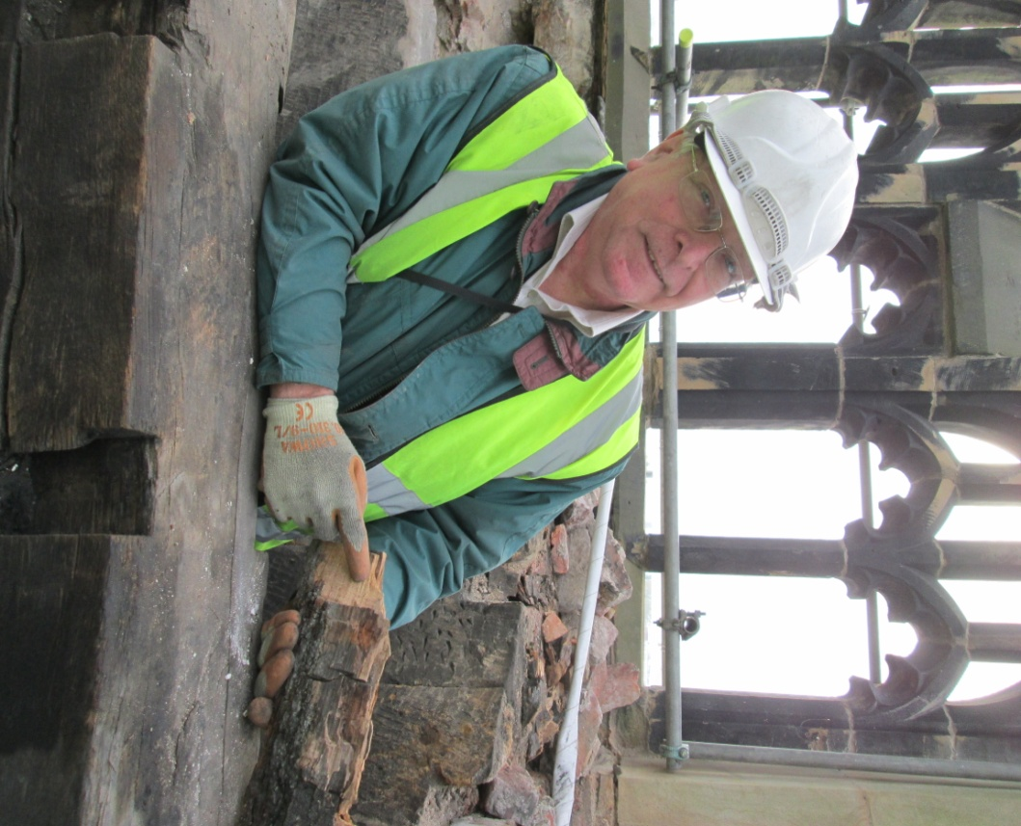

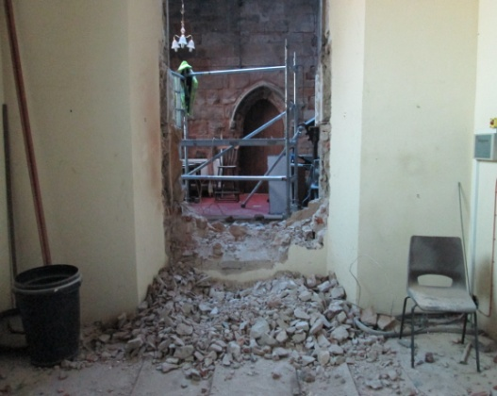
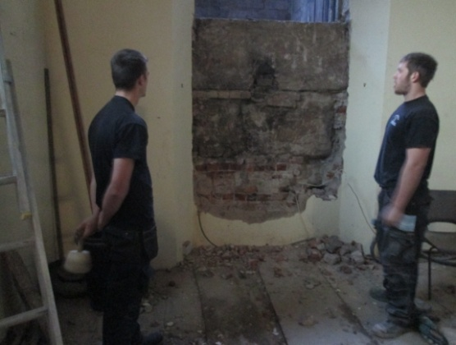

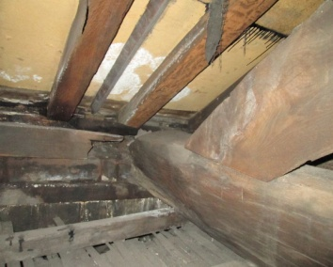
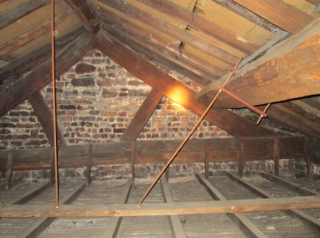
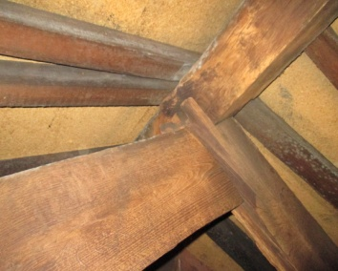
It’ was quite a surprise to see how large the space looks now that the area has been “opened-up”. Floor levels will of course need to be sorted and in due course the lift installed. Due to the damp issues in the Rector’s Vestry there has had to be a few minor changes to our immediate plans - in that the former Choir Vestry will need to remain empty for the time being. This means that the Stockport Heritage Trust will return and use the area immediately in front of the newly opened wall and into the planned shop area. Although temporary roof repairs are being undertaken to the vestry areas (to make them watertight) we will be seeking new grant funding to complete full roofing works (to both Vestry areas) as soon as funds are available from English Heritage. We were however somewhat relieved to have been informed by our contractors that the roof has now been made safe from collapse. We need to give the vestry areas time to dry-out safely (a complex process to ensure that dry-rot does not take hold). We have to ensure that there is sufficient air-flow and that we have a controlled atmosphere. Quite a lot of the panelling is being removed temporarily – including parts of the ceiling. We are however excited at the ancient roof timbers most likely to be as old as the Chancel. This an important feature of that part of the Church and one we may wish to make available for viewing at some time in the future.

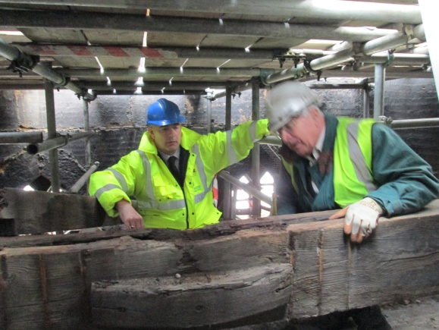
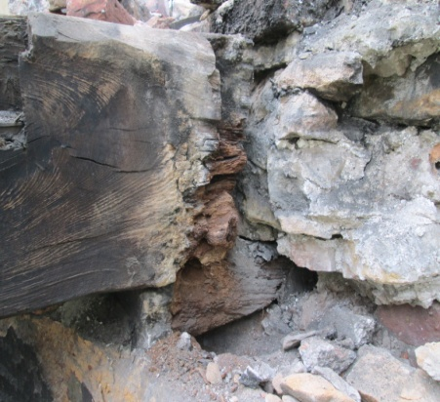
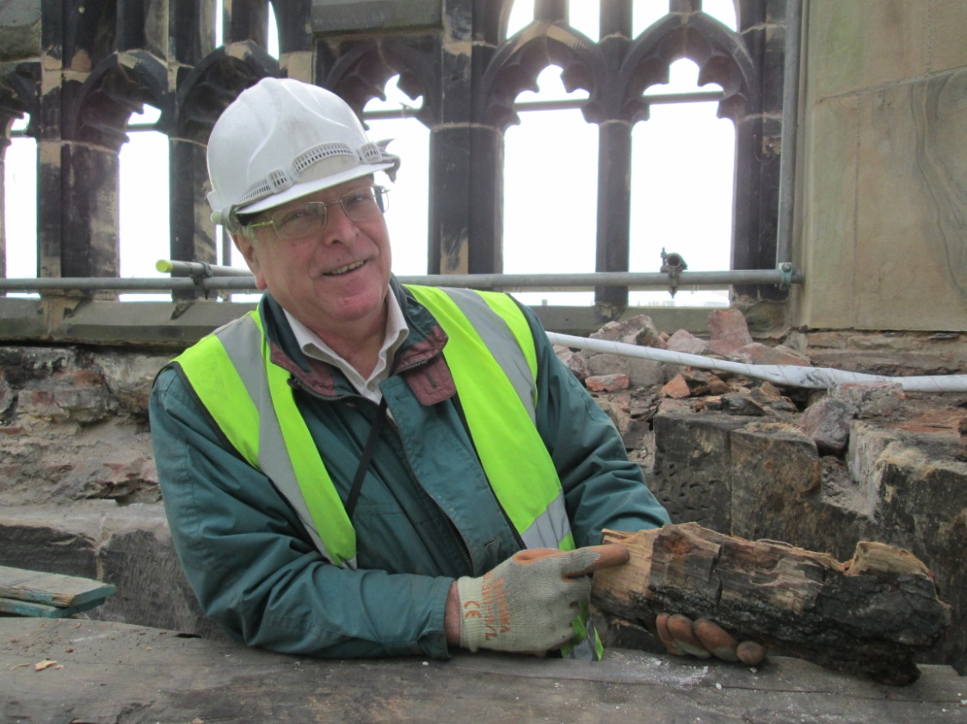
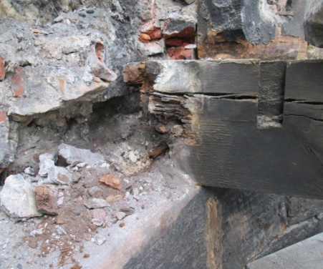
On the tower roof work continues
to cut out the rotten wood, move
the beam-ends on to the support
stones and to splice in new timber.
A rather “tricky” process I suspect,
given the size and weight. Also being
prepared the area which will take the
weight of our replacement flagpole.

