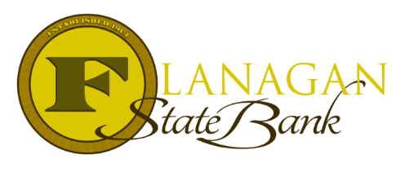
Mortgage Tidbits

Keeping you informed and in the know….

What Is Private Mortgage Insurance?

Mortgage Insurance is an insurance policy the lender uses to protect their investment in case a loan defaults. Mortgage Insurance comes in many different forms. Each agency will offer their own version, but all loans usually have this included. For this discussion, we are going to focus on PMI or Private Mortgage Insurance.

- PMI is required on conventional loans (Fannie Mae & Freddie Mac loans) when a borrower does not have 20% down payment.
- PMI is a tiered program and goes by 5% down payment increments. Each 5% level reached will mean a lower PMI payment for the borrower. PMI does start at the highest level at 97%, which is considered a specialty program. The next level down is 95% and continues each 5% until 80% is reached.
- PMI has many options available.
BPMI – Borrower Paid Monthly Insurance | Borrower Paid Single Premium MI | Borrower Paid Split Premium MI
This is the traditional MI Plan and features a monthly amount added to the Borrower’s payment each month | The Borrower will pay a lump sum at the closing of the loan and will not have a monthly fee for the PMI | The Borrower will have the option of paying part of the MI Premium up front as a single premium and the remaining portion will be part of the monthly payment.

The Single Premium also comes in refundable or non-refundable options and most PMI is cancellable if specific terms are met by the Borrower.

It is wise to explore the options available for PMI. Each Borrower will be able to decide the combination that works best for their situation. Our Loan Officers can provide them a custom quote and educate them on the differences further to make sure they are making an education decision when it comes to choosing PMI options.

Call us today for the best answers to the mortgage questions!

~ Provided to you by ~
Insert photo here or delete box when ready to use
Name: Phone:
Title: Email:
Address: City, State, Zip
Apply Now Link:

