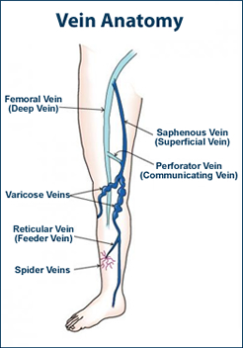
Varicose Veins

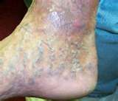
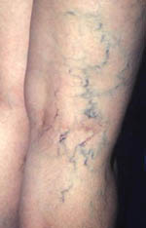
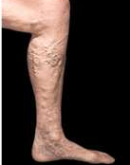

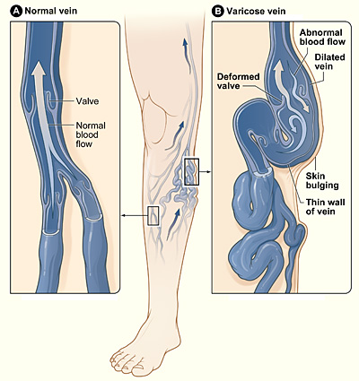
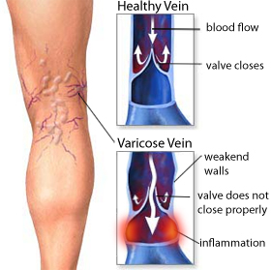

The illustration shows how a varicose vein forms in a leg. Figure A shows a normal vein with a working valve and normal blood flow. Figure B shows a varicose vein with a deformed valve, abnormal blood flow, and thin, stretched walls. The middle image shows where varicose veins might appear in a leg.

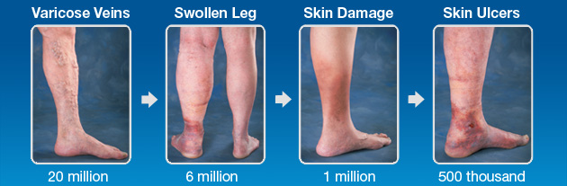

Varicose veins or arteries are veins that have become enlarged. The term commonly refers to the veins on the legs although varicose veins can occur elsewhere.
- Veins have leaflet valves to prevent blood from flowing backwards (retrograde flow or reflux).
- Leg muscles pump the veins to return blood to the heart (the calf muscle pump mechanism), against the effects of gravity.
- When veins become varicose, the leaflets of the valves no longer meet properly, and the valves do not work (valvular incompetence).
- This allows blood to flow backwards and they enlarge even more.
- Varicose veins are most common in the superficial veins of the legs, which are subject to high pressure when standing.
- Besides cosmetic problems, varicose veins are often painful, especially when standing or walking.
- They often itch, and scratching them can cause ulcers.
- Varicose veins, are commonly referred to as "varicosities".
- Varicosities constitute not a disease, but a symptom of superficial venous insufficiency.
- Heaviness, tiredness, swelling, pain, muscle cramps, difficulties walking and even standing are some of other symptoms of the problem
- Varicose veins are distinguished from reticular veins (blue veins) and telangiectasias (spider veins), which also involve valvular insufficiency, the size and location of the veins.
- Many patients who suffer with varicose veins seek out the assistance of physicians who specialize in vein care. These physicians are called phlebologists.
Varicose veins have a hereditary link, and can be caused by
- high pressure produced during pregnancy
- restricted clothing
- prolonged standing
- Obesity
- lack of regular exercise
- chronic constipation
- heavy lifting
- hormonal changes
- and heavy metal toxicity also can contribute to varicose veins.

Prolonged standing or sitting aggravates this condition. Besides cosmetic problems, varicose veins are often painful, especially when standing or walking. They often itch and scratching them can cause ulcers.
Nutrition and supplementation can both prevent and reduce the pain and extent of this discomforting sign of aging.
- Eat a high-fiber diet with whole grains, fresh fruits and vegetables
- Drink eight glasses of pure water daily to prevent constipation
- Avoid fried and fatty foods that contribute to circulation problems
- Daily aerobic exercise such as walking encourages oxygenation and circulation of the blood.
- Elevate your legs often throughout the day
- Wear elastic stockings during the day when advised by your physician.
- Interrupt long periods of standing and sitting by walking to encourage blood flow.
- If you are overweight, lose weight to eliminate that extra stress of the veins.
(Spider veins are dilated capillaries or arterioles that cause thin blue lines under the skin. They are not dangerous and cause no symptoms. They often are a result of pregnancy or aging.

Natural Health Care
To support better Circulation:
- Optimal levels of Vitamin E
- CoenzymeQ10
- OmegaGuard

To support stronger vein walls and valves:
- Optimal Vitamin C
- Optimal Protein (leucine in Cinch Shakes is an excellent choice)

If constipated, Herb Lax and VitalMag is recommended

Other natural supports:
- Wear compression hose
- Elevating your legs, especially after a long walk or stand
- Purchase a set of EPIC BOOTS or a LEG COMPRESSION CHAIR, and use frequently

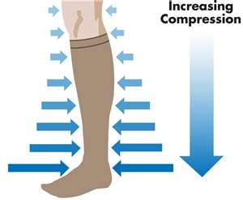
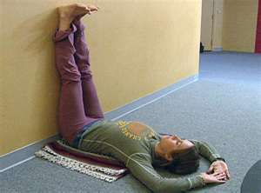

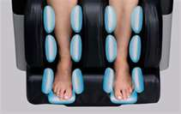
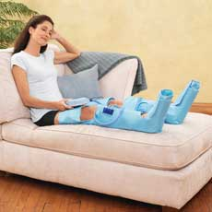
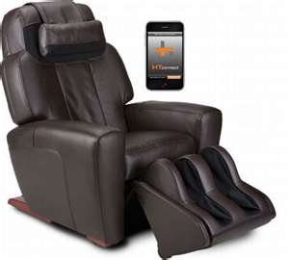
Epic Boots
Leg Compression Chair

